**ECE 6372- ADVANCED HARDWARE DESIGN**

**SAFETY AND MANAGEMENT USING IIOT**

**Team Phoenix**

Kavya Sree Gogadi- 2199257

Praval Goud Madhagouni- 2244585

1. **ABSTRACT**

In the ever-evolving landscape of industrial processes, the imperative for safety and efficient management within chemical plants is non-negotiable. This project represents a pioneering endeavor to revolutionize conventional practices by harnessing the power of the Industrial Internet of Things (IIoT) for remote monitoring. The overarching goal is to address the complex challenges prevalent in chemical plants, introducing a dynamic solution that combines real-time data collection, proactive issue identification, and downtime reduction.

The primary objectives of this project are twofold: to enhance safety measures and to streamline management practices within chemical plants. By deploying IIoT technologies strategically, the project aims to establish continuous monitoring, enabling the immediate detection of potential hazards. The integration of advanced analytics facilitates the interpretation of real-time data, providing actionable insights for informed decision-making. This proactive approach not only fortifies safety measures but also contributes significantly to a substantial reduction in downtime, optimizing overall plant efficiency.

At the core of the project lies the implementation of the STM32 ARM architecture, a robust and cutting-edge hardware solution tailored for reliable data acquisition. Communication protocols, representing the lifeline of any IIoT system, are meticulously selected to ensure seamless connectivity with sensors distributed throughout the plant.

1. **INTRODUCTION**
2. **Brief Overview of the project**

In the realm of industrial operations, particularly within chemical plants, the imperative for safety and efficient management looms large. This project is a pioneering endeavor to integrate Industrial Internet of Things (IIoT) technology for remote monitoring, envisioning a comprehensive solution to prevalent challenges.

**Objectives:**

* **Enhanced Safety Measures:** Implementing IIoT to monitor environmental conditions and detect potential hazards, ensuring timely responses to prevent accidents.
* **Efficient Management:** Real-time data collection and analysis to provide insights for proactive issue identification and subsequent downtime reduction.

1. **Applications of the project in IIOT**

The applications of this project within the realm of IIoT are multifaceted and impactful. The core objective is to leverage IIoT technology to enable remote monitoring in chemical plants. This involves the strategic placement of sensors throughout the plant to collect and transmit real-time data on critical parameters such as temperature, pressure, and vibration. The project aims to harness this data to proactively identify issues, reduce downtime, and prevent accidents, thereby elevating safety standards and optimizing operational efficiency.

1. **BACKGROUND**
2. **Current Challenges in Chemical Plants**

Chemical plants, integral to industrial progress, grapple with a myriad of challenges that necessitate innovative solutions. Traditional monitoring systems often fall short in providing real-time insights into the complex and dynamic processes inherent to chemical production. Challenges include equipment malfunctions, potential environmental hazards, and the critical need for prompt responses to avert accidents.

1. **Definition of IIOT**

The advent of the Industrial Internet of Things (IIoT) presents a transformative paradigm in the industrial landscape. IIoT signifies the integration of sensor technologies, data analytics, and real-time communication within industrial processes. It represents a shift towards interconnected systems that enable seamless data exchange, fostering a more intelligent and responsive industrial ecosystem.

1. **Need for Remote Monitoring**

The need for remote monitoring in chemical plants stems from the inherent risks associated with their operations. Traditional on-site monitoring systems are often insufficient in providing a comprehensive understanding of the operational landscape, particularly in real time. Remote monitoring, facilitated by IIoT, addresses this gap by deploying sensors strategically throughout the plant, capturing crucial data that is transmitted for analysis.

1. **Benefits of remote monitoring**
2. **Real-time Data Collection:** IIoT enables the continuous collection of real-time data, providing a dynamic and up-to-date view of the operational environment.
3. **Analysis and Insights:** The integration of advanced analytics allows for the interpretation of collected data, offering actionable insights for informed decision-making.
4. **Proactive Issue Identification:** Through constant monitoring, potential issues are identified proactively, allowing for immediate corrective actions.
5. **Downtime Reduction:** The combination of real-time data and proactive issue identification contributes to a significant reduction in downtime, optimizing overall plant efficiency.
6. **SYSTEM ARCHITECTURE**
7. **ESP32 ARM:**

The STM32L4S5xx, STM32L4S7xx and STM32L4S9xx devices are an ultra-low-power microcontrollers family (STM32L4+ Series) based on the high-performance Arm® Cortex®-M4 32-bit RISC core.

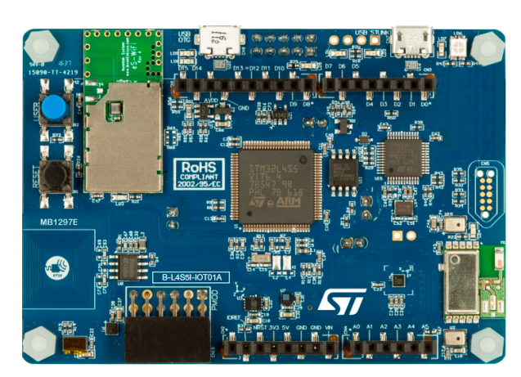

They operate at a frequency of up to 120 MHz. The Cortex-M4 core features a single-precision floating-point unit (FPU), which supports all the Arm® single-precision data-processing instructions and all the data types. The CortexM4 core also implements a full set of DSP (digital signal processing) instructions and a memory protection unit (MPU) which enhances the application’s security.

These devices embed high-speed memories (2 Mbytes of Flash memory and 640 Kbytes of SRAM), a flexible external memory controller (FSMC) for static memories (for devices with packages of 100 pins and more), two OctoSPI Flash memories interface (available on all packages) and an extensive range of enhanced I/Os and peripherals connected to two APB buses, two AHB buses and a 32-bit multi-AHB bus matrix.

The STM32L4Sxxx devices embed several protection mechanisms for embedded Flash memory and SRAM: readout protection, write protection, proprietary code readout protection and a firewall. These devices offer a fast 12-bit ADC (5 Msps), two comparators, two operational amplifiers, two DAC channels, an internal voltage reference buffer, a low-power RTC, two general-purpose 32-bit timer, two 16-bit PWM timers dedicated to motor control, seven general-purpose 16-bit timers, and two 16-bit low-power timers. The devices support four digital filters for external sigma delta modulators (DFSDM).

In addition, up to 24 capacitive sensing channels are available. They also feature standard and advanced communication interfaces such as:

• Four I2Cs

• Three SPIs

• Three USARTs, two UARTs and one low-power UART

• Two SAIs

• One SDMMC

• One CAN

• One USB OTG full speed

• Camera interface

• DMA2D controller

1. **Communication Protocols Used to communicate with sensors.**

In this Project, we are mainly using UART and I2C communication protocols to communicate with the onboard sensors and drivers.

**1. UART (Universal Asynchronous Receiver-Transmitter):**

UART, a widely adopted serial communication protocol, plays a pivotal role in connecting the microcontroller with the on-board sensors. Its asynchronous nature allows for straightforward point-to-point communication, making it well-suited for applications where simplicity and ease of implementation are paramount. The UART protocol is particularly beneficial in scenarios where a direct, one-to-one connection is established between the microcontroller and individual sensors, providing a streamlined and efficient means of data transfer.

**2. I2C (Inter-Integrated Circuit):**

The I2C communication protocol is chosen for its versatility and efficiency in handling multiple devices on the same bus. Unlike UART, I2C is a synchronous, multi-master, multi-slave communication protocol, allowing for the seamless integration of various sensors and drivers into the system. This makes I2C well-suited for applications where a network of sensors needs to communicate with a central microcontroller. The protocol's ability to support multiple devices on the same bus reduces the complexity of wiring and enables a more scalable and modular approach to system design.

1. **IMPLEMENTATION STEPS AND WORKING**
2. **HTS221:**

The HTS221 is an ultra-compact sensor for relative humidity and temperature. It includes a sensing element and a mixed signal ASIC to provide the measurement information through digital serial interfaces.

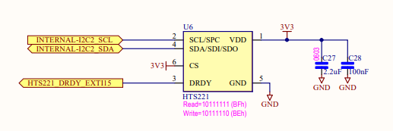

1. **LSM6DSL 3D Accelerometer and 3D Gyroscope:**

The LSM6DSL is a system-in-package featuring a 3D digital accelerometer and a 3D digital gyroscope performing at 0.65 mA in high-performance mode and enabling always-on low-power features for an optimal motion experience.

The Accelerometer here is used to detect motion tracking and the Gyroscope is used to monitor the vibrations in the machines.

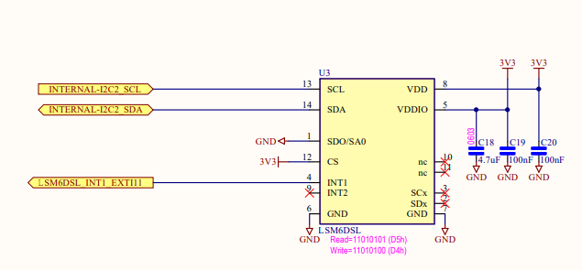

1. **LIS3MDL MAGNETOMETER**

The LIS3MDL is an ultralow-power high-performance 3-axis magnetic sensor with user-selectable full scales of ±4/±8/±12/±16 gauss. The self-test capability allows the user to check the functioning of the sensor in the final application. The device may be configured to generate interrupt signals for magnetic field detection. The LIS3MDL includes and I²C serial bus interface that supports standard and fast mode (100 kHz and 400 kHz) and SPI serial standard interfaces.

1. **BUZZER**

A beeper or buzzer, an audio signalling device, can take on electromechanical, piezoelectric, or mechanical forms. Its primary purpose is to transform audio signals into audible sounds. Typically powered by DC voltage, it finds applications in timers, alarm systems, printers, computers, and more. Depending on its specific design, this device can produce various sounds such as alarms, music, bells, and sirens.

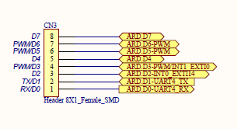

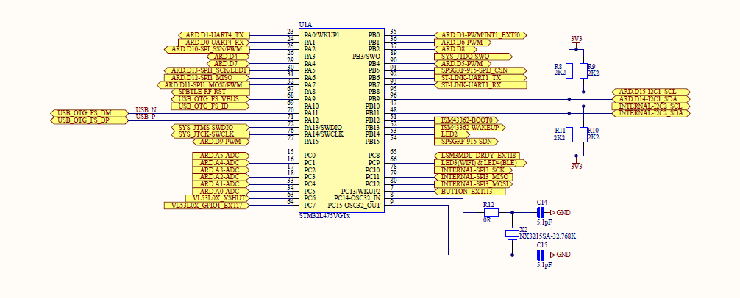

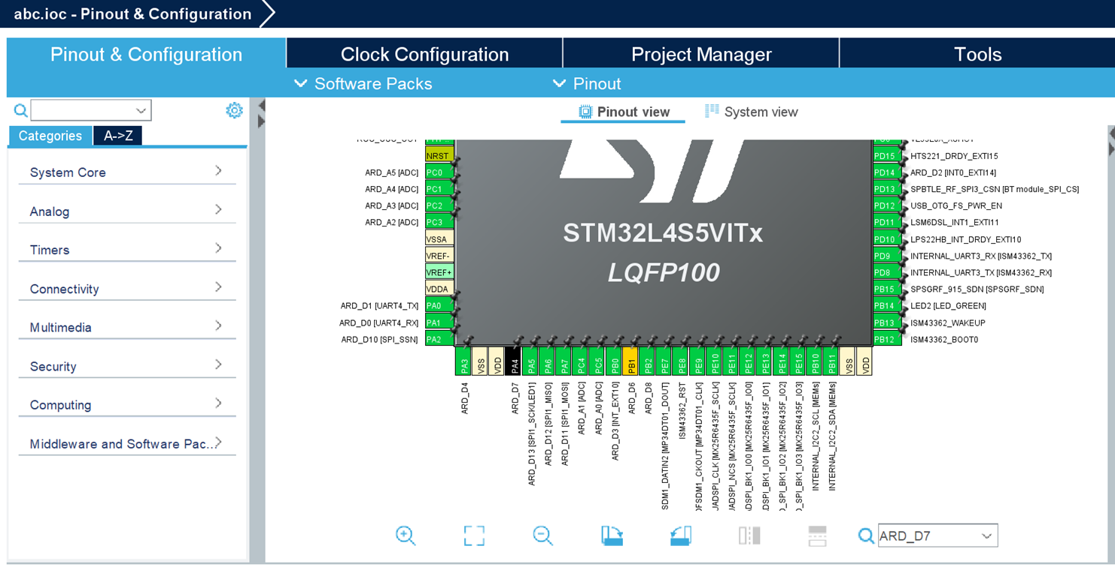

1. **DEMONSTRATION**
2. **HTS221:**

Leveraging the HTS221 sensor module, we are measuring temperature, Humidity and Pressure. Firstly, we are setting up the device by Mode Configuration and Generate Code Respectively.

The STM32 microcontroller is connected to the external buzzer through GPIO pins, so, whenever the temperature Humidity or Pressure crosses the threshold value given, the buzzer acts as an alarm to alert the hazard.

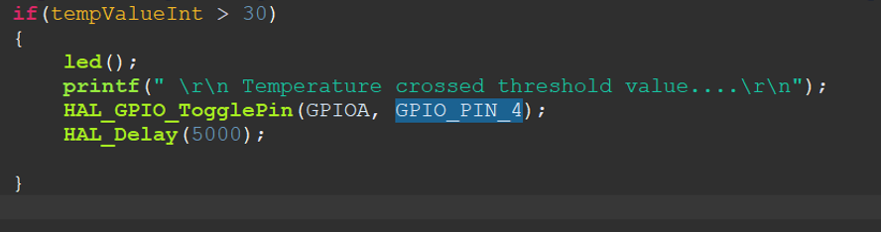

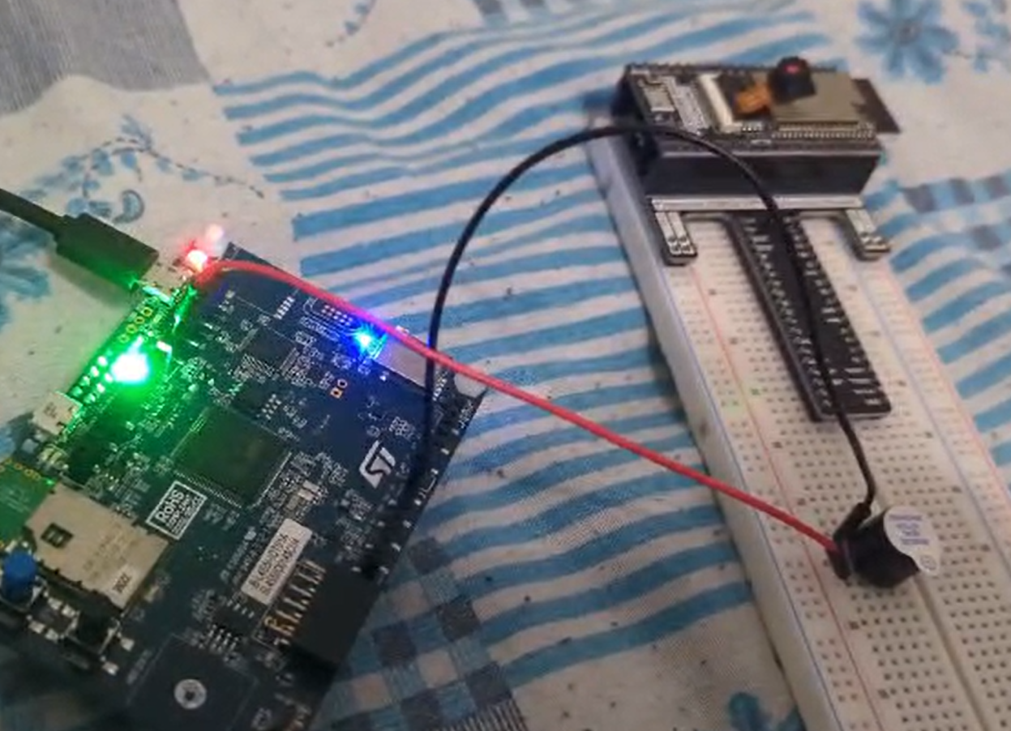

1. **LSM6DSL 3D Accelerometer and 3D Gyroscope:**

In the LSM6DSL sensor module, we are measuring the Accelerometer and Gyroscope. Firstly, we are setting up the device by Mode Configuration and Generate Code Respectively.

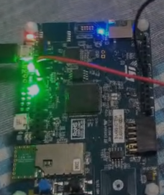

1. **VL53L0X Time of Flight (ToF):**

In the VL53L0X sensor module, we are measuring the Time-of-Flight Gesture detection. Firstly, we are setting up the device by Mode Configuration and Generate Code Respectively.

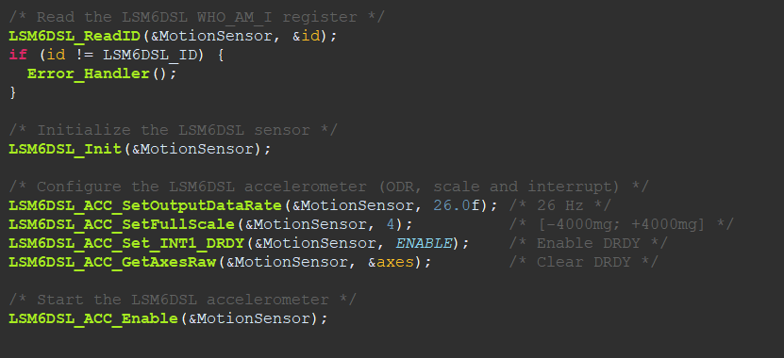

1. **LIS3MDL Magnetometer**

The inclusion of a magnetometer (commonly used to measure the strength and direction of a magnetic field) can introduce additional capabilities and applications to your project. Here are some potential applications for a magnetometer in your project:

Orientation Sensing:

Combine data from the magnetometer with the accelerometer and gyroscope to achieve precise orientation sensing. This can be particularly useful in applications where knowing the exact orientation of the system is crucial.

Magnetic Field Monitoring:

Utilize the magnetometer to monitor changes in the magnetic field around the system. Sudden changes in magnetic fields could indicate the presence of metallic objects, and this information can be used for proximity sensing or to detect the movement of magnetic materials.

Magnetic Interference Detection:

Detect and quantify magnetic interference in the environment. This information can be crucial in environments where magnetic interference may impact the accuracy of other sensors, such as gyroscopes and accelerometers.

1. **BLUETOOTH**

Using the Bluetooth module, we transmit all the parameters to the mobile application called ST BLE Sensor to display the parameters inside the chemical plant.

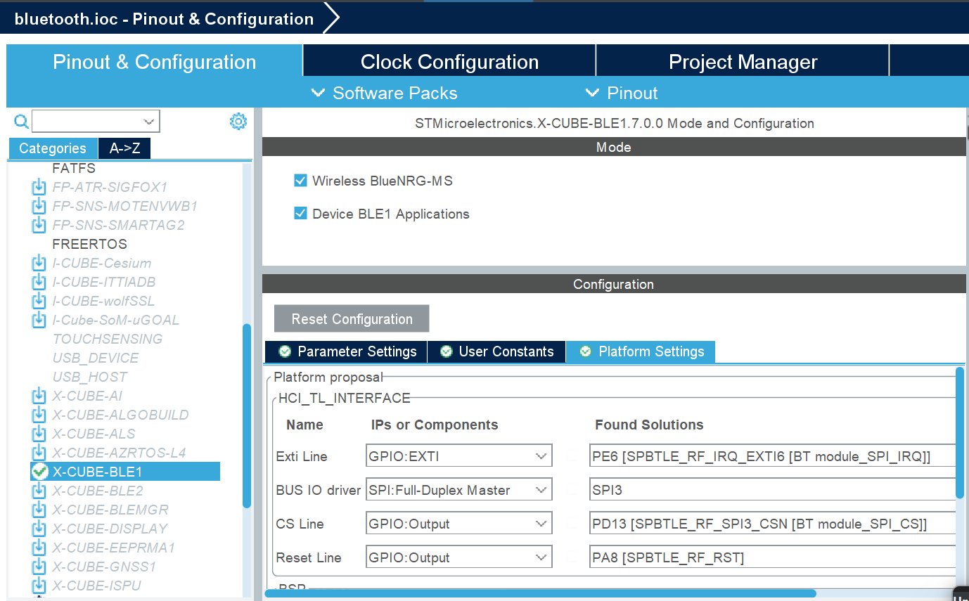

Bluetooth® 4.1 module (SPBTLE-RF) from STMicroelectronics

 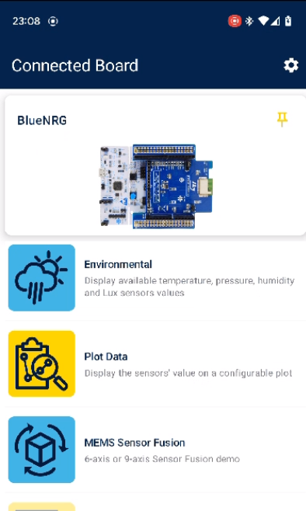

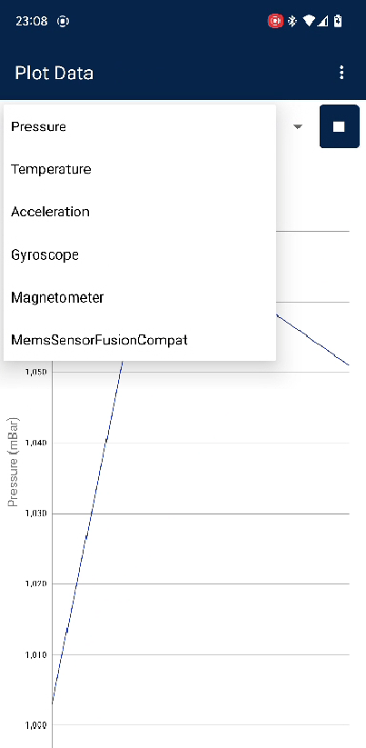

1. **CONCLUSION**

In conclusion, the HTS221 sensor module, measuring temperature, humidity, and pressure, serves as a sentinel against potential hazards by triggering an external buzzer when predefined thresholds are exceeded. The LSM6DSL sensor module expands the project's scope by precisely capturing acceleration and gyration, providing valuable insights into physical dynamics. Meanwhile, the VL53L0X sensor module introduces Time-of-Flight Gesture detection, enhancing user interaction and control possibilities. The inclusion of the magnetometer sensor, LIS3MDL helps measure the strength and direction of the magnetic field, potential applications include precise orientation sensing, magnetic field monitoring, and detection of magnetic interference.

The integration of Bluetooth connectivity further elevates the project's capabilities, enabling wireless communication for remote monitoring and control. This seamless interplay of sensors, microcontrollers, and wireless connectivity not only bolsters safety measures but also facilitates real-time data transmission and dynamic response mechanisms.

**ACKNOWLEDGMENTS**

We would like to thank Dr. Chen for her guidance throughout this project.