**Course:** Foundations of Programming, Python

**Assignment:** 08

**Name:**  Classes in Python Script

**Description:** CreatingPython script with three classes to manage text file and new data

**Created:** 06/06/2020 by Kate Golenkova

**GitHub Page:** <https://kgolenk.github.io/IntroToProg-Python-Mod08/>

**Introduction**

In this assignment I will show how I created a new python script with three classes **Product**, **FileProcessor** and **IO**, that askes user to add new data (Product and Price), read and stores data in text file with handling errors. This script works with variables as objects of **Product** class and operates with list of objects. I will show results of tests run in both PyCharm and Command Line.

**Pseudo-Code of Script**

To create new script for Assignment 08 I used simple template **Assignment08_starter.py**, that you can see in **Figure 1.** below:

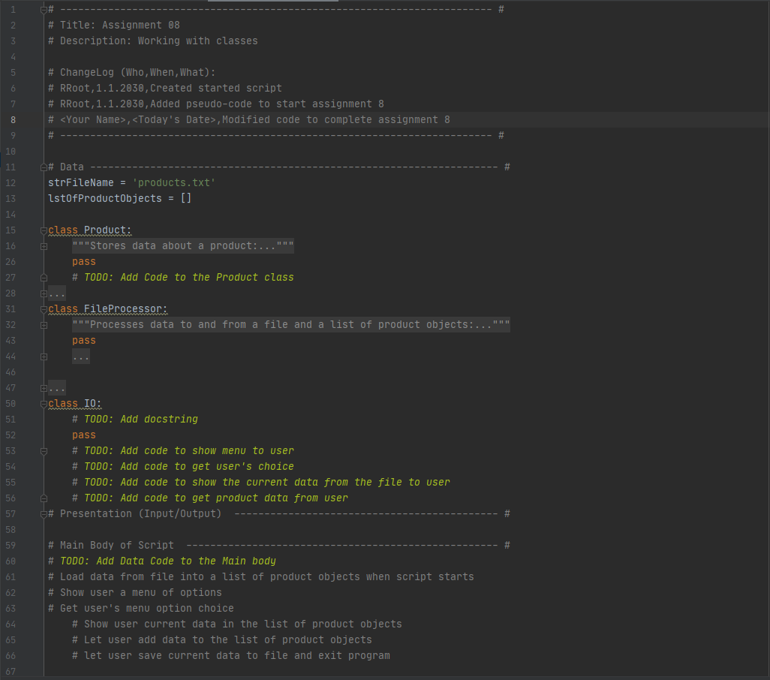

**Figure 1.** Simple Template

**Python Script with Classes, Objects and Exceptions Handling**

I downloaded this file and used it as pseudo-code to create my script. I added Constructor with two attributes and created two properties **product_name** and **product_price**. Then I added setters for them with product name validation. Please see **Figure 2.** to see the Product class:

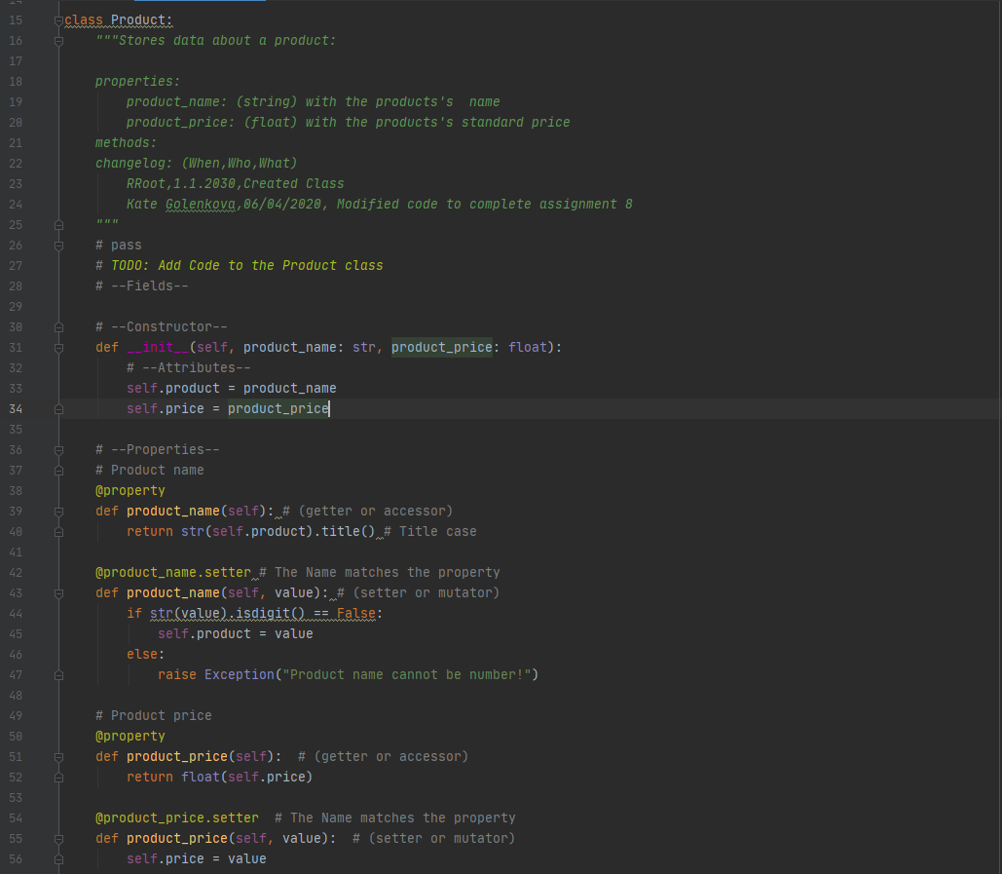

**Figure 2.** Class Product stores product data.

To other classes I added more functions that operate with objects and list of objects to read and write file, get user input, and show current data. For example, to read data from file **product.txt**, I created function **read_data_from_file**(file_name, list_of_product_objects) in class FileProcessor that works with objects of Product class and returns list of objects. The function that saves data to text file, operates with list of objects too. Please see **Figure 3.** below:

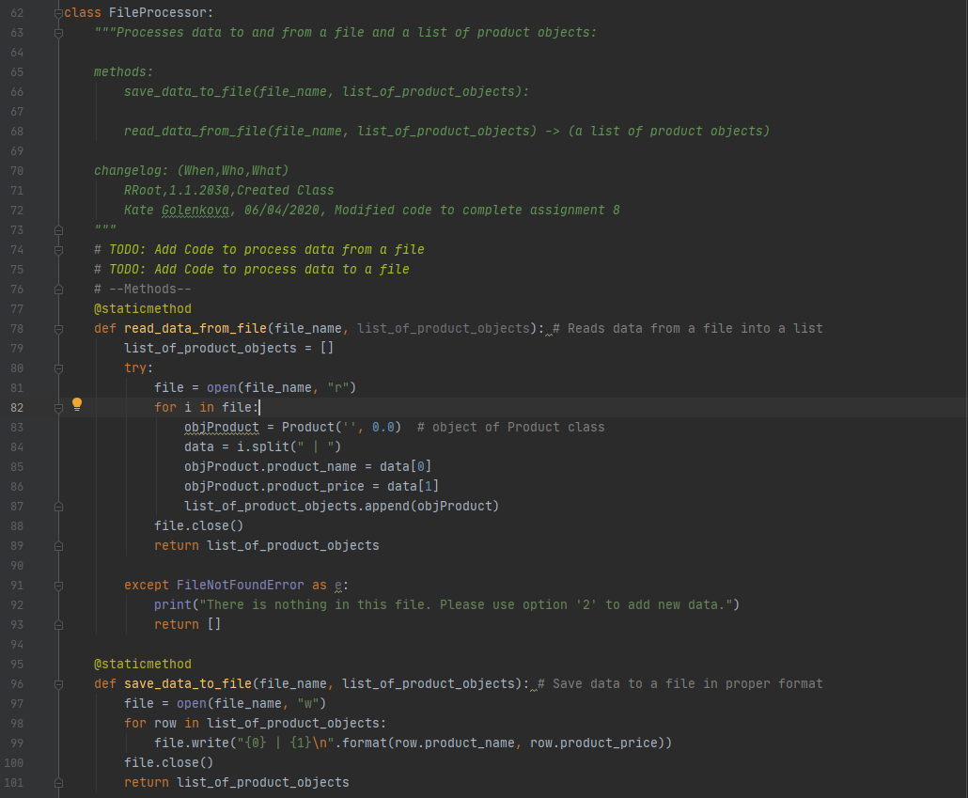

**Figure 3.** Functions in FileProcessor class work with objects of Product class.

As you can see in **Figure 2.** and **Figure 3.** I used try-except blocks to handle errors to avoid execution abruptions. Also, I added functions to IO class to display Menu, get user choice and get user input. Please see Figure 4. to check functions **input_new_data()** and **show_current_data(**list_of_product_objects**)** that operates with objects of Product class:

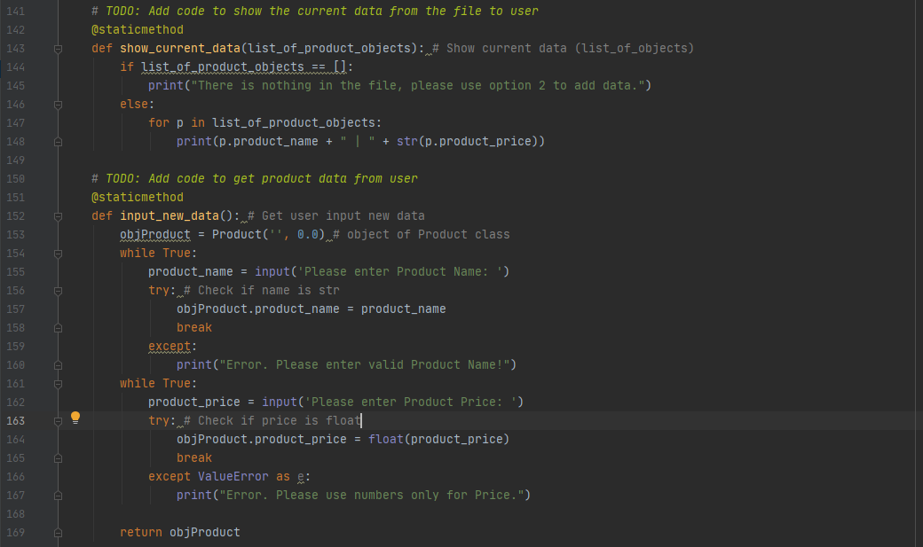

**Figure 4.** Functions in IO class operate with objects of Product class.

As soon I created all needed functions/methods for my classes, I used them to complete main body of the script. In **Figure 5.** you can see the final part of program:

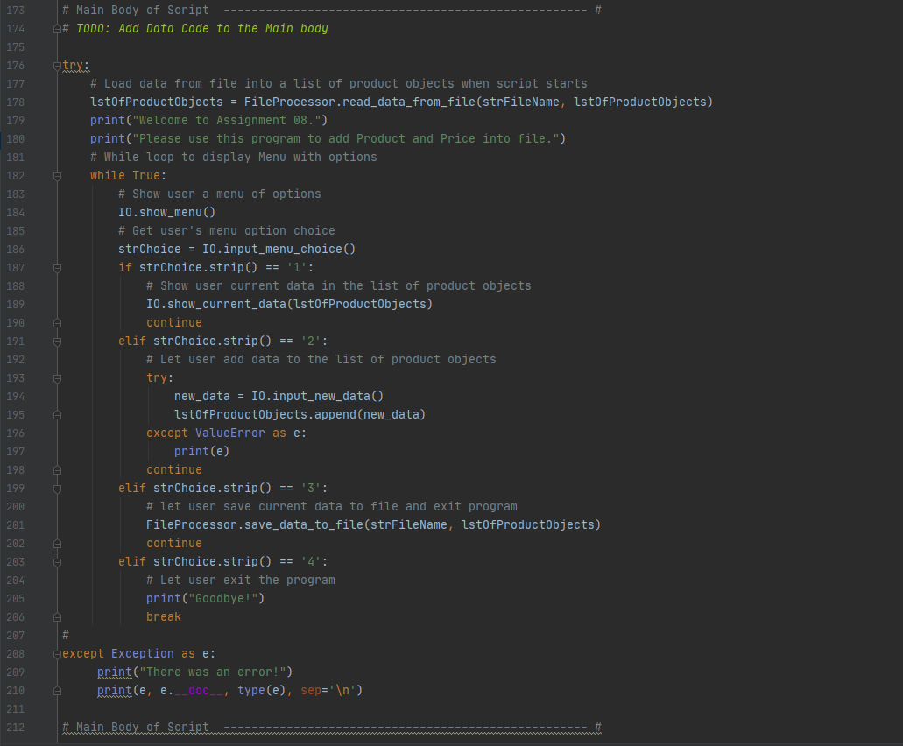

**Figure 5.** Main body of the script.

**Tests of Python Script in PyCharm and CMD**

Finally, my script has been created. Also, I created new empty text file **products.txt** in **Assignment08** folder and tested my program in PyCharm and Command line. Please see screenshots below to check how it works with empty file, adding new data and saving new data to text file.

In **Figure 6.** I tested my code in PyCharm. I checked current data, added new product and saved it to the product.txt file. I tried to do some mistakes and got errors handled.

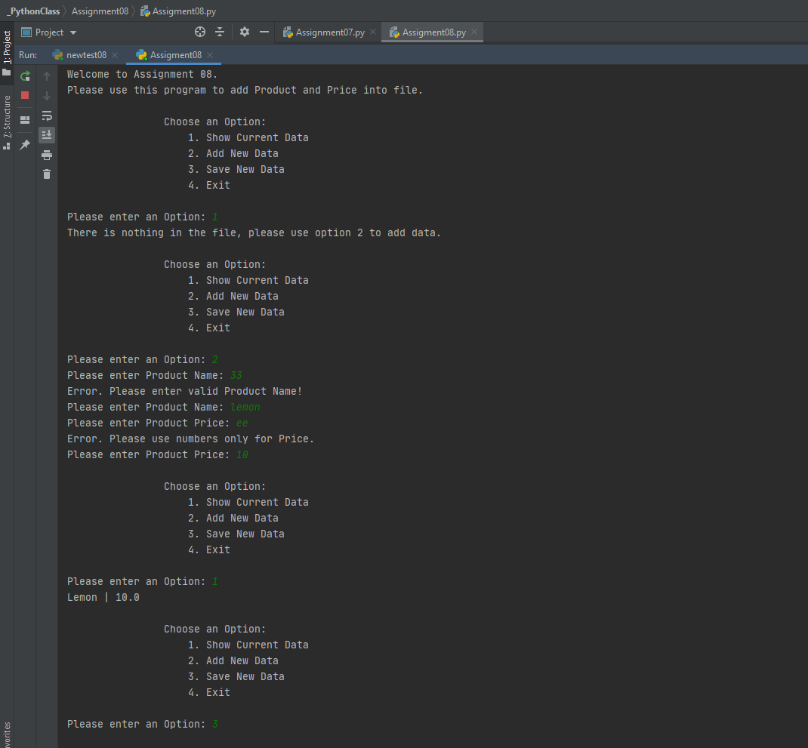

**Figure 6.** Successful test of code in PyCharm.

In **Figure 7.** please check the data in text file after my test in PyCharm:

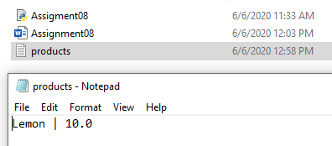

**Figure 7.** Data has been saved to the file **products.txt**.

In **Figure 8.** you can see my test of script in CMD environment. I also checked current data, added new and saved it to my file.

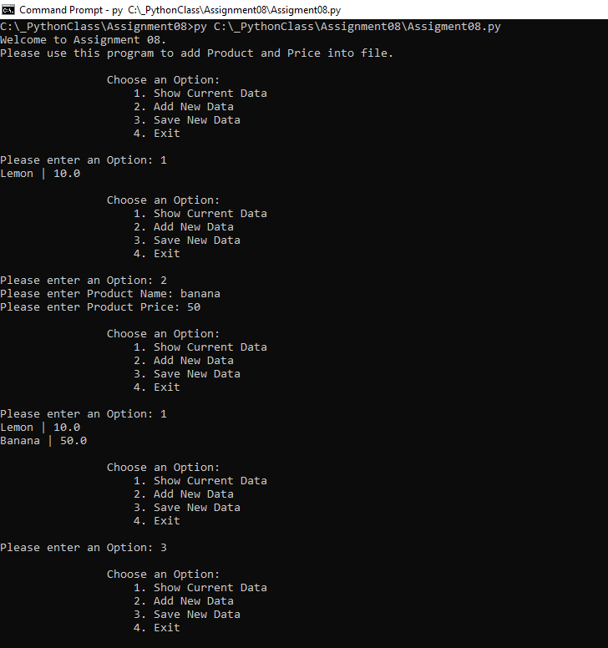

**Figure 8.** Successful test of script in Command Line.

After the script has been tested in CMD, I got new data added to product.txt file. Please see **Figure 9.** below:

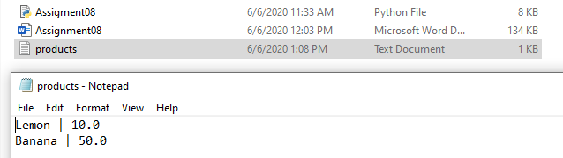

**Figure 9.** New data has been saved to **products.txt** file.

**Summary**

I read the next chapter in the book and Programing Notes for Module08, I also watched several times all the videos and used external resources to understand how to work classes and objects. I completed all labs in this assignment, but even after that it was hard to completely understand how to work with objects from other classes. During script creation I run into some errors that were new for me and sometimes it seems impossible to find the root of issue. Finally, the script has been created and successfully tested in both PyCharm and CMD.

Also, I created new repository **IntroToProg-Python-Mod08** via GitHub desktop application on my GitHub page and added documents there (external link: <https://kgolenk.github.io/IntroToProg-Python-Mod08/>)