**Course:** Foundations of Programming, Python

**Assignment:** 05

**Name:**  ToDoList

**Description:** Python script that reads data from file and represents each row of data as a dictionary and adds rows to a list object to create a table of data. Script works with user input and existing file.

**Created:** 05/17/2020 by Kate Golenkova

**Introduction**

In this assignment I will show how I created a new python script from a template. This script loads each row of data from “**ToDoList.txt**” file into a Python dictionary and then adds each dictionary row to a Python list (Table). To do so program reads file and prints it out asking user to choose the option from the **Menu** what he wants to do with data – add more data, store it in text file, print it out on the screen, or just exit the program. I will use screenshots to illustrate how the script has been created and tested.

**Pseudo-Code of Script**

In this assignment I didn’t create pseudo-code as I used template with good To Do list, showed in **Figure 1.** below:

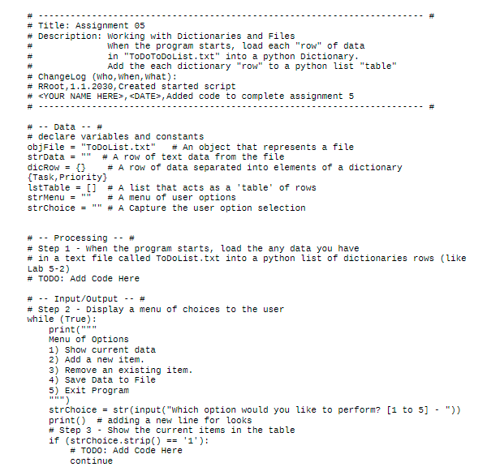

**Figure 1.** Template for Python Script.

As you can see, all the variables already declared, and the Menu already defined. So, I just use the template and worked step by step to complete the program.

**Python Script that Manages ToDolist.txt file**

First, I created **ToDoList.txt** file in new Assignment05 folder and put there two columns of data, as shown in **Figure 2**.:

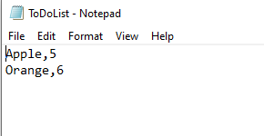

**Figure 2.** ToDoList.txt file with two sets of data.

After the file has been created, I started to add blocks of code to the template that I saved as **Assignment05_Starter.p**y file in the folder Assignment05. I added code for first step to read data from text file and put it to the list. Also, I added code for all the Menu options so user can check current data, add or delete new data, save it to the ToDoList.txt file or just exit the program. Finally, I got the script that you can see in **Figure 3.** and **Figure 4.**:

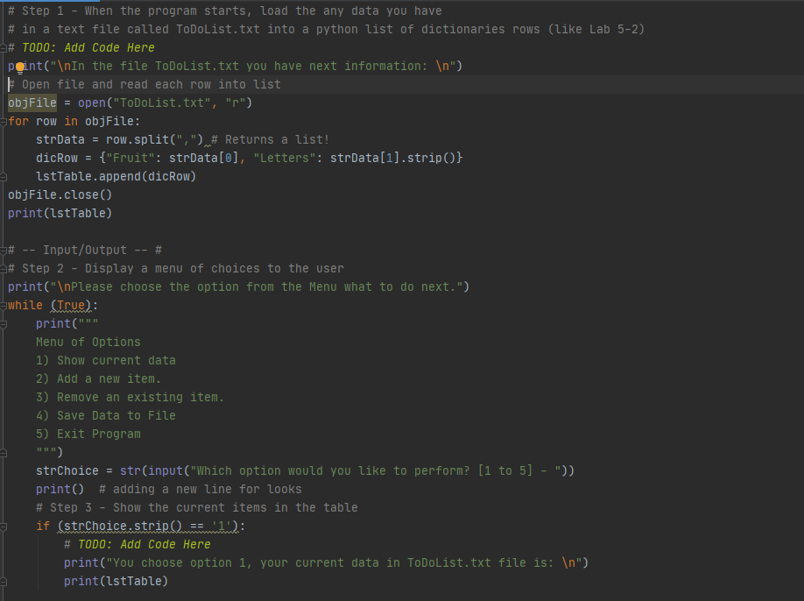

**Figure 3.** First part of script.

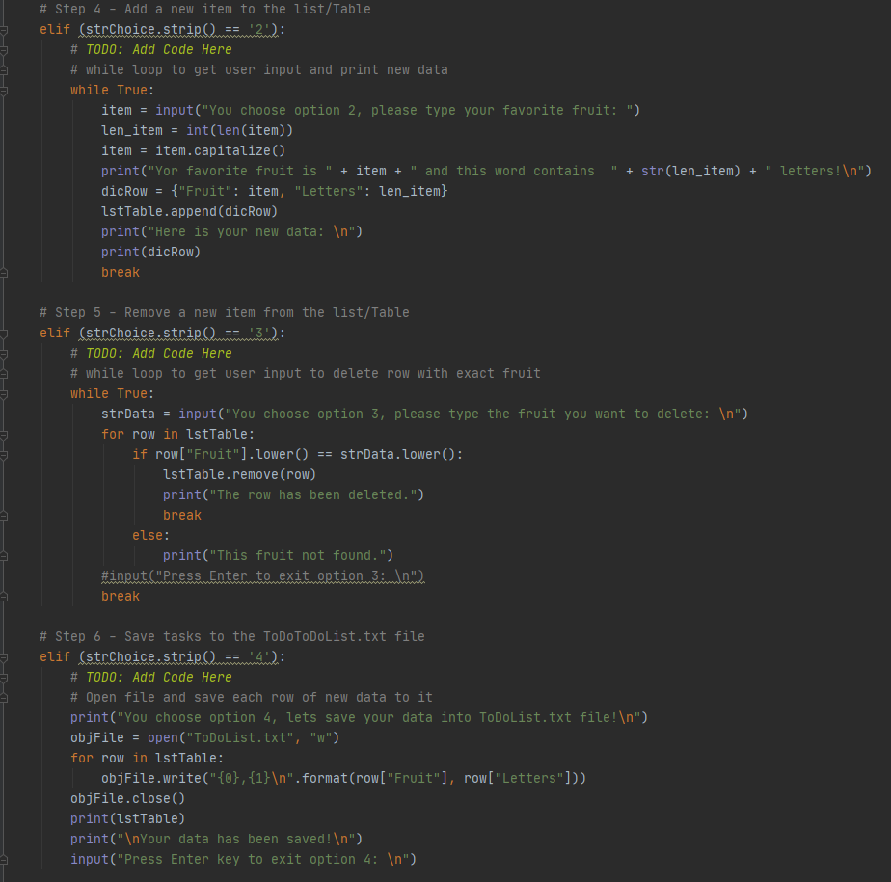

**Figure 4**. Second part of script.

The final part of code contains option 5 form the Menu, so user can exit the program. Honestly, this was the only simple part of the Assignment05. You can see the code in Figure 5.

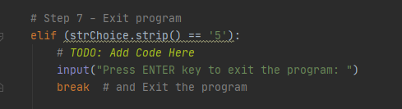

**Figure 5.** Final part of the script.

**Python Script Tests**

In Assignment05 it was asked to test new script in PyCharm and CMD and show it is working. I tested my program in PyCharm first, please find the result below in **Figure 6.**:

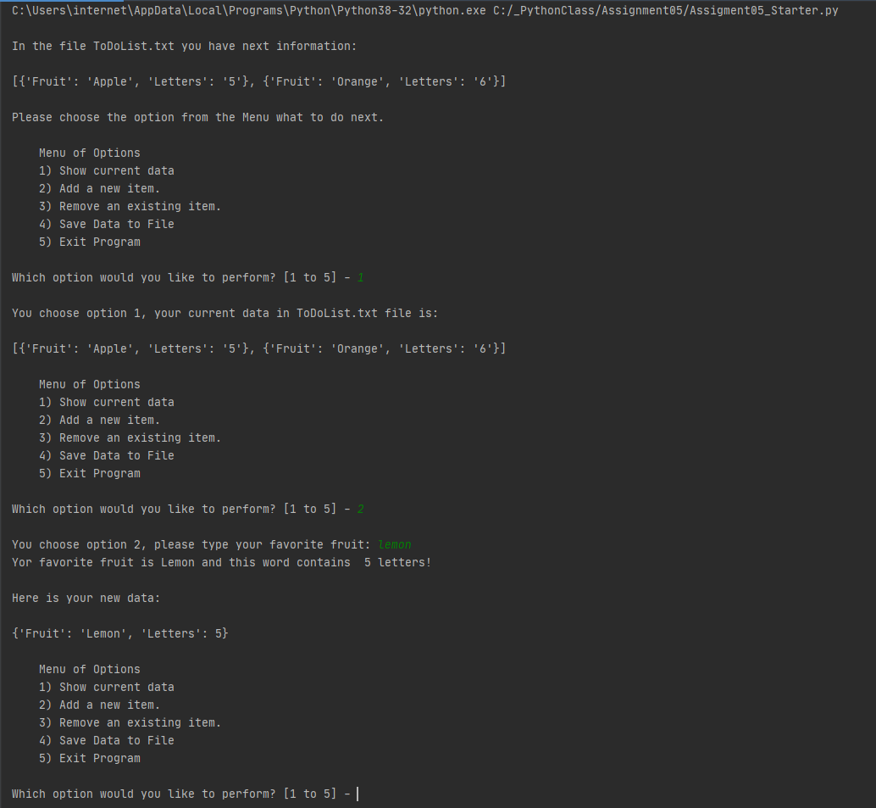

**Figure 6.** Successful test of program in PyCharm.

You can see that I checked current data and added new data. In **Figure 7**. you can find how options 3, 4 and 5 are working in my script.

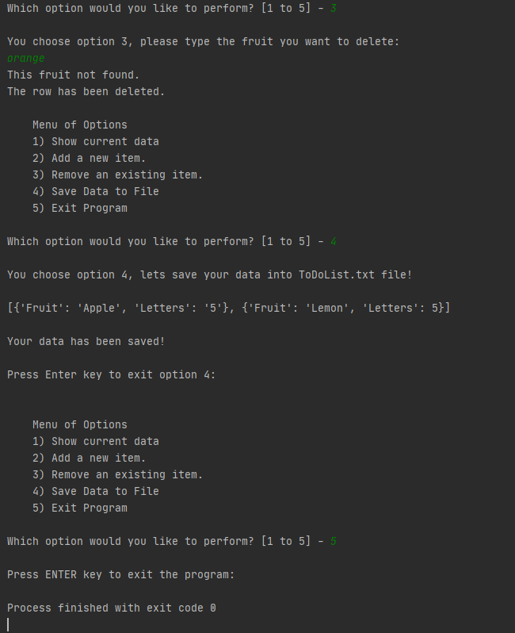

**Figure 7.** Deleting and saving data options tested successfully.

After I added new data and deleted the row with “Orange”, I saved ToDoList.txt file and got the next data in this file:

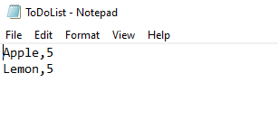

**Figure 8.** New data has been saved in ToDoList.txt file.

As soon my script has been tested successfully in PyCharm and new data has been saved in text file (see **Figure 8.**), I tested the code in Command line. Please see **Figure 9**. below:

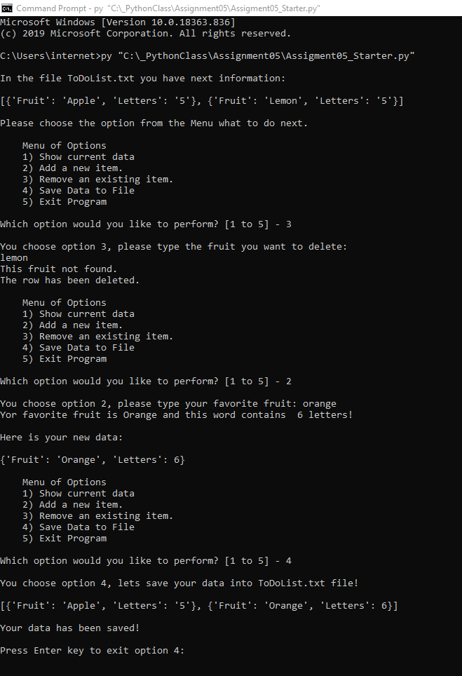

**Figure 9.** Successful test of script in Command Line.

Now, after I deleted the row for “Lemon” and added back in the list item “Orange”, I have got the next data in the ToDoList.txt file:

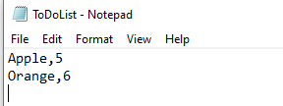

**Figure 10.** Updated ToDoList.txt file after script run in CMD

**Summary**

I read the book and Programing Notes for Module05, I watched all the videos and used external resources to understand how to operate with lists, dictionaries and files. Despite of it was hard to work with template as usually I am using different names to declare variables, I successfully added my code to the template with while loops and if-else conditional statements to get user choose the option and add/delete/save data. Also, I tried to keep it simple.