What is git-rebase:

rebase command is used to merge multipe commit messages into single commit.

To read the git commit messages use the below command:

git log --oneline

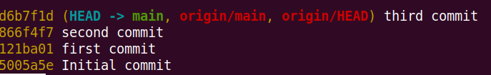

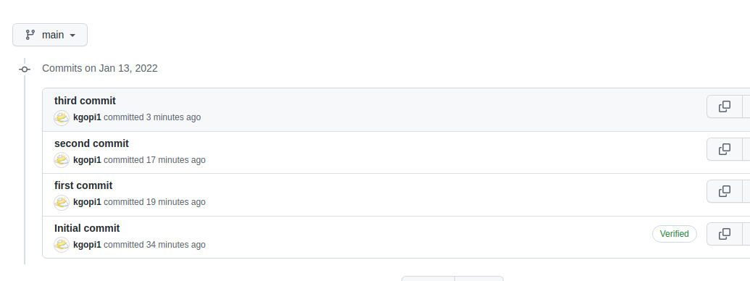

We have 4 commit messages , using the git rebase command we making it as only 2 commits .

such Inital commit message and third commit .

first , second commit and third messages are merged together as single commit as Thrid commit.

git rebase -i HEAD~N

where N is number of commits we want to merge.

