How to use git revert

When you want to undo changes you made in your repo , you will use git revert to undo the changes.

Current status:

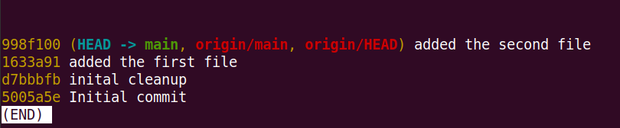

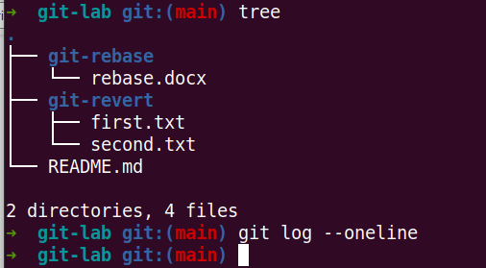

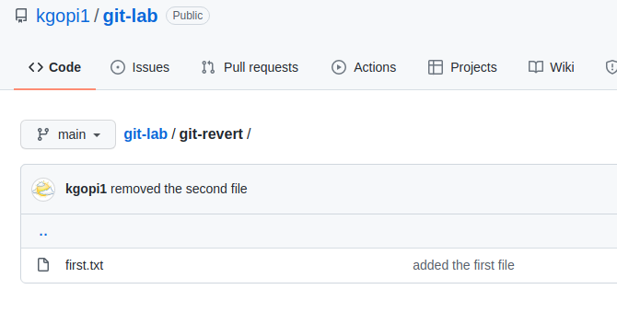

we accidently deleted second file and it has been pushed to the repo.

Now we want undo this commit and restore the file back.

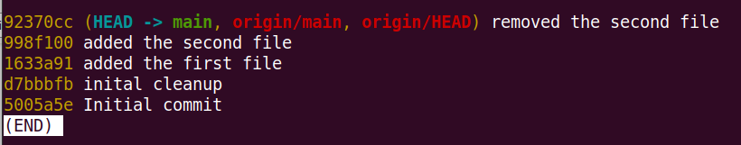

Commit id 998f100 is one we wants to revert it , so second.txt file will be restored.

Soft :

Hard:

You need to use git reset when you want to restore the changes that’s already being commited and pushed to remote repo.

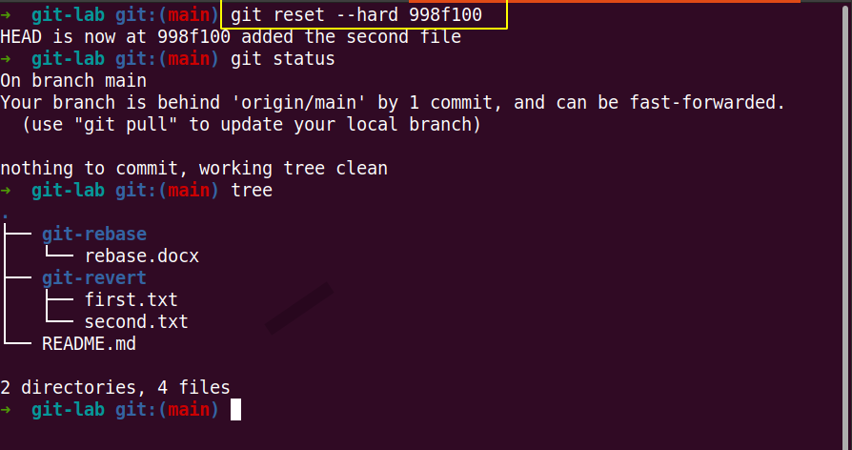

Then run the git push –f to make restored commits into remote repo.

