Figures
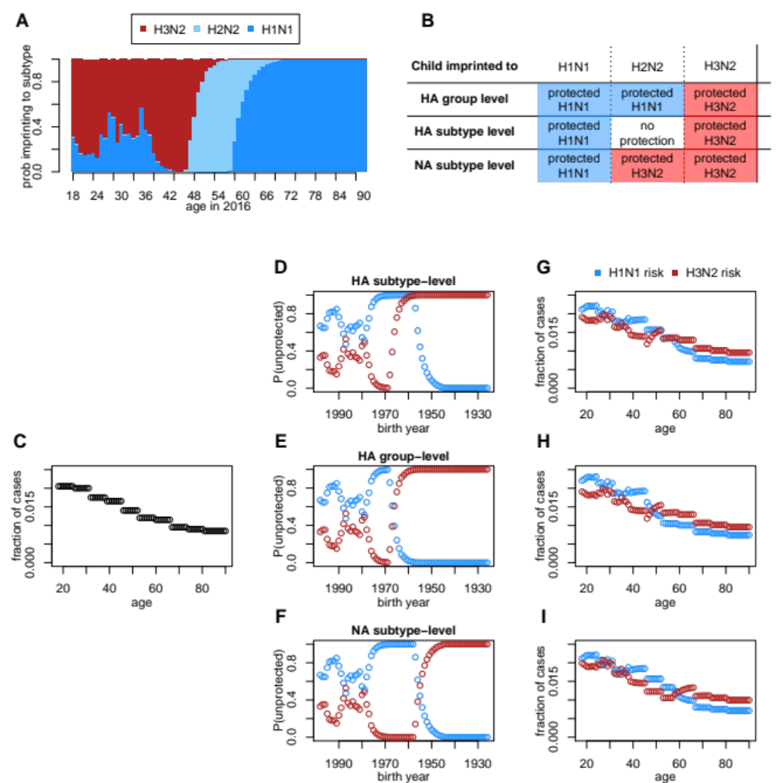
Figure 1. Model and expectations under different imprinting hypotheses. (A) Reconstructed, birth year-specific probabilities of imprinting (representative example specific to Peru for cases observed in 2016). (B) Expected imprinting protection against H1N1 or H3N2 under the three tested models. (C) Cartoon of age-specific risk curve. The shape of this curve is purely hypothetical, but each tested model fit a similar step function to data. (D-F) Fraction of each birth year unprotected by their childhood imprinting (as in A) determines the shape of birth year-specific risk. (G-I) A linear combination of age-specific risk (C), and birth year-specific risk (D-F) give the expected age distribution of H1N1 or H3N2 cases under each model.
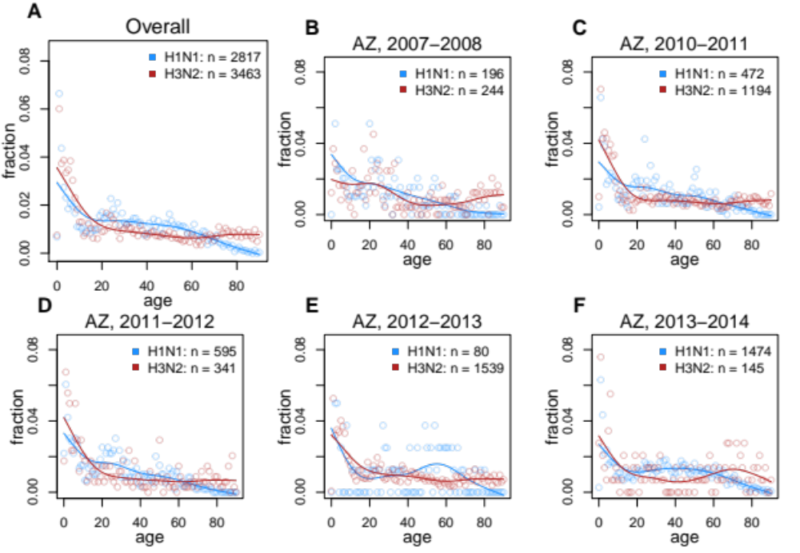
Figure 2. Observed age distributions, Arizona. Points show fraction of confirmed H1N1 or H3N2 cases observed in each single year of age. Lines show a smoothing spline fit to observed distributions. (A) All confirmed cases. (B-G) Season-specific age distributions from seasons in which at least 50 H1N1 and 50 H3N2 cases were confirmed.
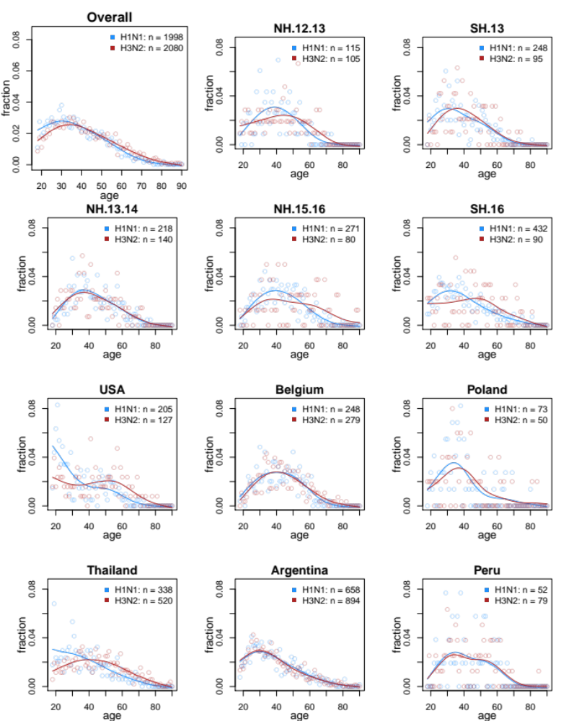
Figure 3. Observed age distributions, INSIGHT outpatient data, 2009-2017. Panels follow the same format as in Fig. 1. (A) All confirmed cases. (B-F) Season-specific age distributions. NH = Northern Hemisphere. SH = Southern Hemisphere. (G-L) Country-specific age distributions.

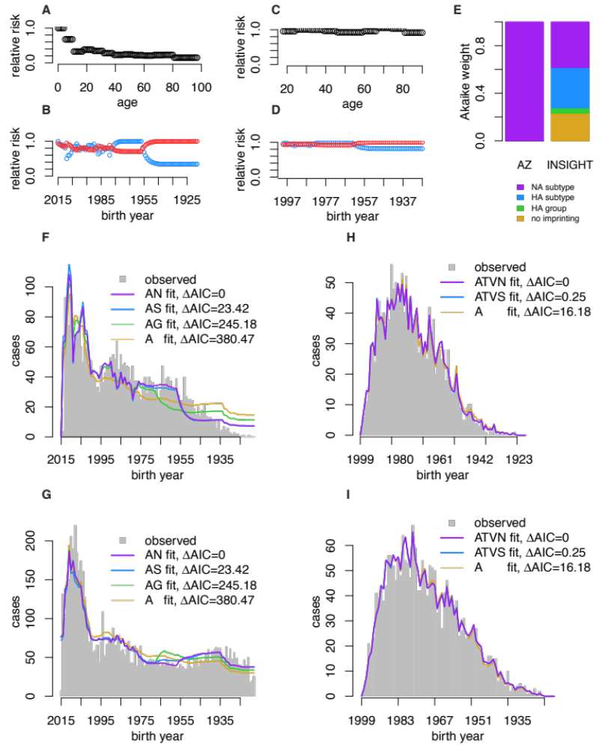Figure 4. Model fits and model selection. (A-B) Effects of age and imprinting from model AN, which provided the best fit to AZDHS data, and (C-D) from model ATVN, which provided the best fit to INSIGHT data. (E) Akaike weights (proportional support) from models assuming different forms of imprinting. Model fits to observed age distributions of H1N1 (F) and H3N2 (G) from the AZDHS data, and from the INSIGHT data (H, I). Model name abbreviations indicate which factors were included: A = age-specific risk, N = NA subtype-level imprinting, S = HA subtype-level imprinting, G = HA group-level imprinting, T = antiviral treatment, V = vaccination.
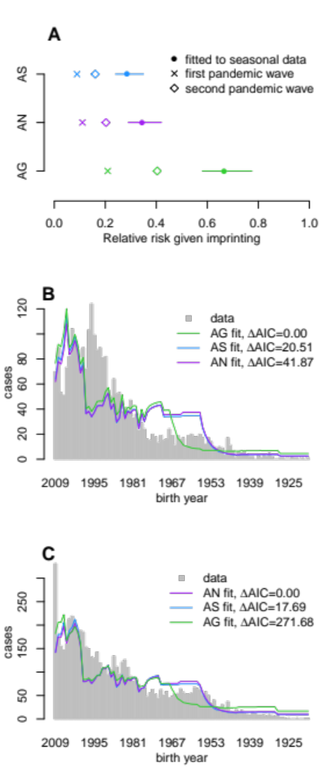
Figure 5. Model selection on H1N1 pandemic data. (A) Estimated reductions in risk from any kind of protective imprinting were stronger during the first and second pandemic waves than against normal seasonal influenza. (B) Fits to data from the 2008-2009 influenza season (first pandemic wave) showed the strongest support for broad, HA group-level protection. (C) During the 2009-2010 season (second pandemic wave), NA subtype-level and HA subtype-level imprinting again received the strongest support, similar to patterns for seasonal influenza.

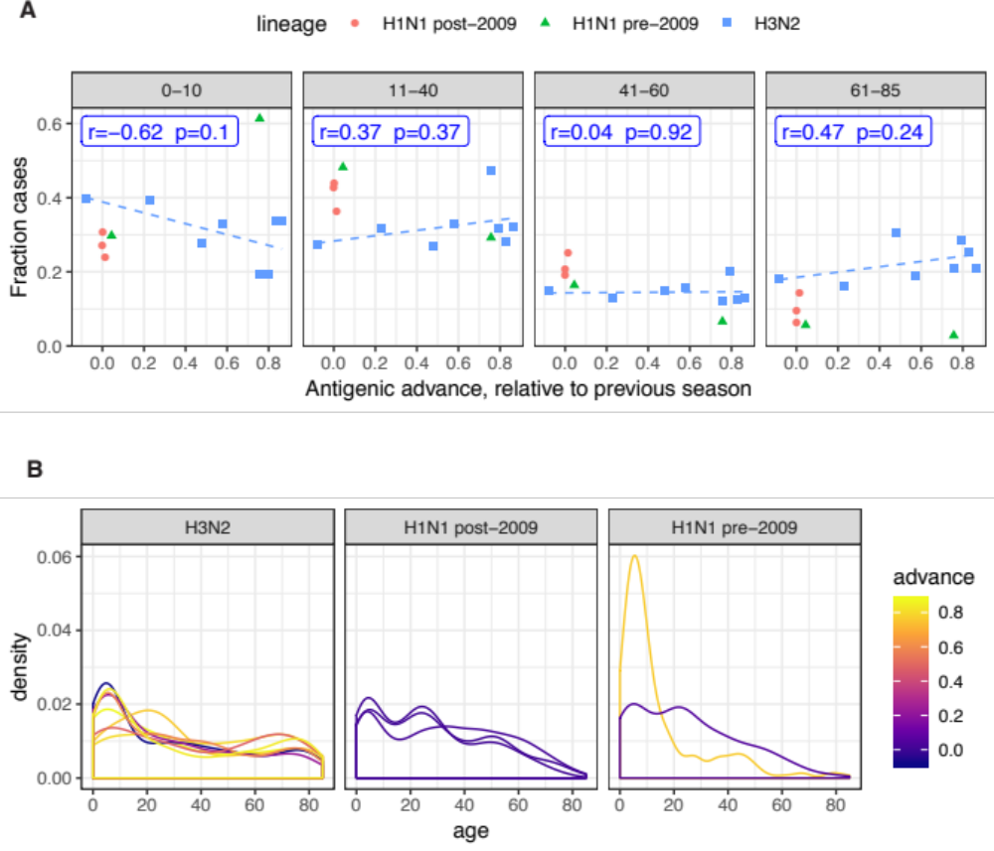Figure 6. Effect of antigenic advance on age distribution. (A) Relationship between annual antigenic advance and the fraction of cases observed in children (0-10), or in adult age groups. Each data point represents a single influenza season in which at least 100 confirmed cases of a given subtype were observed. Blue label shows Pearson correlation between the fraction of H3N2 cases observed in each age group and annual antigenic advance. Blue dashes show linear trend fitted using lm() in R. (B) Season-specific age distributions of infection, colored by antigenic advance since the previous season.

Tables
Table 1. Surveillance data, Arizona, USA. Data representing the first and second waves of the 2009 H1N1 pandemic (*) and were analyzed separately. Following standard definitions, northern hemisphere seasons spanned epidemiological week 40-39, or roughly Oct.-Sept.
Season | Confirmed H1N1 | Confirmed H3N2
1993-94 | 0 | 101
1994-95 | 12 | 38
2002-03 | 71 | 8
2003-04 | 0 | 71
2004-05 | 0 | 131
2005-06 | 1 | 321
2006-07 | 212 | 28
2007-08 | 196 | 244
2008-09* | 2717 | 382
2009-10* | 6261 | 1
2010-11 | 472 | 1204
2011-12 | 595 | 348
2012-13 | 80 | 1578
2013-14 | 1475 | 151
2014-15 | 5 | 2109
Total | 12097 | 6715

Table 2. INSIGHT study data. NH signifies the northern hemisphere season, Oct-May, and SH signifies the southern hemisphere season, June-Sept. Data collected during the 2009 pandemic (*) were excluded from analysis of seasonal epidemiology.
Season | Confirmed H1N1 | Confirmed H3N2 | Country | Total confirmed
NH 2009-10* | 317 | 0 | Argentina | 1552
SH 2010* | 122 | 27 | Australia | 43
NH 2010-11 | 93 | 13 | Austria | 9
SH 2011 | 25 | 243 | Belgium | 527
NH 2011-12 | 1 | 123 | Chile | 22
SH 2012 | 24 | 49 | Denmark | 67
NH 2012-13 | 115 | 105 | Estonia | 98
SH 2013 | 248 | 95 | Germany | 78
NH 2013-14 | 218 | 140 | Greece | 163
SH 2014 | 36 | 349 | Japan | 12
NH 2014-15 | 47 | 320 | Peru | 131
SH 2015 | 36 | 386 | Poland | 123
NH 2015-16 | 271 | 80 | Spain | 49
SH 2016 | 432 | 90 | Thailand | 858
NH 2016-17 | 13 | 60 | UK | 14
Total | 1998 | 2080 | USA | 332

Table 3. Model comparison. Model name abbreviations specific which factors were included. A = age-specific risk, N = NA subtype-level imprinting, S = HA subtype-level imprinting, G = HA group-level imprinting, V = vaccination, U = underlying conditions, T = antiviral treatment. Only INSIGHT data contained sufficient details to test factors V, U and T.

Model | ΔAIC
AZDHS models
AN | 0.00
AS | 23.42
AG | 245.18
A | 380.47
INSIGHT models
ATVN | 0.00
ATVS | 0.25
ATV | 0.98
ATUVN | 2.00
ATUVS | 2.25
ATUV | 2.96
ATVG | 4.26
ATN | 6.16
ATUVG | 6.25
ATS | 6.40
ATUN | 8.10
ATUS | 8.33
AT | 8.67
AVN | 8.79
AVS | 8.95
AV | 9.54
ATU | 10.56
AUVN | 10.79
AUVS | 10.95
ATG | 11.35
AUV | 11.54
AVG | 12.99
ATUG | 13.23
AN | 14.02
AS | 14.18
AUVG | 14.99
AUN | 16.00
AUS | 16.16
A | 16.18
AU | 18.14
AG | 19.17
AUG | 21.12

Supplementary Figures

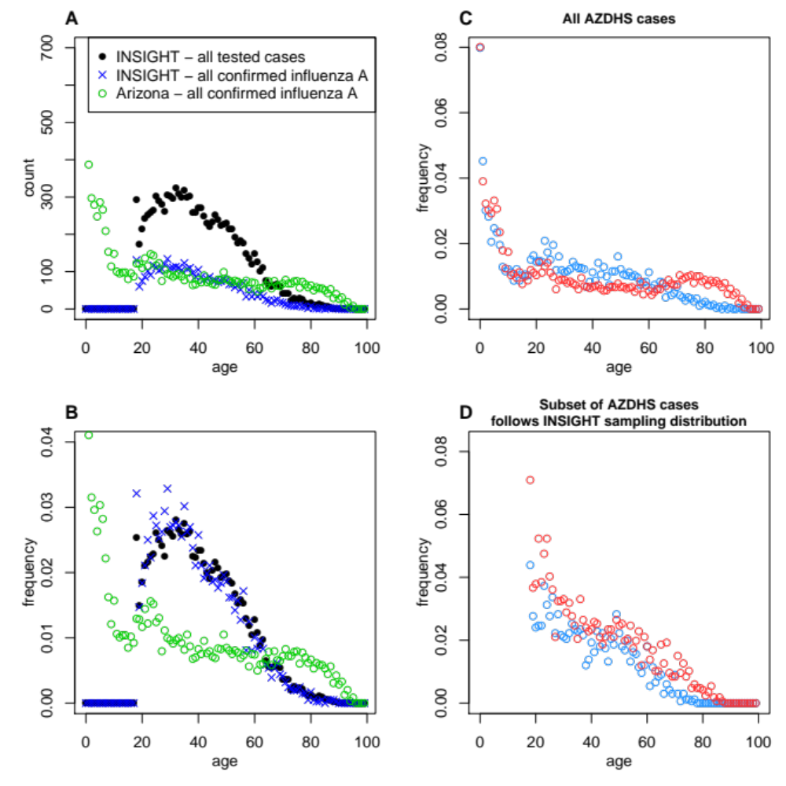
Figure S1. Age distributions of all tested and confirmed cases. (A) Counts and (B), frequencies from the Arizona and INSIGHT data. Note that data on the age distribution of all tested cases was not available in the Arizona data. The Arizona data contained comparatively more confirmed cases at the extremes of age. In INSIGHT data, age distributions of confirmed influenza A were proportional to all tested cases. (C) Age distribution of all confirmed cases in the AZDHS data. (D) Subset of AZDHS cases, of the same sample size and age distribution as all confirmed cases in the INSIGHT data. Panel D illustrates that the age-specific sampling distribution in the INSIGHT data weakened the signal of subtype-specific differences in age distribution.

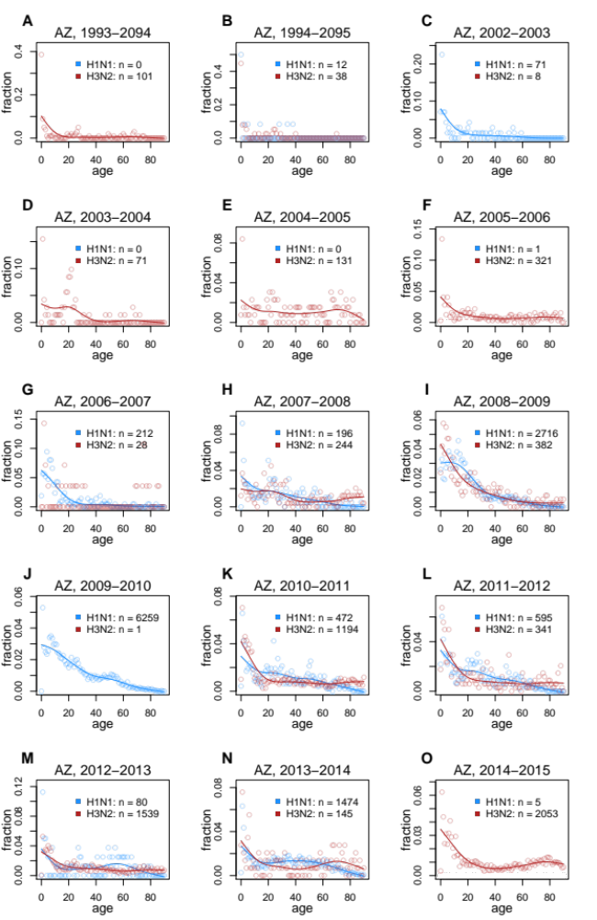
Figure S2. AZDHS age distributions, all seasons. Supplement to Fig. 2 showing observed age distributions from all influenza seasons. Observed case fractions (points) were only plotted if 10 or more cases of a given subtype were confirmed, to avoid extreme stretching of the y axis. Smoothing splines were only plotted if 50 or more cases of a given subtype were observed, as fits to fewer data points would not have been meaningful.

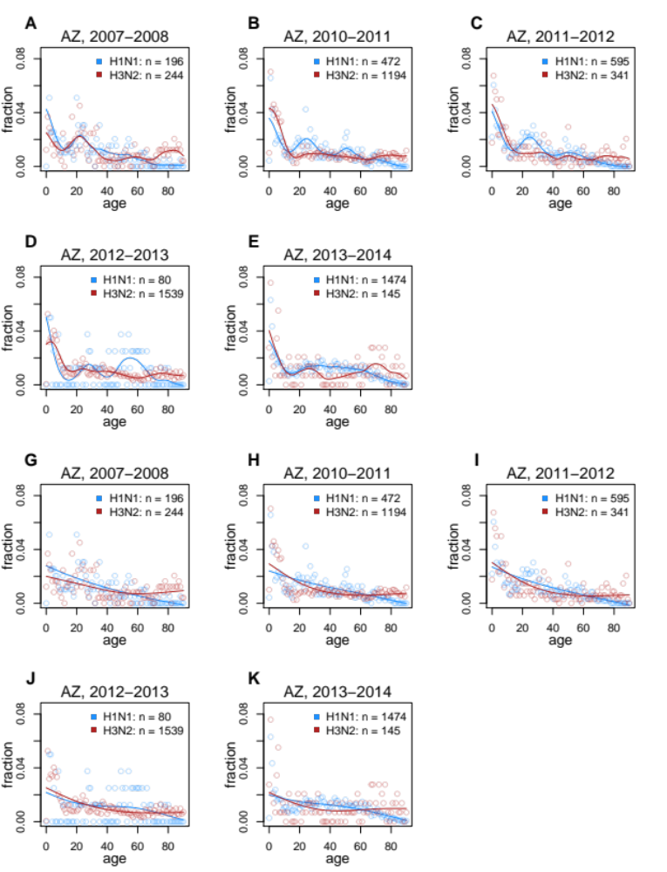Figure S3. Alternate smoothing parameters, AZDHS data. Supplement to Fig. 2, with smoothing parameters chosen to fit splines that are less (A-F), or more (G-L) smooth than the splines shown in the main text.
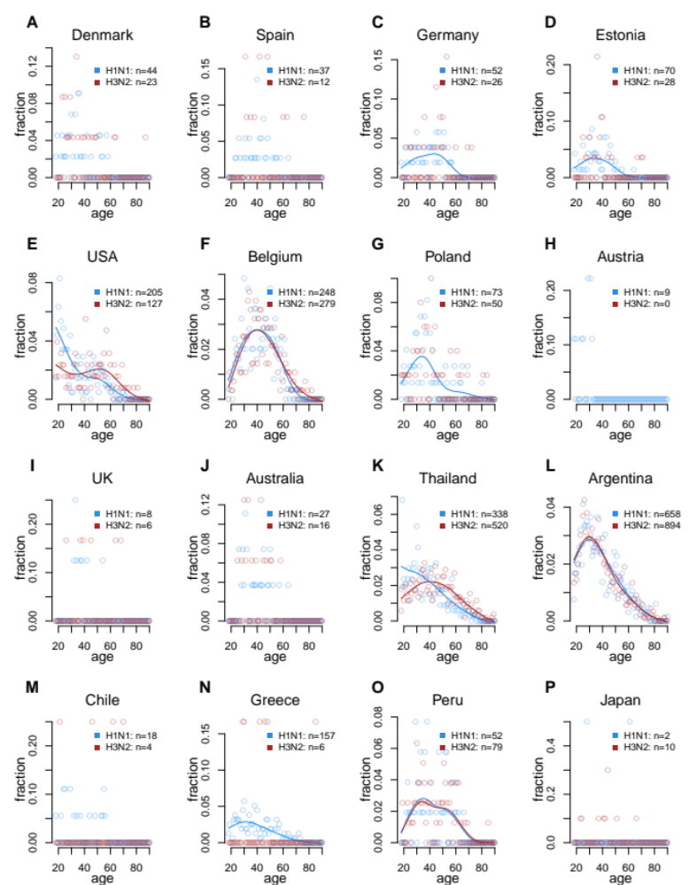
Figure S4. INSIGHT age distributions, all countries. Supplement to Fig. 3. Observed age distributions from all countries in which one or more confirmed cases of either subtype was observed, (as opposed to Fig. 3, in which only countries reporting ≥ 50 cases of both subtypes were shown). Smoothing splines were only plotted if 50 or more cases of a give subtype were observed, as fits to fewer data points would not have been meaningful.
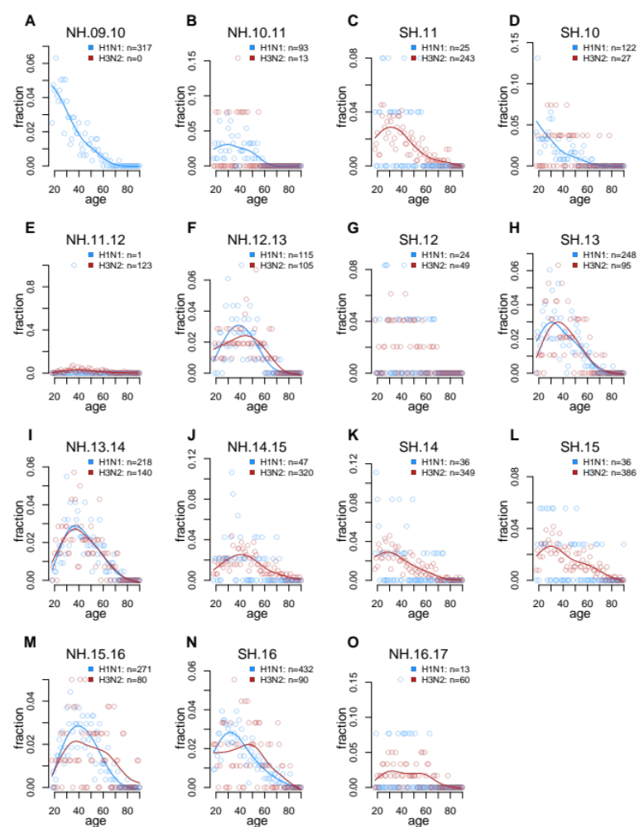

Figure S5. INSIGHT age distributions, all seasons. Supplement to Fig. 3 showing observed age distributions from all seasons in which one or more confirmed cases were observed. Smoothing splines were only plotted if 50 or more cases of a give subtype were observed.

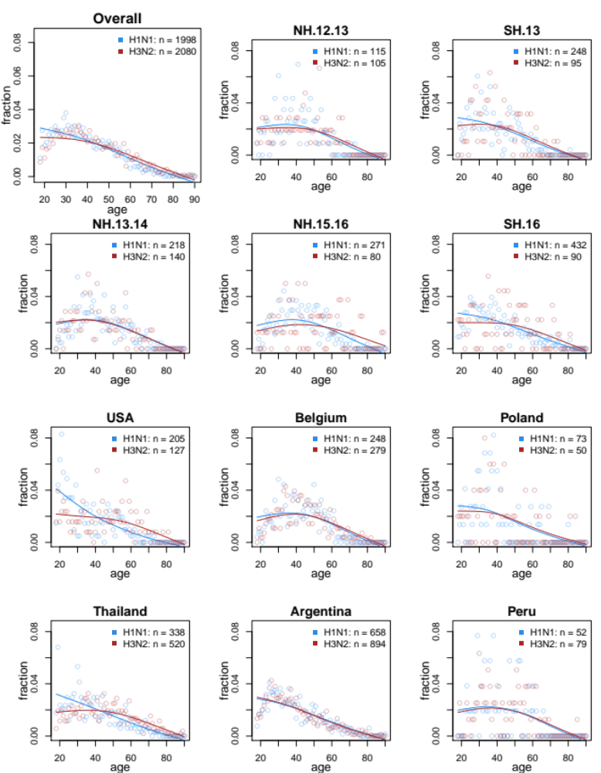
Figure S6. INSIGHT age distributions, increased smoothness. Supplement to Fig. 3, except with a higher smoothing parameter value (greater smoothness) used to fit smoothing splines.
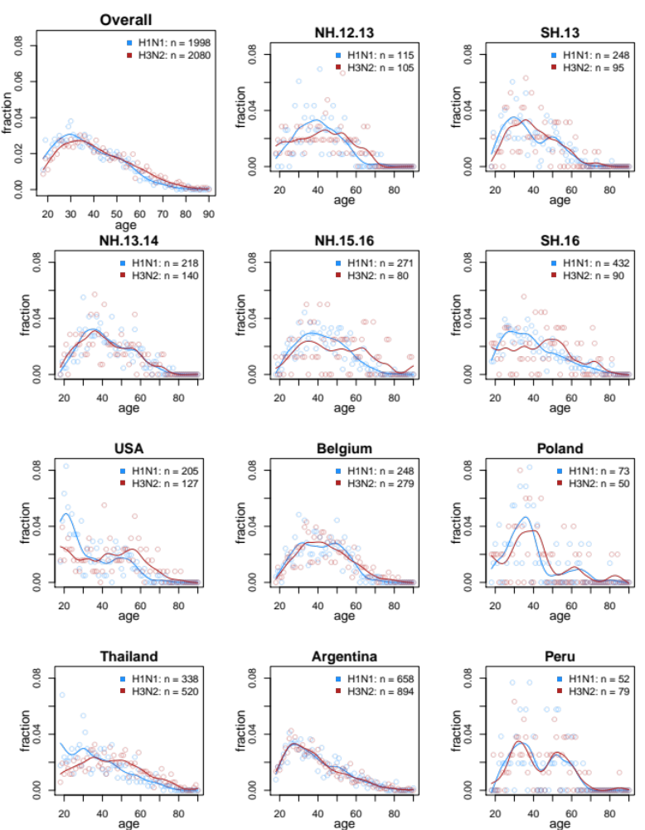
Figure S7. INSIGHT age distributions, decreased smoothness. Supplement to Fig. 3, except with a lower smoothing parameter value (less smoothness) used to fit smoothing splines.

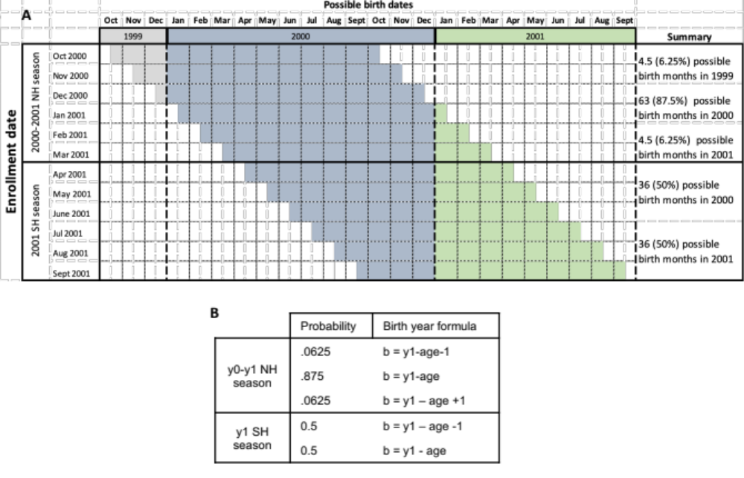
Figure S8. Rationale for birth year estimation, INSIGHT data. (A) Possible birth months (shaded) of a hypothetical case of age 0, observed between Oct, 2000 and Sept, 2001 (October is the start of the NH influenza season). Cases observed from Oct.-Mar., during the NH 2000-2001 season (top half of figure), would most likely have been born in 2000 (blue), with low probabilities of birth in 1999 (gray) or in 2001 (green). Individuals observed from April-Sept., during the SH season (bottom half of figure), have an equal probability of birth in 2000 or 2001. This worked example illustrates that the month of case observation determines the probability of each possible birth year. (B) The patterns shown in (A), were generalized to develop a scheme to calculate the probability of all possible birth years for cases observed during the NH or SH season. Using these probabilities we took a weighted average of birth year-specific imprinting constructions, using different weights for cases observed in the NH or SH seasons.
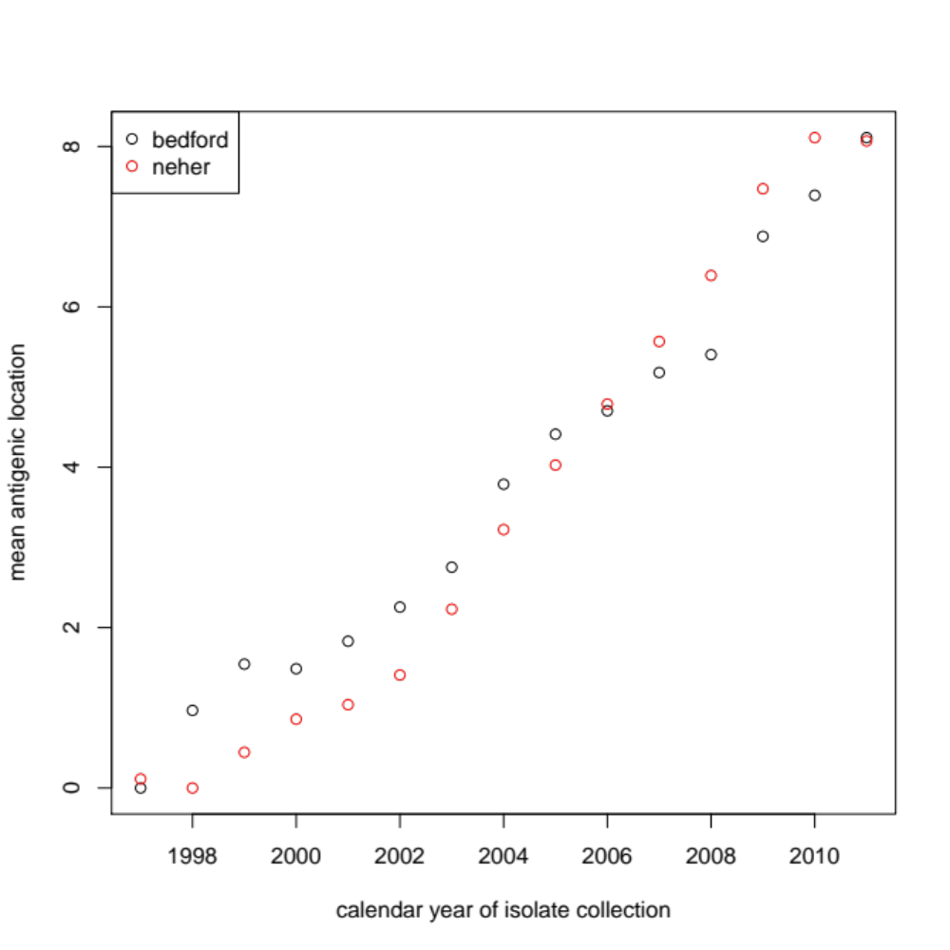
Figure S9. Comparison of rescaled H3N2 antigenic distance estimates from the Bedford et al., and Nextstrain datasets. Points represent average antigenic position of all isolates from a given calendar year. Estimates are very similar after rescaling.

Supplementary Tables

Table S1. Maximum likelihood parameter estimates and 95% profile confidence intervals from each model fit to AZDHS data. All estimated parameters represent the relative risk of confirmed infection, given the factors listed in the left-hand column. An estimated value of 1 (or a confidence interval that contains 1) indicates no measurable difference in risk between the reference group, and the group with the specified risk factor. Estimated values below 1 indicate the factor is associated with reduced risk (stronger protection), while estimated values above 1 indicate the factor is associated with increased risk.

Model | AN | AS | AG | A
ΔAIC | 0.00 | 23.42 | 245.18 | 380.47
H1N1 impr. protection | 0.34 (0.29-0.42) | 0.29 (0.24-0.35) | 0.67 (0.58-0.78)
H3N2 impr. protection | 0.71 (0.62-0.82) | 0.9 (0.78-2) | 0.69 (0.6-0.8)
Ages 5-10 | 0.68 (0.63-0.74) | 0.66 (0.61-0.72) | 0.66 (0.62-0.72) | 0.62 (0.57-0.68)
Ages 11-17 | 0.33 (0.3-0.36) | 0.31 (0.28-0.34) | 0.33 (0.3-0.37) | 0.3 (0.28-0.34)
Ages 18-24 | 0.38 (0.35-0.42) | 0.36 (0.32-0.4) | 0.39 (0.35-0.43) | 0.35 (0.32-0.39)
Ages 25-31 | 0.34 (0.32-0.38) | 0.33 (0.3-0.37) | 0.34 (0.31-0.38) | 0.31 (0.28-0.35)
Ages 32-38 | 0.28 (0.26-0.32) | 0.26 (0.24-0.3) | 0.28 (0.26-0.32) | 0.26 (0.24-0.29)
Ages 39-45 | 0.23 (0.2-0.27) | 0.21 (0.18-0.24) | 0.24 (0.22-0.28) | 0.21 (0.2-0.24)
Ages 46-52 | 0.24 (0.22-0.28) | 0.21 (0.19-0.24) | 0.24 (0.22-0.28) | 0.23 (0.2-0.26)
Ages 53-59 | 0.22 (0.2-0.26) | 0.2 (0.18-0.23) | 0.2 (0.18-0.24) | 0.2 (0.18-0.23)
Ages 60-66 | 0.21 (0.19-0.24) | 0.22 (0.2-0.26) | 0.19 (0.16-0.22) | 0.18 (0.16-0.21)
Ages 67-73 | 0.22 (0.2-0.26) | 0.25 (0.22-0.29) | 0.2 (0.18-0.23) | 0.19 (0.18-0.22)
Ages 74-80 | 0.23 (0.2-0.26) | 0.25 (0.22-0.3) | 0.2 (0.18-0.24) | 0.2 (0.18-0.23)
Ages 81+ | 0.15 (0.14-0.18) | 0.17 (0.15-0.2) | 0.13 (0.12-0.16) | 0.13 (0.12-0.15)

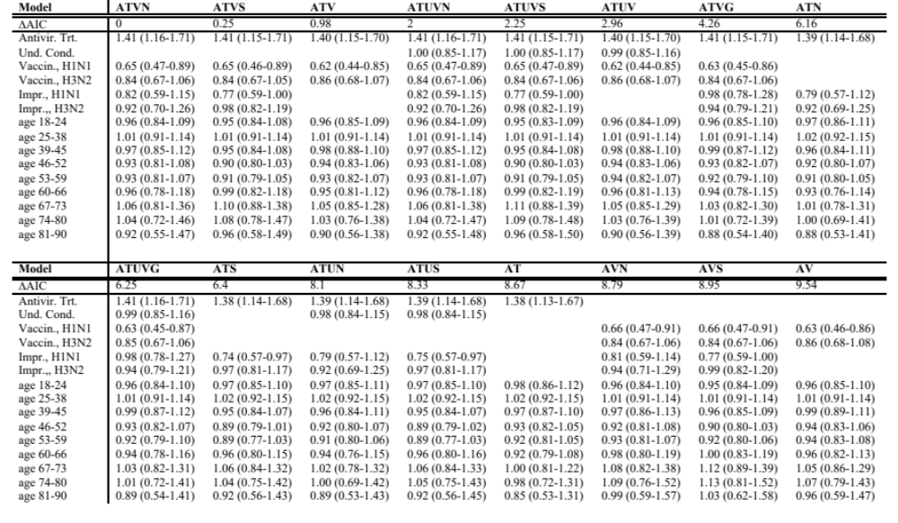
Table S2. Maximum likelihood parameter estimates and 95% profile confidence intervals from each model fit to INSIGHT data (1/2).
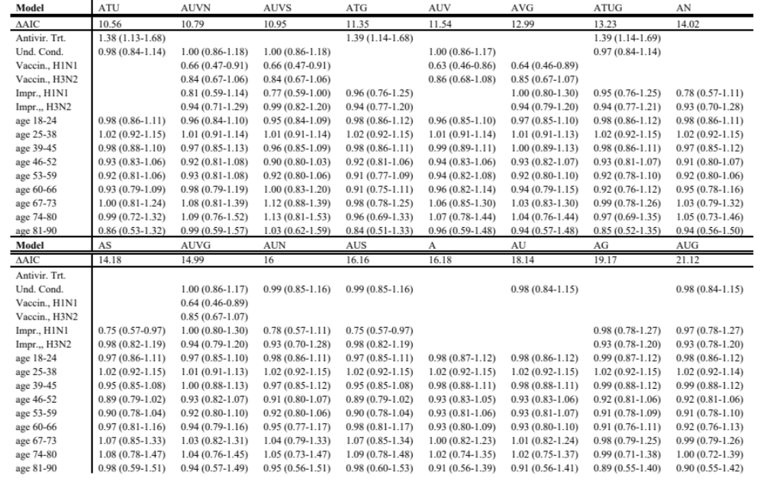
Table S3. Maximum likelihood parameter estimates and 95% profile confidence intervals from each model fit to INSIGHT data (2/2).

