LOW FIDELITY PROFILE

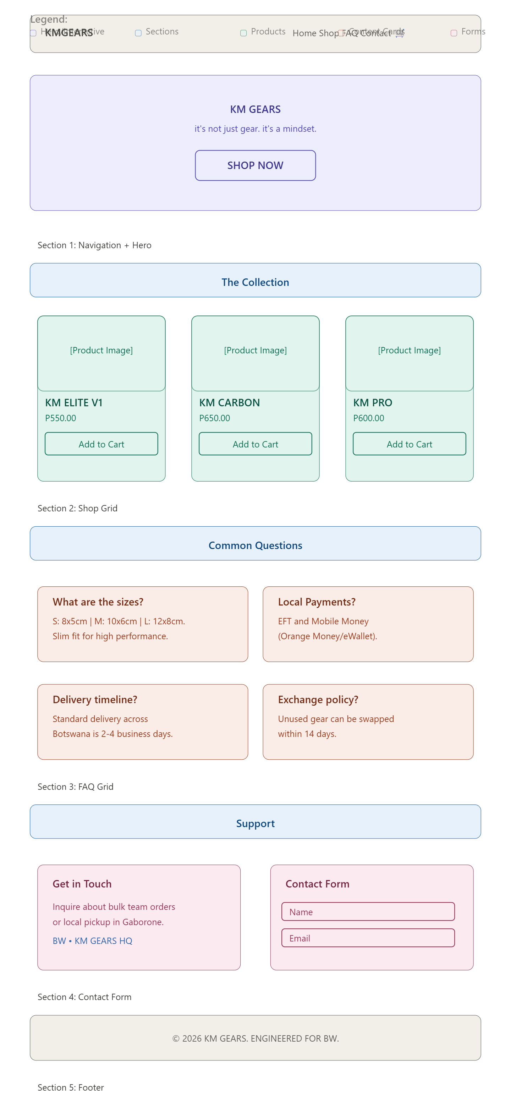
HIGH FIDELITY PROFILE
