Let (x_{i} , y_{i}), i=1,2,3,4,5 be a set of five distinct points with integer coordinates in the xy plane. Show that the mid-point of line joining atleast one pair of these points has integer coordinates.

Let x be an irrational number. Show that for some positive integer j not exceeding n, the absolute value of the difference between jx and the nearest integer to jx is less than 1/n.

True or False: (n²)!/(n!)^{n} is an integer where n is a positive integer.

Prove that 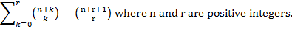

What is the expected number of bins that remain empty when m balls are distributed into n bins uniformly at random.

