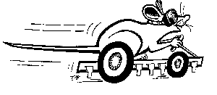
Micromouse Simulation

Introduction
This document describes the Micromouse Simulator. This is a piece of software that helps in the design of a micromouse; a particular type of robot designed to follow a white line. The simulator displays a diagram of the micromouse following its course, and shows how its behaviour changes as you alter the design of the micromouse.

The Micromouse Competition
The Institute of Electrical Engineers (IEE) organise an annual competition for Micromice – robots that have to find their way round a circuit or through a maze as quickly as possible.
At the simplest level of competition, the Micromouse has to follow a rectangular track made up of masking tape on a matt black background, and go round the circuit as quickly as possible. The Micromouse has to follow the track without any external help, and has to carry it’s own power source. Almost without exception, these micromice use battery-powered electric motors and light sensitive sensors.
The competition is open to all, but there is a particular emphasis on secondary schools for the simplest standards.

Why Use a Simulator ?
I began work on the simulator when I became involved with the Technology Club of the Hazel Grove High School as a Neighbourhood Engineer. They had tried to enter to 1998 competition, but didn’t have their entry ready in time, and were trying again for 1999.
Designing and making a micromouse that works is not an easy thing to do for a team from a secondary school. Making a competitive entry is decidedly hard. Starting from scratch, we didn’t have a clue about what gear ratios, wheel sizes, operating voltages etc to use – it was either copy an existing micromouse or go by trial and error. This can be a frustrating experience, so I decided to see if a computer simulation could help us get some of the basics right with minimum heartache.

Limits of a Simulator
It is vital to understand that a simulator can never answer all the questions. There are several limitations:
- It only behaves how it is programmed to behave, so if the programmer hasn’t thought to include a particular design feature, the simulator can’t tell you anything about it. For example, you might think it a good idea to have a trimmer sensor which slows a motor down slightly as it approaches the edge of the white line, so that the mouse follows a nice smooth path down the straights. This software doesn’t have that built in, so it won’t help you decide one way or the other. The features in this simulator reflect the ideas that the Hazel Grove team had during the design process.
- The simulator is prone to programming errors. The mathematics describing the motion of a micromouse are horrendously complex, so if I made a mistake in programming, the simulator will give wrong answers. So far, I haven’t found any, but that doesn’t mean they aren’t there.
- The simulator relies on approximations in the way it calculates the motion of the micromouse. As long as the time between successive calculations is very short, these shouldn’t affect the answers too much, but they will never be 100% correct.
- The simulation relies on you feeding in many parameters that describe your micromouse. Some of these you will not know precisely, so here is another source of error creeping in.
- The simulator ignores a whole range of ‘real-life’ problems, such as wheels that aren’t perfectly round, sensors getting caught on bits of masking tape sticking up, stray lights upsetting sensors, the step between the white line and the background etc. No simulator will help with these – you have to build a micromouse and learn to cope.
I wouldn’t want to give the impression that the simulator is useless – it isn’t. It is a pretty reliable guide to what happens as you change the design of your micromouse. It certainly helped us to sort out the ideas that might work from those that wouldn’t. It is also a lot of fun.
Just don’t go away with the idea that if the simulator says your micromouse will shave 0.327 seconds off the current world record, that’s what will happen in practice.
The simulator can help in some ways, but there really is no substitute for building a mouse and seeing how it works.

Appendices
At the end of the document are two appendices dealing with the mathematical modelling of the mouse.

This is quite complex, and most people don’t need to worry about it – but it’s there if you are interested.

Getting Started

Installing Micromouse
Micromouse should run on any Windows 98, Windows NT or Windows 2000 PC. It needs a screen with 800*600 resolution. The faster the processor the better, but there is no minimum specification.
The software is available from my web page,
http://www.isu.mmu.ac.uk/isu/za9ra50/micromouse/welcome.htm
Download the file from the link on the page and save it somewhere –it is a file called MicromouseZIP.exe. Run this file to unzip four further files,
- micromouse.doc (this document you are reading)
- setup.exe
- setup.lst
- micromouse.cab
To install the software, close any windows applications you are running, run setup.exe and follow the instructions on the screen. You will be asked to agree to the default installation directory, C:\Program Files\Micromouse . If you are happy with this, just press the install button. If you wish to change it, you may specify a different installation directory.
To run the simulator: Start > Programs > Micromouse.
The simulator screen will appear, and a calibration will take place (only the first time you run micromouse). After this, you are ready to go.

Basic Operations
This section describes some of the things you can do with the simulator. More detailed instructions are given in later chapters.

Parts of the Screen
The diagram on the following page shows the screen of the simulator.
Each part is described in more detail later in this document.
- Action Replay – allows you to replay interesting activity
- Exit Button – close the simulation
- Lap Timers – elapsed time, current lap time and best lap time
- Mouse – shows where the mouse is, and key dimensions
- Mouse Mimic – displays information about motor and sensor status
- Parameters – allows you to change the design of the mouse
- Reset Button – puts the mouse back to the start
- Simulation Speed – allows you to run the simulator faster or slower
- Simulator Commands – Open and save mouse designs, and genetic algorithm features

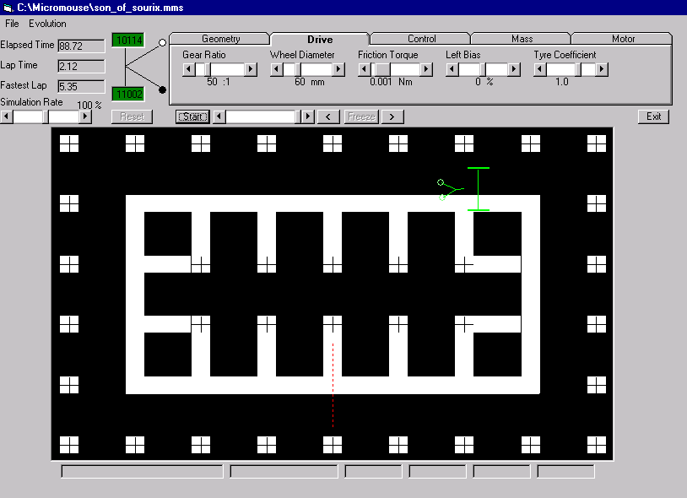
Parameters
Mouse Mimic
Reset Button
Action Replay
Exit Button
Simulation Speed
Mouse
Track
Simulator Commands
Lap timers
Information Displays

The Simulator in Detail

Simulation Commands
The simulator commands are accessed by clicking the menu bar on the top left hand corner of the screen. There are two menus, File and Evolution

File
You can store the design of a micromouse in a micromouse file. From the File menu, you can open existing micromouse files, save the current micromouse or save the current micromouse under a new name. You can also calibrate the simulator.

Calibrate
How fast the simulator runs is affected by how fast your computer is. This command makes the simulator run through a fixed sequence to establish the speed of your computer, so that the simulation runs at the correct rate. This is done automatically the first time you run the program, but you can use this command to do it again at any time. After calibration, the simulator tells you the cycle time, that is how much elapsed time is represented by each ‘frame’ of the simulation when it is running at 100%. When you run the simulator slower or faster, it uses a smaller or larger cycle time.

Open
Open an existing mouse file.

Save
Save the details of the current mouse.

Save As…
Save the details of the current mouse to a new mouse file.

Recent Mice
This lists the five most recently used mice. Click on one to open it.

Exit
Leave the simulator. If the current mouse has not been saved since its last change, you will be asked whether you want to save it.

Evolution
The micromouse simulator can help you design the fastest possible micromouse automatically. It does this by taking the two fastest mice it knows about, and combining them in different ways with random changes to produce six new mice. It then runs each of these mice, finds the fastest two, and starts all over again.
This is known as a genetic algorithm, because it mimics the way that natural selection optimises living creatures over the course of evolution.
To keep these mice separate from the mice you have designed yourself, they are created in a different directory, known as the evolution directory.

Breed
This command produces the next generation of mice, based on the fastest two known mice, and deletes or culls all but the fastest three mice.

Evaluate Fitness
This command runs each mouse whose lap time is unknown, then displays a list of the mice and their lap times.
Each mouse goes round the track twice, and its quickest time is take. The mouse is killed off if it ‘stalls’, goes round in circles, tips over, or goes off the track completely.
During the evaluation, the information displays show the number of the mouse being evaluated, the total number to be evaluated and the name and lap time of the fastest mouse found so far.
An extra button also appears, named “Kill”. This allows you to tell the simulator to stop evaluating the current mouse, perhaps because it is moving so slowly that it will take a long time to complete its two laps.

Auto Evolution
This combines the Breed and Evaluate Fitness commands into a continuous loop, which should eventually breed the fastest possible mouse, within the constraints you have specified.
During auto evolution, an additional button appears, named “Stop Auto Evolve”. This leaves the auto evaluation when the last mouse has been evaluated.

Display Mice
Lists all the mice in the evolution directory, together with their lap times. By selecting one of the mice in the list using the cursor, you can press the ‘Open’ button to open that mouse. By selecting one or more mice, by clicking and dragging with the cursor, you can press the ‘Kill’ button to delete the mice.

Show Variables
The auto evolution feature can change any of the parameters defining the mice. However, this can be very unrealistic. You may already have a pair of motors, and want to know what is the best you can achieve with them.
The show variables command allows you to tell the simulator which parameters it can changes, and which it must leave alone. It brings up an extra row of tick boxes in the parameters area. Ticking a box means that that parameter can be changed during the breeding process. By default, none of the parameters can change, so unless you make some of them free, breeding will not produce any differences in the next generation of mice.
Select this option again to hide the extra row. Your selections remain in place even when the row is hidden.

Display Breeding Log
The simulator keeps a record of its breeding and evaluations. This option displays the log.

Delete Breeding Log
This option clears out the breeding log.

Set Evolution Directory
This option allows you to specify the directory where the mouse breeding will take place.

Action Replay
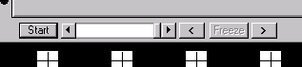
If you want to look at a particular sequence of events in detail, you can use the action replay feature.
By pressing the pause button, the simulation stops. You can then use forward and reverse buttons to view the last few seconds of the simulation, the slider to rapidly find the particular part of the reply you are interested in, and the slider arrow buttons to move forward or backward a ‘frame’ at a time.

Exit Button
Press this button to leave the simulator.

Lap Timers
The show the total time the simulator has been running since the last reset, the current lap time (this freezes for a while after a lap has completed, then resumes timing of the next lap) and the fastest lap time so far.

Mouse
The mouse moves round the track in as realistic a manner as possible, obeying the laws of physics as far as I have been able to model them. It also shows the key dimensions (such as wheelbase and eye length), and you can see them change as you alter the parameters.

Mouse Mimic
This static mimic of the mouse shows whether each sensor is ‘seeing’ black or white, whether the motor is ‘on’ (green) or ‘off’ (red) and the current speed in RPM of each motor.

Parameters
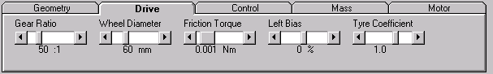
Drag Slider
Click Scroll Bar for large change
Click button for fine change
Click tab to select other parameters
You can alter many parameters of the micromouse design, such as the size of wheels, the voltage applied to the motors, the mass of the micromouse etc. These changes take effect immediately, and you can see how they change the way the micromouse behaves. The parameters are collected together under five tabs, Geometry, Drive, Control, Mass and Motor. To change one of the parameters, click on the tabs until you find the parameter you want, then use the scroll bar arrow buttons, click on the scroll bar or drag the slider to change the value of the parameter.
The parameters are described in more detail later in this document.

Reset Button
This re-sets all the timers and puts the mouse back at its starting position behind the start line.

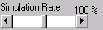
Speed of Simulation
Move slider left for slow motion, right to speed up
Instead of running the simulation in real time, you can slow it down so to see things happen in more detail, or speed it up. To do this, use the simulation speed slider.
You can drag the slider to the left or right, click on the scroll bar to the left or right to decrease or increase simulation speed by increments of 10%, or click on the left or right buttons to decrease or increase simulation speed in increments of 1%.
Simulation speed can be changed from 0% to 200%. In general, the faster the simulation rate, the less accurate the simulation will be.

Micromouse Parameters
The micromouse parameters are the dimensions and characteristics of the mouse that determine how it behaves. They are grouped together under five headings for convenience.

Geometry
Figure 1 illustrates some of the main geometry of the micromouse.

Wheelbase
The distance between the driving wheels, in millimetres. Cannot exceed 250mm because of the rules.

Eye Pivot
How far in front of the axle the eye pivot is. If your micromouse doesn’t have swivelling eyes, set this to zero and adjust the eye length.

Eye Length
The distance in millimetres between the eye pivot and the eyes.

Eye Width
The distance between the eyes, in millimetres.

Castor Pivot
How far in front of the axle the castor arm pivot is, in millimetres. This can be negative for trailing castors.

Lookin
The gearing between the castor wheel arm and the eyes. At 100%, the eyes move left or right through the same angle as the castor wheel arm. At 0%, the eyes are fixed.

Eye Slop
How much ‘slop’ there is in the mechanism linking the eyes to the castor wheel arm, in degrees. If your engineering is good enough to build a mouse which is going to be competitive, this should be zero. However, it is interesting to see the effect.

Drive

Gear Ratio
The velocity ratio of your gear box. For example, 80 means the motor rotates 80 times for each revolution of the gearbox output shaft.

Wheel Diameter
The diameter of the driving wheels, in millimetres.

Friction Torque
The torque, in Nm, needed to overcome friction in the gearbox, as measured at the input shaft. This doesn’t seem to have much effect, unless you have a particularly stiff gearbox.

Left Bias
The percentage difference in torque generated by each motor given the same input. Interesting to see the effect on straight line performance, but turns out not to be a major factor.

Tyre Coefficient
The coefficient of friction between the tyres and the track. This really is crucial, and is one of the factors which truly limits how fast your mouse can go. You can measure this by finding the steepest slope the mouse will stand still on. The coefficient of friction is the tangent of the angle of the slope.
Watch what happens as you reduce the value – it can get spectacular !
If the mouse starts to slip, one of the information displays will turn red.
Modelling what happens to a slipping mouse is much harder that modelling what happens without slip, so don’t expect the simulator to give accurate results once the tyres start to lose their grip.

Control

On Voltage
The voltage applied to the motor when it is being driven.

Off Voltage
The voltage applied to the motor when it is ‘stopped’. This can be zero, positive or negative.

Braking Resistance
If zero volts are applied to a motor when it is off, a braking resistance can be put across it. This uses the voltage generated by the motor when it is turning to brake it, and results in much greater deceleration that just removing the driving voltage.
Zero ohms means full braking effect, 50 ohms means no braking effect.

On Delay
The delay, in milliseconds, between an eye seeing the colour that makes its motor drive (white for the inside eye, black for the outside eye) and the ‘on’ voltage being applied to the motor.
This is particularly important if you use relays to drive the motor. Any delay reduces stability significantly.

Off Delay
The delay, in milliseconds, between an eye seeing the colour that makes its motor stop (black for the inside eye, white for the outside eye) and the ‘off’ voltage or braking resistance being applied to the motor.

Mass

Mass
The mass of the mouse in grams. Surprisingly, this has less effect on performance than you might think.

Radius of Gyration
Ask a physics teacher ! It’s measured in millimetres, and represents how far, on average, the mass of the mouse is away from the centre of gravity as far as rotational inertia is concerned.

CG Above Axle
How far, in millimetres the centre of gravity of the mouse is above the main axe. This matters because narrow wheelbase, large wheeled mice can topple on corners.

Motor

Motor Inertia
The second moment of inertia of the motor in gram square millimetres.
This determines how long it takes for the motor to get up to speed and slow down again.
This can sometimes be found in the technical specification for the motor, otherwise multiply half the mass of the motor by the square of a quarter of its diameter.

Torque Constant
How much torque the motor generates for each amp of current it draws. You will have to get this from a specification for the motor, or do some fancy experiments !

Generator Constant
How much back EMF the motor generates for each radian per second it is rotating. I am reliably informed that it should have the same numerical value as the torque constant.

Armature Resistance
The resistance of the motor armature. You can measure this with a multimeter and the motor held still, if you are quick.

Y
Eye Length
Eye Width
Wheel Radius
Wheel Diameter
Wheelbase
Semi Base
Castor Pivot
Eye Pivot
α
β
δ
Yc
X
Xc
θ
Figure 1 Mouse Geometry
- Mouse Dynamics Assuming No Slip

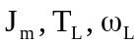
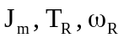
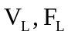
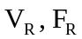
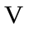
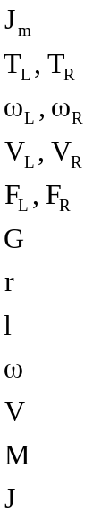
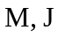
G
G
G
l
r
Second moment of inertia of the motor armature
Torque after friction generated by each motor
Angular velocity of each motor
Linear velocity of each wheel rim
Tangential contact force at each wheel
Gear ratio between motor and wheel
Radius of driving wheels
Semi-wheelbase
Angular velocity of mouse
Linear velocity of mouse
Mass of mouse
Second moment of inertia of mouse
The torque generated by each motor generates force at the wheel and accelerates the motor armature.
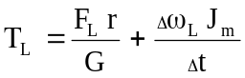
Equation 1
&
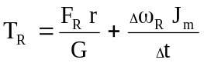
Equation 2

The angular velocity of each motor is related to the wheel velocity by the gear ratio and wheel radius:
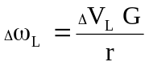
Equation 3
&
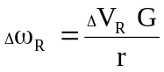
Equation 4
Substituting Equation 3 into Equation 1, and Equation 4 into Equation 2 gives:
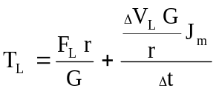
Equation 5

&
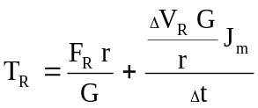
Equation 6

The linear acceleration of the mouse is given by:
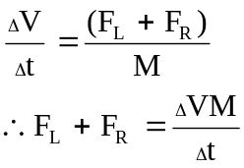
Equation 7

The angular acceleration of the mouse is given by:
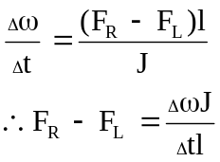
Equation 8

Subtracting Equation 8 from Equation 7 gives
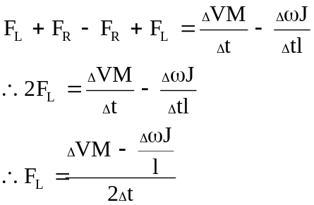
Equation 9
Adding Equation 7 to Equation 8 gives:
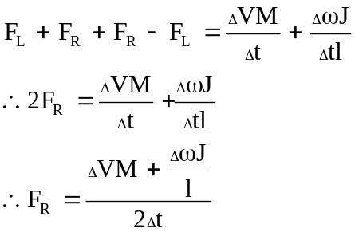
Equation 10
Substituting Equation 9 into Equation 5 gives:
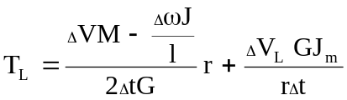
Equation 11
Substituting Equation 10 into Equation 6 gives:
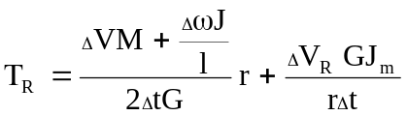
Equation 12
The overall linear velocity of the mouse in terms of the individual wheel speeds is given by
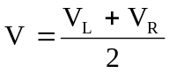
Equation 13
The overall angular velocity of the mouse in terms of the individual wheel speeds is given by
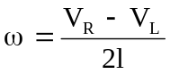
Equation 14
Substituting Equation 13 and Equation 14 into Equation 11 gives:
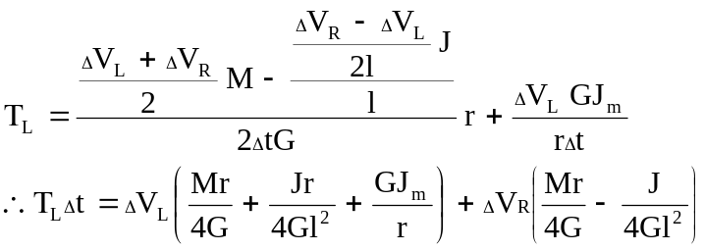
Equation 15
Substituting Equation 13 and Equation 14 into Equation 12 gives:
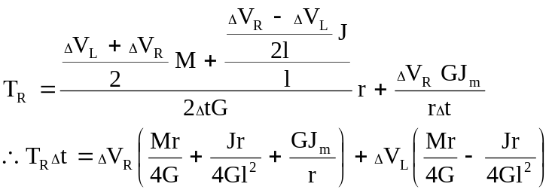
Equation 16

Let
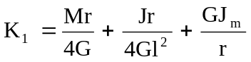
Equation 17

And
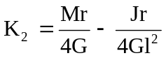
Equation 18

Then Equation 15 becomes:
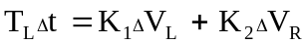
Equation 19

And Equation 16 becomes:
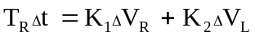
Equation 20
Equation 19/K2 - Equation 20/K1 gives:
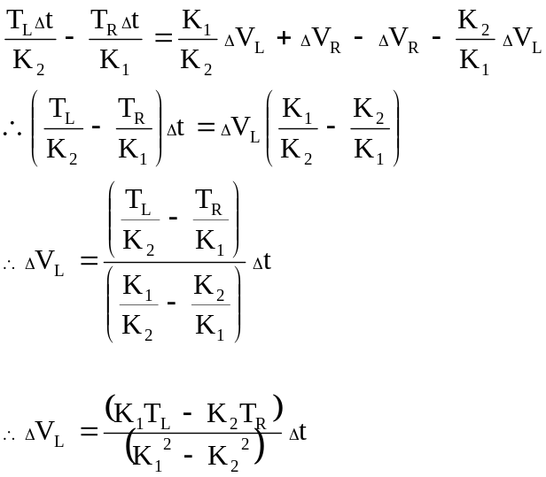
Equation 21
Equation 20/K2 - Equation 19/K1 gives:
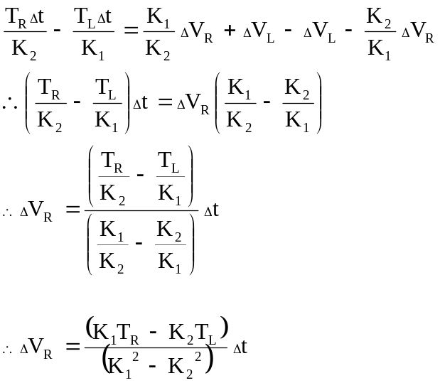
Equation 22

So,
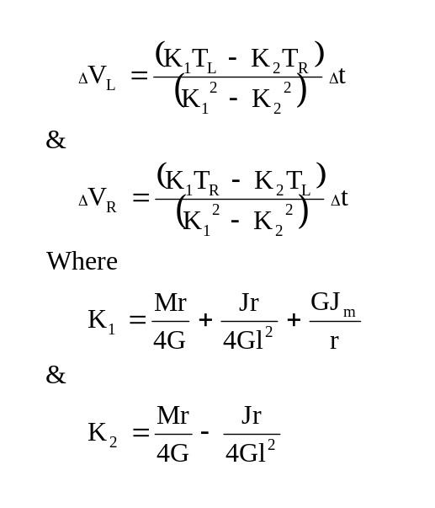
- Motor Characteristics
Consider the motor to consist of an armature with no intrinsic resistance in series with a non-inductive resistance which in reality represents the resistance of the armature windings.
V
V_{emf}
V_{a}
I
T,rpm
R_{a}
Figure 2 Motor Characteristics
Motor torque is proportional to current.
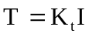 where K_{t} is the torque constant
Equation 23
Ohm’s Law gives
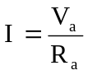
Equation 24
The voltage drop across the armature ( the back EMF) is the difference between the supply voltage and the drop across the armature windings.
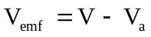
Equation 25
The back EMF is proportional to the speed of rotation of the armature.
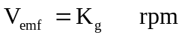 where K_{g} is the generator constant
Equation 26
Combining Equation 23, Equation 24, Equation 25 and Equation 26 gives
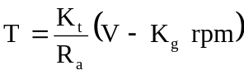
Equation 27
At the stall, rpm is zero, so
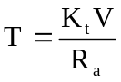
Equation 28
Under no load conditions (unachievable in practice due to internal friction in the motor)
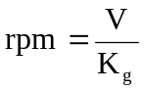
Equation 29

