ITWS III Project
Automated Omega Plotter With GUI
Students: 1. K.G. Pavan Kumar
2. Phani Krishna K S S S
Mentor: Raina Arora
Description:
An RNA molecule has a large number of nucleotides that form the basic chain of the molecule. The RNA molecule, unlike the DNA molecule is a single strand and this strand is intermingled to form a big cluster. The nucleotides in the different parts of the molecule get connected with each other by different base pair combinations to form bonds and hold the molecule together.
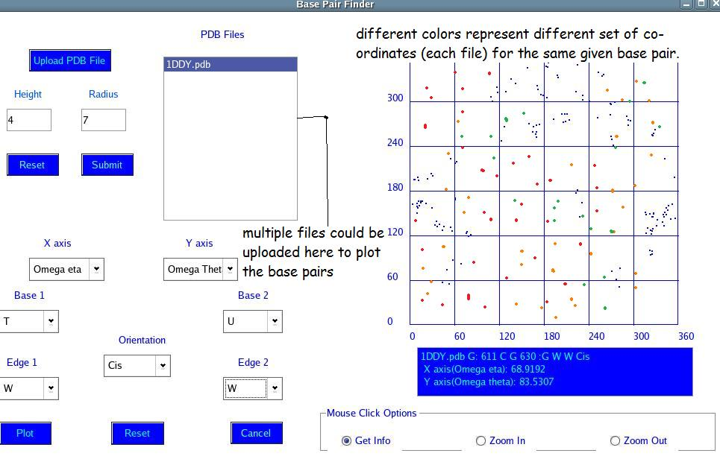
Screen Shot : Omega Plotter GUI

Now in our project, we have a file that contains the co-ordinates of all the atoms in the molecule. This file can be uploaded to the GUI. The list of the uploaded files can be seen in the text box next to the “Upload PDB File” button. Around each co-ordinate in the file, a cylinder will be drawn of radius and height as given by the end user. The base pairs that exist in this cylindrical volume will be plotted in the graph field. The given angles Omega eta, theta, 1, 2 can form the co-ordinate axes (as given by the user). If no base pairs are specified, the graph default has all the base pairs plotted. The orientation and other parameters like the edges (W or H or S) should be entered by the user for successful plotting of the base pairs.
Now the GUI shall provide for uploading of multiple files and the plots related to each of the set of co-ordinates in each of the files for the same base pairs shall be in different colors. The graph shall have plots corresponding to each of these co-ordinates each in a different color.
Database:
Now that the co-ordinates of the atoms as given in the file are plotted in the graph, we get information regarding which base pairs are there around that particular atom corresponding to each of these atoms. So we have to efficiently store information regarding which base pairs are there and their ids, at which edges do they form the bonds, whether they are cis or trans orientations and other such related data. So we shall have a table that stores all this information.
We shall have fields which contain base_ID, base_Name, Orientation, Edge1, Edge2, Co-ordinateX, Co-ordinateY, Co-ordinateZ, for each of these atoms given in the PDB file. One should be able to efficiently retrieve information from this database based on the base pairs asked for. If no base pairs are specified , then all the combinations should be extracted and plotted. The extraction from the database file is most important as the information got from these requests will be plotted on the graph.
The present program that generates the database appends new information for each run in the database file. We should be able to sensible delete the database file each time the window (or GUI) is closed and keep it intact till then. Similarly, when there are multiple files to be considered, we should also keep track of all the base pairs corresponding to each set of co-ordinates. So here database and their appropriate usage plays a key role.

