Automated Omega Plotter With GUI
ITWS III Project 2008
Students: 1)K. G .Pavan Kumar
2) Phani Krishna K S S S
Lab: CCNSB
Advisor: Dr. Abhijit Mitra
Mentors: 1) Raina Arora
2) Monica Sharma

Overview:
An automated omega plotter is a Graphical User Interface (an in-house tool) that efficiently computes various parameters defining the structure and arrangement of the consistent molecules based on some predefined algorithms. The co-ordinates of the atoms of the RNA molecule will be stored in a file and that file will be uploaded to the GUI. The file can contain the atomic co-ordinates of nearly thousands of atoms. The GUI should provide for a facility to upload many such files and do the necessary computations. The GUI should be able to provide for a user friendly environment and provide proper visualization and accurate results which are precise.
The Project:
The RNA molecules are made up of nucleotide molecules of four different types of bases. Each nucleotide structure has a sequential connectivity of its constituent atoms. The tool (algorithm) given calculates five parameters related to each RNA molecule. These parameters explain the base pair geometry of the molecule and the orientation of the constituent atoms and how they form the strands of the RNA molecule.
The project was already done by a student last year and this time we are supposed to make it a better interface with more features that can make work easier
and smarter for the end user (other researchers who analyse the plotted graphs and end results).
The GUI given to us looks as follows:
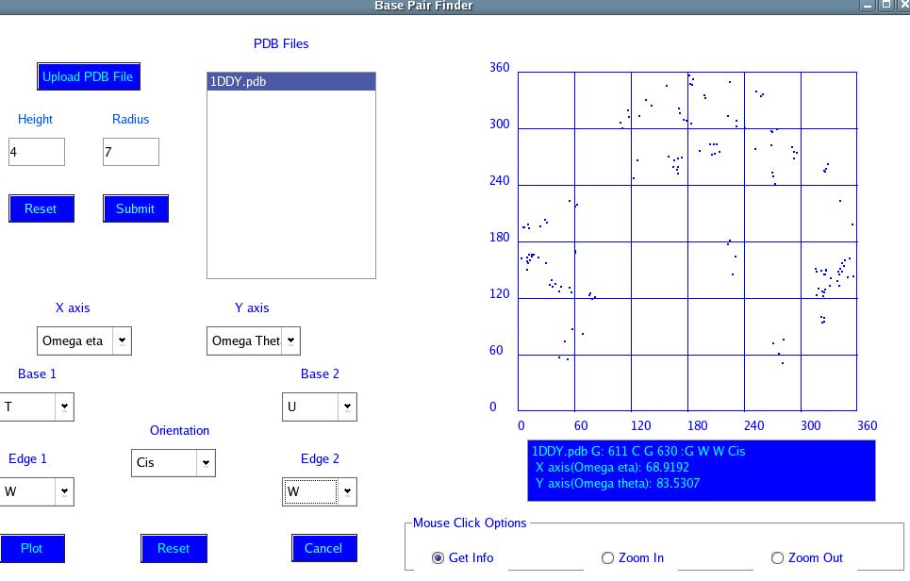
Automated Omega Plotter with GUI
The GUI will provide space for uploading files and the names of the files will be displayed in the region numbered 5. The X and Y axes will be set in theregion numbered 7 along with the other parameters in various other regions 8 and 9. When the Plot button is clicked, the GUI displays the graph related to the co-ordinates in the uploaded file above the region 14.
The GUI allows for some options such as Zoom IN and Zoom OUT and other similar functions. The Get Info function provides information about the selected region in the plotted graph in the region numbered 14. It allows for resetting some of the basic parameters such as the co-ordinate axes, the basic bases, the edges and the orientation which play a key role in the plotting of the graphs. The PDB file contains all
the co-ordinates of the constituent atoms. The textbox next to the “Upload PDB file” button displays the name of the uploaded file.
The GUI given to us can now handle only one file at a time i. e. it can plot the graphs only for one file or set of co-ordinates. So our aim is to make the GUI able to handle multiple files at the same time and plot the graphs for each set of co-ordinates in a different color simultaneously for better analysis by the end user. It should also be able to provide comparative details of the graphs for each set of co-ordinates. The GUl still does not provide the user with an option of plotting a specific type of base pairs for more than one file simultaneously, with points from different files being indicated in different color which should be implemented this time.

Bugs:
A known bug in the Plotter tool is the lack of precision of mouse click events on the graph. As pixels on the form widget can be addressed only as integral values, there are chances that attempts at retrieving information about a particular residue using the Get Info option does not provide the information about the residue which the user wanted. Such a case would arise when residues are co-joined or are very near each other.
The graph which the plotter plots now disappears on a single mouse click on the graph which should not happen. This should be modified.
Another problem with the GUI is that it is unable to function properly in all the resolution modes and works best with 1024x768 resolution of the monitor. It should be made compatible with any resolution mode.
Technologies Required:
Qt 3.3, MySQL 5.0.22 and programming language like C++.
Platform:
Linux

