Meditector:
Search Medicine by Photo with Machine Learning

Woongbi Kang
Information Systems
Hanyang University
Seoul, Korea
kgr2140@hanyang.ac.kr

Taeeui Choi
Information Systems
Hanyang University
Seoul, Korea
xodml@hanyang.ac.kr

Gunwoo Kim
Information Systems
Hanyang University
Seoul, Korea
rjsdnrrkem@hanyang.ac.kr
Minyoung Hwang
Information Systems
Hanyang University
Seoul, Korea
augreatity32@hanyang.ac.kr

Abstract—Nowadays, as kinds of medicine become more varied, consumers require more detailed information of medicine such as name, effect, or any side effects of medicine. For example, some consumers may need to avoid getting certain kinds of medicine. Based on those demands, we made an application which provides information of medicines to customers by image searching, based on machine learning.

Role Assignments
Roles | Name | Task description
Software Developer | Woongbi Kang | Make Google ML study pill data and develops Android applications based on Java and Android.
User | Taeeui Choi | Utilizes the apps and tell developers what they easy to forget or overlook and what leads user feeling dissatisfied.
Development  Manager | Minyoung Hwang | Conduct processes of development, optimize program by reflecting opinions of members, and adjust the program schedule to be completed on time.
Customer | Gunwoo Kim | Feeling that developer made this app to make something positive for customers, but the performance of this app is obviously not enough for customers. I believe this app will get better performance, and help more customers.

Keywords— medicine, pill, machine learning, image comparison, classification, customized information

Introduction
In real life, information of medicine has become more important. First, for example, if some different kinds of medicines are mixed by chance, it is obviously needed to separate medicines by related kinds of medicines. Second, consumers should be able to choose medicine. Even if it might be risky to take certain kinds of medicine arbitrarily, it would be helpful in terms of letting consumers be able to have more positive choices.
To satisfying these purposes, we made an application to identify medicines by image. With rapid growth of machine learning method, now we are able to apply machine learning method in application. We used machine learning method for image comparison to identify medicines and provide the information of it. Using this application, customers would get not only information about medicines, but also more choices in their life.

RELATED SOFTWARES
Before we start, there were some applications about providing information about medicines. ‘Smart DUR’, ‘Searching medicines’, ‘Recommendation app by using prescription and barcode’, ‘KIMS Mobile’ are similar applications in terms of searching. These applications provide information about the ingredients of the medicine, the interaction with the food, and so on. And ‘Pill Scanner’ application also has same functions, but this application’s main function is scanning medicine by photos. Based on AI, this application analyzes the medicine(photo) and shows information about the medicine.

Smart DUR
This application has these functions. First, users can search medicines they can get information about medicine, how to take drugs, and cautions about medicine. Second, applications tell whether the medicine has any problems. Lastly, if users do not know the medicine name, user can search the medicine by medicine’s shape, color, etc.
And this application saves history that users had searched. Our application also needs this function.

Medication Search
This application also give information to users about the medicines. Also, this application added the functions that telling information about diseases, and how to act he first aid method according to the situations. Uniquely this application has barcode reading function for blind people.
This application provides Korean and English when people search the medicine. And this application provides more information than related applications. So this application will be of great help in terms of information.

Pill Scanner(Beta)
Pill Scanner’s main function is searching medicine by image analyzing. This function is what we want to make mainly. Users can search the medicines by name.
But this application has weakness about searching. When search by image, it doesn’t recognize the medicine well. This application is not enough in performance, but these functions will help us for making our application.

Google ML KIT
This is a new SDK that gives mobile developers Google machine learning expertise in a powerful yet easy-to-use package on Firebase. And this program is a machine running for all skill levels. For beginners, the ML Kit provides five out-of-the-box APIs that cover common mobile use cases. There are text recognition, face detection, barcode scanning, image labeling, landmark recognition, maybe we can use text recognition technology here. ML Kit is available through Firebase, so we can easily take advantage of the larger Firebase platform.

Google OCR
This technology can be used in Google Drive, without a any installation. Upload at the google drive with the file that is end with .jpg, .png, .pdf, etc. Open these files with google docs, then users can see the photos with letters that is in photos. We can use this method with our works.

Requirements

. Splash Page
When you run an app, the app's logo or name appears briefly. After about a second, it automatically switches to the main page.

Guide Page
When the app is installed and run for the first time, it provides a brief guide to using the application, and in this case, you can only go to the main page by pressing the skip button

Main Page
The main page consists of a pill search function which are the core of this app and additional menus.
Search functions include searching through images, searching through categories, and searching through text. Users can perform searches in any way, depending on the situation.

Searching through images :
Users can either take a picture of a pill themselves or retrieve a pill picture from a gallery to find out what the pill is. This search is useful when user does not have information such as the name or ingredients of a pill and user has pictures or the substance of the pill.
Based on machine learning and pill image data, the app can identify which pill is in the entered image. To make app identify better, app highlight certain section of camera display in which medicine should be.

Searching through categories :
Users can search by category for the shape, color, form, and dividing line of the pill. This method is useful when searching through images does not produce the desired results.

Searching through text :
Users can search through text such as name, component, and identifier of the pill. This method is useful if user knows the name and ingredients of a pill.

My Page
A page to store and manage user records. If the user has previously searched for a pill, and made bookmarked, the user can select the record on this page without having to perform a new search.
Users can check their medical characteristic on the list. List includes pregnancy, heart diseases, high or low blood pressure, and etc. Based on these checks, app intends to provide customized information in the information pages.

Result Page
This page opens automatically when you perform a search on the main page. It provides search results such as a list of results and a detailed description. The results list is provided first, and users can receive detailed information about the pill when the user selects an item on the list.

List Page
If an image search is conducted, a list of results is provided based on AI image analysis. If the user takes a picture of a pill, the app compares the shape, color, and identification letters of the drug based on the data learned and provides a list of the drugs in the most accurate order.
When searching for categories, a list of pills with data matching the selected elements is provided. If user chooses the property circle and the property red, user will see a list of all the pills with the data, circle and red.
When you perform a search through text, this page provides a list of drugs that contain the text you searched for. If the user searches for the exact name of the drug, a list of drugs with similar ingredients is provided.

Detailed Page
This page provides basic and customized information for pills.

Basic information
It provides general information about pills such as name, photo, composition, and how to take them.

Customized information
The app provides customized side effects, cautions, and how to take pills based on data checked on the User Options page. For example, if users check that they are pregnant, the app will warn them if the pill contains substances that are dangerous for pregnant women or that they should be careful about.

Development Environment

Choice of software development platform

Platform
Based on Linux and Mac OS, we are going to develop application, especially run virtual machine on Windows and use Ubuntu. Android offers a robust operating system, a comprehensive set of libraries, rich multimedia user interfaces, and phone applications. The mobile phone is equipped with Andriod, which provides a variety of functions and interwork that can be applied not only to mobile phones but also to various information home appliances. Android is a mobile operating system developed by Google, based on the Linux kernel and designed primarily for touchscreen mobile devices such as smartphones and tables. There are lots of guidelines of mobile application, so our application could be built with Android studio and open source that are available for both Linux and Mac OS.

Programming language

Java
Java is an object-oriented programming language that is highly secure, simple and easy, and is most actively used in programming nowadays. Java programs could be run on most systems regardless of the type of operating system. It is efficient providing object-oriented advantages, and it is a based language in Android studio.

Python
Python has wide user range and very general programming language that can be used on a variety of platforms and it has a large library module. In addition to its function as a pure programming language, Python is often used as a glue language that links modules written in other languages.

Cost estimation
Cost for purchasing medicines to build dataset unless we fine enough amount of data. Price would be calculated later.

Detailed information of development environment.

We would like to prefer the latest version of all development environment with their reliability and usefulness. Ubuntu 18.04.1, Python 3.7.1, Java SE 11.0.1, and Tensorflow.

Software in use

Tensorflow
Tensorflow is a machine learning engine developed by Google used in Google applications such as search, voice recognition and translation. It has been distributed into open source software and used in various fields of development. It provides a python application programming interface (API).

Android studio
Android studio is an official integrated development environment (IDE) for Android. The IDE is being offered by Google for free and become popular with a fully featured Android developing environment based on stable environment. Lots of developers would like to get used and associated with Android application because of incredible growth, this tool is helping them achieve their thoughts.

Github
Github is a webhosting service that supports projects using a distributed version of the management tool, Git. Github offers both commercial and free services for open source. It provides free accounts and repositories to users, and is one of the most commonly used web hosting services worldwide for managing open source projects. It makes work comfortably providing access control and several collaboration features, such as a wikis and basic task management tools for every project. This tool will help us to co-work each other and see our own code more easily.

Task distrubution

Name | Task description
Woongbi Kang | Build Android application
Taeeui Choi | Arrange detailed description of medicine
Minyoung Hwang | Procure photo dataset of medicine for machine learning
Gunwoo Kim | Conduct machine learning with Google Tensorflow.

Specifications

Splash
When users come into our application first, show the logo of our application’s name ‘Meditector’ to let them recognize it.

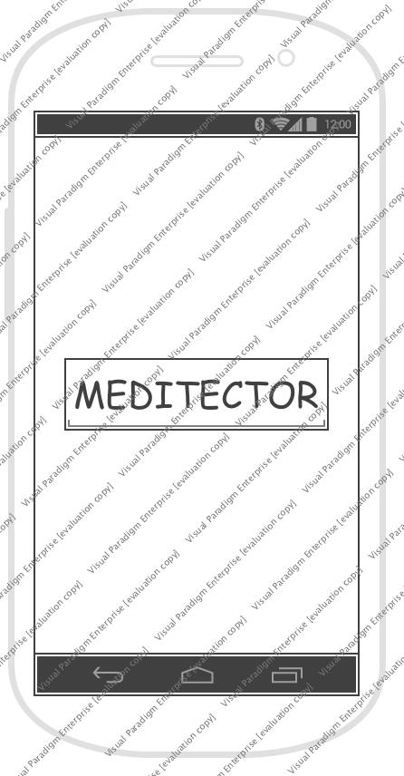

Popup guide

If it is the first time to execute the application, a guide page would be appear to user to demonstrate the usage of ‘Meditector’. There would be two buttons ‘Ok’ and ‘Never see again’.

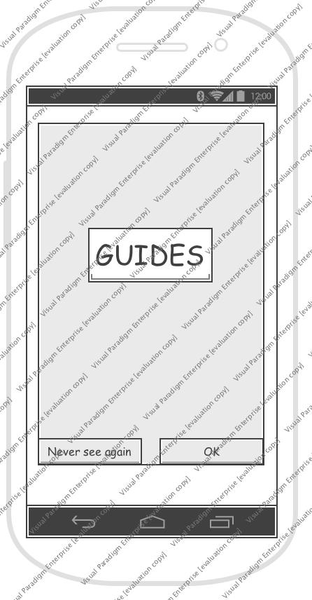

Main page
At the main page, our logo would be placed at the top, and at the middle, there are four round buttons to use functions. ‘Image’, ‘Category’, ‘Text’, and ‘My page’.

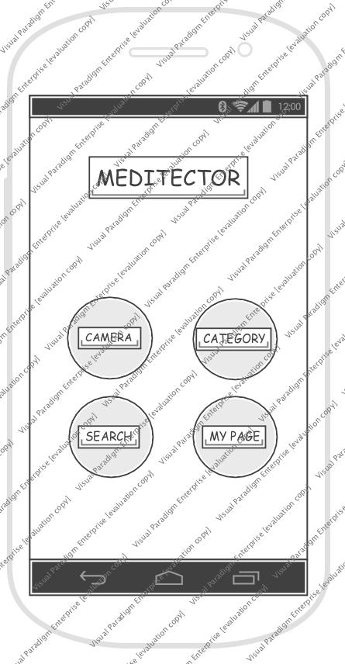

Image search
To search pill medicines with image, there would be a popup screen if a user clicks the image button. There are also two buttons ‘Camera’ and ‘Gallery’.
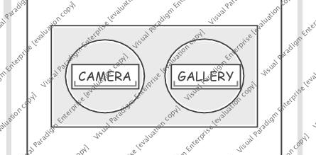

Camera
If users want to search information with photo that is taken right now, the camera in their mobile phone would be activated to take a picture. There would be a square guideline to enhance accuracy, encouraging taking a picture of a pill to be fitted inside the guideline. And a notification for guideline will be placed on top of the screen. At the bottom, there is a button for taking picture.

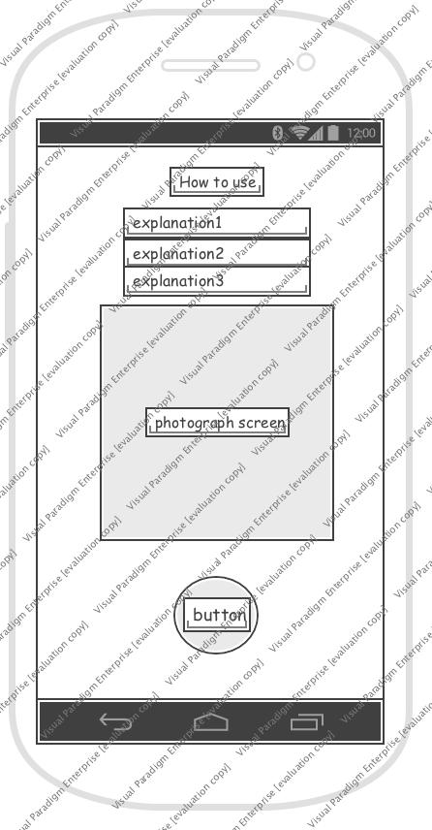

Gallery
To search information with photo that was taken a while ago, the users could bring the photo in their phone gallery application. After selecting one, they have to crop the image to make it to be fitted. So there would be a notification also.

Category search
To search with characteristics that a pill has, users could use category search. In the functionality, there will be a search button on the right side of the top, and a textbox for identification characters will be placed under that. Categories are very segmentalized such as shape, color, split line, and etc.

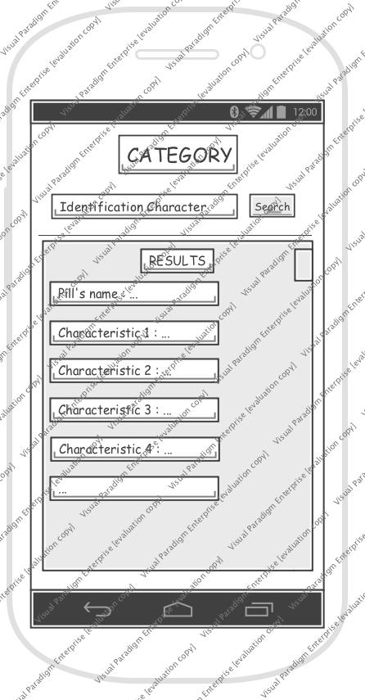

Text Search
With text, users could find information of medicines by entering the name of tablet.

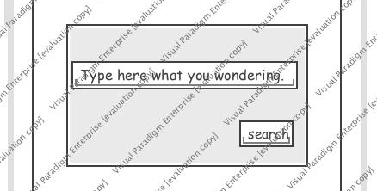

My page
In the My page section, users could set and register their own information on the application. There are two buttons ‘Bookmark’ and ‘My health’.

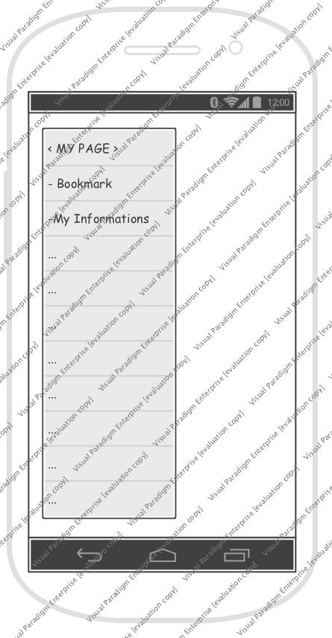

Bookmark
With bookmark function, users could make a list of pills that they frequently take or want to remember.

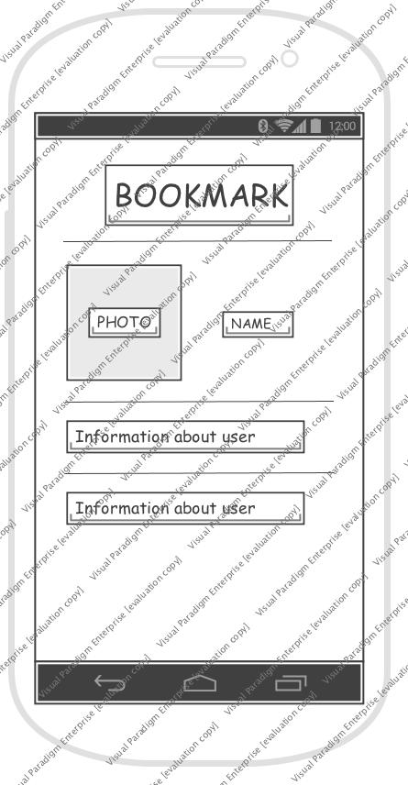

My health information
Users could register their own health information to use the function of our application that recommends or warns taking specific kinds of medicine based on their health such as pregnant and diseases.

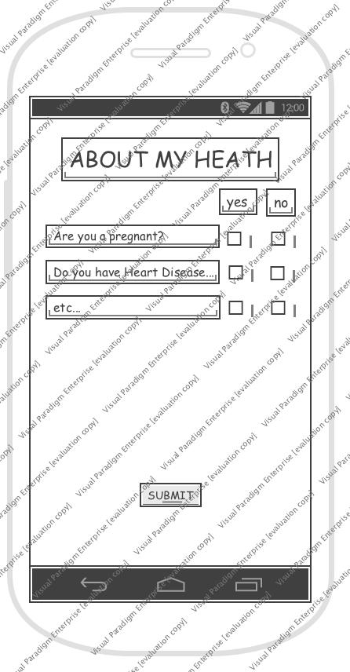

Result page

List
After searching with image or category or text, there would be a list of tablets that could possibly be a medicine that users want to find. With thumbnail images of each medicine, there are name of it.

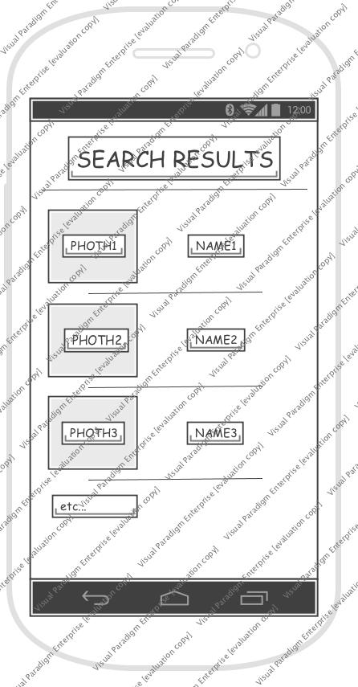

Detailed information
If users click one of the listed medicines, a detailed information of that would be shown with a new page. The name of a pill will be placed on the top, and bookmark button also on the right side. And an image would be under that, description and customized information also.

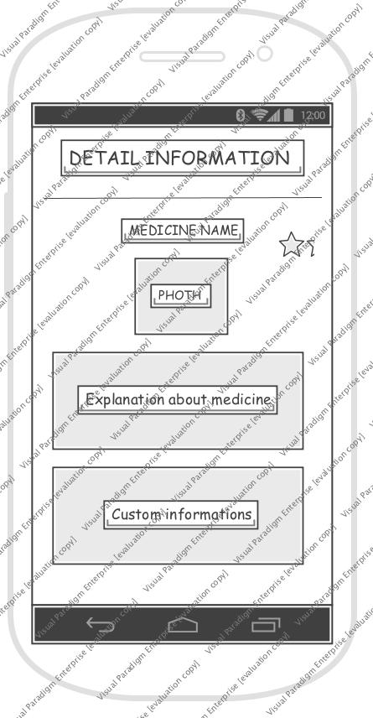

Pill Recognition with Deep Learning
For the recognition of pills in given picture, app need to have search technique which is based on deep learning method.

Region of Interest
In given picture, ROI(Region of Interest) should be caught correctly, which means to know where the pills are in picture. Without additional function, we highlight center part of camera view so users can focus on setting pills in center of the picture. This way not only gives more exact ROI, but also let users make better quality of picture. In case of pictures loaded from gallery, same thing is applied. Users can move and zoom in and out to make pills be on center of the picture.

Method and Model
We use CNN method for pill recognition with computer vision. CNN, Convolution Neural Network is most dominant method in computer vision. Among the open source model of CNN, we take the GoogleNet Inception V3 because this model has some precedent for similar tasks and has been used more commonly in other studies, which means it has lot of reference we can look for. There are three features for pill recognition in CNN: Color, Shape, Overall feature. We use three models
separately.

Compatibility for Android
Not all tensorflow graphs can be used directly in Android platform. So first, make .pb file(binary) of trained model. We make two files each of trained value and graph, then integrate them into frozen graph file.

Architecture Design & Implementation

Overall Architecture
Basically we have two modules in our application. First, Android Studio accounts for front-end, which is the UI/UX. Android activities are displayed on users’ phone according to xml files of Android Studio. This helps us our overall application containing several functions and designs. Second, backend part consists of machine-learning graph of tensorflow library. Without server, the graph works itself in application by helping of interface between frontend and backend, Classifier.java API, the tensorflow mobile library. The model which is used for retraining is Google Inception-v3. Based on that, we re-train and transform so that make it work in mobile, android platform.

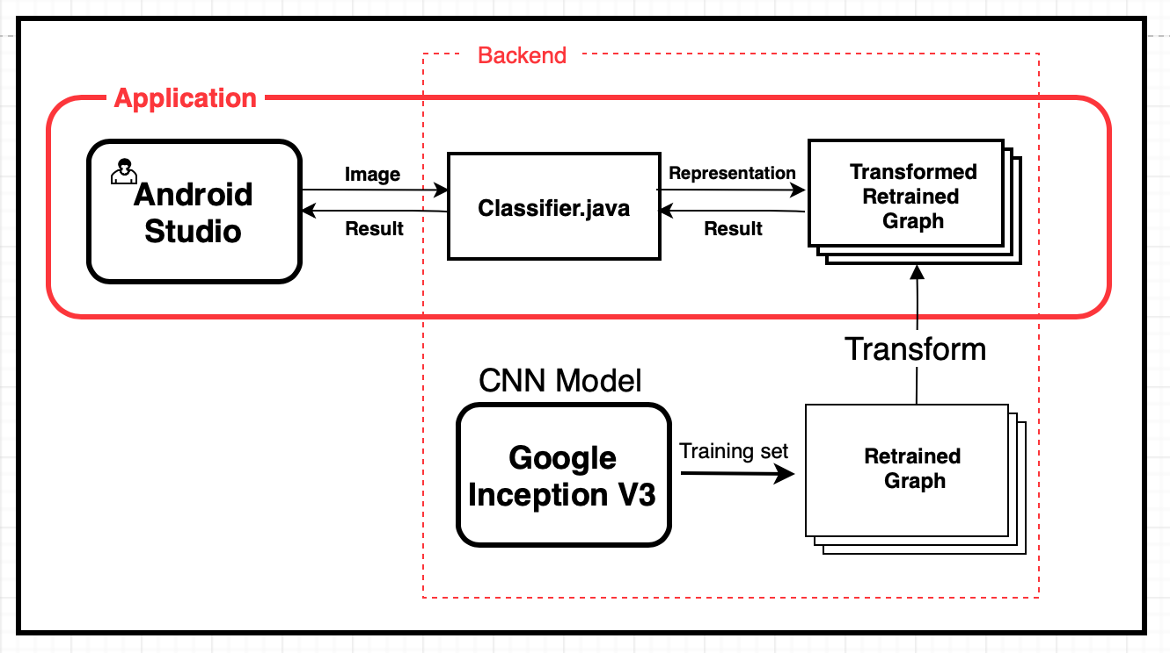

Directory Organization
This picture describes our directory organization. We are using 2 big modules which follow the overall architecture. One is Android Studio and the other one is TensorFlow. Each module has distinct directories. In addition, we have additional directory for latex which is our project document file.

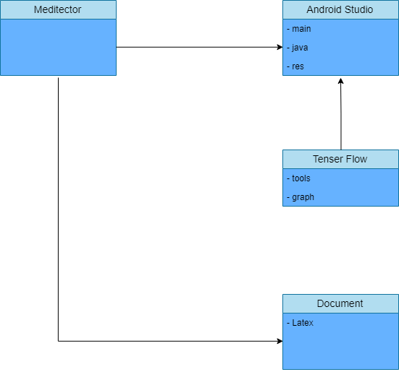

This is the table which shows directory, file name and module name.

Directory | File name | Module name
AndroidStudioProjects/  Meditector/app/src/main | AndroidManifest.xml | Android Studio
AndroidStudioProjects/  Meditector/app/src/main/java/com/meditector/jmt/meditector | CameraActivity.java  ImageDialogActivity.java  MainActivity.java  ResultActivity.java  SplashActivity.java  GalleryActivity | Android Studio
AndroidStudioProjects/  Meditector/app/src/main/res/drawable | circularbutton.xml  ic_launcher_background.xml | Android Studio
AndroidStudioProjects/  Meditector/app/src/main/res/layout | activity_camera.xml  activity_imagedialog.xml  activity_main.xml  activity_result.xml  activity_splash.xml  fragment_friends.xml | Android Studio
AndroidStudioProjects/  Meditector/app/src/main/res/values | Colors.xml  Strings.xml  Styles.xml | Android Studio
TensorFlow/tools | Retrained.py  Retrain_test.py | Tensor Flow
TensorFlow/tools/image/pills/advil | Advil1.jpg  Advil2.jpg  Advil3.jpg  …  Advil30.jpg | Tensor Flow
TensorFlow/tools/image/pills/aspirin | Aspirin1.jpg  Aspirin2.jpg  Aspirin3.jpg  …  Aspirin30.jpg | Tensor Flow
TensorFlow/graph | Output_graph.pb  Output_labels.txt  Stripped_graph.pb | Tensor Flow
Document/latex | document.docx  document.pdf | Documentation

Module 1 : Android Studio

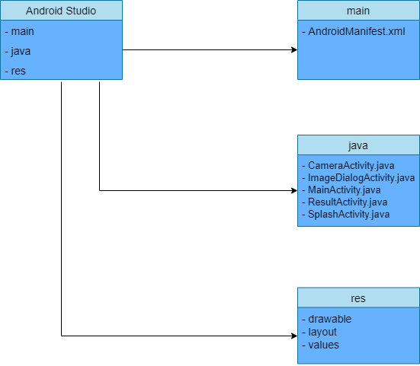

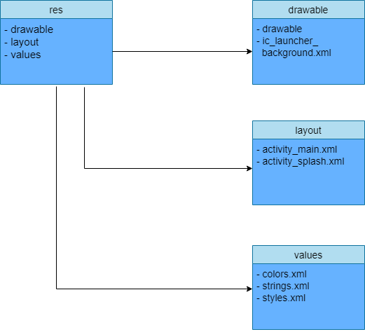

1. Purpose : We use Android Studio, an integrated development environment, to develop a identifying pills application for the Android mobile platform. We are developing ‘Meditector’ for users who use the Android mobile device, so we used Android Studio. Android Studio is the official integrated development environment (IDE) for Android app development, and it provides a basic layout and uses the Java language to help us develop applications easily.

2. Functionality : Android Studio is an environment that is based on all aspects of application development. We build the front end to be displayed on the user's display through the Android studio. Android Studio also allows you to design applications using the features provided. This module also connects backend servers and DBs for application-wide development. In addition, you can develop additional functions in your application through various SDK tools provided by Android Studio.

3. Location of Source Code : AndroidStudioProjects/
Meditector

4. Class component : There are several components in the Android Studio.

(1) SplashActivity.java : Set the splash activity so that the user can see the ‘Meditector’ logo after implementing our application. The MainActivity.java page will be implemented via the intent function to move from the splash screen after 2 seconds.

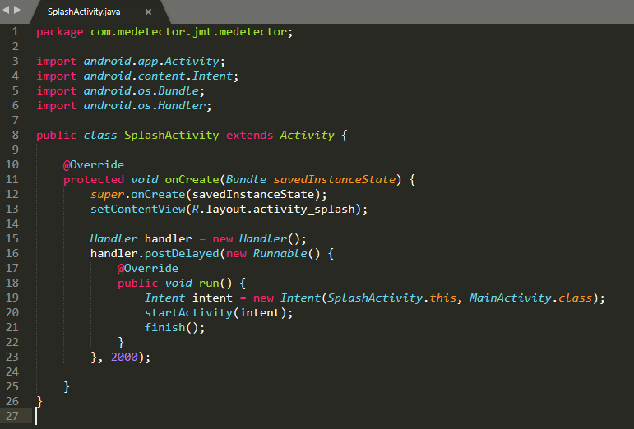

(2) MainActivity.java : After processing the event that goes from the splash page to the main page, we designed the main activity in earnest. We made ‘image’ button which calls out the ImageDialogActivity through intent function.

(3) ImageDialogActivity.java : When this screen is implemented, two buttons are floating like pop-up. One is ‘camera’ button, and the other one is ‘gallery’ button. If the user click the ‘camera’ button, CameraActivity.java will be carry out. And if the user click the ‘gallery’ button, GalleryActivity will be implemented. All these process take place via intent function.

(4) CameraActivity.java : In this page, the user can take pills picture which they want to know. We used a base camera application in this page. At this stage, the picture is analyzing through tensorflow, and the result is showing in the ResultActivity page.

(5) ResultActivity.java : This page shows the result that what the user’s pills are. It gives a pill’s picture and name through pop-up. And it also tells the probability that our application will match the actual pill.

5. Where it is taken from : We collected information about
android studio in Google. Also, many source codes are taken from the library list of Android studio official homepage.
(https://developer.android.com/studio/intro/index.html?hl=ko)

6. How and Why we used it : We write the java code using android studio. And we build the project. Using this IDE, we interconnect this with GitHub. It helps our team member share our code and receive public app build function. Android studio provide fast and well-made emulator, so it helps test a system.

Module 2 : TensorFlow

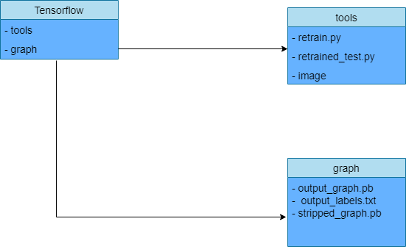

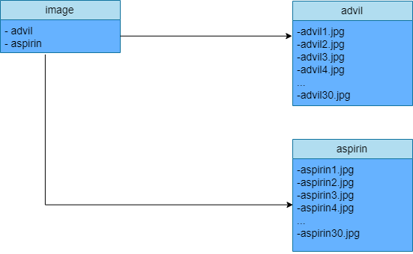

1. Purpose : We used tensorflow because machine learning is a complex discipline. But implementing machine learning models is far less daunting and difficult than it used to be, thanks to Google’s tensorflow that ease the process of acquiring data, training models, serving predictions, and refining future results. Created by the Google Brain team, TensorFlow is an open source library for numerical computation and large-scale machine learning. So we can relatively easily access machine learning by using tensorflow.

2. Functionality : Tensorflow is the most popular machine learning library. It supports python as a main language, also java and c++, which make it enable to work in other different platforms.
3. Location of Source Code : Tensorflow/…

4. Class component : There are several components in the Android Studio.

(1) Google Inception v3 model : This model is a kind of CNN model from google. CNN, Convolution Neural Network is a dominant deep learning method in computer vision and image recognition. A CNN consists of an input and an output layer, as well as multiple hidden layers. The hidden layers of a CNN typically consist of convolutional layers, pooling layers, fully connected layers and normalization layers Description of the process as a convolution in neural networks is by convention. Mathematically it is a cross-correlation rather than a convolution. This only has significance for the indices in the matrix, and thus which weights are placed at which index.
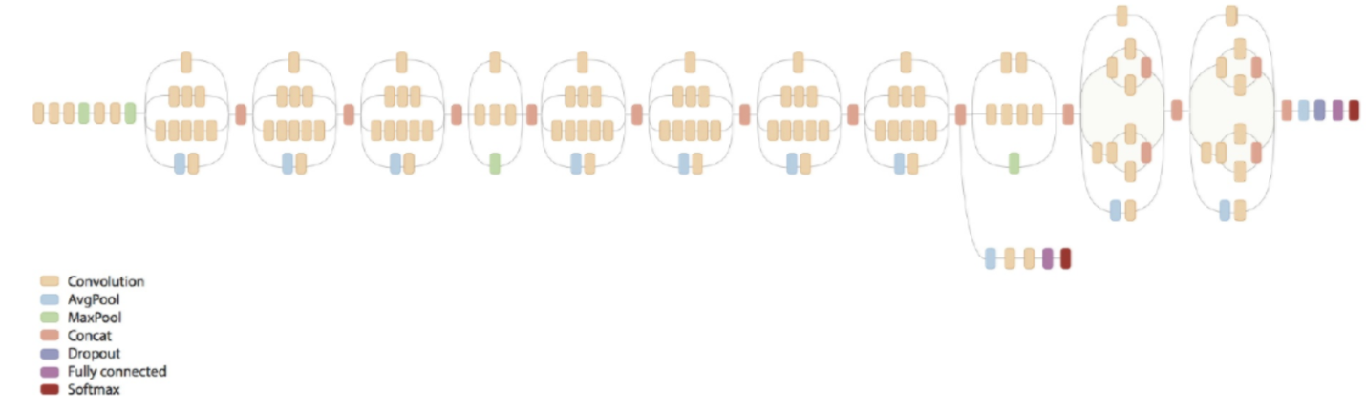

(2) Retraining.py : the CNN model is basically trained with lots of general images. So we do ‘transfer learning’ to make it be able to classify our pill images.
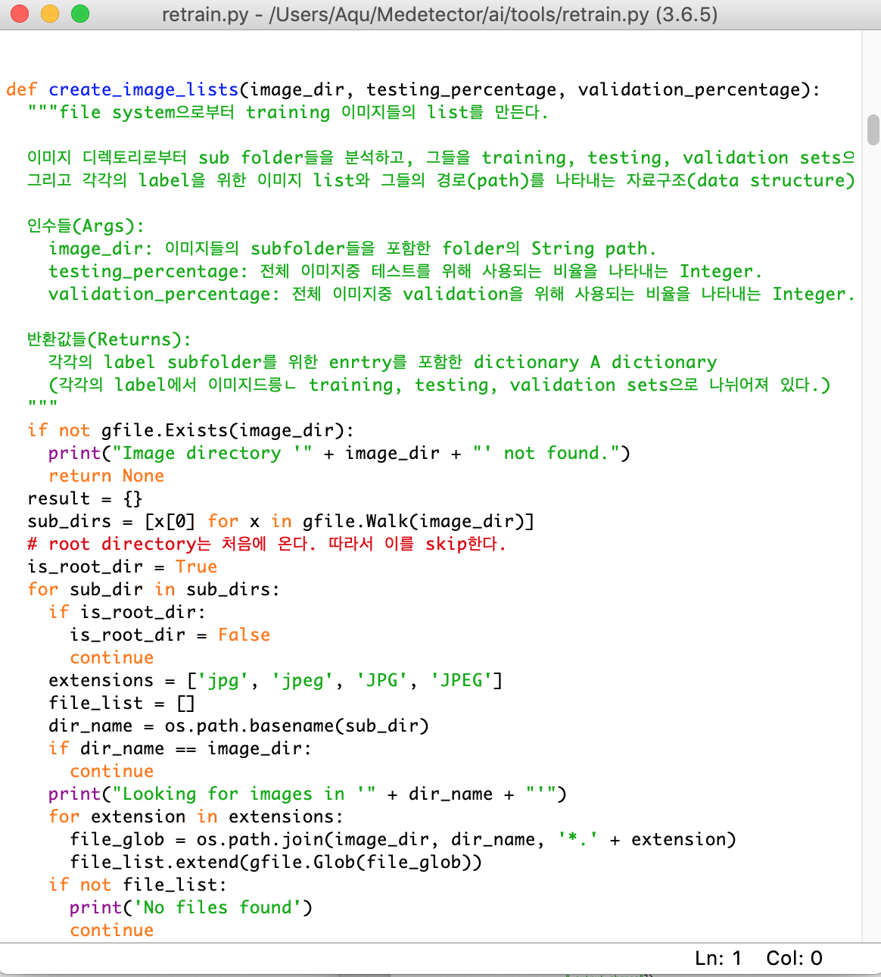

(3) Stripping.py : To make it work in android, graph transforming process is needed.

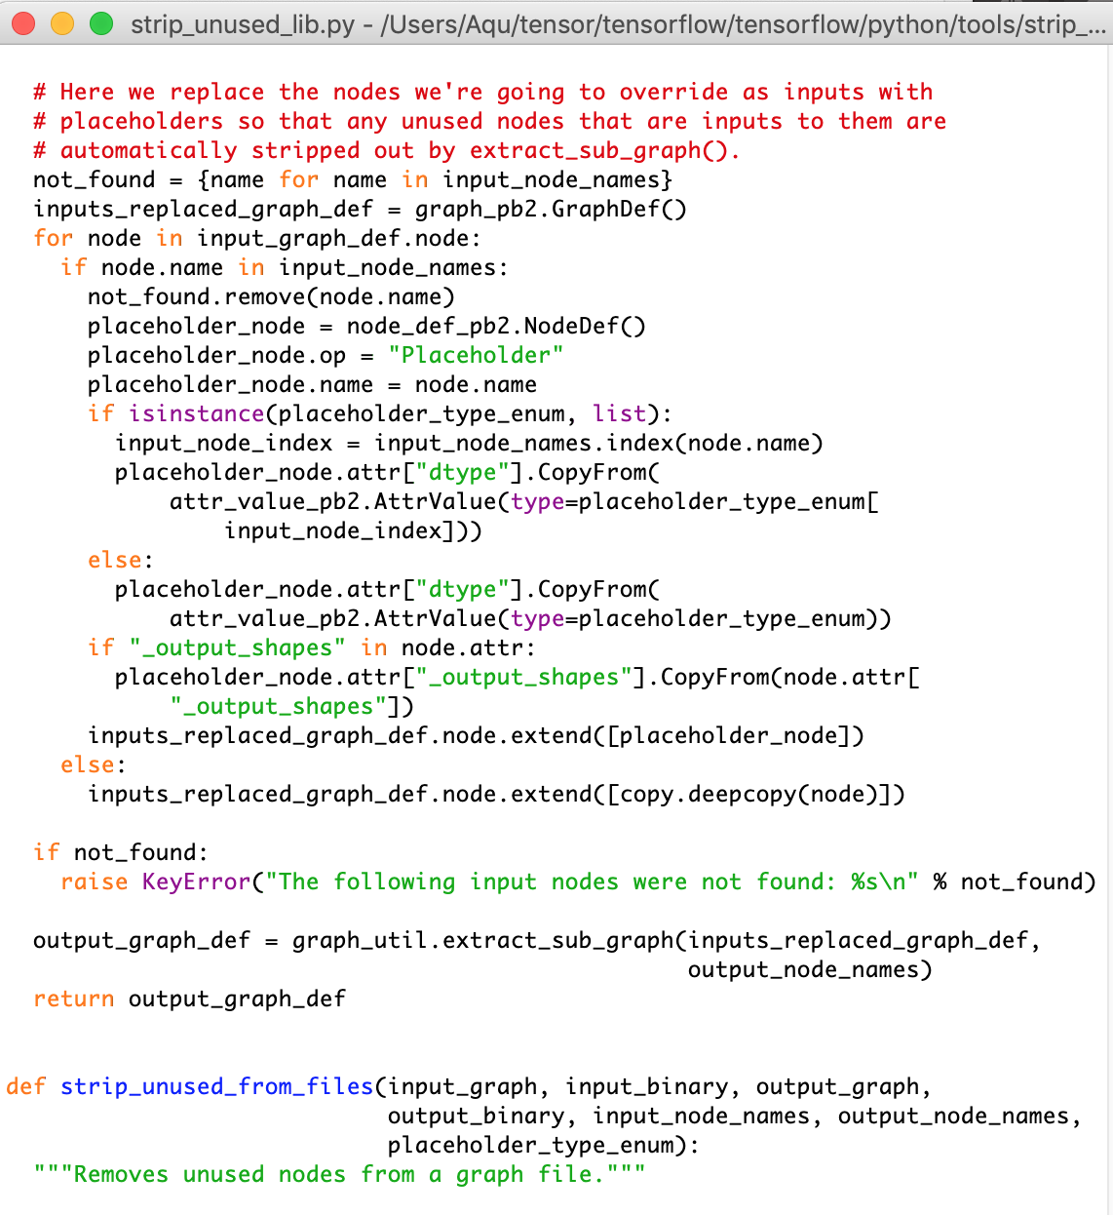

(4) Classifier API : It brings results which are obtained from the learned graphs as performing a role of the interface between user input and machine learning graphs in the overall structure.

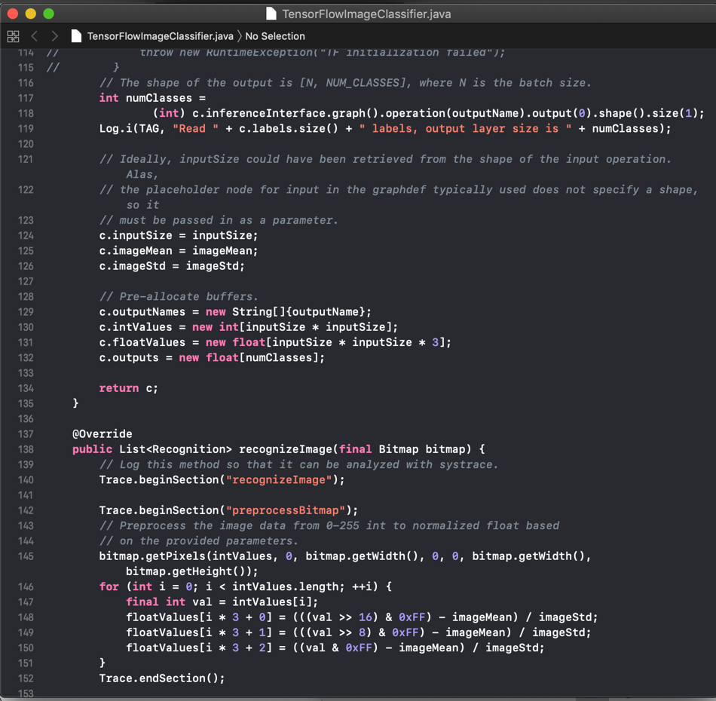

5. Where it is taken from : We collected information about tensorflow in Google. Also, many source codes are taken from the library list of Tensorflow official homepage.
(https://www.tensorflow.org/)

Use Cases

Installation
When users enter to ‘Google Play store’ and search the word ‘medicine’ or ‘pill’, our application would appear to be downloaded. If they select downloading, ‘Meditector’ would be installed in their Android mobile phone.

Implement application
If users decide to implement our application after installation, they would encounter the splash page that shows the name of application for a second. After that, a guide page for using would appear to let them know how to use it. They could select between two buttons, ‘Never see again’ and ‘OK’.

‘Never see again’ button
After reading and understanding the user guide, people could eliminate application guide permanently by pressing this button. And they don’t have to see it next implementation of application.

‘OK’ button
If users click ‘OK’ button, they could see user guide next time again. They could select it to see guide once again when they implement the application.

Main page
The main page is the page that users could recognize a function of application. It provides a ‘Image’ button to identify pill. After clicking the button, a pop-up page would appear how to provide an image to be cognized with two buttons, ‘Camera’ and ‘Gallery’.

Image search
There are two ways to identify by image, one is taking picture immediately with camera in mobile phone, the other is providing image in gallery that is installed inside a phone.

Camera
When a user clicks ‘Camera’ button, the page would be changed and camera application implemented to take a picture.

Explanation
There would be an explanation how to take a picture to be cognized more precisely. The recognition rate would be increased if a pill is big and whole in the picture.

Shutting button
To take a picture, there is a button to shut.

Gallery
When a user clicks ‘Gallery’ button in the previous pop-up page, the gallery application in mobile phone would be implemented to select an image. By using this function, users could recognize with a picture that had taken a while ago, so they could realize about a pill even if they don’t have the medicine in the moment of using our application.

Explanation
There would be an explanation to crop a picture to be fitted in our application. Users have to set image barely having background, with whole shape of a pill and big enough.

Next button
After crop image suitably, users could click next button to move to result page.

Result
With a photo that user provide, our application decides what is this medicine. The result would appear immediately with a brief information of pill.

Name
The result includes name of medicine according inference of our application to recognize what it is.

Photo
A representative image of a result medicine would be shown to users to let them make sure of outcome.

