**CMS Manhattan API and Design document**

DRAFT. Author Konstantin Grabko . 516-777-0945 , konstantin.grabko@yahoo.com

1. **Project description**

CMS Manhattan is sales application engine with Marketplaces functionality. J2EE Standards

1. **System Design for Amazon Cloud.**

1. **Application Design.**

**3.1 Buy Flow Components**

BuyFlow Component diagram

The MVC diagram describes main components for buy flow process of application.

* 1. **Publish item Components.**

Publish Items Component diagram

The MVC diagram describes main components for publish data process of application.

1. **CMS MVC Framework**

There are 4 parts that represent CMS MVC Framework

**MVC - VEW** : implemented via JSP and XSLT .

So JSP provides data to display in XML format then XSLT can transform to HTML or JSON or ANOTHER format.

So assign VIEW developer must use **@PageController** **annotation**

**@PageController( jspName = "AccountHistory.jsp" )**

**public class AccountHistoryAction extends TemplateAction {**

**}**

And VIEW transformation via **@PageXsltView for model class.**

**@PageXsltView( jspName = "AccountHistory.jsp" , xsltName="accounthistory.xsl" , responseType= Type.XML )**

**public class AccountHistoryBean extends com.cbsinc.cms.WebControls implements java.io.Serializable {**

**}**

Then Maven build script will add the MVC component in configuration file .

**MVC – CONTROLLER**: implemented via java class.

So since developer assigned @PageController **annotation then**

Maven builds script will add the MVC component in configuration file.

**@PageController( jspName = "AccountHistory.jsp" )**

**public class AccountHistoryAction extends TemplateAction {**

**}**

**MVC-MODEL:** implemented via java class.

So since developer assigned @PageModel **annotation then**

Maven builds script will add the MVC component in configuration file.

**@PageXsltView( jspName = "AccountHistory.jsp" , xsltName="accounthistory.xsl" , responseType= Type.XML )**

**@PageModel( Id="accountHistoryBeanId" , scope=Scope.SESSION )**

**public class AccountHistoryBean extends com.cbsinc.cms.WebControls implements java.io.Serializable {**

**}**

1. **CMS MVC API**

CATALOG COMPOMENT – Product list

ProductlistAction . java is Controller

Get requests API

Default request URL - Productlist.jsp?**catalog**_id=-2

Scroll result set cursor for request URL - Productlist.jsp?catalog_id=-2& **offset**=10

Use “**offset**” for every request for every page .

Open a catalog by catalog_id request URL - Productlist.jsp?catalog_id=-101

Search via search key words by catalog_id request URL - Productlist.jsp?**creteria1**_id=211&**creteria2**_id=7895&creteria3_id=235&creteria4_id=775&creteria5_id=115&creteria6_id=577&creteria1_i7=25

Scroll result set cursor for Productlist.jsp?**creteria1**_id=211&**creteria2**_id=7895&creteria3_id=235&creteria4_id=775&creteria5_id=115&creteria6_id=577&creteria1_i7=25& **offset**=10

Setup currency for items from catalog request URL - Productlist.jsp? currency_cd=USD

Search via between dates :

Productlist.jsp?dayfrom_id=1

Productlist.jsp?mountfrom_id=1

Productlist.jsp?yearfrom_id=2006

Productlist.jsp?dayto_id=1

Productlist.jsp?mountto_id=1

Productlist.jsp?yearto_id=2006

POST requests

So **offset** avoid pulling big data set to avoid fill all memory

Search by text request .

<form name="searchform" action="Productlist.jsp" method="POST">

<input name="search_value" type="text" size="20 value="">

<input name="search_char" value=”” type="hidden">

<input name="**searchquery**" type="hidden" value="**1**" >

<input type="HIDDEN" name="**offset**" value="0">

</form>

Search via search key words

<form name="searchcreform" action="Productlist.jsp" method="POST">

<input name="search_value" type="text" size="20 value="">

<input name="search_char" value=”” type="hidden">

<input name="**searchquery**" type="hidden" value="**6**" >

<input type="HIDDEN" name="**offset**" value="0">

</form>

Search via char

<form name="searchform" action="Productlist.jsp" method="POST">

<input name="search_value" type="text" size="20 value="">

<input name="search_char" value=”” type="hidden">

<input name="**searchquery**" type="hidden" value="**2**" >

<input type="HIDDEN" name="**offset**" value="0">

</form>

Catalog Response in XML Format .



PRODUCT INFORMATION – Product full description

ProductInfoAction.java – Controller

Get requests API

Default request URL - ProductInfo.jsp?policy_byproductid=982

ADD ITEM TO CART

<form name="order" action="Order.jsp" method="POST>

<input autocomplete="off" type="HIDDEN" name="position" value="23316050137317597">

<input autocomplete="off" type="HIDDEN" name="action" value="add">

<input autocomplete="off" type="number" size="6" min="1" max="90000" name="quantity" value="1>

<input class="button" autocomplete="off" type="Submit" name="Submit" alt="Add to cart" value="Add to cart>

</form>

Product information - Response in XML Format.



ORDER – Shopping cart



ORDER LIST – Purchase History



AUTHORIZATION - Registration and Authorization page

<form action="Authorization.jsp" method="post" id="form-login" class="form-login">

<input autocomplete="off" type="TEXT" name="Login" value="user">

<input autocomplete="off" type="PASSWORD" name="Passwd1">

<input class="button" type="submit" value="Enter" name="Submit"></div>

</form>



1. **Buyflow Database schema**

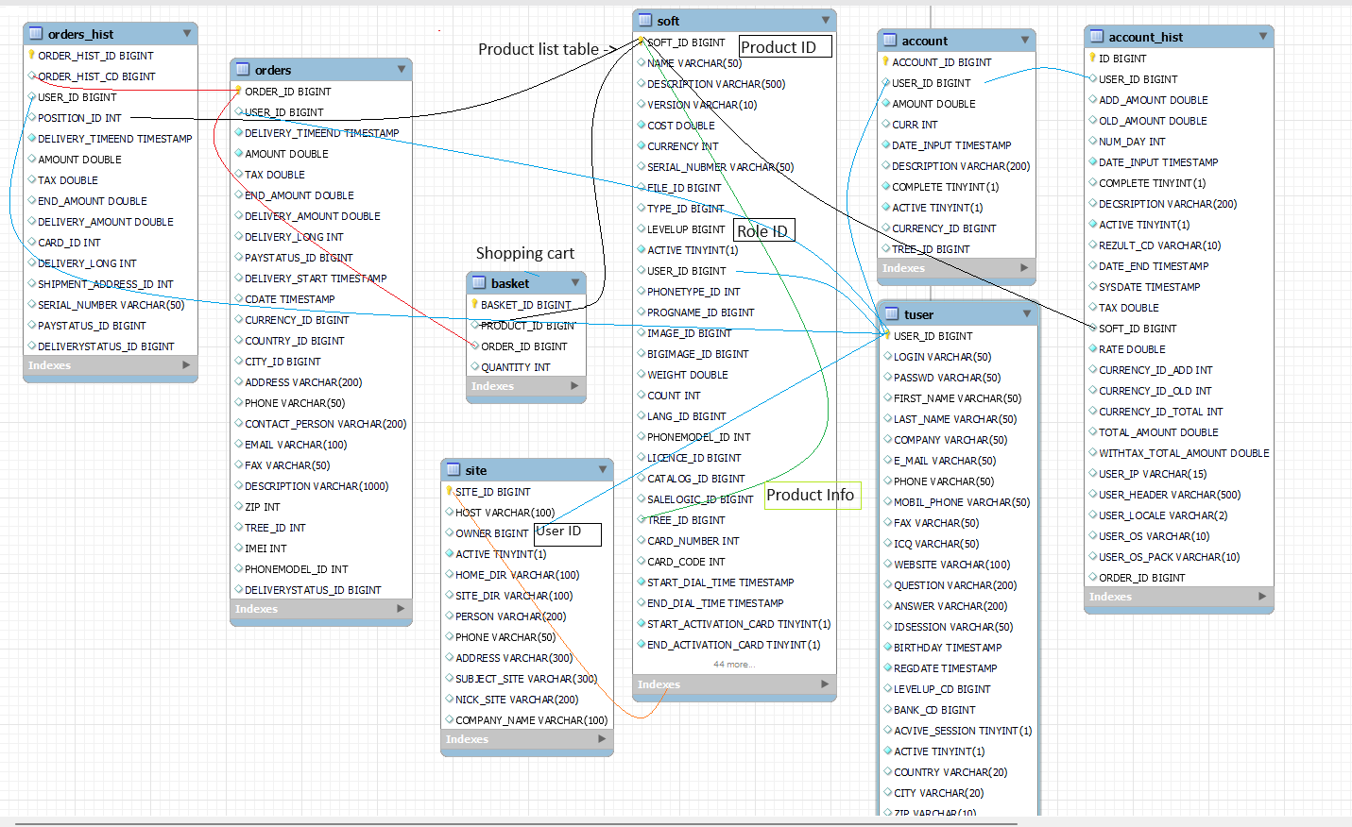

Notes:

Table named as soft is product table.

soft.portlettype_id – It is Product info description type on product.

soft.portlettype_id = 1 It is column 1 in product info

soft.portlettype_id = 2 It is column 2 in product info

soft.portlettype_id = 3 It is review message for product

soft.portlettype_id = 4 It is description in product tab block

soft.portlettype_id = 5 It is attached file

soft.tree_id . it is product Id as reference to find other related for product info which above.

soft.siteId = User Site ID or User Wallet ID . it is the same idea.

soft.type_id It is product visibility area So User site or Market place as global post .

1. **Product content Database schema ( CMS )**

So, the data model show how product have connections to images and files and catalog to display in used interface (GUI).

When do search you can find product via criteria ( search key words or product attributes ) which nested as tree structure or DOM structure .

So those search key words, or product attributes could be used as suggestion for search by text for product description fields since it is part of product content.

Next a search for key words or product attributes can be used as linked drop down list as filter for product list via product attributes since those product attributes have linked tree or DOM structure .

Any product must be displayed or found by soft_id filed for product info page.

When you display search you must display small image but for product info big one.

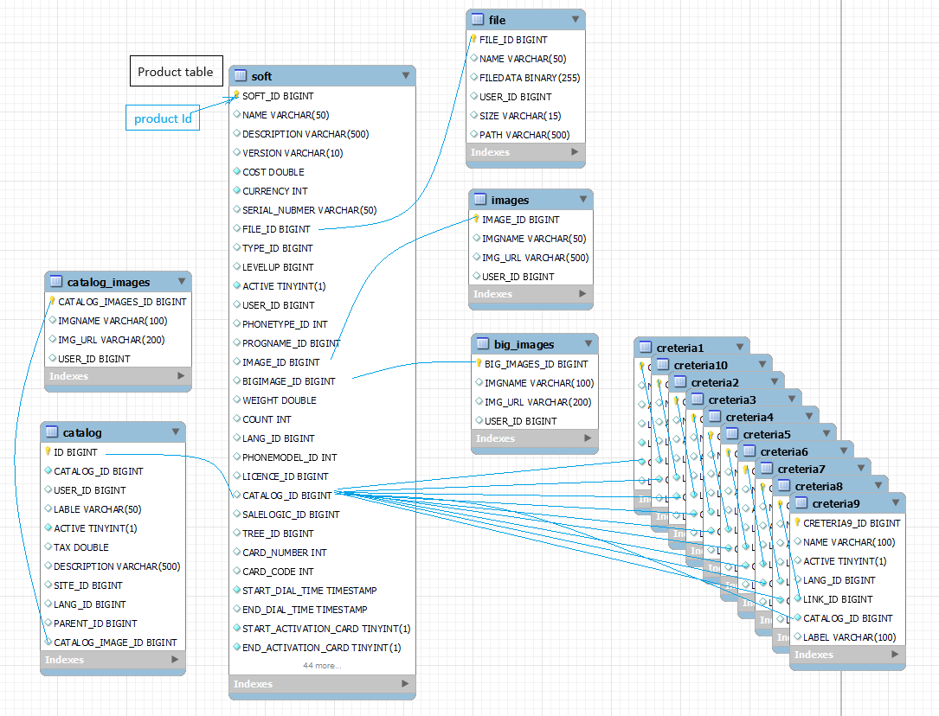

7.1 **Search key words or product attributes**

The picture display component that do search via criteria ( search key words or product attributes ). So there is request html form for ProduclistAction controller via post url http://localhost:8080/cms-manhattan-one/Productlist.jsp

See below

<form name="searchcreform" action="Productlist.jsp" method="POST">

<input name="search_value" type="text" size="20 value="">

<input name="search_char" value=”” type="hidden">

<input name="**searchquery**" type="hidden" value="**6**" >

<input type="HIDDEN" name="**offset**" value="0">

</form>

**7.1.1. Search via text.**

So it used http quest below

<form name="searchform" action="Productlist.jsp" method="POST">

<input name="search_value" type="text" size="20 value="">

<input name="search_char" value=”” type="hidden">

<input name="**searchquery**" type="hidden" value="**1**" >

<input type="HIDDEN" name="**offset**" value="0">

</form>

So a field named as **offset**  to scroll result set via SQL limit and offer mechanism .

* 1. **Catalog of products component**

So catalog source is pulling from XML response from ProductListAction controller via Productkist URL with catalog id .

localhost:8080/cms-manhattan-one/Productlist.jsp?catalog_id=-2

So Publish catalog screen can be done from any publisher form for product via edit page UI controls

Since you authorized as site administrator then you will see edit site content controls .

* 1. **Menu component**

So menu source is pulling from XML response from ProductListAction controller via Product list URL with catalog id but it generated via catalog tree automatically .

localhost:8080/cms-manhattan-one/Productlist.jsp?catalog_id=-2

* 1. **New arrivals of product**

This is a new arrival component.

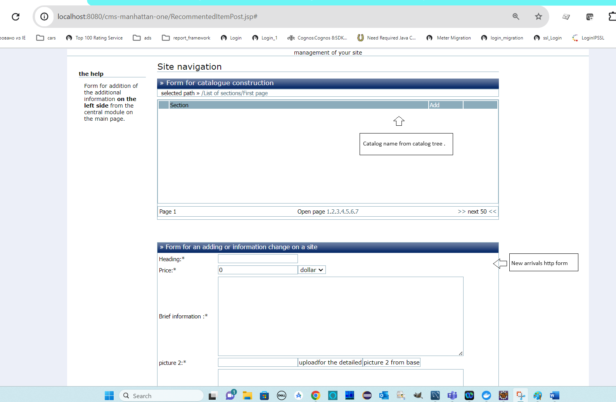

**There is request http form below**

<form method="post" name="**postsoftform**" ACTION="Co1ProductPost.jsp" onSubmit="return IsFormOk()" >

<input type="hidden" name="action" value=""/>

<input name="**softname**" size="20" value=" book" > <!-- product name -->

<select name="**catalog_id**" id="catalog_id" value="-1" > <!-- location in site catalog or site menu -->

</select>

<input name="imagename" disabled="disabled" size="20" value="" > <!-- image name to display in search - JavaScript local page actions -->

<input type="button" name="newimage" value="New Image" onclick="dwindow('Image.html'); return false;" > <!-- new image name to display in search after upload - JavaScript local page actions-->

<input type="button" name="selectimage" value="select image" onclick="dwindow(**'SelectImage**.jsp'); return false;" > <!-- selected an image after upload process - JavaScript local page actions -->

<input type="hidden" name="**image_id**" size="20" value="-1" > <!-- image id to send to page controller -->

-->

<input name="**softcost**" size="20" value="0" > <!-- product price -->

<select name="**currency_id**" > <!-- product currency id -->

<option value="1">dollar

</select>

<textarea name="**description**" rows="10" cols="70" ></textarea> <!-- product description or article description if there is not price for that -->

<input name="bigimagename" disabled="disabled" size="20" value="" > <!-- image name to display in product info page - JavaScript local page actions -->

<input type="button" name="newbig_image" value="uploadfor the detailed" onclick="dwindow(**'NewBigImage**.jsp'); return false;" > <!-- new image name to display in search after upload - JavaScript local page actions-->

<input type="button" name="selectbig_image" value="picture 2 from base" image" onclick="dwindow(**'SelectBigImage**.jsp'); return false;" > <!-- selected an image after upload process - JavaScript local page actions -->

<input type="hidden" name="**bigimage_id**" size="20" value="-1" > <!-- image id to send to page controller -->

<textarea name="fulldescription" rows="10" cols="70" ></textarea> <!-- product full description or article description if there is not price for product info page -->

<input name="filename" disabled="disabled" size="20" value="" > <!-- file name to display in product info page - JavaScript local page actions -->

<input type="button" name="newfile" value="upload file" onclick="dwindow(**'NewFile**.jsp')" > <!-- display page to upload file - JavaScript local page actions -->

<input type="button" name="selectfile" value="Choose a file" onclick="dwindow(**'SelectFile**.jsp')" > <!-- select an uploaded file - JavaScript local page actions -->

<input type="hidden" name="**file_id**" size="20" value="-1" > <!-- file id to send to page controller -->

<select name="**type_id**" > <!-- Publish the product to Market place -->

<option value="3">Show item on site

</select>

<input type="hidden" name="**insert**" value="false"/> <!-- copy function , use old content with new product id -->

<input type="hidden" name="**portlettype_id**" value="1"/>

<input type="hidden" name="**type_id**" value="3"/> <!-- Publish the product to Market place -->

<input type="hidden" name="**catalog_id**" value="-1> <!-- publish in new arrivals catalog area -->

</form>

* 1. **Product component**

**Ss**