Illustrative example

Close the delivery gap in two stages
Decision brief for the operating committee
Strategy Office · September 2026

Recommendation
Approve four additional monthly delivery slots in two stages. Confirm staffing for the first two, then review quality and unit economics before releasing the next two.

Evidence and assumptions
The illustrative plan has ten committed projects and six available slots in the same month. The four-project gap is a capacity shortfall, not a revenue forecast. The model assumes comparable effort per project. If complexity differs, use effort-weighted capacity; if staffing is delayed, revisit customer start dates.
Exhibit 1. Capacity expansion should follow two operating gates
Monthly projects · Illustrative planning case · September 2026
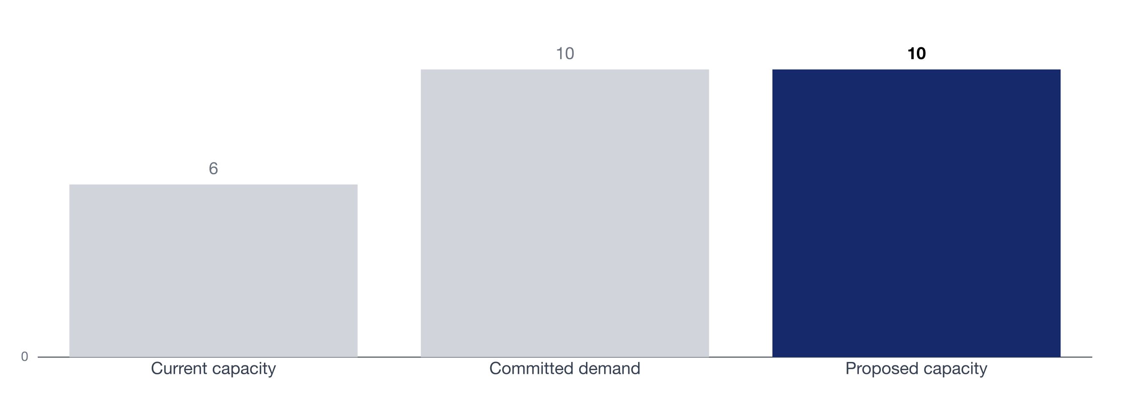
Capacity and commitments use the same monthly period; no conversion from revenue is assumed.
Source: illustrative operating model; replace with approved planning data.
Stage the capacity increase
Start with two additional delivery slots.
Release the next two after quality and cycle-time checks.

Decision and accountability
Gate | Owner | Evidence required
Add two slots | Operations lead | Confirm staffed capacity and project mix
Release the next two | Operating committee | Review cycle time, quality, and unit economics
Revisit demand | Commercial lead | Reconcile signed commitments and start dates

