# *Operational Concept Description (OCD)*

**Field Progress App**

**Team 04**

|  |  |
| --- | --- |
| ***Akanksha Diwedy*** | *Operational Concept Engineer* |
| ***Aishwarya Joisa*** | *Feasibility Analyst* |
| ***Kevin Grimes*** | *IIV&V* |
| ***Madhavi Shantharam*** | *Life Cycle Planner* |
| ***Mayank Kulkarni*** | *Requirements Engineer* |
| ***Sahithi Reddy*** | *Software Architect* |
| ***Uche Uba*** | *Program Manager* |

**10/27/2019**

# Version History

| *Date* | *Author* | *Version* | *Changes made* | *Rationale* |
| --- | --- | --- | --- | --- |
| *09/28/19* | *Akanksha* | *1.0* | * *Original template* | * *Initial draft for Field Progress OCD documentation* |
| *10/13/19* | *Akanksha* | *2.0* | * *Added section 3.2, 3.3, 3.4* | * *Determining the information from the conditions agreed upon during win-win negotiations.* |
| *10/17/19* | *Akanksha* | *2.1* | * *Updated section 2.3, 2.2, 3.2, 3.3* | * *Changes in tech stack for including full stack application potential.* |
| *10/27/19* | *Akanksha* | *3.0* | * *Updated section 2.3, 3.3* | * *Evolving the document to the status as Development Commitment.* |
| *12/3/2019* | *Akanksha* | *4.0* | * *Updated sections 1.1, 1.2, 2.3* | * *Evolving the document for final deliverables.* |

# Table of Contents

*Operational Concept Description (OCD) i*

*Version History ii*

*Table of Contents iii*

*Table of Tables iv*

*Table of Figures v*

*1. Introduction 1*

*1.1 Purpose of the OCD 1*

*1.2 Status of the OCD 1*

*2. Shared Vision 2*

*2.1 Benefits Chain 3*

*2.2 System Capability Description 4*

*2.3 System Boundary and Environment 5*

*3. System Transformation 6*

*3.1 Information on Current System 6*

*3.2 System Objectives, Constraints and Priorities 8*

*3.3 Proposed New Operational Concept 10*

*3.4 Organizational and Operational Implications 12*

# Table of Tables

Table 1: The Program Model .2

Table 2: Artifacts 6

Table 3: Capability Goals 8

Table 4: Level of Service Goals 8

# Table of Figures

Figure 1: Benefit Chain Diagram…………………………………………………………3

Figure 2: System Boundary and Environment…………………………………………..5

Figure 3: Proposal Approval Workflow 7

Figure 4: Entity Relationship Diagram for Field Progress 10

Figure 5: New Proposal Approval Workflow 11

### Introduction

#### *Purpose of the OCD*

*This document provides, in detail, the shared visions and goals of the success-critical stakeholders of Field Progress Application.*

*This document has the following objectives:*

* *Describe the proposed web application in terms of the requirements.*
* *Describe the way the campaign managers will interact and use the system to benefit their efficiency in turf cutting.*
* *Communicate qualitative and quantitative system characteristics to all stakeholders.*

*The success-critical stakeholders of the project are Issac Wang, Evan Shulman, Nikolaj Baer as clients; Campaign managers as users and members of Team 04 in CSCI 577a 2019, as the developers.*

#### *Status of the OCD*

*The status of the OCD is currently at the version number 4.0. The current system has been analyzed and the operational concept of current system has been accessed. The scope of the new system has been re-evaluated to accommodate the challenges faced during foundation and development phase of the project. It has been updated as a part of TRR package.*

### Shared Vision

***Table 1: The Program Model***

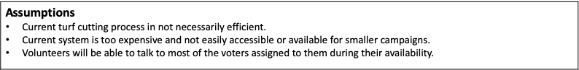

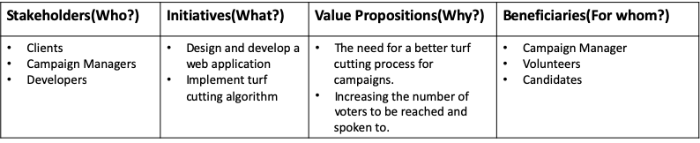

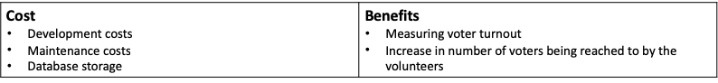

#### Benefit Chain

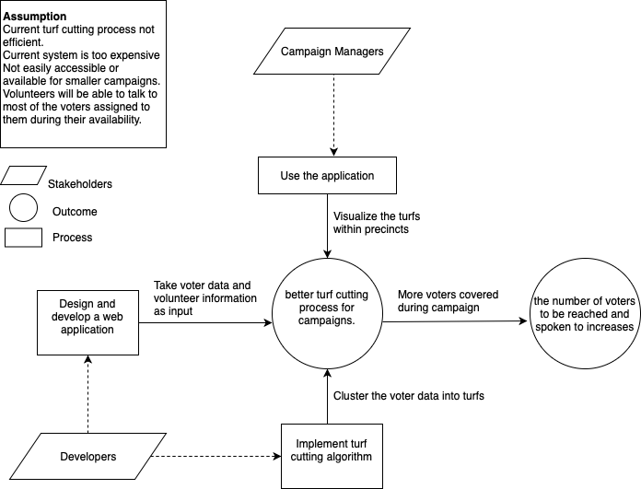

*Figure 1: Benefits Chain Diagram*

#### System Capability Description

***Problem: Existing Auto cutting doesn’t always reflect the terrain and neither do they take “walkability” factor into account.***

* *The field progress web app is a user-friendly mapping tool for Field Directors and Campaign Managers to streamline their turf cutting process and make their campaigns efficient.*
* *Through this application, the aim is to increase the voter turnout given that it can be increased with high quality face to face interactions.*
* *Efficient turf cutting algorithm which can take into account all possible limitations of volunteers and geography*
* *The app should be able to take voter data, volunteer information as input and then determine possible and efficient turfs within one precinct.*
* *Visualization of such information and the results of turf cutting algorithm is the final part of the task for this application.*

#### System Boundary and Environment

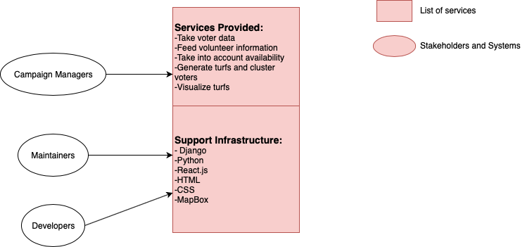

*Figure 2: System Boundary and Environment Diagram of Field Progress App*

### System Transformation

#### Information on Current System

##### Infrastructure

*The current infrastructure is that the campaign managers maintain an excel sheet of voters. They divide the excel workbook into different sheets with every sheet including voters belonging to a particular precinct. After this, they manually assign volunteers to every precinct.*

*Apart from Microsoft excel no other software is being utilized which is very time consuming and requires a lot of manual effort.*

##### Artifacts

***Table 2: Artifacts***

|  |  |
| --- | --- |
| ***Artifact*** | ***Description*** |
| *Excel Workbook of voters* | *The voter’s information and location is maintained in an excel workbook structured format for all the manual division of voters into precinct.* |

##### Current Business Workflow

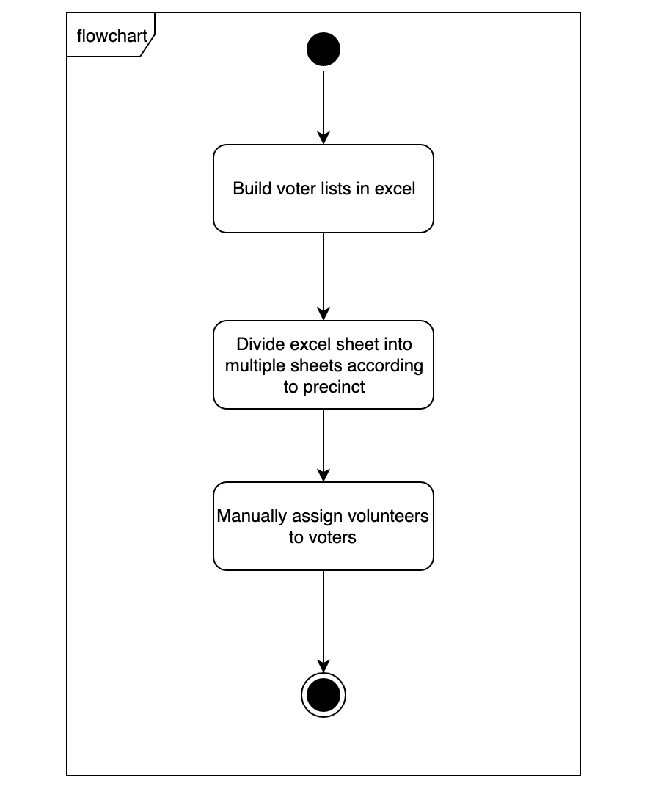

#### System Objectives, Constraints and Priorities

##### Capability Goals

*Table 3: Capability Goals*

|  |  |
| --- | --- |
| ***Capability Goals*** | ***Priority Level*** |
| ***OC-1 Take Voter Data as Input:*** *The system is capable of taking the voter data as input in a csv format.* | *High* |
| ***OC-2******Take volunteer information as Input:*** *The system should be capable of taking all volunteer information including their limitations in terms of availability and walkability.* | *High* |
| ***OC-3 Create clusters and generate turfs:*** *The backend system provides the ability to utilize the input information and create efficient clusters of voters and then assign the clusters to volunteers/set of volunteers.* | *High* |
| ***OC-4 View turfs:*** *The module provides the campaign managers the ability to visualize the turfs in an interactive map.* | *Medium* |

##### Level of Service Goals

*Table 4: Level of Service Goals*

|  |  |  |
| --- | --- | --- |
| ***Level of Service Goals*** | ***Priority Level*** | ***Referred WinWin Agreements*** |
| ***Cross Browsers Support:*** *support IE 8 and above, Firefox 4 and above, Chrome 16 and above* | *High* | ***LOS-1*** |
| ***Mobile Support:*** *support for accessing the application from mobile* | *Medium* | ***LOS-2*** |
| ***Memory Scalability:*** *able to scale to large amount of input data without overflow* | *High* | ***LOS-3*** |

##### Organizational Goals

***OG-1:*** *Decrease the time to campaign in various regions using volunteers.*

***OG-2:*** *Increase the voter turnout with increase in the number of voters reached out to or spoken to during campaigning.*

***OG-3****: Make efficient campaign management tools available to smaller campaign directors.*

##### Constraints

* ***Browser Compatibility:*** *The application should be compatible with commonly used browsers like Chrome, Firefox, and Safari.*
* ***MapBox Compatibility****: MapBox API allows efficient route between a minimum of 2 and maximum of 12-point locations on the map.*

*This generates the need of hierarchical clustering.*

* ***Monetary Funds:*** *Limitations in terms of funds doesn’t allow use of Google Maps API because it starts billing after certain number of API calls.*

##### Relation to Current System

*Table 5: Relation to Current System*

|  |  |  |
| --- | --- | --- |
| ***Capabilities*** | ***Current System*** | ***New System*** |
| *Roles and Responsibilities* | *．Campaign manager/ volunteers performing manual turf cutting procedure.* | *．Campaign manager/volunteers can use new system and get automated efficient turfs.* |
| *User Interactions* | *．Campaign manager make verbally informs volunteers their turfs and the voters they should cover.* | *．Campaign managers can input volunteer information and after generating turfs allocations is done automatically based on their availability.* |
| *Infrastructure* | *．List of mapping voter to volunteers and turfs.*  *．No visualization* | *．Interactive map visualization.*  *．Clustering done on intelligent parameters.* |
| *Stakeholder Essentials and Amenities* | *．Turf information is stored in campaign manager’s computer or emails.* | *．Turf information is stored in the backend and complete view visible to campaign manager whereas turf view visible to allocated volunteer.* |
| *Future Capabilities* |  | *．Include walkability and terrain/geography limitations into the system algorithm.* |

#### Proposed New Operational Concept

##### Element Relationship Diagram

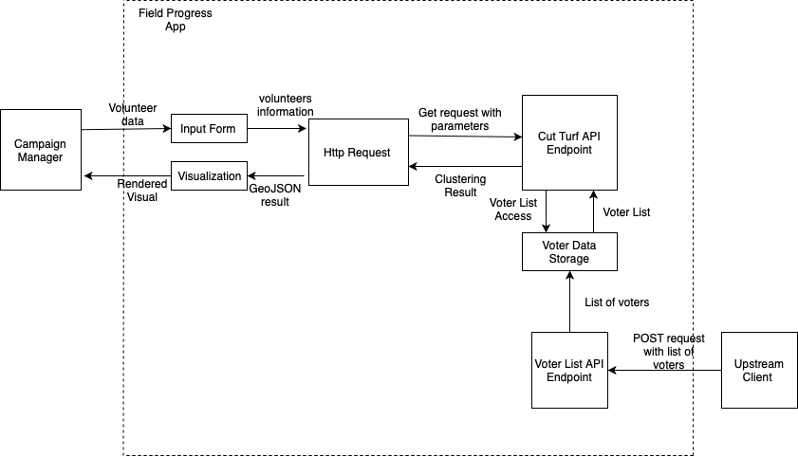

*Figure 4: Entity Relationship Diagram for Field Progress App*

##### Business Workflows

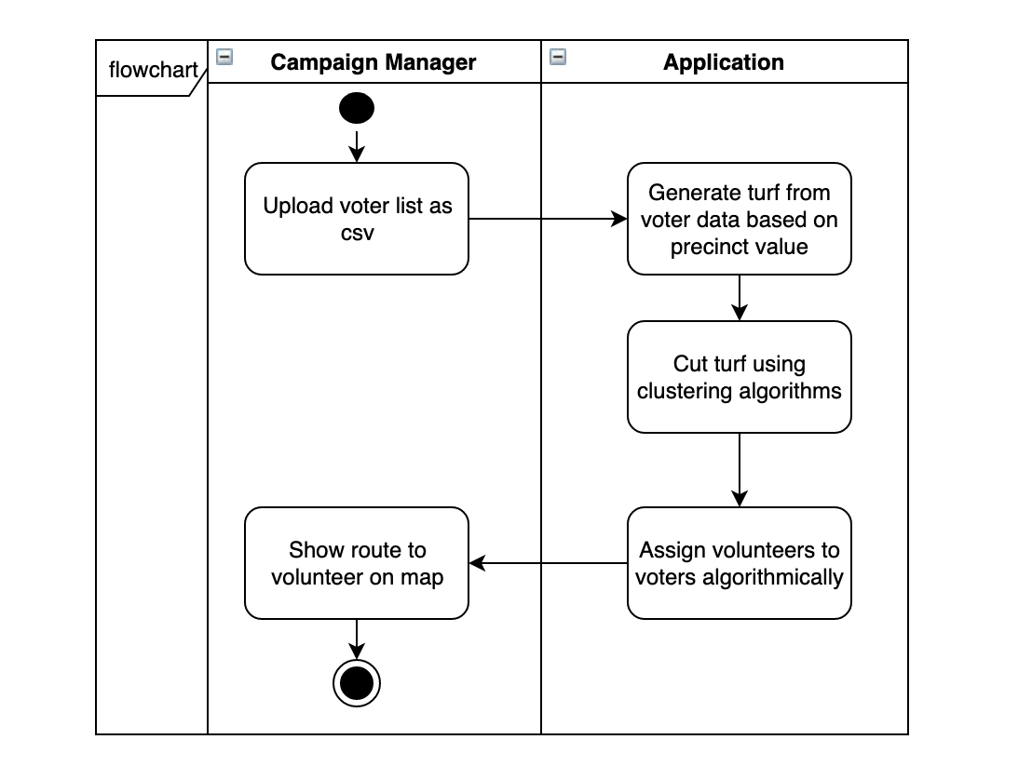

#### Organizational and Operational Implications

##### Organizational Transformations

* *The campaign manager needed to be trained to use the new system and determine how to access the results with which volunteers associated with which turfs etc.*
* *The need to hire a maintainer/manager to send voter data through POST requests to the server.*

##### Operational Transformations

* *Field Progress Application will enable the campaign managers to automate the manual effort that goes into turf cutting and turf allocation to volunteers.*
* *Volunteers will know the efficient routes within their turf to cover all voters in their available time.*