# System and Software Architecture Description (SSAD)

**Field Progress Web App**

**Team Number 04**

**Uche Uba – Project Manager**

**Madhavi Shantharam – Life Cycle Planner**

**Sahithi Reddy Velma – Software Architect**

**Akanksha Diwedy – Operational Concept Engineer**

**Aishwarya Joisa – Feasibility Analyst**

**Mayank Kulkarni – Requirements Engineer**

**Kevin Grimes – IV&V**

**12-08-2019**

# Version History

|  |  |  |  |  |
| --- | --- | --- | --- | --- |
| *Date* | *Author* | *Version* | *Changes made* | *Rationale* |
| 10/28/19 | SV | 1.0 | * Added all the required sections for SSAD document. | * Final draft required for the DC package. |
| 12/08/19 | SV | 1.1 | * Implemented recommended changes from DCR Package Review | * Final deliverable for client |

# Table of Contents

System and Software Architecture Description (SSAD) i

Version History ii

Table of Contents iv

Table of Tables v

Table of Figures vi

1. Introduction 1

1.1 Purpose of the SSAD 1

1.2 Status of the SSAD 1

2. System Analysis 3

2.1 System Analysis Overview 3

2.2 System Analysis Rationale 7

3. Technology-Independent Model 8

4. Technology-Specific System Design 9

4.1 Design Overview 9

4.2 Design Rationale 13

5. Architectural Styles, Patterns and Frameworks 14

# Table of Tables

Table 1: Actors Summary 3

Table 2: Artifacts and Information Summary 4

Table 3: Process Description- Add volunteers info 5

Table 4: Typical Course of Action – Add volunteer info 5

Table 5: Alternate Course of Action – Invalid Inputs 5

Table 6: Process Description – Add no. of Volunteers 5

Table 7: Typical Course of Action – Add no. of volunteers 6

Table 8: Process Description- Generate Turfs 6

Table 9: Typical Course of Action- Generate turfs 6

Table 10: Process Description- View Turfs 6

Table 11: Typical Course of Action- View Turfs 7

Table 12: Hardware Component Description 10

Table 13: Software Component Description 11

Table 14: Supporting Software Component Description 11

Table 15: Design Class Description 11

Table 16: Architectural Styles, Patterns, and Frameworks 14

# Table of Figures

Figure 1: System Context Diagram 3

Figure 2: Artifacts and Information Diagram 4

Figure 3: Process Diagram 4

Figure 4: Conceptual Domain Model 9

Figure 5: Hardware Component Class Diagram 9

Figure 6: Software Component Class Diagram 9

Figure 7: Deployment Diagram 10

Figure 8: Supporting Software Component Class Diagram 10

Figure 9: Design Class Diagram 11

Figure 10: Robustness Diagram 12

Figure 11: Process Realization Diagram 13

### Introduction

#### Purpose of the SSAD

The purpose of the SSAD is to provide an architectural view of the project. It provides the details about the system architecture as well as the components that it is composed of. The document can also be used to identify the main actors of Field Progress Application and how they would interact with system.

#### Status of the SSAD

This document is the final draft for the SSAD. This version includes updates that were made based on the feedback given in the DCR ARB package review. Additionally, minor changes in the use case diagram have also been made.

### System Analysis

#### System Analysis Overview

The primary purpose of Field Progress App is to act as a means, through the use of technology to help campaign managers travel to their voters more efficiently. The aim of the project is to automate the process of turf cutting for the campaign managers. This way we free up time for the campaign managers to put towards other productive activities. The application aims to take various parameters about volunteer availability as input and provides a visualization of the most efficient route on a map*.*

##### System Context

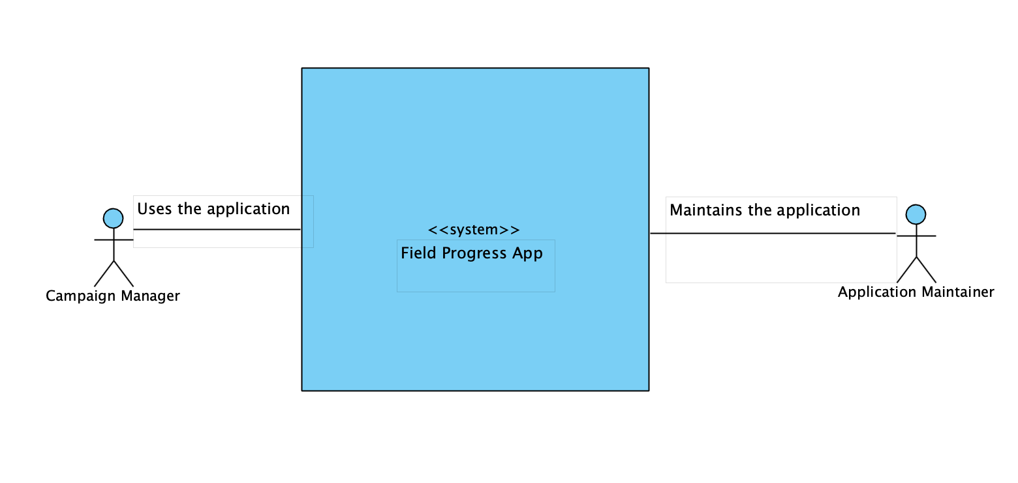

**Figure 1: System Context Diagram**

Table : Actors Summary

| **Actor** | **Description** | **Responsibilities** |
| --- | --- | --- |
| Campaign Manager | A user who takes up the responsibility of overlooking campaigning activities for a candidate | * Assign volunteers to travel to the voters in a district. * Cut out Turfs based on volunteer availability. |
| Application Maintainer | A person who maintains the upkeep of the application | * Fixes bugs in the algorithm * Updates the application with voter data from upstream. |

##### Artifacts & Information

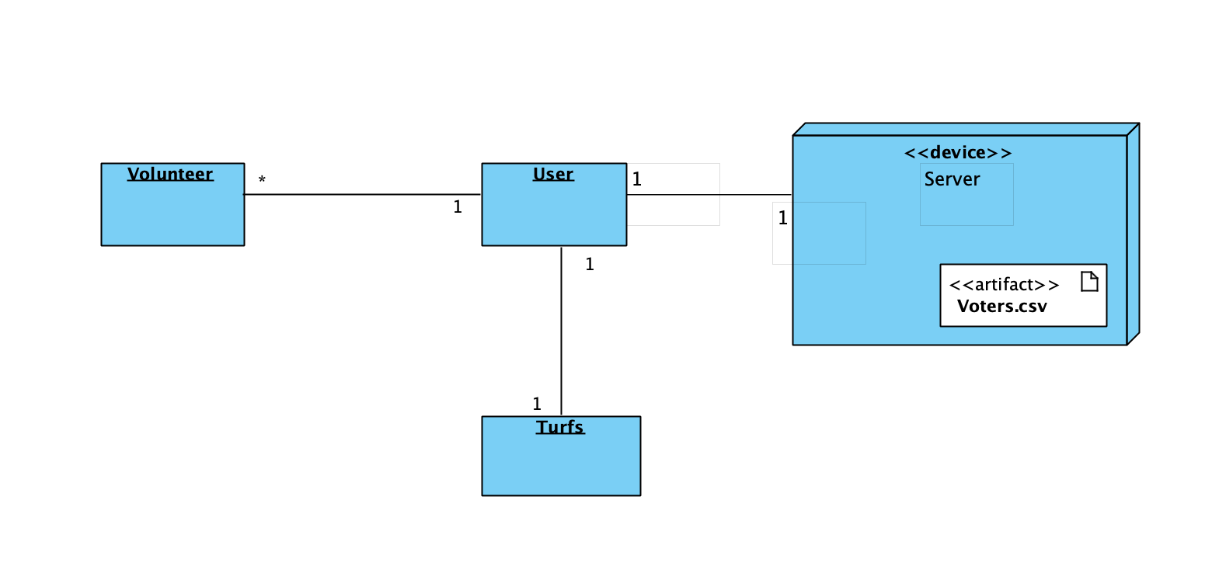

Figure : Artifacts and Information Diagram

Table : Artifacts and Information Summary

|  |  |
| --- | --- |
| **Artifact** | **Purpose** |
| ATF-1: Voters | Contains voter data in a csv format which would be an input to the turf-cutting algorithm |
| ATF-2: Volunteers | Contains information about volunteers like name and time of availability which would be inputs to the algorithm |
| ATF-3: Turfs | Contains information about the cluster each voter belongs to along with the volunteer assigned to that cluster. This is the result of the turf-cutting algorithm. |

##### Behavior

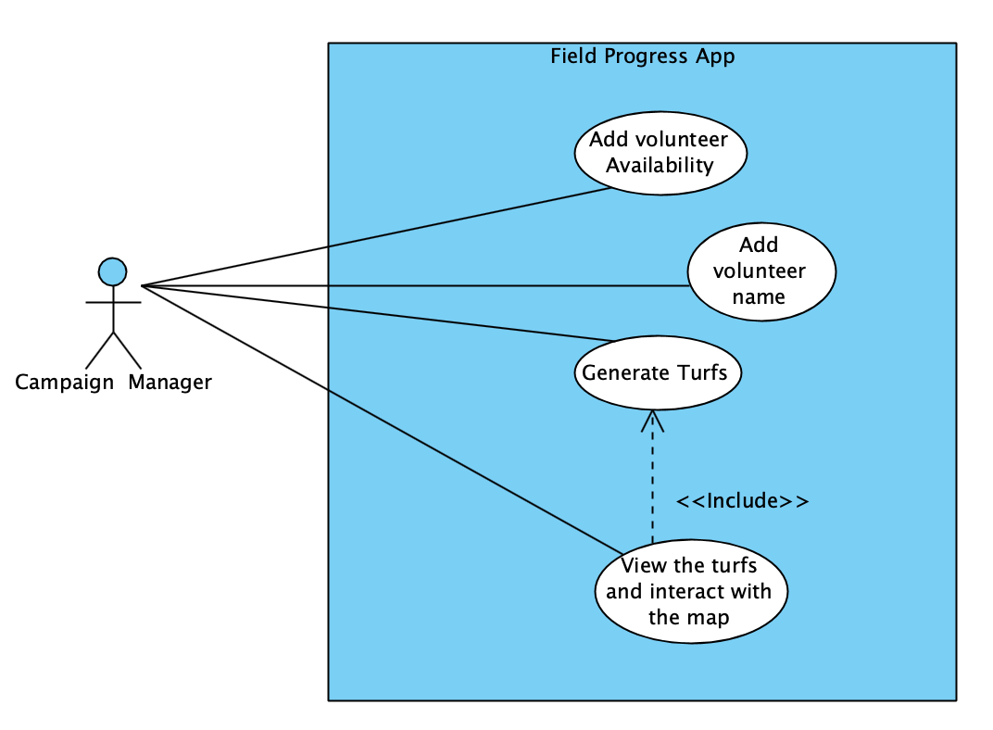

**Figure 3: Use case Diagram**

###### Input Volunteer Parameters

###### Add Volunteers Information

Table : Process Description- Add volunteers’ Availability

|  |  |
| --- | --- |
| **Identifier** | UC-1 Add volunteer Availability |
| **Purpose** | Gives volunteer availability times as input to the algorithm |
| **Requirements** | WC_5508 |
| **Development Risks** | Taking into account availability time can be challenging to implement as part of the algorithm. |
| **Pre-conditions** | User is currently viewing the turf cutting form. |
| **Post-conditions** | After entering the volunteer info, the algorithm would take into account these parameters and cut turfs accordingly. |

Table : Typical Course of Action – Add volunteers’ Availability

|  |  |  |
| --- | --- | --- |
| **Seq#** | **Actor’s Action** | **System’s Response** |
| **1** | Click on add volunteer button |  |
| **2** | Enter volunteer availability in the form generated |  |
| **3** |  | Validate input. |

Table : Alternate Course of Action – Invalid Inputs

|  |  |  |
| --- | --- | --- |
| **Seq#** | **Actor’s Action** | **System’s Response** |
| **1-3** | Refer to typical course of action | |
| **4** |  | Clears the text box for volunteer availability time. |
| **5** |  | Displays an error message “Please check your inputs” below the add volunteer form. |

##### 2.1.3.1.2 Add no. of Volunteers

**Table 6 – Process Description – Add volunteers’ name**

|  |  |
| --- | --- |
| **Identifier** | UC-2 Add volunteer name |
| **Purpose** | Gives the volunteer name as an input to the clustering algorithm for the purpose of assigning a cluster to a volunteer |
| **Requirements** | WC_5508 |
| **Development Risks** | None |
| **Pre-conditions** | User is currently viewing the turf cutting form. |
| **Post-conditions** | After entering the volunteer name and availability, the algorithm would take into account these parameters and cut turfs accordingly. |

Table 7: Typical Course of Action – Add volunteers’ name

|  |  |  |
| --- | --- | --- |
| **Seq#** | **Actor’s Action** | **System’s Response** |
| **1** | Click on add volunteer button |  |
| **2** | Enter volunteer name in the input field. |  |
| **3** |  | Validate input. |

###### 2.1.3.2 Turf-Cutting

2.1.3.2.1. Generate Turfs

Table 8: Process Description- Generate Turfs

|  |  |
| --- | --- |
| **Identifier** | UC-3 Generate Turfs |
| **Purpose** | Generates turfs for assigning volunteers to a turf. |
| **Requirements** | WC_5696 |
| **Development Risks** | None. |
| **Pre-conditions** | User is currently viewing the turf cutting form  User has entered the volunteer name and availability parameters. |
| **Post-conditions** | User will be to view the cut-out turfs on a map and see the assigned volunteer to each turf. |

Table 9: Typical Course of Action- Generate turfs

|  |  |  |
| --- | --- | --- |
| **Seq#** | **Actor’s Action** | **System’s Response** |
| **1** | Click on Cut Turfs button. |  |
| **2** |  | Create a list of voters and an assigned volunteer to this turf. |

2.1.3.1.2 View Turfs

Table 10: Process Description- View Turfs

|  |  |
| --- | --- |
| **Identifier** | UC-4 View Turfs |
| **Purpose** | Visualizing the cut-out turfs on a map. |
| **Requirements** | WC_5696 |
| **Development Risks** | None. |
| **Pre-conditions** | User is currently viewing the turf cutting form  User has entered the volunteer name and availability parameters. |
| **Post-conditions** | User will be able to view the cut-out turfs on a map. |

Table 11: Typical Course of Action- View Turfs

|  |  |  |
| --- | --- | --- |
| **Seq#** | **Actor’s Action** | **System’s Response** |
| **1** | Click on View Turfs button. |  |
| **2** |  | Create a Visualization of turfs on a map. |

##### Modes of Operation

Field Progress application will operate only in one mode; therefore, no description is stated in this section.

#### System Analysis Rationale

The Field progress app is an application that allows campaign managers to travel to their voters more efficiently by automating the process of turf cutting and picking out the most efficient route for the volunteers.

The main user of the application is a campaign manager.

**Campaign Manager –**

This is a user who is entrusted with the responsibility of overlooking the campaigning activities of a candidate. The campaign manager can use the field progress app to get auto cut -out turfs to assign volunteers effectively and also provide an optimal route so that the volunteers can reach their potential voters in a time efficient way.

The campaign manager enters the volunteer’s info i.e. volunteer name and time of availability in the form and can view the visualization of the turfs on map and can get a list of volunteers assigned to a turf based on the inputs.

### Technology-Independent Model

This section has been omitted as we have already decided on the technology that will be used.

Therefore, to avoid redundancy, the diagrams in this section have been specified in the next section.

### Technology-Specific System Design

#### Design Overview

##### System Structure

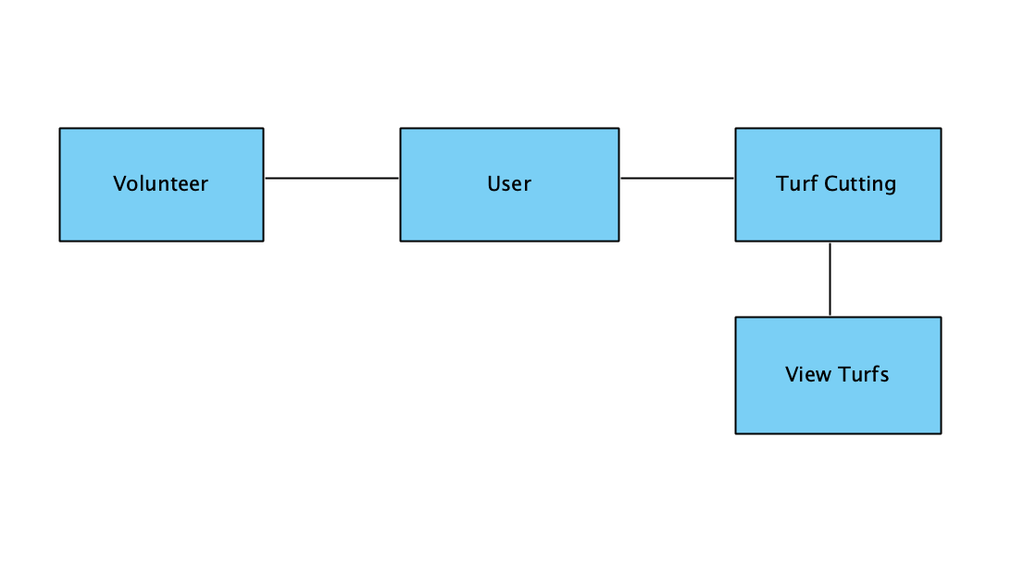

**Figure 4: Conceptual Domain Model**

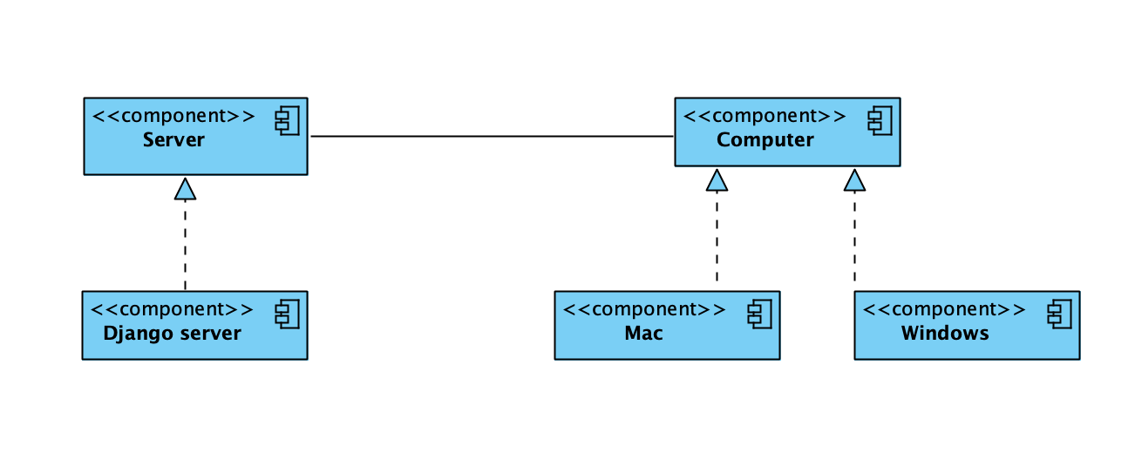

Figure 5: Hardware Component Class Diagram

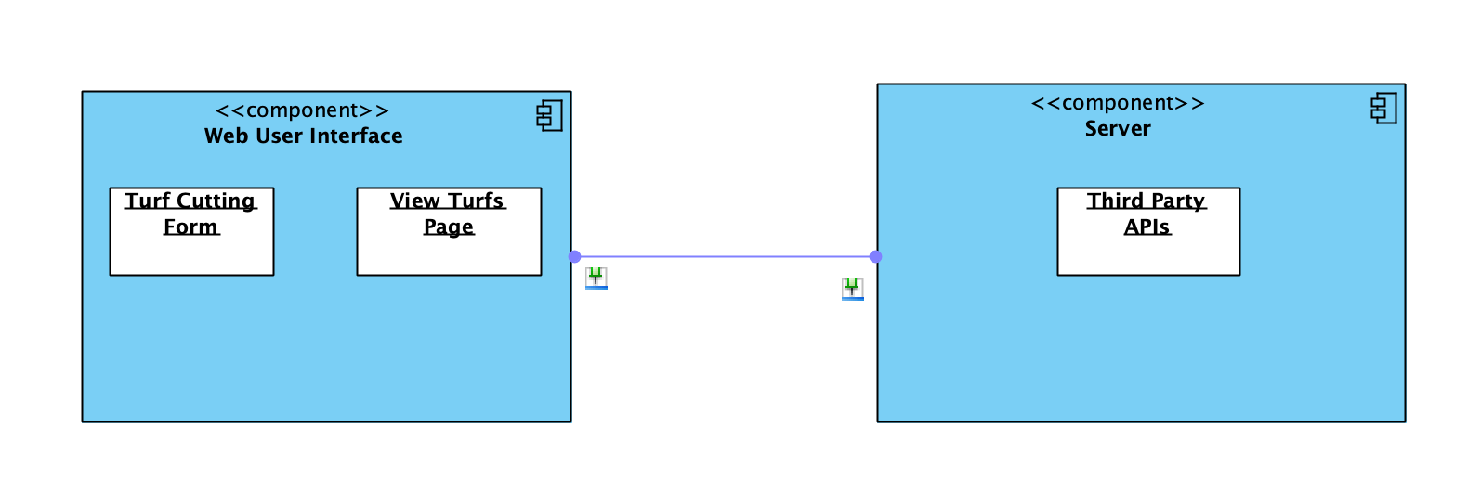

Figure 6: Software Component Class Diagram

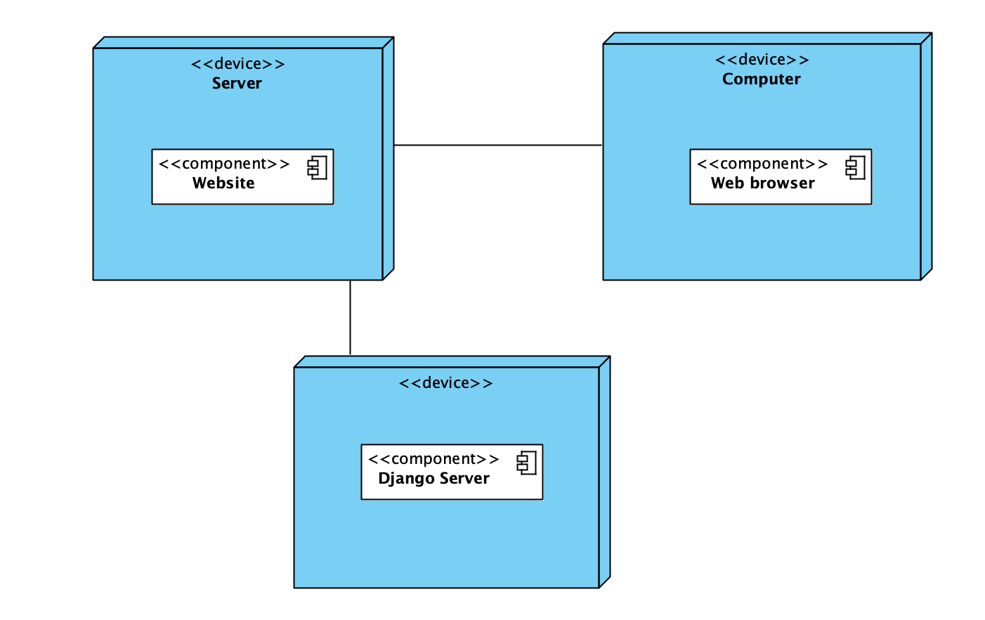

Figure 7: Deployment Diagram

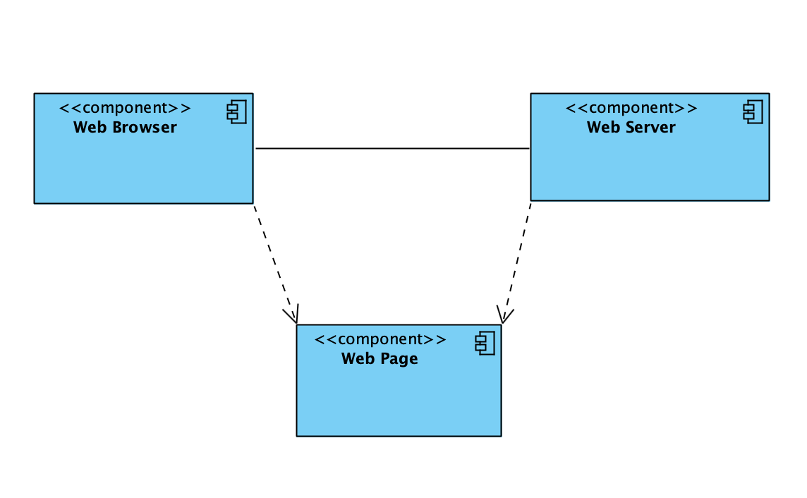

Figure 8: Supporting Software Component Class Diagram

Table 12: Hardware Component Description

|  |  |
| --- | --- |
| **Hardware Component** | **Description** |
| Server | The web server is used for hosting the application and for the Django server. All the API calls to the algorithm (generate turfs) are sent to the web server. |
| Computer | Web application will be accessed from a computer, which can be either Windows or MacOS. |

Table 13: Software Component Description

|  |  |
| --- | --- |
| **Software Component** | **Description** |
| User Interface Component | This component contains Field Progress Application web pages or use by all users |
| Turf Cutting Form | This page allows the user to input various parameters of the volunteers in the form as an input to the algorithm |
| View Turfs Page | This page allows the user to view and interact with the turfs displayed on a map. |
| Third Party APIs | APIs provided by third party like google maps APIs for implementing features like walkability. |

Table 14: Supporting Software Component Description

|  |  |
| --- | --- |
| **Support Software Component** | **Description** |
| Browser | An internet browser that connects to the Field Progress web application and displays the web pages. |
| Web Server | The server component that deploys the application. |
| Web Pages | The web pages part of the field progress app. |

##### Design Classes

###### System Diagram

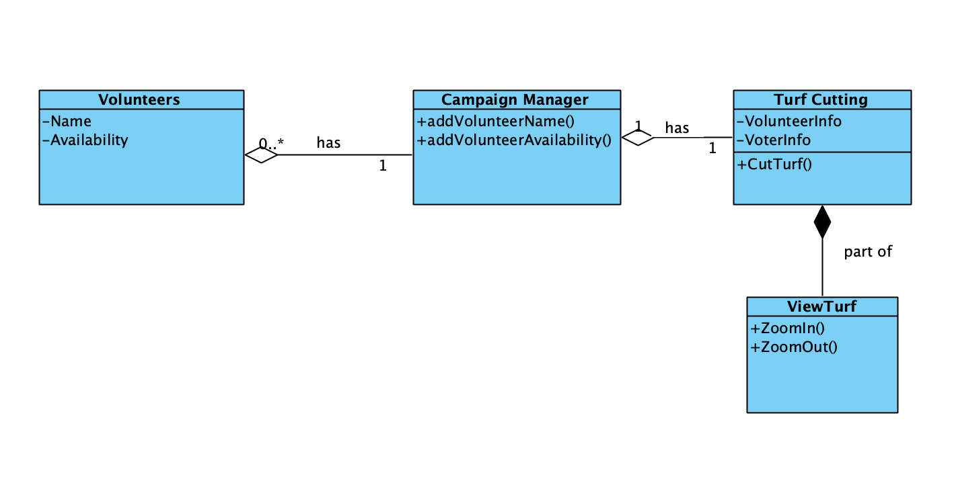

Figure 9: Design Class Diagram

Table 15: Design Class Description

|  |  |  |
| --- | --- | --- |
| **Class** | **Type** | **Description** |
| Campaign Manager | Entity | User who uses Field Progress App for help with campaigning responsibilities. |
| Volunteer | Entity | Contains volunteer data like name and hours of availability. |
| Turf cutting | Component | Component for cutting out turf given volunteer and voter info. |
| View | Component | Section for visualizing the cut-out turfs on map. |

##### Process Realization

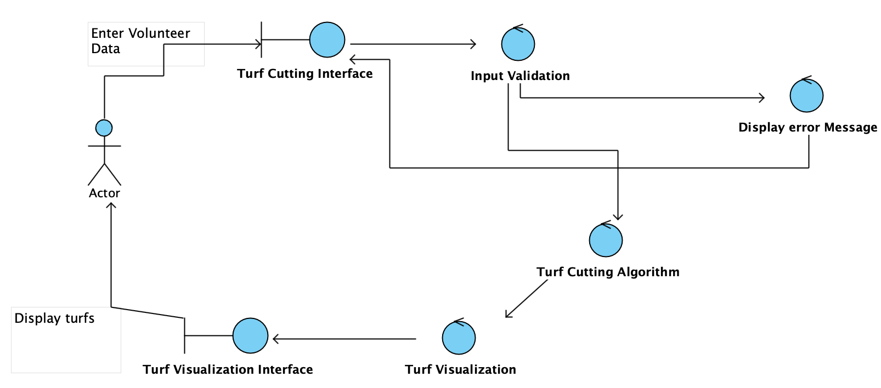

Figure 10: Robustness Diagram

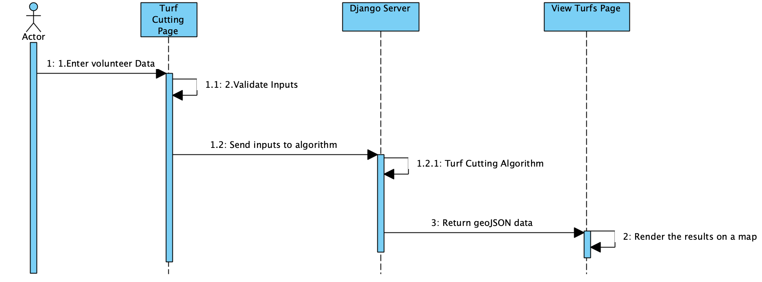

Figure 11: Process Realization Diagram

#### Design Rationale

This is a web application with the focus being on the efficiency of the algorithm for cutting- out turf. Along with the algorithm, we have also provided a visualization in order to view the results of the algorithm.

To develop the front-end of our system, we used React.js because it is easy to learn, and component based. There is a time constraint, since it is a one semester project hence it is important to go with a framework that is easy to learn. Additionally, component based front-end helps in encapsulation and separation of concerns and hence makes it easier to develop as a team.

We have used a Django server as the backend, since the algorithm was developed in python using libraries for implementing clustering, we decided to choose Django framework as this integrates well with python. All the HTTP requests would be routed to the URL containing the algorithm. By having a backend separate from the front-end we were able to achieve modularity in the application. Also, it makes it easier to make any changes in the future due to the separation of the two components.

### Architectural Styles, Patterns and Frameworks

Table 16: Architectural Styles, Patterns, and Frameworks

|  |  |  |
| --- | --- | --- |
| **Name** | **Description** | **Benefits, Costs, and Limitations** |
| React.js | A JavaScript library for building reusable UI components for data that changes frequently. | Benefits:   * Easy to learn * With reusable components time for development is reduced * With components, working in teams becomes easier. * Improved website performance with virtual DOM.   Limitations:   * Not all browsers support React.js |
| Django | A high-level web-based python framework. | Benefits:   * Django framework takes care of the hassle of the web development, so that we could focus on the development of the algorithm. * Supports MVC pattern to keep UI and business logic separate.   Limitations:   * Makes web application components tightly coupled. |