Smart Drones

Beyonder(s)

Phase 1

**GitHub -:** <https://github.com/kgs09/SMART-DRONES>

Submitted by -:

|  |  |  |
| --- | --- | --- |
| NAME | SAP ID | ROLL NUMBER |
| Aditya Rastogi | 500068848 | 05 |
| Kunal Gaurav Srivastava | 500068583 | 23 |
| Rahul Sharma | 500066535 | 39 |
| Vasu Tayal | 500068847 | 67 |

Table of Contents

# Aim & objective

# Abstract

# Manifesto

# Introduction

# Entity Relation Diagram

# Data Flow Diagram

# ETVX

# PERT Chart

# Methodology

# Project Planning & Control

Aim and objectives:-

**Aim:**

Our aim is to make the drones smarter by upgrading their software(s) and hardware according to user.

**Objective:**

We are looking forward to innovate and upgrade all the drones based on the domain(s) they’re currently being used in. And we are also planning to provide user specified customisations. To optimise it for the best usage.

We are planning to innovate the current technology by optimising the power source, enabling the drones to have a self-navigating program to find the best path and adding a safety feature of self-dodging pattern with help of ML & AI codes. And to provide it on reasonable price.

Our goal is to upgrade the drones to be smart enough to do the work in most efficient way possible and in least time.

Abstract:

Over the past few years, drones have become central to the functions of various businesses and governmental organizations and have managed to pierce through areas where certain industries were either stagnant or lagging behind. From quick deliveries at rush hour to scanning an unreachable military base, drones are proving to be extremely beneficial in places where man cannot reach or is unable to perform in a timely and efficient manner.

Our objective is to make the drones smarter with help of real-time machine learning & artificial intelligence. To make them more efficient and autonomous, with various safety levels and anonymous features. Our approach is completely user driven.

We are aiming to upgrade the hardware for more speed, reliability, strength & to optimize it to be more power sufficient.

We also plan to make user specific customisations in every domain to give the users the best experience.

Currently there are 7 Generations of drones, from which most of the drones being used today are from 5th & 6th Generation. We focus on making all the drones with 7th Generation Technology

Manifesto

1. Individuals and interactions over processes and tools
2. Working software over comprehensive documentation
3. Customer collaboration over contract negotiation
4. Responding to change over following a plan

Introduction:-

In the era of artificial intelligence and machine learning, this project gives insight on the self-navigation and real-time machine learning in unmanned aerial vehicles (UAVs) often known as drones. Basically this project will tell you about how do UAVs choose shortest route given by the users and react to the real-time situation itself without the help of the user. UAVs used today are mostly require the presence of man driven, automation is still not significant factor in this industry. As such human errors in situations facing an un-occasional barrier are very problematic to counter. This system acts as a safety switch which automatically turns on when required thus eliminating human errors to the best possible extent.

Drones, a mechanical marvel have become an integral part of our life. They are used in almost every sector, from military to farming, from surveillance to recreational activities, thus covering all possible angles. For example in military sector drones are used for surveillance, for attacking etc. Also this technology is becoming increasingly popular among common people. Its application has vastly affected the day to day lives such as in the farming sector drones are used for spraying pesticides as well as analysing the state of crops, in the educational sector drones have become a famous recreational target of young engineers.

Advances in this technology are very recent and it is still in a developing phase. Although drones have proved extremely vigilant in reducing human effort they have a number of limitations in itself. The limitations of the navigation system, is one of the factors that this software will try to overcome. The main idea behind it is the concept of machine learning & artificial intelligence which will help in reducing physical interference in the working of these drones.

Recent statistics about the drones and facts gathered in 2018-2019. Exactly, this statistic is about the economic impact from the UAVs in United States of America (in billion U.S. Dollars). In 2015, industry was earning about 1.2 billion dollars, in 2016 it rose to 2.3 billion dollars, in 2017 it rose to 3.5 billion dollars, in 2018 it roses to 3.6 billion dollars, in 2019 it was 3.8 billion dollars, in 2020 it is estimated about 4 billion dollars, in 2021 it is estimated about 4.2 billion dollars, in 2022 it will rise to 4.4 billion dollars, in 2023 it will rise to 4.6 billion dollars, in 2024 it will rise to 4.9 billion dollars and till 2025 it will rise to 5 billion dollars approximately. In the past ten years, the technology and functionality of the drones have increased about 4times as in 2015 it was about 1.2 billion dollars and in 2025 it will be about 5 billion dollars.

Till current time there are 7 Generations of UAVs based on the technology used in them.

**Generation of UAVs**

Generation 1: Basic remote control aircraft of all forms.

Generation 2: Static design, fixed camera mount, video recording and still photos, manual piloting control.

Generation 3: Static design, two-axis gimbals, HD video, basic safety models, assisted piloting.

Generation 4: Transformative design, Three-axis gimbals, 1080P HD video or higher-value instrumentation, improved safety modes, autopilot modes.

Generation 5: Transformative designs, 360° gimbals, 4K video or higher-value instrumentation, intelligent piloting modes.

Generation 6: Commercial suitability, safety and regulatory standards based design, platform and payload adaptability, automated safety modes, intelligent piloting models and full autonomy, airspace awareness.

Generation 7: Complete commercial suitability, fully compliant safety and regulatory standards-based design and payload interchangeability, automated safety modes, enhanced intelligent piloting models and full awareness, auto action (take-off, land, and mission execution).

Our target is to make all the drones with the 7th Generation technology. With best optimised features needed in major domains. We our targeting certain domains, which are as follow:

Target Domain(s):

Military Drones Technology / Security Drones -: Military usage of drones has become the primary use in today's world. Used as target decoys, for combat missions, research and development, and for supervision, drones have been part and parcel of the military forces worldwide.

Commercial Drone Technology / Industry Based Drones -: commercial drones have become a very important and time managing tool in industries. They’re also being used for delivery.

Personal Drone Technology -: Personal drones have taken place of many entertainment devices, people are getting drones for almost everything, from racing to photography.

Research Drone Technology -: Research drones are being used to make archaeological discoveries.

Rescue Drone Technology -: Rescue Drones are being used in many hazardous situations, to supply necessary goods and to rescue people/animals from places man can’t reach.

Entity relation digram

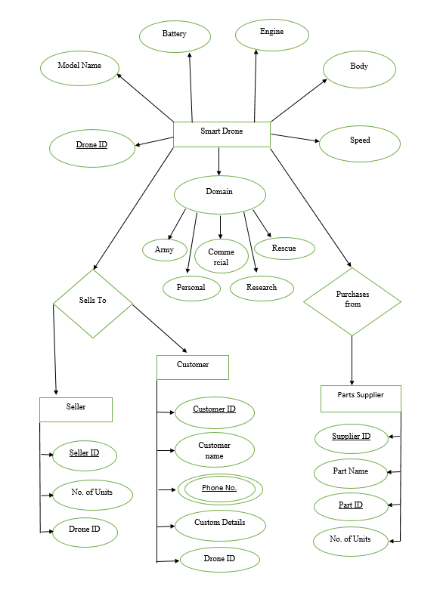

Data Flow Diagram(s)

1. 0-Level DFD

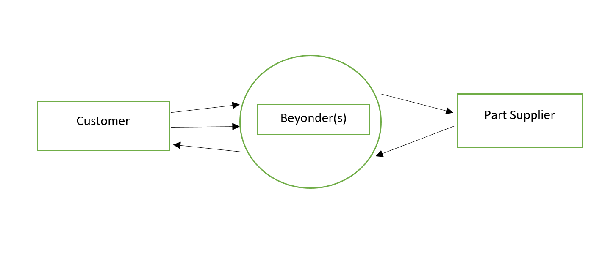

1. The customer will provide customization idea(s).
2. User will be providing us with their needs and wants.
3. All the data received from customer will be converted into information.
4. With the help of that information we will demand for parts.
5. Supplier will provide with the parts.
6. 1-Level DFD

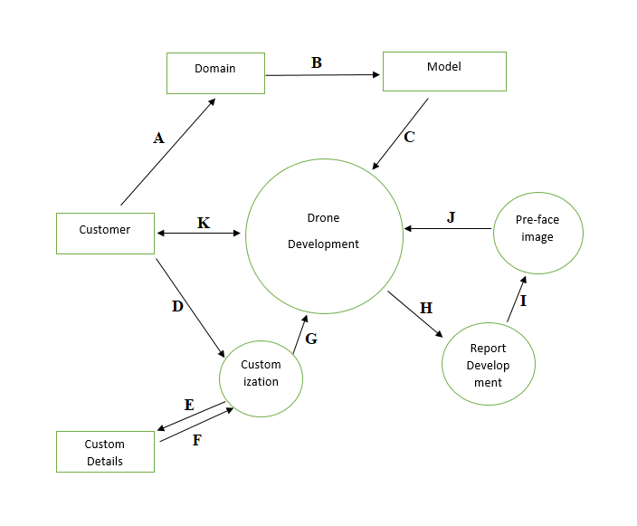

1. Customer can go for specific domain.
2. Customer can check if the base features provided in that domain meets his/her expectations or not.
3. Customer can select the base features according to the need.
4. Customer can also go for custom features according to the need.
5. All the custom details would be stored.
6. Custom details would be taken to process.
7. Details go for development.
8. Report is made by developer.
9. Pre-face image is developed.
10. Pre-face image is given to user.
11. User checks if the image meets his expectations.

**Entry, Task, Verification, and Exit**

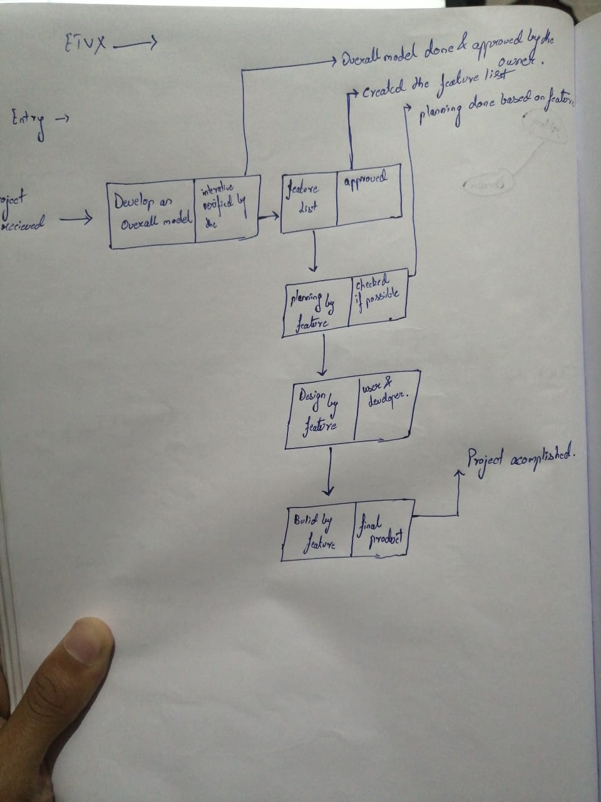

**Program Evaluation and Review Technique**

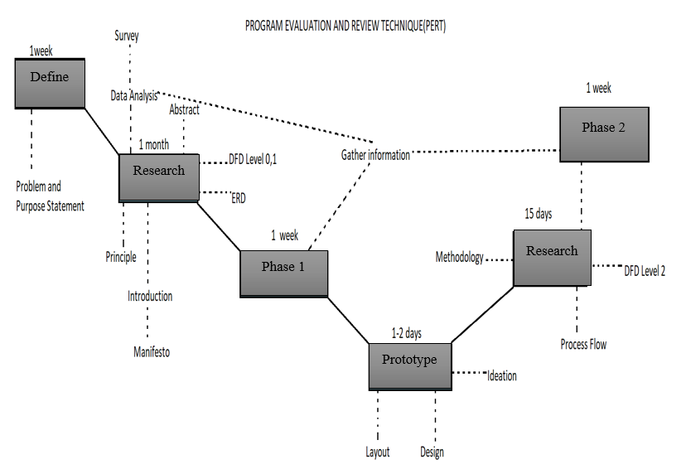

Methodologies:-

Out of all the methodologies Feature Driven Development methodology is the best foot toward our project. This is a model-driven, short-iteration process that was built around software engineering and is the best practices such as domain object modelling, developing by feature, and code ownership. The blending of these practices that resulted in a cohesive whole is the best characteristic of FDD.

Some key features of FDD are:-

* Development of an overall model
* Building a feature list
* Planning by feature
* Designing by feature
* Building by feature

FDD begins by establishing an overall model shape, which will result in a feature list. It then continues with a series of two-week “plan by feature, design by feature, build by feature” iterations. The features are small, “useful in the eyes of the client” results. If they will take more than two weeks to build, then they will have to be broken down into smaller features.

Goal of FDD:-

FDD’s main purpose is to deliver tangible, working software in a timely manner, repeatedly.

Advantages

1. It can be deployed to large group of teams due to the concept of “just enough design initially” (JEDI).
2. It is a great solution to maintain control for incremental and inherently complex agile project management.

Disadvantages

1. Iterations are not well defined by the process as other agile methodologies.

Methodology used in this project is FDD i.e. Feature Driven Development.

This methodology’s main factors is as follows:-

a) Develop an overall model

b) Build a feature list

c) Plan by feature

d) Design by feature

e) Build by feature

Overall Model:-

Our model when completed will be a drone which would have ability to navigate itself when the pilot is idle. A self-equipped drone is the future.

Feature list:-

In order to complete this project it requirements are:-

• Material of the drone

• Propellers

• Brushless Motor

• Landing gear

• Battery

• Team of programmer to program the drone

• Sensors

• GPS module

• Receiver and transmitter

Plan by feature:-

The drone would be planed according to the feature declared above and will also depend on the domain to be used in.

Design by feature:-

The drone will be designed in this process and will be better than the overall model which was the basic idea. After completion of this process the drone will in its prime form which will be made using software.

Build by feature:-

The final process, the drone will be made in reality under this process.

Project Planning and control

Project planning is an organized and integrated management process, which focuses on activities required for successful completion of the project. It prevents obstacles that arise in the project such as changes in projects or organization's objectives, non-availability of resources, and so on. Project planning also helps in better utilization of resources and optimal usage of the allotted time for a project.

Project planning process consists of the following things-:

Identification of the project requirements

Following are the products from that a simple drone can be made-:

• Motors

• Electronic speed control

• Flight controller

• The drone frame

• GPS Receiver (Depends on the domain)

• Propellers

• Batteries

• Connectors

• Camera (Depends on the domain)

• Gimbal

• A mounting pad

• A micro SD card

• An RC receiver

Identification of cost estimates

We have to keep our selling price low as we our new in this industry and we also have to try to minimize the cost price of the drone as we our new in this industry and no one will supply the material in less price. And we have one advantage of customization option in that we can sell them on high rates compare to the drones based on the domains and can make more profit from there.

Identification of risks

The main risk is to compete with the existing company like Yuneec, UVify, Hubsan, Parrot, Autel-Robotics and many more big companies. These companies are already well settled and have good goodwill in market. So, competing with them will be a challenged for us. And we have to minimize the cost price of one drone so that we can provide services to our customer in low prices to the already settled companies.

Identification of critical success factor

Our critical success factor is customization of drones and domain based drones on less price. The most important factor will be customization as now people want their drones to be according to their choice and if we are able to provide this in the same range the other companies provide simple drones based on the domains. This factor could be great for our company.