**Cognizant Technology Solutions**

**My Travel Application**

**Frequently Occurring Issues**

**Ver. 1.0**

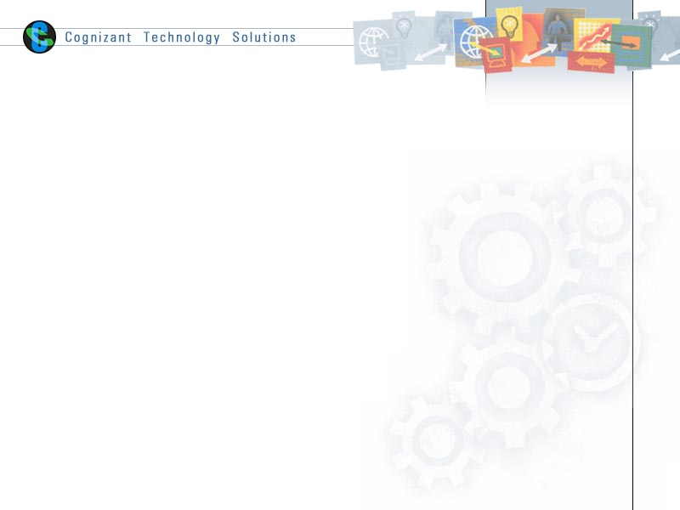

Contents

1. How to view the status of your travel request? 5

2. How to close a travel request which is in approved state? 7

3. How to cancel a travel request which is in approved state? 9

4. How to cancel a travel request which is not in approved state? 11

5. How to cancel a travel request which is not in approved state? 14

6. How to approve a travel request which is pending for your approval? 16

7. How to raise a multi – city travel request? 19

8. How to Raise/Edit/Cancel a request for Accommodation(Hotel/Guest House) in India Hospitality Application ………………………………………………………………………………………………………….20

9. Change the billability of an international travel request : 28

10. Change the billability of a domestic travel request : 28

11. Change the ‘Client Facing’ field of an international travel request: 29

12. Change the ‘Client Facing’ field of a domestic travel request : 29

13. Change the ‘Visa Type’ of an international travel request: 29

14. Change the ‘Type of Travel’ of an international travel request: 29

15. Change the ‘Destination Country’ or ‘Destination Location’ of an international travel request:…………………………………………………………………………………………………………………………………29

16. Change the ‘Destination Location’ of a domestic travel request: 30

17. Change the Travel Dates of a travel request: 30

18. Change the Project ID or Purpose of a travel request: 30

19. Reinstating/Reopening a closed/cancelled travel request: 31

20. Travel ID is not appearing while filing the expense report: 31

21. Raising a travel request for your dependents: 31

22. Common errors faced while raising travel request: 31

1. **How to view the status of your travel request?**
2. Please go to the my travel portal using link

<https://onecognizant.cognizant.com/?globalappid=748>  . Then click [**CLICK HERE**](https://onecognizantbcapps.cognizant.com/748/Main/Home.aspx?userSelected=domflight) to navigate to other menu options.

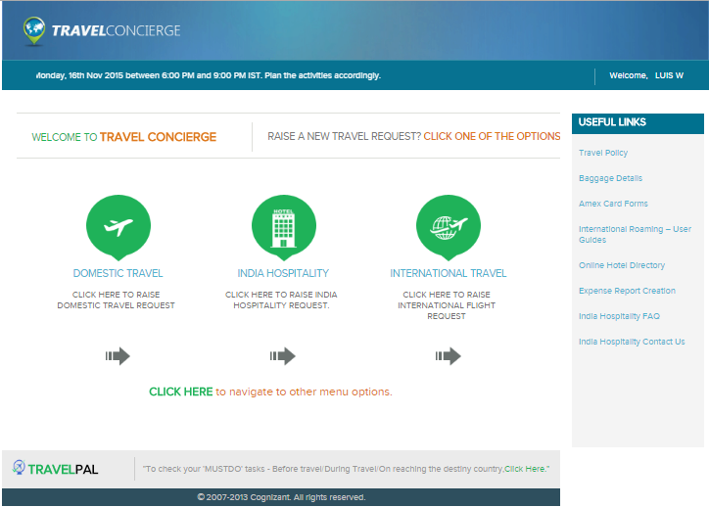

1. Then go to the menu Travel Status -> Pending Requests.

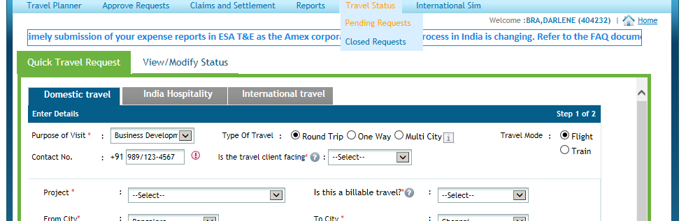

1. Find out the status of each travel ID from there. It has listed the corresponding Project Manager, VH Approver, BU COO Approver for each travel ID.

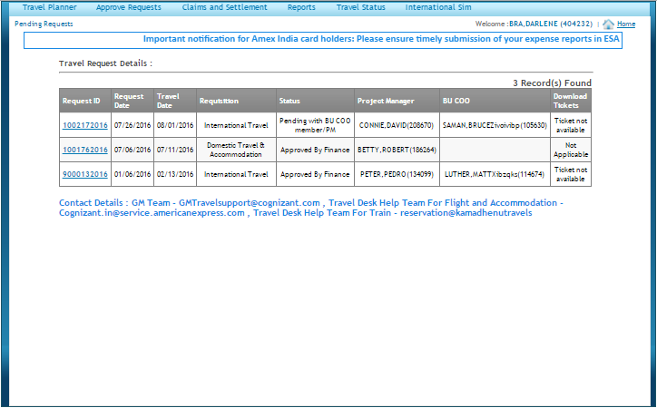

1. **How to close a travel request which is in approved state?**
2. Please go to the my travel portal using link

<https://onecognizant.cognizant.com/?globalappid=748>  . Then click [**CLICK HERE**](https://onecognizantbcapps.cognizant.com/748/Main/Home.aspx?userSelected=domflight) to navigate to other menu options.



1. Then go to the menu Travel Planner -> Close Requests.

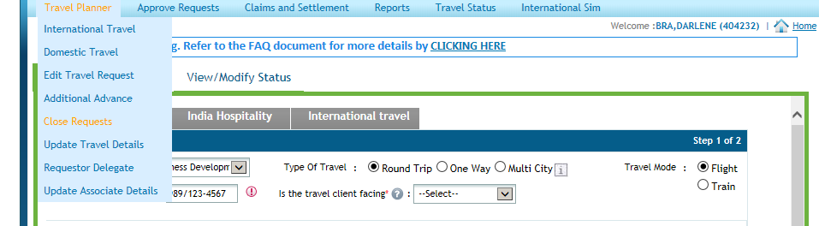

1. Select the appropriate reason for closure. Check the travel ID.

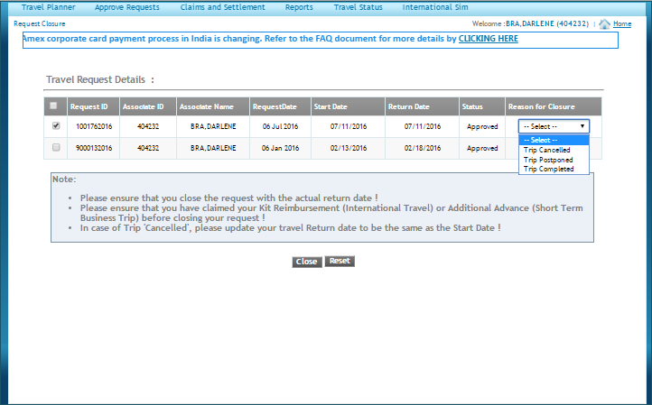

1. Click the Close button to close the request.
2. **How to cancel a travel request which is in approved state?**
3. Please go to the my travel portal using link

<https://onecognizant.cognizant.com/?globalappid=748>  . Then click [**CLICK HERE**](https://onecognizantbcapps.cognizant.com/748/Main/Home.aspx?userSelected=domflight) to navigate to other menu options.



1. Then go to the menu Travel Planner -> Close Requests.



1. Select the reason ‘Trip Cancelled’. Check the travel ID.



1. Click the Close button to close the request.
2. **How to cancel a travel request which is not in approved state?**
3. Please go to the my travel portal using link

<https://onecognizant.cognizant.com/?globalappid=748>  . Then click [**CLICK HERE**](https://onecognizantbcapps.cognizant.com/748/Main/Home.aspx?userSelected=domflight) to navigate to other menu options.



1. Then go to the menu Travel Status -> Pending Requests.



1. Click the travel id it will go to another section.



1. Then scroll the page using the scroll bar on the right side.

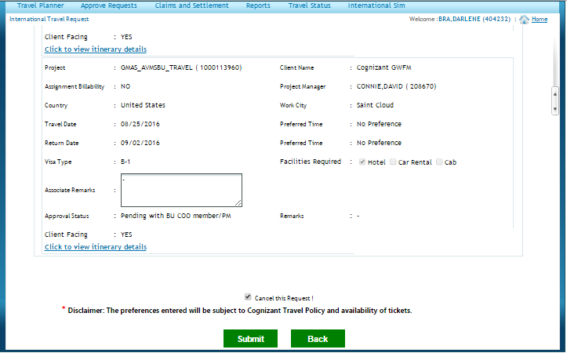

1. Check the ‘Cancel this Request!’ check box.
2. Then click the submit button to cancel the request.
3. **How to cancel a travel request which is not in approved state?**
   1. Please go to the my travel portal using link

<https://onecognizant.cognizant.com/?globalappid=748>  . Then click [**CLICK HERE**](https://onecognizantbcapps.cognizant.com/748/Main/Home.aspx?userSelected=domflight) to navigate to other menu options.



* 1. Then go to the menu Travel Status -> Pending Requests.



* 1. Click the travel id it will go to another section.



* 1. Then scroll the page using the scroll bar on the right side.



1. Check the ‘Cancel this Request!’ check box.
2. Then click the submit button to cancel the request.
3. **How to approve a travel request which is pending for your approval?**
4. Please go to the my travel portal using link

<https://onecognizant.cognizant.com/?globalappid=748>  . Then click [**CLICK HERE**](https://onecognizantbcapps.cognizant.com/748/Main/Home.aspx?userSelected=domflight) to navigate to other menu options.



1. Then go to the menu Approve Requests -> Pending.

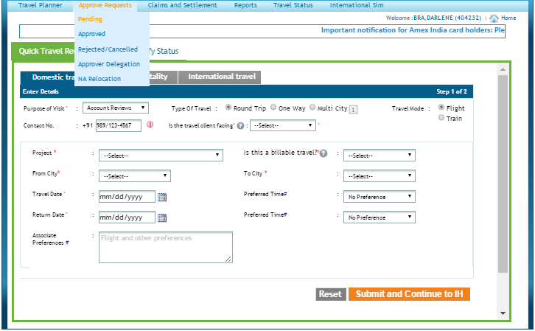

1. Now you will see Tab for both International and Domestic. Click on it to expand and click on the travel id.

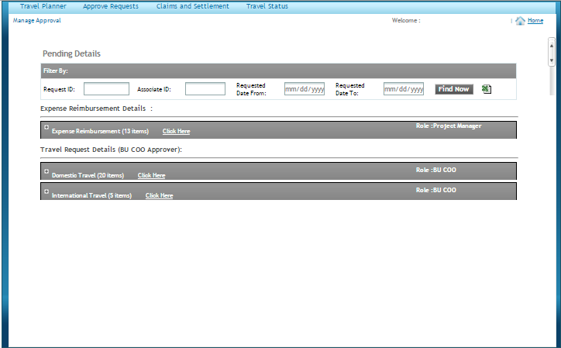

1. Click the Approve button to approve the request.

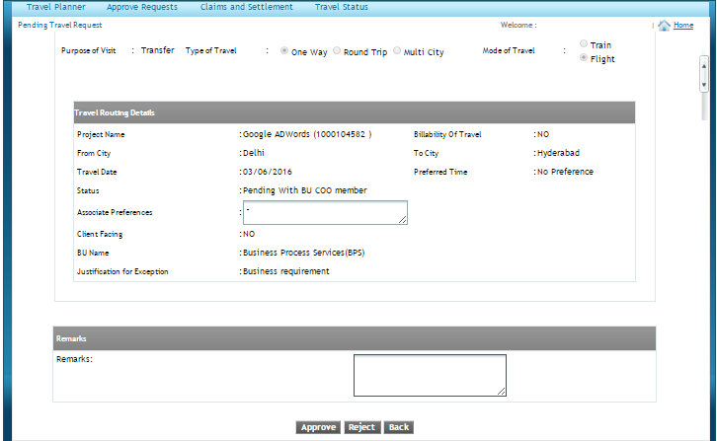

1. **How to raise a multi – city travel request?**

**Domestic Travel:**

1. Please go to the my travel portal using link

<https://onecognizant.cognizant.com/?globalappid=748>  . Then click [**CLICK HERE**](https://onecognizantbcapps.cognizant.com/748/Main/Home.aspx?userSelected=domflight) to navigate to other menu options.



1. Click on Domestic Travel and Select the ‘Multi City’ radio button.

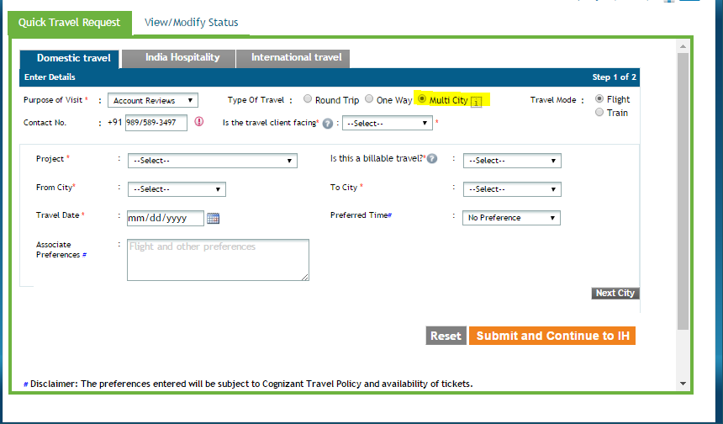

1. Fill all the details and then press the **‘Next City’** button at the bottom right hand side.

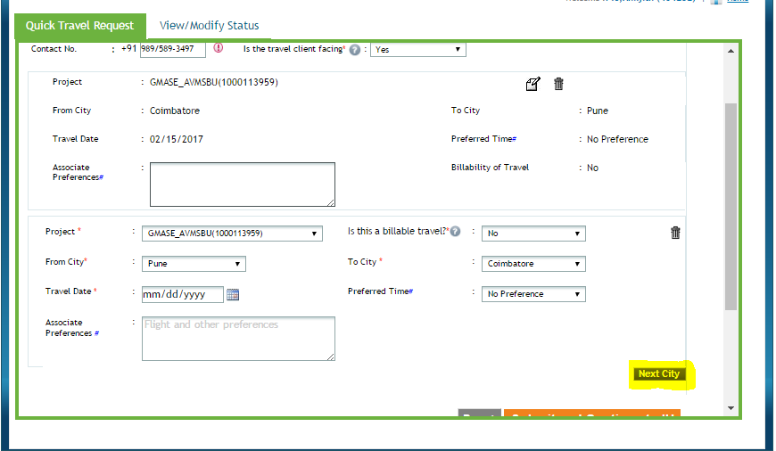

1. Fill all the details and press the **‘Submit and Continue to IH’** Button.

**International Travel:**

1. Please go to the my travel portal using link

<https://onecognizant.cognizant.com/?globalappid=748>  . Then click [**CLICK HERE**](https://onecognizantbcapps.cognizant.com/748/Main/Home.aspx?userSelected=domflight) to navigate to other menu options.



1. Then click on ‘International Travel’.

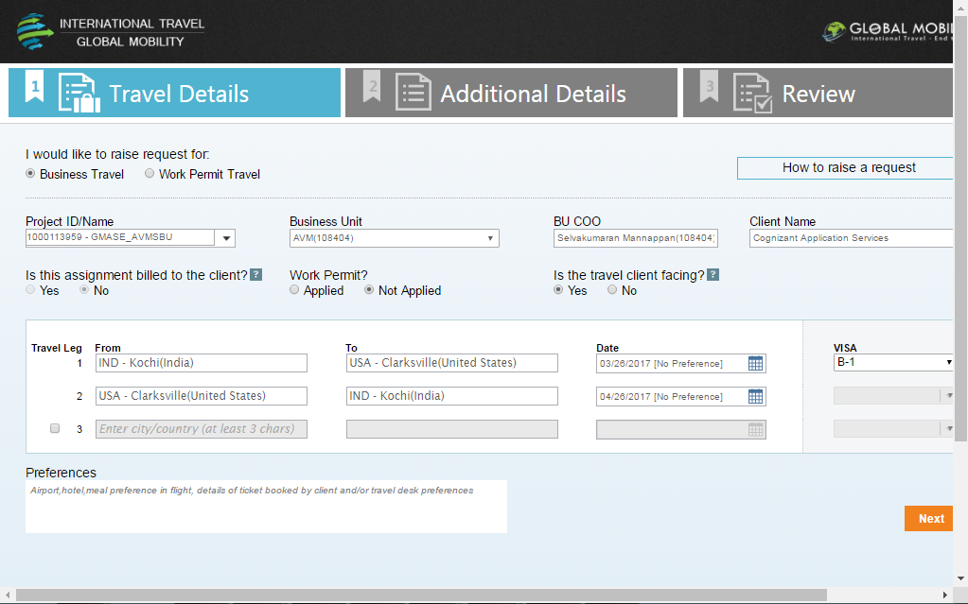

1. Please click on the highlighted check box as shown in the below screenshot to add more legs to your travel request.

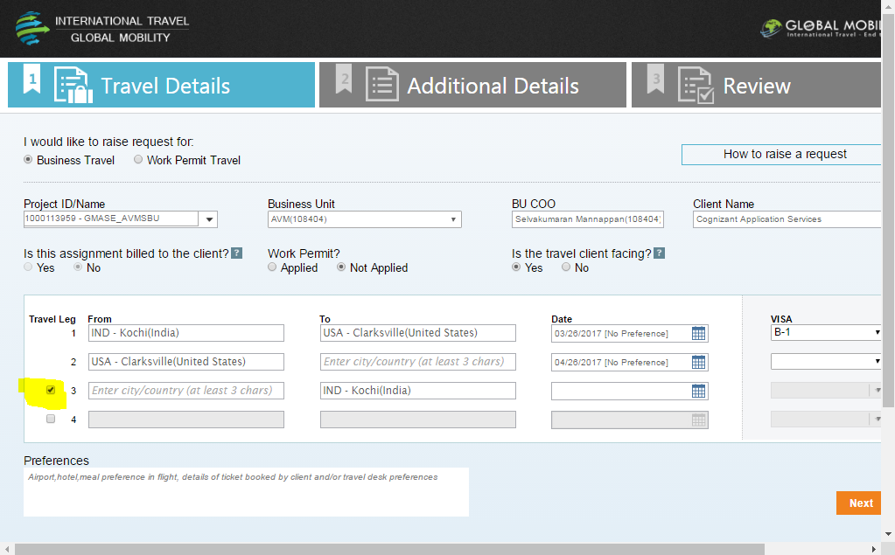

1. **How to Raise/Edit/Cancel a request for Accommodation(Hotel/Guest House) in India Hospitality Application :**
   1. Please go to the my travel portal using link

<https://onecognizant.cognizant.com/?globalappid=748>  . Then click [**CLICK HERE**](https://onecognizantbcapps.cognizant.com/748/Main/Home.aspx?userSelected=domflight) to navigate to other menu options.



* 1. Click on India Hospitality option.
* The raise request page will displays the option to provide the basic details for the travel, options to select Facility access, Accommodation and Cab.
* Associate have the provision to choose the travel id which created from MyTravel id as well as they will be able to raise without a travel id.
* If there is no active MyTravel request is available, by default it will be “NA-Travel ticket not requested”

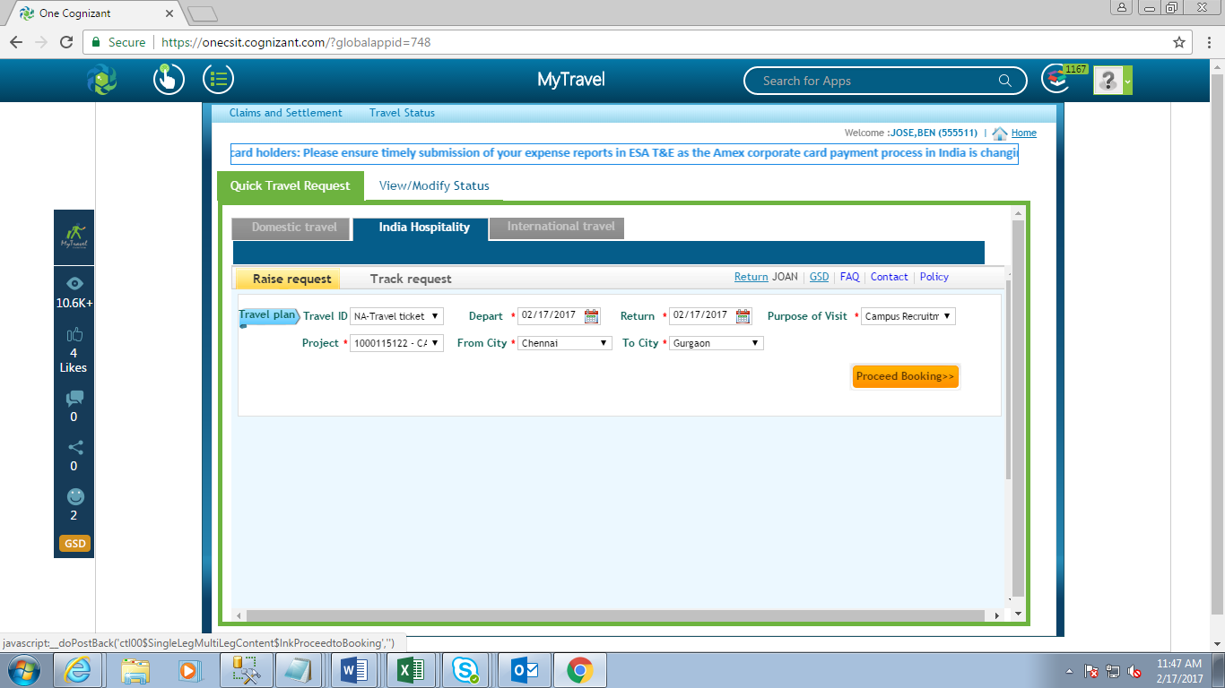

* 1. Please proceed with Proceed Booking button.
* By default the from date and to date for the travel part will be current date, from city will be fetching based on the GSMS data and associate’s details like home address and authenticated mobile(if any) will fetch from CRS according to the data available in HCM.
* Associate can select multiple facilities for getting access for the visiting city.
* For accommodation service, associate can select the accommodation type as guesthouse or hotel and the preferred guesthouse/hotel can be provided along with the check-in/check-out date and time.

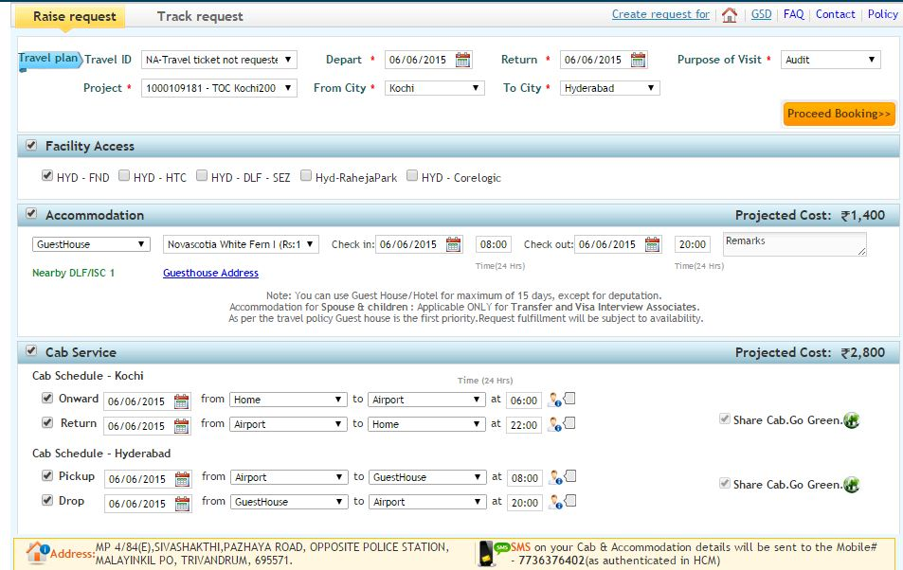

* 1. Proceed with Submit button

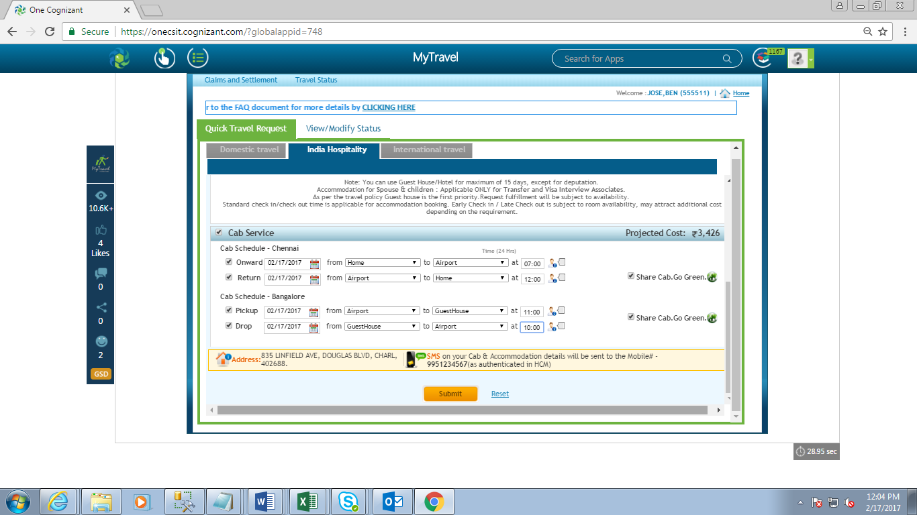

**Edit/Cancel an accommodation request in India Hospitality Application.**

* 1. Please go to the my travel portal using link

<https://onecognizant.cognizant.com/?globalappid=748>  . Then click [**CLICK HERE**](https://onecognizantbcapps.cognizant.com/748/Main/Home.aspx?userSelected=domflight) to navigate to other menu options.



* 1. Click on India Hospitality option.

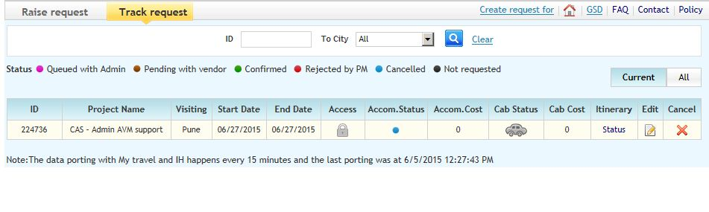

* Associate will be able to track the submitted request from this page.
* They will be able to know the status, edit and cancel the services which is raised by them if the travel dates is not passed.
* All active request will be displayed under category “Current” tab and all the past request raised by the associate will come under “All” category.
  1. On click of cancel button in track request page, a pop up will be opened.

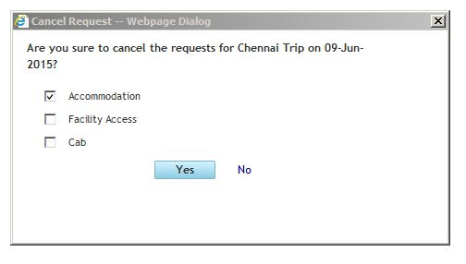

* They can cancel either all the services among Facility, Accommodation, Cab or any one of the services among those
* Even though the request has been cancelled, the raised request will present in the track request page with status as “Cancelled”.
  1. By clicking the edit button in track request page, you can edit the accommodation request.

1. **Change the billability of an international travel request :**
2. If the Travel Request is either pending with PM or BU COO or any combination of these, then kindly **cancel** your travel request and raise a new travel request with correct values.
3. Once the Travel Request enters the status ‘Pending with Gm Travel Support’ or ‘Pending with Amex Travel Desk’ or any combination of those, then kindly reach out to Gm Travel Team ([**gmtravelsupport@cognizant.com**](mailto:gmtravelsupport@cognizant.com)) for changing the billability of travel request.
4. **Change the billability of a domestic travel request :**
   1. If the Travel Request is either pending with BU COO or with Amex Travel Desk, then kindly **cancel** your travel request and raise a new travel request with correct values.

Once the Travel Request is in the ‘Approved’ status and still you want to change the billability then kindly raise a GSD [Click here to raise GSD](https://onecognizant.cognizant.com/254/UserShout.aspx?g=748&tr=0&ty=1&ts=1424670255652&sd=0).

1. **Change the ‘Client Facing’ field of an international travel request:**
2. If the Travel Request is either pending with PM or BU COO or any combination of these, then kindly **cancel** your travel request and raise a new travel request with correct values.
3. Once the Travel Request enters the status ‘Pending with Gm Travel Support’ or ‘Pending with Amex Travel Desk’ or any combination of those, then kindly reach out to Gm Travel Team ([**gmtravelsupport@cognizant.com**](mailto:gmtravelsupport@cognizant.com)) for changing the ‘Client Facing’ field of travel request.
4. **Change the ‘Client Facing’ field of a domestic travel request :**
5. If the Travel Request is either pending with BU COO or with Amex Travel Desk, then kindly **cancel** your travel request and raise a new travel request with correct values.

Once the Travel Request is in the ‘Approved’ status and still you want to change the billability kindly raise a GSD [Click here to raise GSD](https://onecognizant.cognizant.com/254/UserShout.aspx?g=748&tr=0&ty=1&ts=1424670255652&sd=0).

1. **Change the ‘Visa Type’ of an international travel request:**
2. If the Travel Request is either pending with PM or BU COO or any combination of these, then kindly **cancel** your travel request and raise a new travel request with correct values.
3. Once the Travel Request enters the status ‘Pending with Gm Travel Support’ or ‘Pending with Amex Travel Desk’ or any combination of those, then kindly reach out to Gm Travel Team ([**gmtravelsupport@cognizant.com**](mailto:gmtravelsupport@cognizant.com)) for changing the ‘Visa Type’ of travel request.
4. **Change the ‘Type of Travel’ of an international travel request:**
5. If the Travel Request is either pending with PM or BU COO or any combination of these, then kindly **cancel** your travel request and raise a new travel request with correct values.
6. Once the Travel Request enters the status ‘Pending with Gm Travel Support’ or ‘Pending with Amex Travel Desk’ or any combination of those, then kindly reach out to Gm Travel Team ([**gmtravelsupport@cognizant.com**](mailto:gmtravelsupport@cognizant.com)) for changing the ‘Type of Travel’ of travel request.
7. **Change the ‘Destination Country’ or ‘Destination Location’ of an international travel request:**
8. If the Travel Request is either pending with PM or BU COO or any combination of these, then kindly **cancel** your travel request and raise a new travel request with correct values.
9. Once the Travel Request enters the status ‘Pending with Gm Travel Support’ or ‘Pending with Amex Travel Desk’ or any combination of those, then kindly reach out to Gm Travel Team ([**gmtravelsupport@cognizant.com**](mailto:gmtravelsupport@cognizant.com)) for changing the ‘Destination Country’ or ‘Destination Location’ of travel request.
10. **Change the ‘Destination Location’ of a domestic travel request:**
11. Kindly raise a GSD [Click here to raise GSD](https://onecognizant.cognizant.com/254/UserShout.aspx?g=748&tr=0&ty=1&ts=1424670255652&sd=0).
12. **Change the Travel Dates of a travel request:**

* *For* ***International******Travel*** *date changes:*

1. If the Travel Request is either pending with PM or BU COO or any combination of these, then kindly wait for the status to become status ‘Pending with Gm Travel Support’ or ‘Pending with Amex Travel Desk’ or any combination of those.
2. Once the Travel Request enters the status ‘Pending with Gm Travel Support’ or ‘Pending with Amex Travel Desk’ or any combination of those or ‘Approved’ or ‘Trip Completed’, then kindly reach out to Gm Travel Team ([**gmtravelsupport@cognizant.com**](mailto:gmtravelsupport@cognizant.com)) for changing the dates of travel request.
3. If you want to extend your return date after you have travelled, kindly reach out to Gm Travel Team ([**gmtravelsupport@cognizant.com**](mailto:gmtravelsupport@cognizant.com)), with valid ticket copies for the required date.

* *For* ***Domestic******Travel*** *date changes:*

1. If the Travel Request is pending with BU COO, then kindly wait for the status to become ‘Pending with Amex Travel Desk’.
2. Once the Travel Request enters the status ‘Pending with Amex Travel Desk’ then kindly raise a GSD [Click here to raise GSD](https://onecognizant.cognizant.com/254/UserShout.aspx?g=748&tr=0&ty=1&ts=1424670255652&sd=0). for changing the dates of travel request.
3. Once the Travel Request enters the status ‘Approved Finance’ or ‘Trip Completed’, then kindly raise a GSD [Click here to raise GSD](https://onecognizant.cognizant.com/254/UserShout.aspx?g=748&tr=0&ty=1&ts=1424670255652&sd=0).
4. **Change the Project ID or Purpose of a travel request:**

* For **Project ID** change:

1. Kindly raise a GSD [Click here to raise GSD](https://onecognizant.cognizant.com/254/UserShout.aspx?g=748&tr=0&ty=1&ts=1424670255652&sd=0). Also, please make sure that you have an active allocation in the corresponding project.

* For **Purpose** change:

1. Kindly raise a GSD [Click here to raise GSD](https://onecognizant.cognizant.com/254/UserShout.aspx?g=748&tr=0&ty=1&ts=1424670255652&sd=0).
2. **Reinstating/Reopening a closed/cancelled travel request:**
3. Kindly raise a GSD [Click here to raise GSD](https://onecognizant.cognizant.com/254/UserShout.aspx?g=748&tr=0&ty=1&ts=1424670255652&sd=0).
4. **Travel ID is not appearing while filing the expense report:**
5. Kindly raise a GSD [Click here to raise GSD](https://onecognizant.cognizant.com/254/UserShout.aspx?g=748&tr=0&ty=1&ts=1424670255652&sd=0).
6. **Raising a travel request for your dependents:**

* An associate can only raise a travel request for his/her dependents if the following criteria are met:

1. The associate must have his/her dependents listed in HCM.
2. The type of travel must be a ‘Work Permit Travel’.
3. The difference between the Date of travel and Date of Return should be greater than 120 days.
4. **Common errors faced while raising travel request:**
5. ***Internal Server Error:***

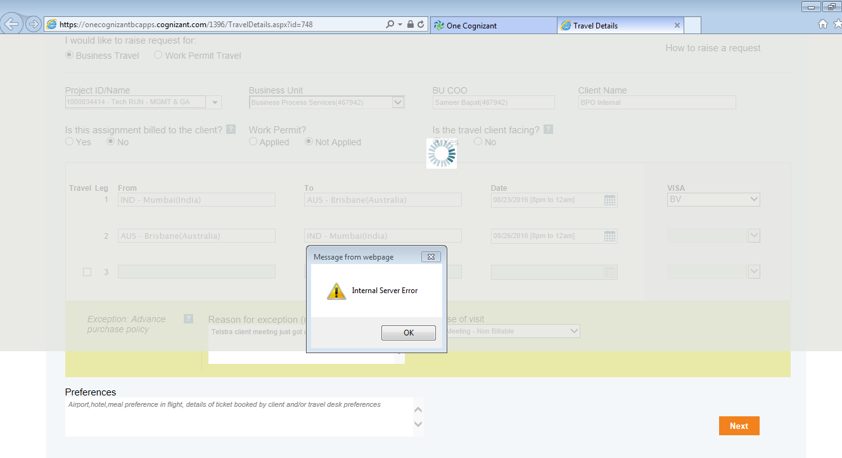

* + If you are facing an internal server error while raising a Domestic or International request, kindly clear your browser cache and cookies and please try raising a travel request both in Internet Explorer and Google Chrome.

1. ***‘Select BU for Exception’ dropdown empty:***
   * If the ‘Select BU for Exception’ dropdown is having empty value while raising an international/domestic travel request kindly follow the below steps:
2. Open the travel request raising page.
3. Press CTRL+F5.
4. Close the browser.
5. Try Step 1.
6. If still you are unable to raise a travel request, kindly raise a GSD [Click here to raise GSD](https://onecognizant.cognizant.com/254/UserShout.aspx?g=748&tr=0&ty=1&ts=1424670255652&sd=0).
7. ***‘Travel Dates Overlapping’ Error:***
   * Please see if you have any active travel IDs (follow step num. 1).
   * If yes, kindly close the active travel ID (follow step num. 2 and 3).
   * If No, Kindly raise a GSD [Click here to raise GSD](https://onecognizant.cognizant.com/254/UserShout.aspx?g=748&tr=0&ty=1&ts=1424670255652&sd=0).
8. ***‘Project ID not present in the dropdown’ Error:***

* Please make sure that you have active allocation in the respective project.
* Once allocation is given in ESA, it takes minimum 8 hours to flow to CRS, after which the project ID will be available in My Travel Application.
* Even after 8 hours, if the project ID is not populated in My Travel, Kindly raise a GSD [Click here to raise GSD](https://onecognizant.cognizant.com/254/UserShout.aspx?g=748&tr=0&ty=1&ts=1424670255652&sd=0) with the ESA project allocation screenshot.

1. ***‘Travel dates overlapping’ Error:***

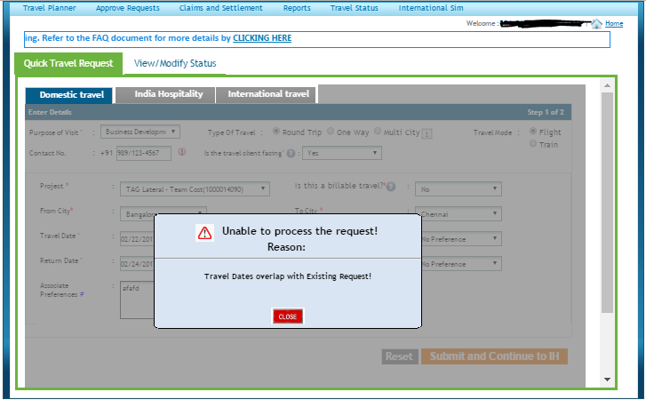

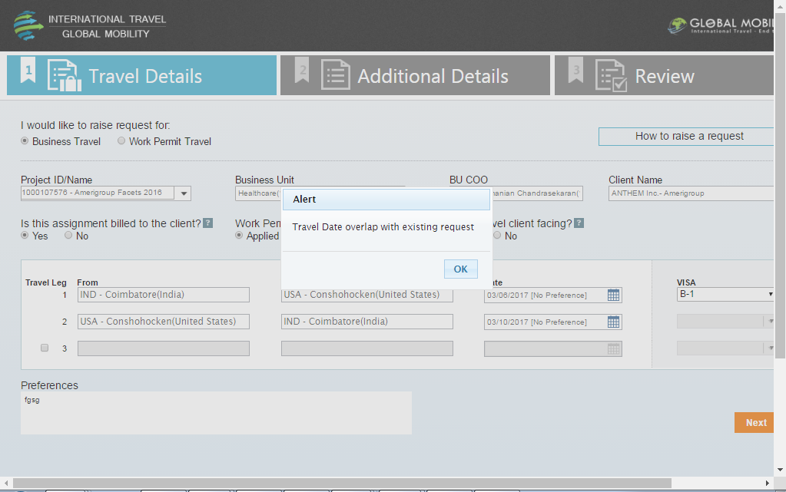

1. Please go to the my travel portal using link

<https://onecognizant.cognizant.com/?globalappid=748>  . Then click [**CLICK HERE**](https://onecognizantbcapps.cognizant.com/748/Main/Home.aspx?userSelected=domflight) to navigate to other menu options.

1. Then please go to **‘Travel Status -> Pending Requests’**. Please check if there are any travel requests already present for the respective days which you want to travel.
2. If **Yes**, Please go to **‘Travel Planner -> Close Requests’** Tab and close the respective travel request by selecting the appropriate reason.
3. If **No**, then please raise a GSD - [Click here to raise GSD](https://onecognizant.cognizant.com/254/UserShout.aspx?g=748&tr=0&ty=1&ts=1424670255652&sd=0).