**ATMEGA328P-AU Bootloader Burn Fixture**

**Rev 1.0**

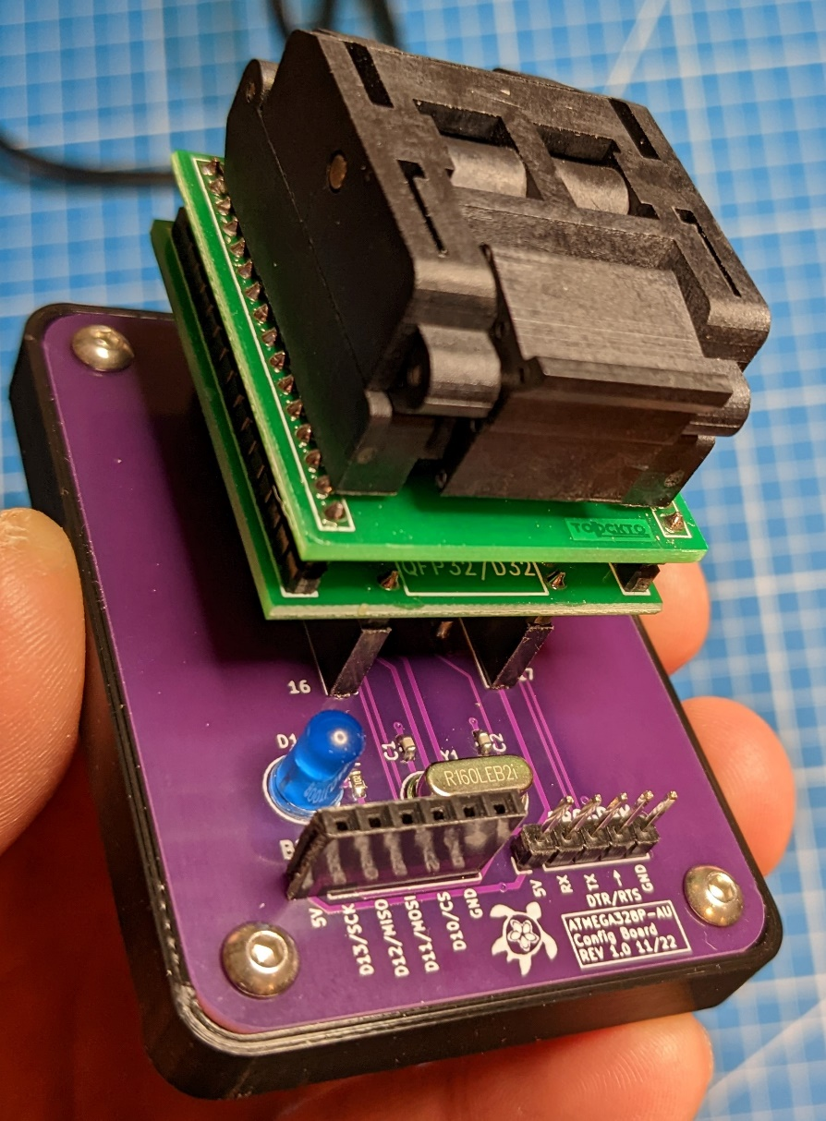

**Ken S. 11/2022**

# Description

This is a design for a PCB that includes the components necessary to more easily burn the Arduino bootloader onto a new ATMEGA328P-AU microcontroller chip. Using a second Arduino connected to the indicated header pins, the user can burn the bootloader onto the new QFP32 chip. Using an external USB-UART bridge (such as an ‘FTDI Friend’), the user can then upload the blink sketch to test (design includes onboard LED connected to digital GPIO 13) for proper operation.

**Note: This PCB is designed to use a QFP32 to DIP32 IC Adapter socket (QFP32 socket to male header pins). Links to examples are included in the Addendum section and are included on the electrical schematic.**

Design files are included for the following:

1. Controller Electrical Schematic (w/ manufacturer and P/N component properties)
2. Controller PCB Layout
3. Interactive PCB Bill of Materials (BOM) – HTML format
4. 3D Printed PCB Base

# Electrical / PCB

The PCB includes the minimum required components in order to support the operation of an ATMEGA328P microcontroller (passive components, external crystal, etc.), as well as header pins for connections required for bootloader burn and UART communication for uploading a sketch.

Pin definitions are indicated on the silkscreen layer and the bootloader pins list which GPIO pins are to be connected on the ‘Programmer’ Arduino (D10 – D13).

Accommodation for a 5mm THT LED allows the user to upload the blink sketch after the bootloader has been burned (by using an external USB – UART bridge). The LED is connected to GPIO 13 of the microcontroller (same as LED_BUILTIN). Please mind polarity when soldering the LED to the PCB.

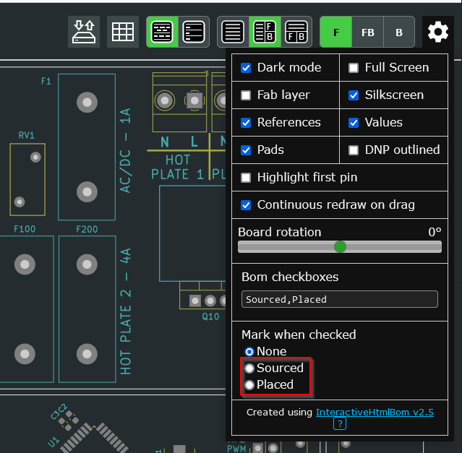Please refer to the included electrical schematic / PCB design / interactive BOM (html format) for further details. Note that selection of one of the options shown in the screenshot of the interactive BOM may be helpful during PCB assembly –

# Assembly / Construction

Please refer to the included design files for assembly / construction details. Various format 3D models (STEP, F3D, and STL) are included, along with associated drawings.

**NOTE:** M3 Threaded heat press inserts are required for PCB mounting holes. Holes for PCB mounting are sized in the 3D model to accept these inserts – fasteners will not thread into these holes due to their diameters.

It is recommended to install rubber ‘feet’ or ‘cabinet bumpers’ on the underside of the mounting base in order to prevent movement when placed on a desk or table.

The QFP32 to DIP socket adapter should be inserted such that the clam-shell opens away from the section of the board with the ‘BOOTLOADER’ and ‘PROGRAM’ pin headers.

# Operation / Usage

**Bootloader Burning –**

Insert the blank ATMEGA328P-AU into the QFP32 socket in the correct orientation and close the socket cover (on mine, this meant that pin 1 is in the upper left corner when the PCB is viewed such that the text is oriented in the normal left to right direction).

NOTE: The bootloader burn PCB / ATMEGA328P-AU will be referred to as the ‘Target’, while the Arduino that the ArduinoISP sketch is loaded onto will be referred to as the ‘Programmer’.

Using jumper wires, make the connections between 5V, GND, GPIO10, GPIO11, GPIO12, and GPIO13 on the ‘Programmer’ Arduino and the indicated pin locations on the bootloader burn PCB (note that the silkscreen on the bootloader burn PCB pin header indicates which pins on the ‘Programmer’ Arduino that each pin location should be connected to – NOT which pins on the traces are connected to on the QFP32 socket. The bootloader burn PCB makes the necessary pin connections on the ‘Target’ microcontroller in the socket).

Follow the guide from the following URL starting at Step 2: Burn the bootloader in Arduino IDE

<https://support.arduino.cc/hc/en-us/articles/4841602539164-Burn-the-bootloader-on-UNO-Mega-and-classic-Nano-using-another-Arduino>

Alternatively, ELECTRONOOBS provides an excellent guide as well:

<https://electronoobs.com/eng_arduino_tut6.php>

Once bootloader burning is complete, the ‘Programmer’ can be disconnected from the ‘Target’ and the external USB – UART serial bridge can be used to program the blink sketch.

**Sketch Upload –**

Make the relevant connections from the external USB – UART serial bridge to the pin header labeled ‘PROGRAM’.

Connect the external USB – UART serial bridge to the computer being used to upload the sketch and install drivers if necessary.

Create / load the example blink sketch (ensure that GPIO Pin 13 is being used for the LED output) and upload as normal.

# Addendum

**Links / Part Numbers for various off-board / supporting parts:**

**QFP32 TO DIP32 IC ADAPTER SOCKET:**  
<https://www.ebay.com/itm/261576182550>  
<https://a.co/d/6MSsSa6>

**External USB – UART Bridge:**<https://a.co/d/5V9MGa3>  
<https://a.co/d/dKaJK05>

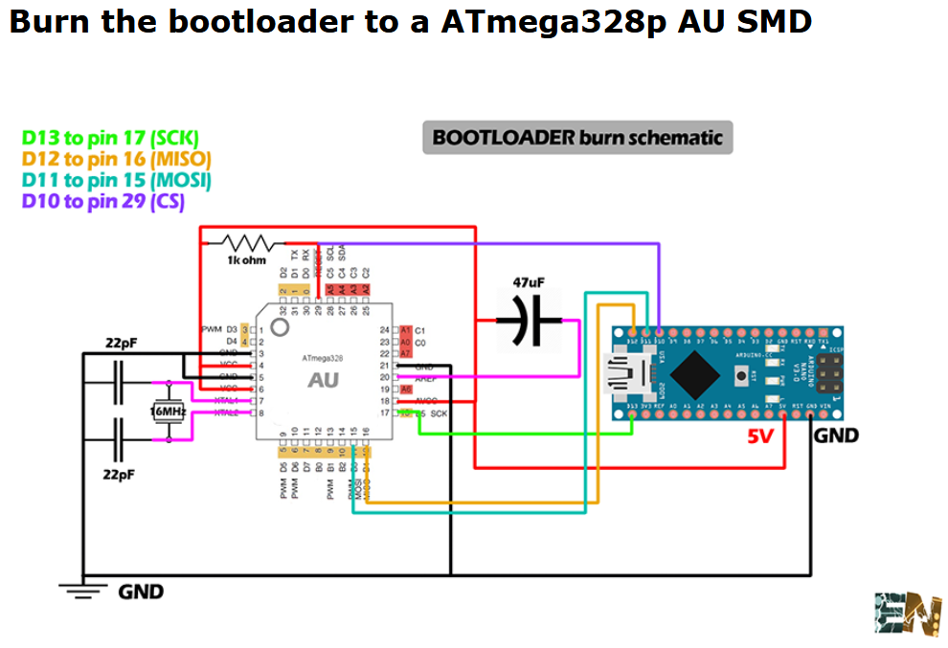**Connection Schematic (From the ELECTRONOOBS Website):**  
<https://electronoobs.com/eng_arduino_tut6.php>