**Solder Reflow Hot Plate**

**Rev 1.1**

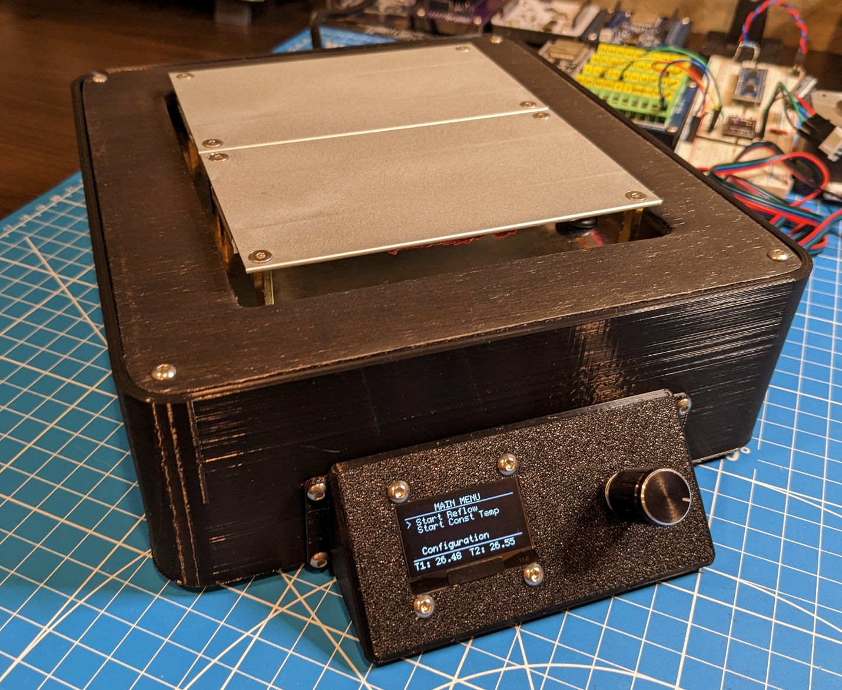

**Ken S. 03/2023**

**DANGER!**

**This project uses mains voltage to power portions of the circuit and the heating elements in the hot plates. This represents an electric shock hazard that can cause serious injury or death. Take appropriate care and do not attempt if you are not comfortable with or qualified to work with mains voltage.**

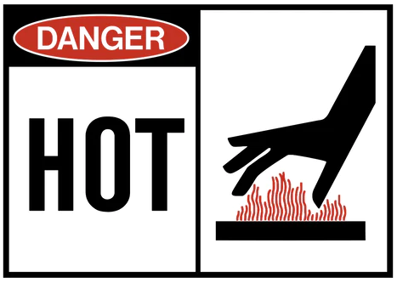**DANGER!**

**The heating plates used in this project can exceed 200°C and present burn and fire risks.**

# Description

This is an ATMEGA328P-AU based design for a solder reflow hot plate to be used for soldering SMD components onto custom PCBs. The microcontroller uses 2 PID loops to individually control the temperature for 2 aluminum heating plates. An OLED display and rotary encoder with push button allow the user to configure various parameters (reflow profile, PID tuning constants for the hot plate PID loops, etc), save the configuration to the microcontroller EEPROM memory, and start the unit in either constant temperature mode, or reflow profile mode.

Design files are included for the following:

1. Controller Electrical Schematic (w/ manufacturer and P/N component properties)
2. Controller PCB Layout
3. Interactive PCB Bill of Materials (BOM) – HTML format
4. Arduino IDE & PlatformIO based code
5. 3D Printed Enclosure
6. Sheet metal hot plate base
7. Wood cover plate

# Electrical / PCB

The controller PCB uses zero crossing optocouplers / TRIACs to convert the PWM outputs from the microcontroller and regulate the input AC power used to drive the hot plates to a specified setpoint temperature.

A DIP socket is suggested to be used between the Optocoupler TRIACS (U10 & U20) and the PCB. This is not listed as an item in the BOM.

Please note that the following fuses are required, but not listed –

1. QTY 1 – 5x20mm 1A Time Delay Fuse (for AC / DC Converter)
2. QTY 2 – 5x20mm 4A Fast Acting Fuse (1 for each hot plate output, assumes 120VAC, amperage will need to be changed for 240VAC)

This design uses a Cypress / Infineon CY7C65213-28PVXI USB – UART bridge IC. The newer CY7C65213A-28PVXI may be used in its place. Please use the configuration utility that can be found at the following URL along with the included configuration file to program the USB – UART bridge:

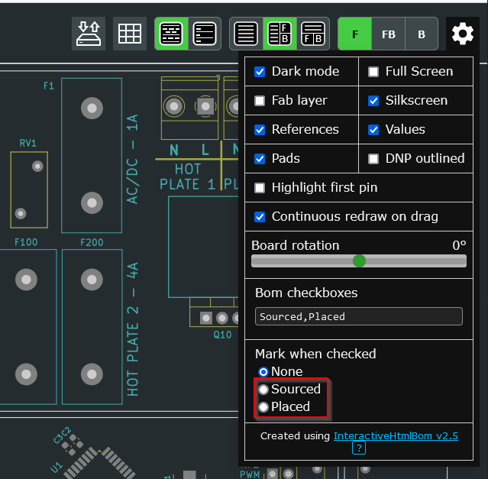<https://www.infineon.com/cms/en/design-support/tools/configuration/usb-uart-config-utility/>

Please refer to the included electrical schematic / PCB design / interactive BOM (html format) for further details. Note that selection of one of the options shown in the screenshot of the interactive BOM may be helpful during PCB assembly –

Completed PCB Pictures:

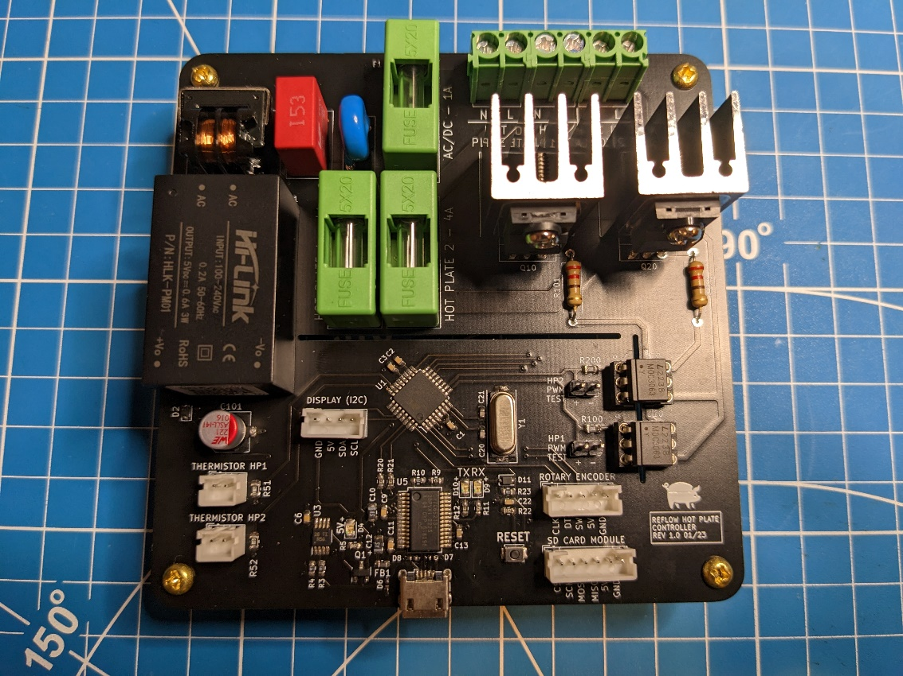

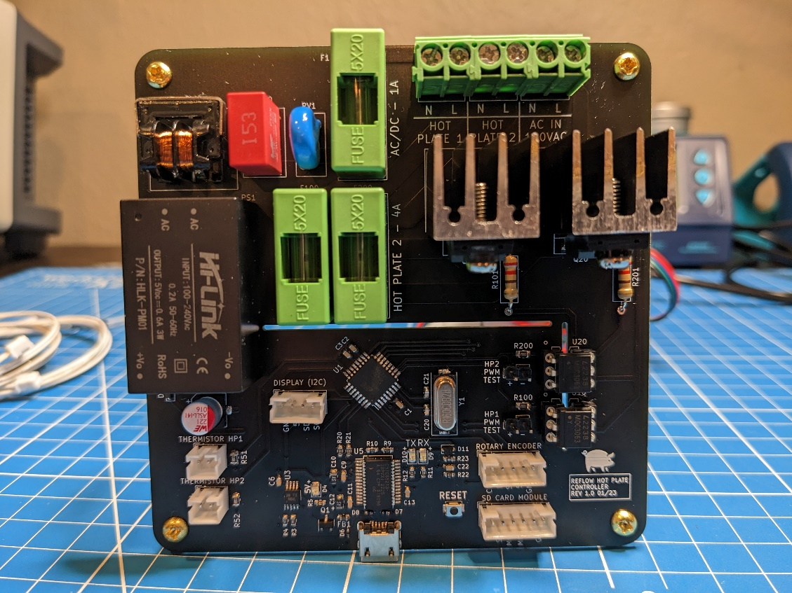

# Assembly / Construction

Please refer to the included design files for assembly / construction details. Various format 3D models (STEP, F3D, and STL) are included, along with assembly drawings, and detail drawings for non-3D printed enclosure components.

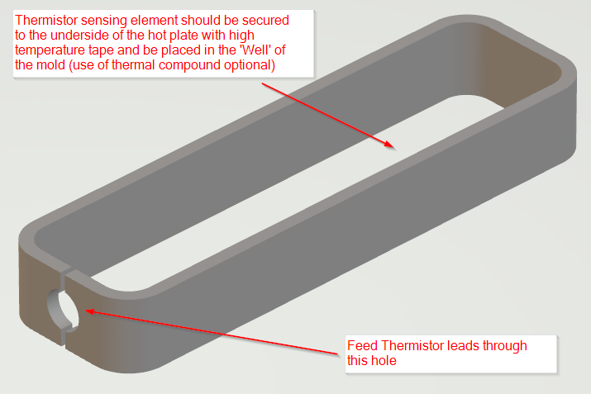**NOTE:** The ‘Thermistor Silicon Mold’ model can be 3D printed and used as an aid to secure the thermistors to the underside of the heating plates.

Thermal compound can be applied to the underside of the hot plate and the thermistor sensing element set inside of it. High temperature tape is then used to secure the thermistor to the plate. Excess tape should be cut away. The ‘Thermistor Silicon Mold’ can then be set in place and be temporarily secured so that high temperature silicon may be applied to fill the mold ‘well’ and ensure the thermistors remain in place.

# Microcontroller Code

Either the Arduino IDE or VS Code / PlatformIO may be used to upload the code to the microcontroller (both variants are included).

The code uses the following libraries:

1. Wire.h – Included in IDE by default
2. EEPROM.h – Included in IDE by default
3. PID_v1.h – PID by Brett Beauregard (v1.1.1)
4. U8g2lib.h – U8g2 by oliver (v2.33.15)

The U8g2lib object is configured in the included code to be used with an SH1106 based 128 x 64 OLED display. If the OLED display being used differs, this object will need to be reconfigured.

The code includes thermistor failure / thermal runaway protection. If either of the thermistors reads < -20°C, or the same measurement is read 3 consecutive times, heating is disabled and a thermistor failure message is presented on the display.

Configured reflow profile parameters and PID tuning constants are read from the microcontroller EEPROM at boot, and can be saved to the EEPROM by user selection of the ‘Save Configuration’ menu option. *Note that the first time the controller board boots after the code is uploaded, default values may be present in the EEPROM. If this is the case, please refer to the code for default values for reflow profile / PID tuning parameters. Default reflow profile parameters are applicable to the reflow curve of the solder paste listed in the comments.* ***Default PID tuning constants are a starting point – the PID loops will need to be tuned to the individual components for each build.***

In reflow profile heating mode, the code is configured to take an initial snapshot of the hot plate temperatures and ramp the setpoint from the initial snapshot value to the programmed setpoint over the configured time. This is designed to ‘smooth’ the PID response to the heating curve. This can result in some initial lag when the setpoint starts to change, but helps to prevent overshoot / oscillation when compared with a step change in the temperature setpoint. It also allows the temperature to increase according to an implied ramp rate.

In constant temperature heating mode, the user sets the desired setpoint and the system interprets this as a step change.

# Operation / Usage

Use / configuration of the reflow hot plate is achieved by use of the rotary encoder and display menu system. Rotation of the encoder changes the current selection and depressing the encoder knob selects the currently indicated option.

## Menus

The currently selected menu item is indicated / denoted by the ‘>’ character appearing at the left of the menu item.

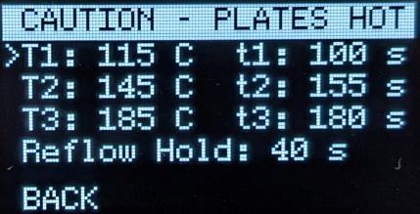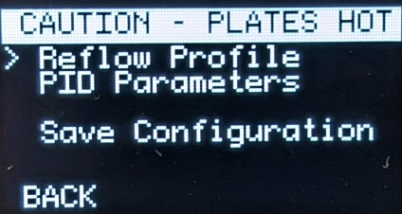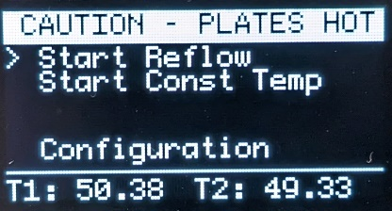Note – If either of the hot plate temperatures exceed the programmed setpoint value (40°C), the top banner will change to display a high contrast ‘Caution – Plates Hot’ message.

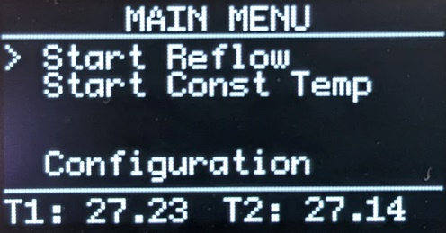**Main Menu** – Used to start Reflow Profile / Constant Temperature heating modes / enter the configuration menu. This menu will also display the current hot plate temperatures at the bottom of the screen.

**Start Reflow** – Used to start the unit in ‘Reflow Profile’ heating mode. This mode uses the parameters set in the ‘Reflow Profile’ configuration menu and will automatically vary the temperature over time to attempt to coincide with the reflow curve. Upon selection of this menu option, the user is presented with a confirmation to start. The default selection is ‘No’ to prevent unintended start of reflow heating mode.

When reflow heating mode is running, the user is presented with information pertaining to which section of the reflow profile curve the unit is currently in (RAMP, SOAK, REFLOW RAMP, REFLOW, COMPLETE), elapsed time, temperatures of the hot plates (T1 / T2) and the setpoint value (SP).

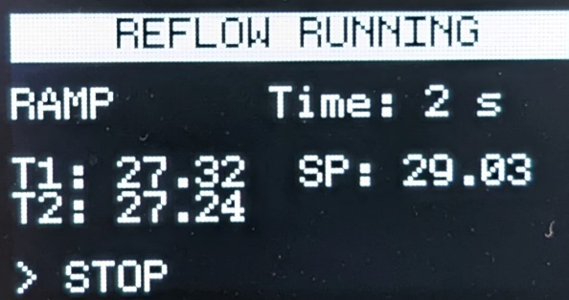Selecting stop will prompt the user to confirm stopping the reflow heating mode.

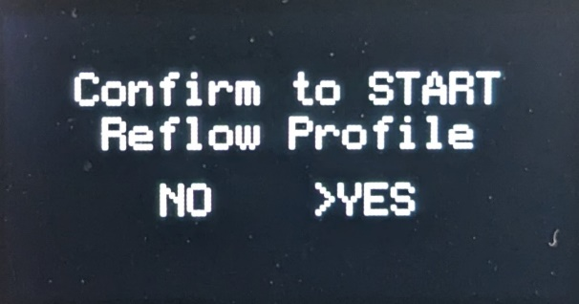

**Start Constant Temp** – Used to start the unit in ‘Constant Temperature’ heating mode. In this mode, the unit will heat the hot plates to a single specified temperature setpoint which won’t vary over time. When selected, the user is prompted to confirm start. Upon entering constant temperature heating mode for the first time, the temperature setpoint is set artificially low (default is 35°C) for safety reasons, and the user must select the ‘SP’ menu item, and change to the desired temperature setpoint.

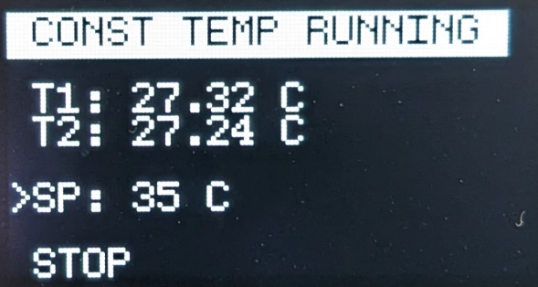Selecting stop will prompt the user to confirm stopping the constant temperature heating mode.

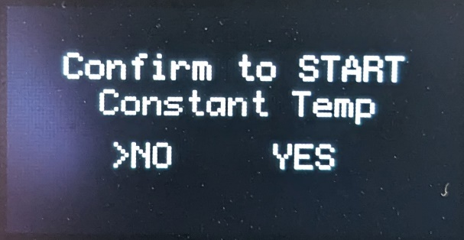

**Configuration Menu** – Used to select which configuration parameters to view / modify. The Main menu can be accessed by selecting ‘Back’.

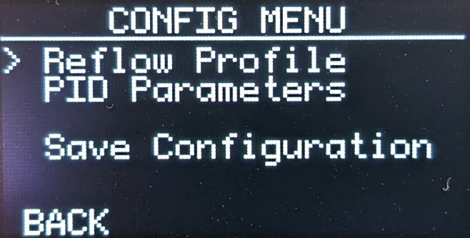

**Reflow Profile** – This menu allows the user to configure the reflow heating profile. Temperature setpoints are indicated by ‘uppercase’ T and time setpoints are indicated by ‘lowercase’ t. Selecting a menu item will draw a rectangle around the selected parameter, at which point the value can be changed. Pressing the rotary encoder will set the parameter value.   
The Configuration Menu can be accessed by selecting ‘Back’.

Please refer to the following diagram for further explanation regarding reflow profile setpoints. *Note that t1 through t3 are times along the X axis of the profile curve, and the reflow hold is a duration.*

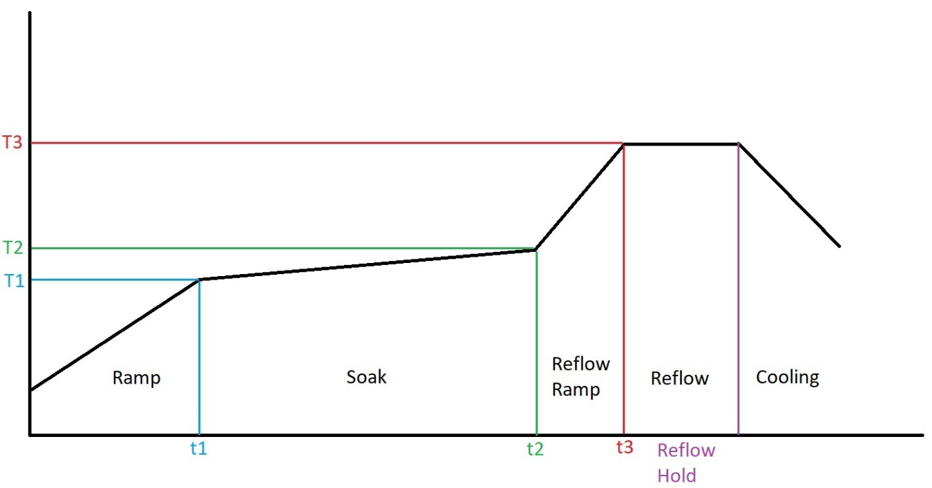

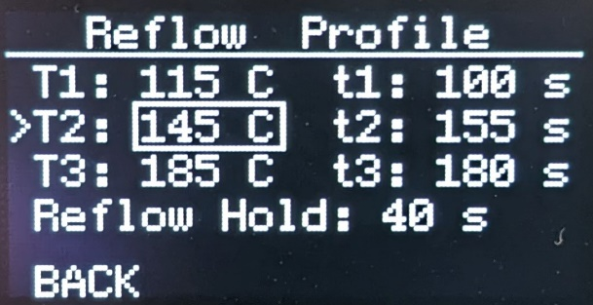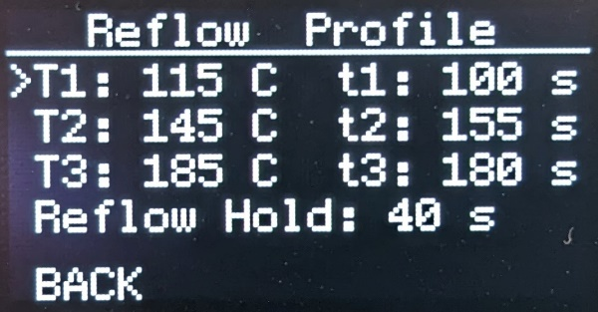

**PID Parameters** – This menu allows the user to configure the PID tuning constants for the 2 hot plate PID loops. Selecting a menu item will draw a rectangle around the selected parameter, at which point the value can be changed. Pressing the rotary encoder will set the parameter value.  
***Default PID tuning constants are intended to be a starting point. The hot plate PID loops will need to be tuned for each individual build as component performance / responses can vary.***

The Configuration Menu can be accessed by selecting ‘Back’.

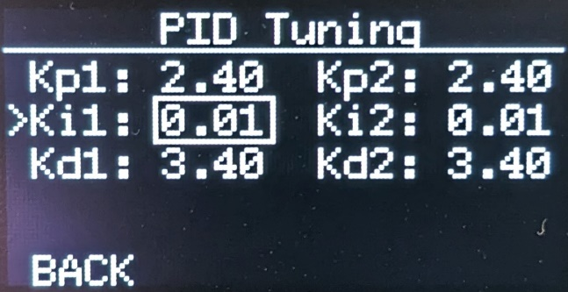

**Save Configuration** – Selecting this menu option will write the values of the reflow profile parameters and PID tuning constants to the microcontroller EEPROM. When selected, the user is presented with a message to indicate settings are being saved. Once complete, the display returns to the configuration menu screen.

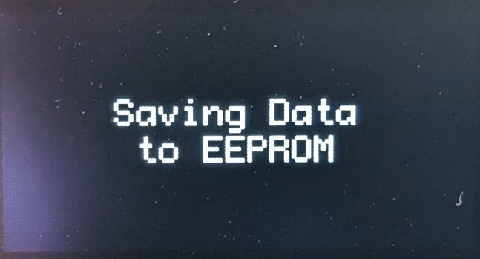

# Addendum

Links / Part Numbers for various off-board / supporting parts:

**AC SOCKET:**  
250V / 10A, 3 PIN IEC320 C14 MALE  
<https://www.amazon.com/dp/B0BCYYNRGP?psc=1&ref=ppx_yo2ov_dt_b_product_details>

**TO-220 TRIAC HEATSINK / HARDWARE:**HEATSINK - RADIOSHACK 2761368MOUNTING HARDWARE - RADIOSHACK 2761373

**HOT PLATES (QTY 2 PLATES REQ'D):**<https://www.amazon.com/gp/product/B0BBGCKD5C/ref=ppx_yo_dt_b_search_asin_title?ie=UTF8&psc=1>

**ROTARY ENCODER MODULE:**<https://www.amazon.com/gp/product/B07F26CT6B/ref=ppx_yo_dt_b_search_asin_title?ie=UTF8&psc=1>

**OLED SCREEN (SSD1106 VERSION):**<https://www.amazon.com/gp/product/B08V97FYD2/ref=ppx_yo_dt_b_search_asin_title?ie=UTF8&psc=1>