Debugging –

Q1.

1. Check Ambari Operations logs why the service is talking long time to startup

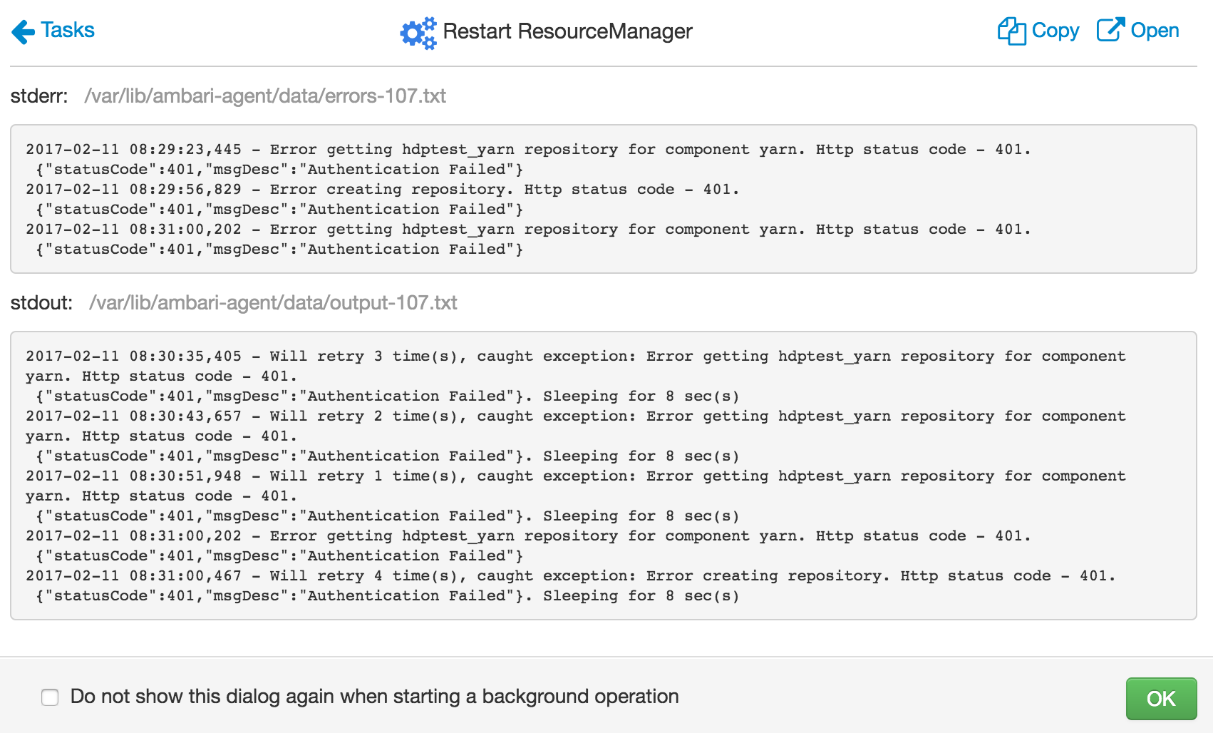

1. Check “/var/log/ranger/admin/xa_portal.log” for any warnings/messages

|  |
| --- |
| 2017-02-11 08:36:07,023 [http-bio-6080-exec-9] INFO org.apache.ranger.security.listener.SpringEventListener (SpringEventListener.java:87) - Login Unsuccessful:amb_ranger_admin | Ip Address: 127.0.0.1 | Bad Credentials  2017-02-11 08:36:15,288 [http-bio-6080-exec-4] INFO org.apache.ranger.security.listener.SpringEventListener (SpringEventListener.java:87) - Login Unsuccessful:amb_ranger_admin | Ip Address: 127.0.0.1 | Bad Credentials  2017-02-11 08:36:23,541 [http-bio-6080-exec-10] INFO org.apache.ranger.security.listener.SpringEventListener (SpringEventListener.java:87) - Login Unsuccessful:amb_ranger_admin | Ip Address:127.0.0.1 | Bad Credentials |

From above logs we see that its complaining about “amb_ranger_admin” user “Bad Credentials”

1. Check if you are able to see any warning in Ambari UI Alerts w.r.t “amb_ranger_admin” User Password   
     
   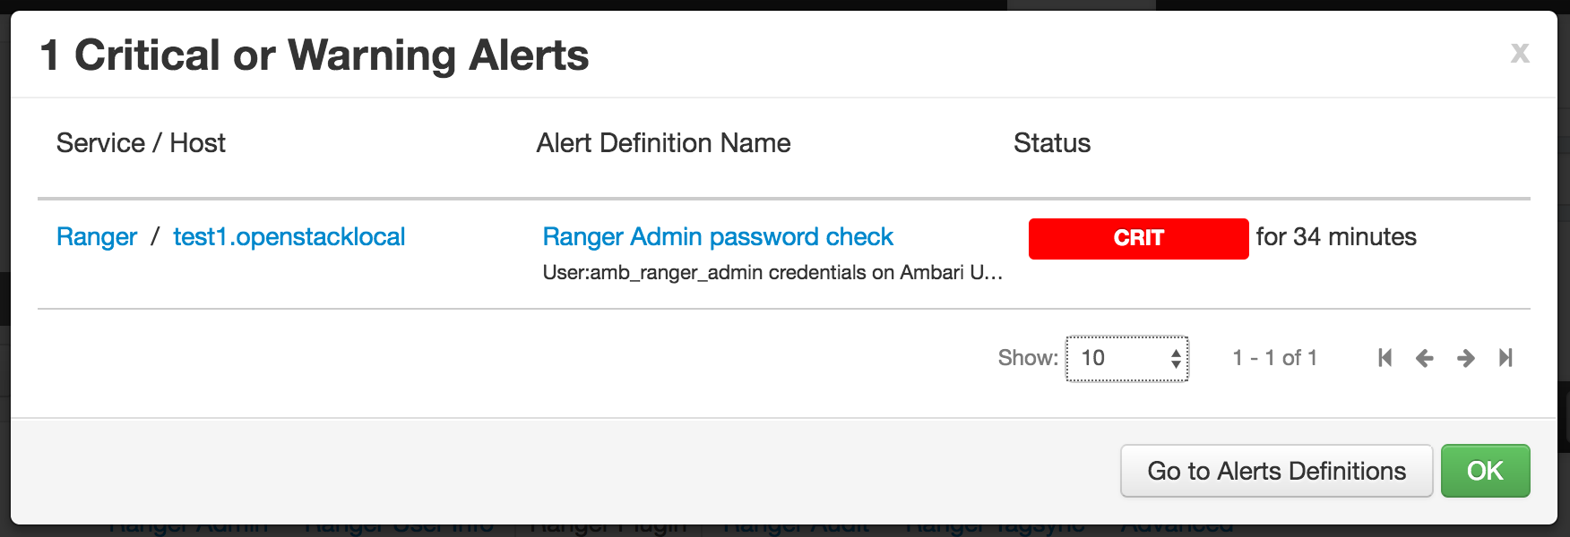

**Answer 1: Modify “amb_ranger_admin” password from Ranger UI->”Users/groups” and Ambari UI->Ranger-Configs**

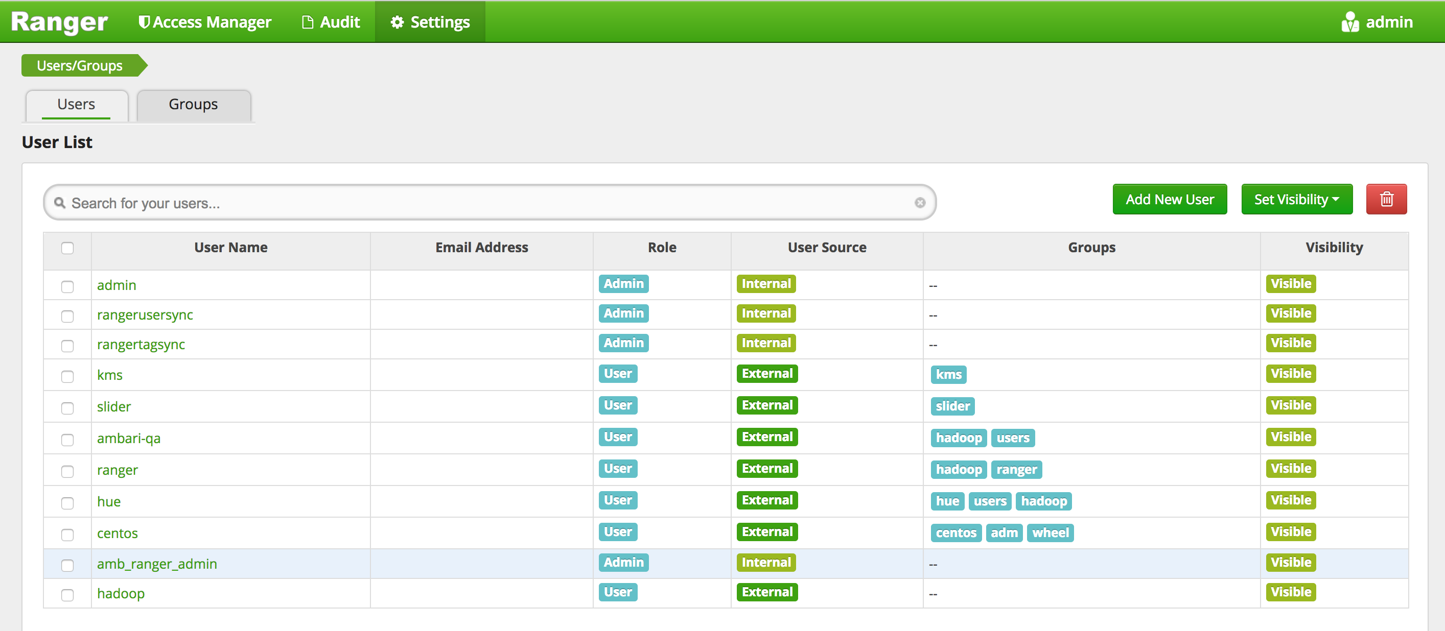

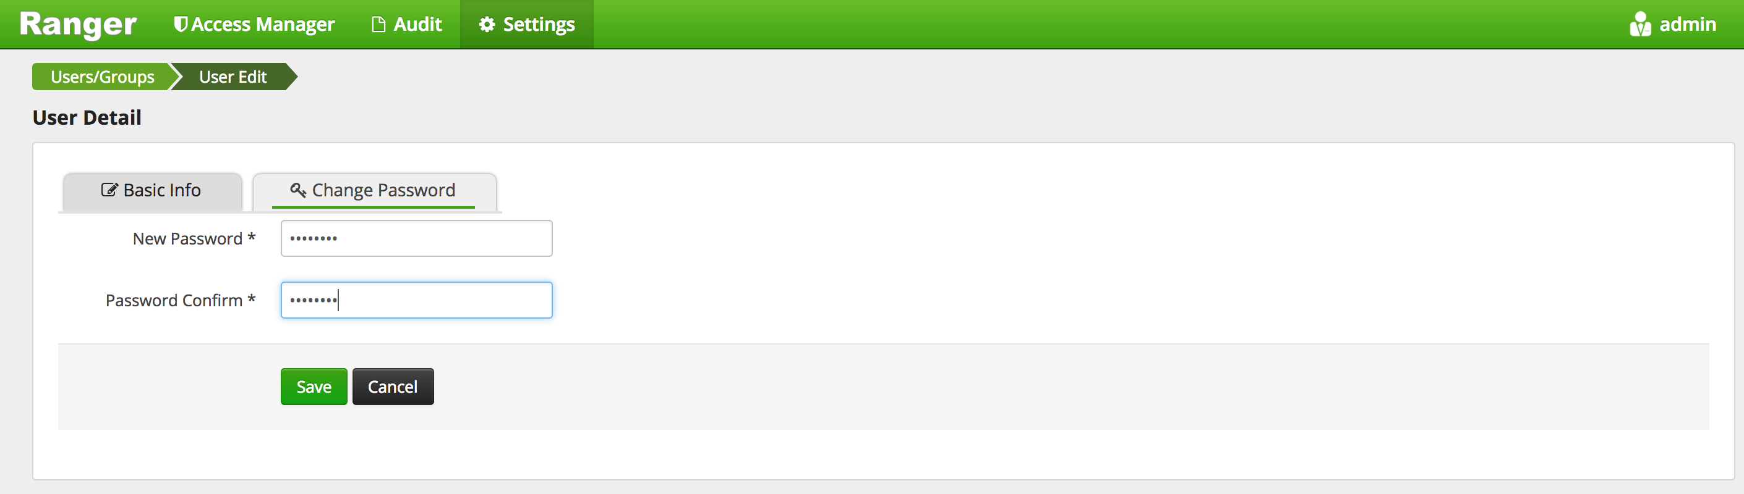

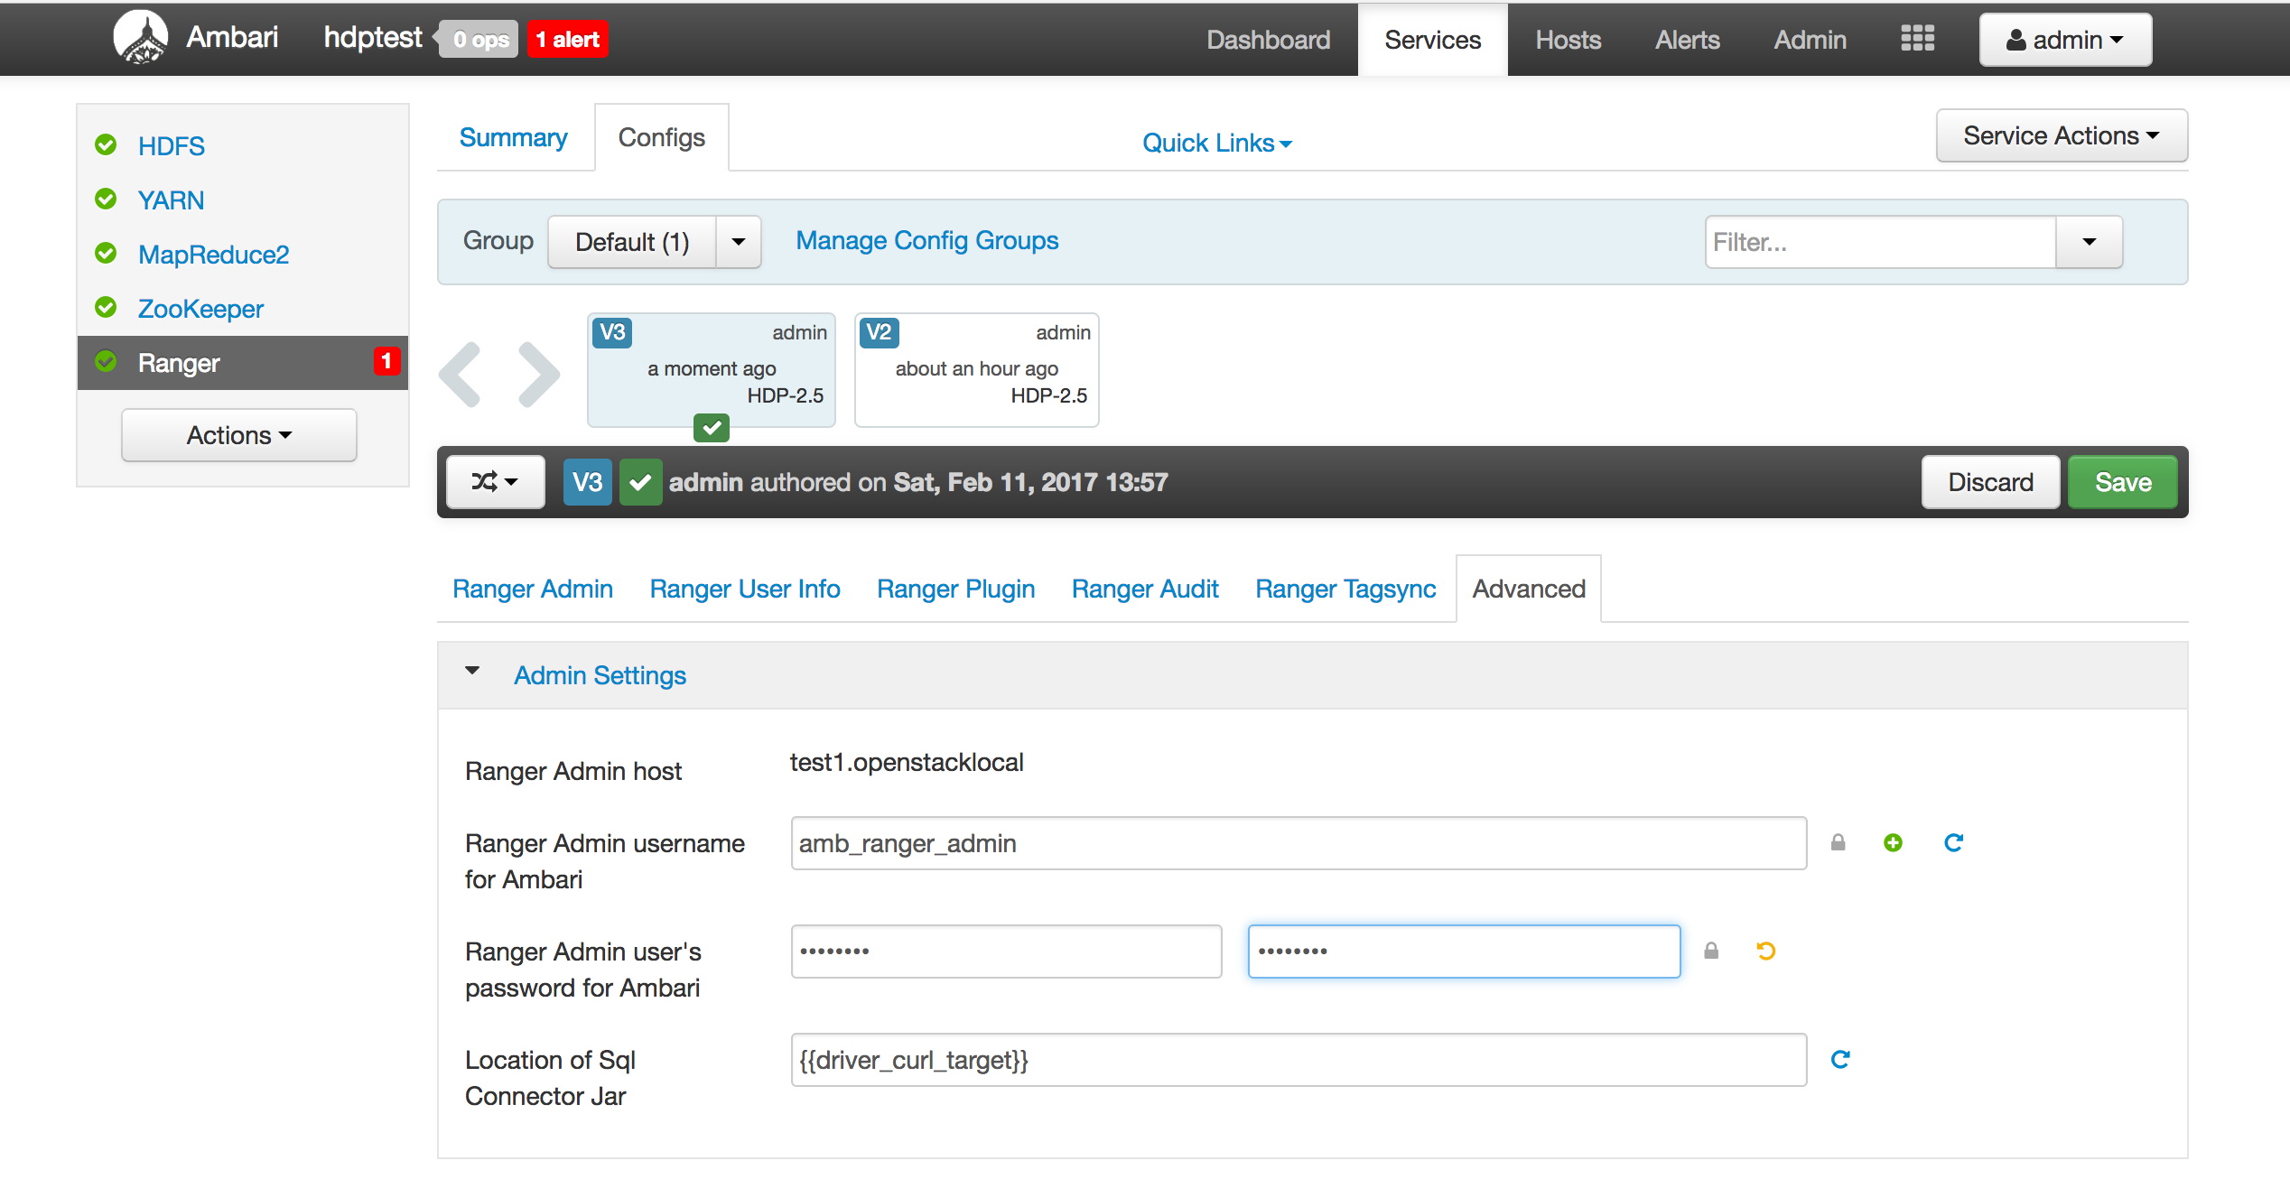

**Restart Yarn and check in Ranger Webui if Yarn repository is created.**

**Q2.**

1. **For policy not getting sync make sure you should check plugin logs. In this case its Ranger HDFS plugin issue so check Hadoop Namenode logs for any Warning or ERROR messages.   
   You might see some error as below –**

|  |
| --- |
| 2017-02-11 09:05:37,306 ERROR util.PolicyRefresher (PolicyRefresher.java:loadPolicyfromPolicyAdmin(255)) - PolicyRefresher(serviceName=hdptest_hadoop): failed to refresh policies. Will continue to use last known version of policies (2)  java.lang.IllegalArgumentException: Illegal character in scheme name at index 0: http://test1.openstacklocal:6080/service/plugins/policies/download/hdptest_hadoop  at java.net.URI.create(URI.java:852)  at com.sun.jersey.api.client.Client.resource(Client.java:433)  at org.apache.ranger.plugin.util.RangerRESTClient.getResource(RangerRESTClient.java:157)  at org.apache.ranger.admin.client.RangerAdminRESTClient.createWebResource(RangerAdminRESTClient.java:242)  at org.apache.ranger.admin.client.RangerAdminRESTClient.getServicePoliciesIfUpdated(RangerAdminRESTClient.java:112)  at org.apache.ranger.plugin.util.PolicyRefresher.loadPolicyfromPolicyAdmin(PolicyRefresher.java:232)  at org.apache.ranger.plugin.util.PolicyRefresher.loadPolicy(PolicyRefresher.java:188)  at org.apache.ranger.plugin.util.PolicyRefresher.run(PolicyRefresher.java:158)  Caused by: java.net.URISyntaxException: Illegal character in scheme name at index 0: http://test1.openstacklocal:6080/service/plugins/policies/download/hdptest_hadoop  at java.net.URI$Parser.fail(URI.java:2848)  at java.net.URI$Parser.checkChars(URI.java:3021)  at java.net.URI$Parser.checkChar(URI.java:3031)  at java.net.URI$Parser.parse(URI.java:3047)  at java.net.URI.<init>(URI.java:588)  at java.net.URI.create(URI.java:850)  ... 7 more |

**From above logs you can see it clearly says “**Illegal character in scheme name at index 0**”**

**It seems there is space at starting [ie.** index 0**] at Ranger URL** <http://test1.openstacklocal:6080>

**Check the “**External URL**” in Ranger Configs and make sure the settings are correct.**

**The below screenshot shows there is space at starting at url. Remove the space and try to restart the Ranger service again.**

**In this case HDFS service will not prompt you for restart. But you make sure you start HDFS service since the plugin needs to get the updated settings from Ranger.**

**After restart check if the yarn user is able to reflect in the <policy>.json file.**

**Eg.**

|  |
| --- |
| $grep yarn /etc/ranger/hdptest_hadoop/policycache/hdfs_hdptest_hadoop.json |

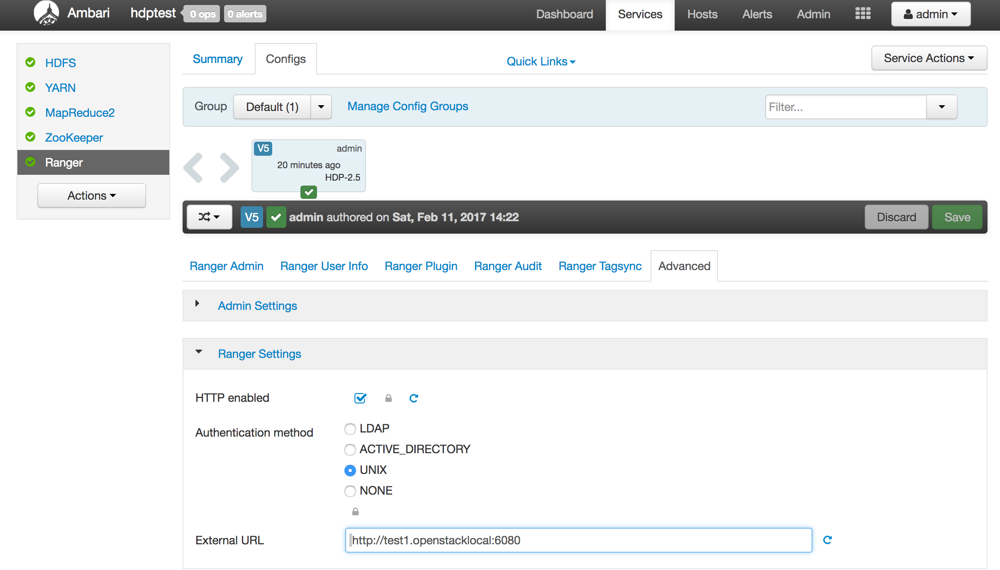

Q3.

1. “Ranger User Sync” service is responsible for syncing users from [UNIX/LDAP/AD/FILE]in Ranger UI.
2. Check the ranger usersync logs – you can see ERROR messages below -

|  |
| --- |
| 11 Feb 2017 09:39:39 ERROR UserGroupSync [UnixUserSyncThread] - Failed to initialize UserGroup source/sink. Will retry after 60000 milliseconds. Error details:  java.lang.Exception: User Group Source File /tmp/usergroup.txtdoesn't not exist or readable |

From above error its seems the sync source is set to File and hence its expecting to sync user from FILE where as its not able to get the file –  
“User Group Source File /tmp/usergroup.txtdoesn't not exist or readable”

The “Sync Source” should point to UNIX if you are trying to sync users from local filesystem to Ranger UI.

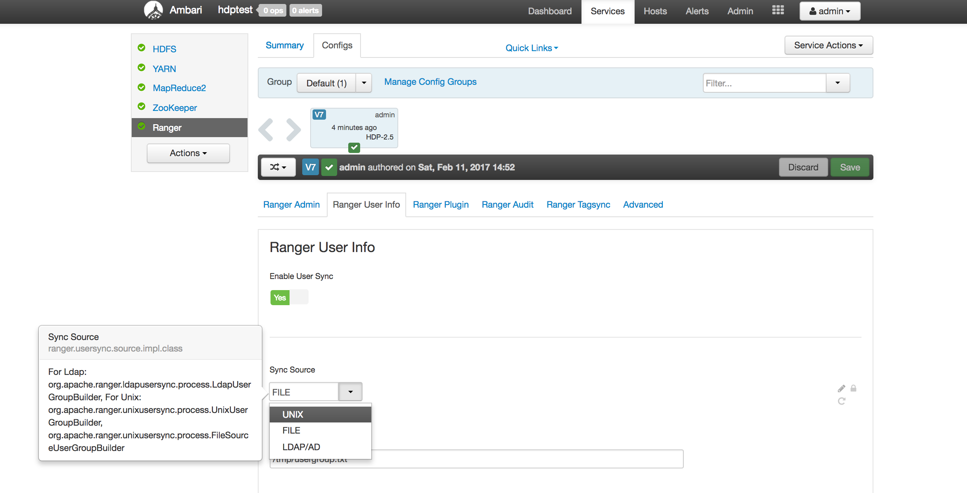

Once you set the Sync Source to UNIX you will see below messages in logs –

|  |
| --- |
| 11 Feb 2017 09:50:36 WARN UnixUserGroupBuilder [UnixUserSyncThread] - DEPRECATED: Unix backend is configured to use /etc/passwd and /etc/group files directly instead of standard system mechanisms. |

Save “Sync Source” to UNIX and restart Ranger service and check if the user is able to reflect in Ranger UI->Users/Groups.

Q4.

1. First check the uid of the user using command “$id <username>”

|  |
| --- |
| [root@test1 scripts]# id user1  uid=1003(user1) gid=1003(user1) groups=1003(user1)  [root@test1 scripts]# |

From above output you can see the uid is 1003 for user1. Make sure ranger has the “Minimum User ID” property set below the id of the “user1” to sync it in Ranger WebUI.

From current settings we see the “Minimum User ID” is set to 1500 and hence its not able to sync user id below 1500.

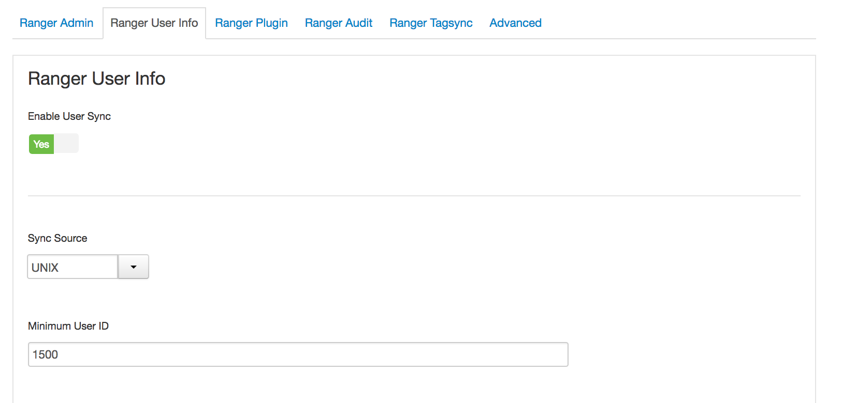

Modify the “Minimum User ID” to 1000 and restart ranger service and check if “user1” reflects in Ranger UI->Users/Groups.

Q5.

1. Check ranger logs – “/var/log/ranger/admin/xa_portal.log”

|  |
| --- |
| 2017-02-11 10:22:16,020 [http-bio-6080-exec-3] INFO org.apache.ranger.security.listener.SpringEventListener (SpringEventListener.java:87) - Login Unsuccessful:user1 | Ip Address:127.0.0.1 | Bad Credentials |

Check for the property below in ranger configs and make sure its set to true.

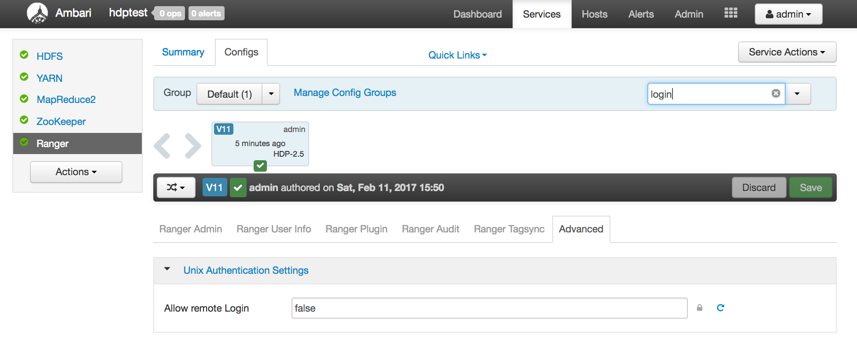

Set the property to “true” and restart Ranger service. Now try to login with “user1”.

Q6. For Ranger HA please set below properties in Ranger HDFS Repository section –

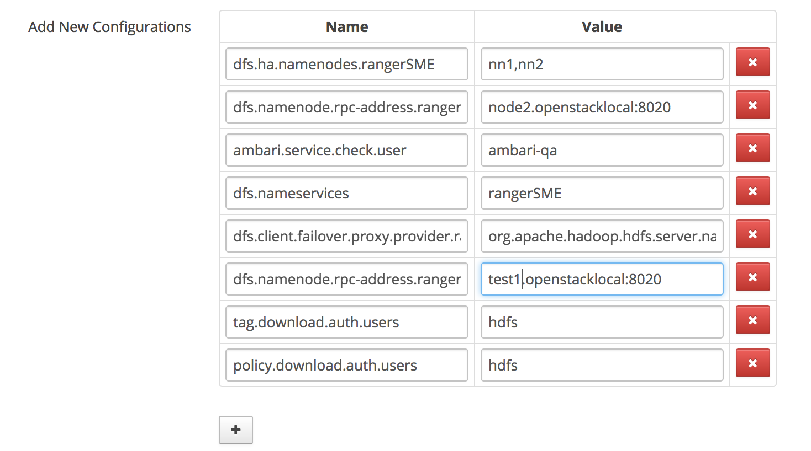

You can get those property values from /etc/hadoop/conf/hdfs-site.xml