Annual fires reduce local species richness but do not homogenize the composition of savanna woody species

Karlo G. Guidoni-Martinsa*, Leandro Maracahipesb,c, Adriano S. Melod, Marcus V. Cianciarusoe

aPrograma de Pós-Graduação em Ecologia e Evolução, Universidade Federal de Goiás, CP 131, Goiânia, GO, CEP 74001-970, Brazil

bInstituto de Pesquisa Ambiental da Amazônia (IPAM), Brasília, DF, Asa Norte CLN 211 B1 B Sala 201 - Asa Norte, CEP 70863-520, Brazil

cInstituto de Biologia, University of Campinas (UNICAMP), Campinas, SP 13083-970, Brazil

dDepartamento de Ecologia, IB, Universidade Federal do Rio Grande do Sul, Av. Bento Gonçalves 9500, Porto Alegre, RS, CEP 91501-970, Brazil

eDepartamento de Ecologia, ICB, Universidade Federal de Goiás, CP 131, Goiânia, GO, CEP 74001-970, Brazil

*Corresponding author

*[**kguidonimartins@gmail.com**](mailto:kguidonimartins@gmail.com) (K G. Guidoni-Martins), [lmaracahipes@gmail.com](mailto:lmaracahipes@gmail.com) (L. Maracahipes), [asm.adrimelo@gmail.com](mailto:asm.adrimelo@gmail.com) (A.S. Melo), [cianciaruso@gmail.com](mailto:cianciaruso@gmail.com) (M.V. Cianciaruso)

# ABSTRACT

Savanna woody species evolved with fire. However, the effect of changes in the fire regimes, which tend to increase in the next decades, is not yet fully understood. Here, we tested the effects of increased fire frequency on species richness and the composition of woody plant communities. Specifically, we tested if a high frequency fire management reduces local species richness of communities and homogenizes species composition. We sampled woody plants in 40 sites, distributed in 20 pairs, in Emas National Park (Brazil). Each pair included sites with high fire frequency (firebreaks that are burned annually since 1994) and with natural fire frequency (occurring every 3-5 years). We used a paired t-test to assess effects of the two fire frequency treatments on species richness and permutation tests to compare distance decay in similarity composition and relative abundances. We found that sites with high fire frequency had lower species richness compared to their paired sites subjected to natural fire frequency. However, similarities in species composition among sites with high fire frequency were only slightly higher than among sites subjected to natural fire frequency. The rate of distance decay in similarity was similar on the two treatments. At local scales, the high frequency of fire reduced species richness, an impact that in the long run may be irreversible. However, at broader spatial scales, effects were small as two treatments included similar sets of species. Prescribed fires have the potential to modify the natural dynamics of the woody communities in the savannas we studied. In our study, fire appears to act as a hierarchical filter, selecting species at broader spatial scales and nesting communities at local scales.

*Keywords:* beta diversity; Cerrado; fire management; Neotropical savanna

# 1. Introduction

Understanding how biological communities respond to disturbances has been one of the main goals of Ecology (Connell, 1978; Grime, 1973; McLauchlan et al., 2020; Pausas et al., 2017; Pausas and Bond, 2019). Fire is one of the principal types of disturbance and along with other factors such as grazing, climate, and soil plays a fundamental role shaping biodiversity in savanna ecosystems (Buisson et al., 2018; Pausas and Bond, 2019). Indeed, there is evidence that fire is the main factor that maintains alternative states of Neotropical savannas (Dantas et al., 2016; Pausas and Bond, 2020). Despite our knowledge about the potential of fire in altering structure and dynamics of plant communities in savannas (Cianciaruso et al., 2012; Dantas et al., 2013; Govender et al., 2006; Higgins et al., 2000; Lehmann et al., 2014; Maracahipes et al., 2014; Silva and Batalha, 2010), studies about the role of frequent fires on the spatial variation of species composition in Neotropical savannas are still lacking. Identifying how fire regimes controls the spatial structure of communities is essential to predict changes in both the species richness and composition in future climatic scenarios in which the frequency, duration, extent, and intensity of anthropogenic and wildfires are expected to increase (Bowman et al., 2009; Dale et al., 2001; Field et al., 2014).

Fire promotes landscape heterogeneity (Pausas and Ribeiro, 2017) and can lead to differences or similarities in species composition among communities (beta-diversity), via distinct mechanisms (Dantas et al., 2016; Myers et al., 2015). For example, convergence of species composition may emerge when fire selects similar sets of species [tolerant species; Laliberté et al. (2013)]. In this case, communities subjected to frequent disturbances may be composed by a subset of species from undisturbed communities [a pattern known as nestedness; Ulrich and Almeida-Neto (2012)] or by exclusively fire-resistant species. On the other hand, divergence in species composition may emerge when a disturbance interacts with environmental filters along environmental gradients (Myers et al., 2015). In the case of fire, communities along gradients may have distinct species compositions because fire effects depend on local conditions [for example, the amount of standing dry biomass (Gomes et al., 2018) which can be controlled by soil characteristics along gradients].

Changes in beta-diversity in consequence of different fire regimes are important information for fire management in protected areas. Tropical grasslands and savannas naturally burn every 2-5 years, mostly due to lightning strikes in the beginning of the rainy season (França et al., 2007; Ramos-Neto and Pivello, 2000). To prevent fire propagation inside protected areas large strips of vegetation (firebreaks) are burned annually, often during the dry season (Ramos-Neto and Pivello, 2000). This resembles the anthropogenic fire regimes that occur over large areas with native vegetation in the Cerrado (Miranda et al., 2009). The effects of the specific fire regime in firebreaks thus allow us to predict the consequences of high fire frequency on plant communities. Even if savanna plant species are adapted to natural fire that occur in the beginning of the rainy season [October – May; Bond and Midgley (2001); Gignoux et al. (1997); Gignoux et al. (2016); Pausas et al. (2017)], both high fire frequencies and burning during the dry season may deplete carbohydrate and nutrients which are essential to post-fire regrowth (Miyanishi and Kellman, 1986) and increase the mortality of savanna woody species (Hoffmann, 1996). As a consequence, recurrent anthropogenic fires should select those woody species that are extremely resistant or resilient to high fire frequencies (Cianciaruso et al., 2012).

Additionally, the spatial scale of fire occurrence is important (Bond, 2008; Pausas and Dantas, 2017). For example, high fire frequency occurring in large patches homogenizes species composition (Pausas and Verdú, 2008) and drives the functional clustering of plants (Silva and Batalha, 2010). Large and frequent fires affect the regional species pool by reducing both the chance of species to colonize open areas and the survival of species (Dickson and Foster, 2008; Lloret et al., 2005). Thus, the similarity of species composition of communities affected by large and frequent fires is expected to be high (Mouquet and Loreau, 2003). Conversely, fires occurring at local scales and in high frequencies create a mosaic landscape with habitat patches differing in frequency and time since the last fire (Burkle et al., 2015). In this scenario, annually burned patches are expected to present lower woody species richness in relation to patches experiencing natural fires [which occur in the Cerrado every 2-5 years due to lightning strikes; Júnior et al. (2014); Ramos-Neto and Pivello (2000)]. Patches under natural fires are exposed to both different fire frequencies and intensities, which selects different species groups resistant to these conditions. Contrarily, firebreaks are burned annually during the dry season with the aid of drip torches. The differences between natural fires and high frequency anthropogenic fires should lead to distinct beta diversity patterns. Annual dry season fires employed in firebreaks should homogenize species composition and cause reduced beta diversity compared to areas with natural fire regimes. Identifying these patterns in different spatial scales can reveal the processes that maintain beta diversity and improve our knowledge on the consequences of annually burned firebreaks on woody species diversity.

We tested the effect of high fire frequency (firebreaks burned annually during the dry season) on species richness and community structure of savanna woody species. We expect that species richness of the communities under high fire frequency is lower than those under natural fire regimes (areas naturally burned every 2-5 years by lightning strikes, mainly during the transition between dry to wet season). Also, high fire frequency should homogenize communities and, thus, beta diversity among communities subjected to high fire frequency should be lower than that among natural fire regimes.

# 2. Material and Methods

## *2.1 Study sites and sampling*

We conducted the study at Emas National Park (ENP), one of the largest Cerrado reserves located in the Brazilian Central Plateau (Figure 1). The park covers an area of 132,941 hectares and the vegetation is a mosaic of open savannas (68.1% of its area), woodland savannas (25.1%), wet grasslands (4.9%), and riparian and semi-deciduous forest formations (1.2%). Climate is classified as tropical humid, with dry winters (June – September) and wet summers (October – May). The annual rainfall varies from 1,200 to 2,000 mm, and the average annual temperature is 24.6 °C (Ramos-Neto and Pivello, 2000). We conducted our sampling in areas of open savannas.

The ENP was created in 1961, but was burned annually in the dry season between 1963 and 1984 to promote forage regrowth, which in that period was exploited for cattle ranching (França et al., 2007). In 1984 the park was fenced and a fire exclusion policy was applied (Ramos-Neto and Pivello, 2000). Consequently, several catastrophic wildfires occurred due to biomass accumulation. Since 1994, a network of 340 km of firebreaks is burned annually to control the spreading of fire inside the park (Ramos-Neto and Pivello, 2000). However, the firebreaks did not avoid all the uncontrolled wildfires and extensive wildfires still occur in the park. For instance, in years of extreme drought, as in 2005 and 2010 wildfires burned, respectively, 50% and 98% of the total area of the park (Silva et al., 2011).

During the wet season of 2017, we sampled 40 sites, distributed in 20 pairs along 35 km of firebreaks (Figure 1). Each pair included woody plant assemblages (shrubs and trees) subjected to two distinct fire treatments: a high fire frequency (50 m wide firebreaks burned annually since 1994 at the beginning of the dry season) and a moderate fire frequency (natural fires, burned every 3-5 years, mostly at the transition between dry and wet seasons). On average, the number of fires between 1994 and 2016 in these sites was 5.86 ± 0.52 (mean ± standard deviation). Distance between pairs varied between 1 and 34 km. In each sample site, we recorded 60 woody plant individuals. Each sample site consisted of 15 points systematically spaced 20 m from each other along a line of 300 m. In each point, we used the point-quarter method (Mueller-Dombois and Ellenberg, 1974) to sample four living woody individuals in the shrub-tree layer with at least 10 cm of diameter at ground level.

## *2.2 Data analyses*

We tested the effect of fire frequency on species richness using a paired t-test. As the number of individuals in each sample was fixed (60 individuals), standardization of sample effort using rarefaction was unnecessary. Our hypothesis regarding species richness is that high fire frequency reduces species richness and, thus, a one-tailed test was employed.

We assessed resemblance among communities subjected to natural and high fire frequencies using a permutational multivariate analysis of variance [PERMANOVA; Anderson (2001)]. This analysis is based on the partitioning of the sum of squares of dissimilarity matrices between treatments (fire frequency) and among sample pairs, as the latter takes into account the spatial structure of the sampling design. If high fire frequency changes species composition, we expect to observe a large difference in species composition between fire treatments. Dissimilarities were obtained either for species composition and community structure (species composition and relative abundances) using Sorensen and Bray-Curtis indices, respectively. Our field sampling avoided differences in abundance among samples as well as large discrepancy in abundance values. Accordingly, Bray-Curtis dissimilarities were obtained using raw abundance data. We decomposed Sorensen’s total dissimilarity into turnover and species richness differences (Baselga, 2010). Turnover represents species replacement without the influence of species richness among sampling sites along our spatial gradient. When two communities have the same number of species, the dissimilarity emerges from differences in species identity between those communities. In this case, Sorensen’s total dissimilarity is equal to Simpson’s dissimilarity (Baselga, 2010). Thus, we refer to our results based on turnover as Simpson (turnover). In contrast, species richness difference informs that communities differ in species richness. For instance, even if all species in one site are present in the other site, differences may occur as the species rich site includes species not observed in the species poor site. When that difference occurs orderly (i.e., when one community has a subset of species richness from another community), this phenomenon is classified as nestedness (Baselga, 2010). Nestedness is calculated by subtracting Simpson’s dissimilarity from Sorensen’s total dissimilarity (Baselga, 2010). We refer to our results based on species richness difference as richness difference (nestedness).

We used two approaches to test the effect of fire frequency on beta diversity among communities. First, we used the multivariate dispersion analysis to verify the homogeneity of dissimilarity values within the treatments [PERMDISP; Anderson (2006)]. If high fire frequencies homogenize communities, we may expect lower overall dissimilarity among sites subjected to high fire frequency (i.e., low dispersion in the ordination) compared to those dissimilarities among sites subjected to natural fire regimes. PERMDISP does not allow inclusion of a second predictor and, thus, it was not possible to take spatial effects into account. In our second approach, however, we took space into account by using distance decay in similarity analyses. We regressed (Ordinary Least Square) the similarities (1 - dissimilarity) against the Euclidean distances of spatial coordinates pairwise sites within each fire frequency to assess how similarities within each fire treatment decay with distance and, thus, only within-treatment similarities were used. Because similarity values were not independent to each other (samples were used multiple times), we used a permutation procedure to estimate probabilities that differences in intercept and slope between the two fire treatments were produced by chance. In our permutation procedure, the triangular matrices of similarities calculated separately for the two treatments were unfolded into a single vector. The same procedure was repeated for spatial distances, which were paired with their respective similarities. We adjusted linear regression models (similarities against spatial distances) for each treatment group, obtained the coefficients for intercept and slope and recorded the differences between the two treatments. Next, we permuted labels of the two treatment groups, maintaining each similarity value paired with its respective spatial distance. Regressions were fit and differences in coefficients of permuted groups recorded. We repeated this procedure 9999 times and estimated the chance the observed differences in coefficients were generated simply by chance as the proportion of differences obtained in the 9999 permutation that were equal or more extreme than those obtained using the original data (two-tailed test). If high fire frequency homogenizes species composition, we expect to observe a flat relationship between similarities within high fire frequency and spatial distances while observing a distance-decay relationship between similarities within natural fire frequency and spatial distances. Thus, our regression results should present significant differences between intercept and slope coefficients of fire treatments. PERMDISP and the similarity decay analyses were done using the Sorensen and Bray-Curtis dissimilarities as well as the Simpson (turnover) and species richness difference (nestedness) components of the former.

All analyses were done using the R environment (R Core Team, 2019). Multivariate analyses (dissimilarity matrices, PERMANOVA, and PERMDISP) were done using the *vegan* and *betapart* packages (Baselga et al., 2018; Oksanen et al., 2019). We wrote R scripts to compute the permutation tests.

# 3. Results

We recorded a total of 2400 tree and shrub individuals (60 individuals in each of the 40 sampling units) distributed among 59 woody species (Table A1). A total of 58 and 47 woody species were sampled in sites with the natural fire and high fire frequencies treatments, respectively. Most samples under natural fire frequency had higher woody species richness than their counterparts under high fire frequency (16 out of 20 pairs; *t*19 = 2.56, *p* = 0.009; Figure 2). Thus, we corroborate the hypothesis that communities under high fire frequency have lower species richness at both local (paired sites) and regional (overall species richness in the two treatments) scales.

We found that, after taking into account spatial effects using the paired sampling design, fire frequency changed community composition and structure (Table 1). Yet, the effects were small compared to the high variation in species composition and structure due to space (Figure 3). In fact, communities under high fire frequency were almost totally superposed on the multivariate space defined by communities under natural fire frequency, indicating they have only slightly dissimilar species composition (Figure 3).

Dispersion of samples in the ordination space was similar for the two treatments, indicating they have overall similar beta diversity (Table 2; Figure 3). The slopes of the distance decay of similarity were similar for the two fire frequency treatments (Table 3; Figure 4). Similarity in species composition among samples subjected to high fire regime was slightly higher than among those samples subjected to natural fire frequency except for the species richness difference components of Sorensen index (Figure 4; Table 3). Yet, species composition changed more in function of the spatial distance than in function of fire frequency (Figure 4). Unexpectedly, similarity due to differences in species richness increased with the distance (Figure 4).

# 4. Discussion

We investigated differences between sites with high fire frequency (annual fires) and with natural fire frequency (burned every 3 to 5 years) regarding woody species richness and woody species community composition in a Neotropical savanna. We found that high fire frequency reduces woody species richness locally, leading to a subset of species from sites with natural fire frequency (Figure 2). Also, total number of woody species observed in all high fire frequency samples (47) was lower than that observed in natural fire regime (58). Similarity between samples in the high fire treatment tended to be slightly higher and significant than between those under natural fire frequency when controlled for spatial distances. Yet, even if firebreaks are burned during the dry season and at much higher frequency than natural fires, this did not affect the overall woody species composition at the larger scales, encompassing all samples irrespective of spatial distance (Figure 3. The decay of similarity of the woody species composition with the spatial distance was similar for the two fire frequencies (Figure 4).

These results reveal that the fire management done in ENP may have small effects on the homogenization of woody species composition (i.e., species composition under different fire frequencies are similar). However, annual burns in the firebreaks reduce woody species richness at local and regional scales. This indicates that high fire frequency resulted in local communities that were a subset of the nearby communities under natural fire frequency. Cerrado woody species have fire-adaptative traits that allow their establishment, persistence, and reproduction even under severe fire conditions (Batalha et al., 2011; Cianciaruso et al., 2012). However, repeated annual fires at the dry season can extirpate species from local communities by preventing individuals to attain high heights, stem diameter, and thick bark, important traits related to fire-escape in savannas (Hoffmann et al., 2012; Maracahipes et al., 2018; Medeiros and Miranda, 2008). In addition, as most of the species concentrates seed maturation in the beginning of the wet season, dry season fire can have negative impacts for their population dynamics (Hoffmann, 1998; Hoffmann and Moreira, 2002). Because frequent fire reduces the plant height and basal area (Medeiros and Miranda, 2008), our results suggest that the species impoverishment in areas under high fire frequency maybe a consequence of tree topkill, in which vegetative and reproductive structures of woody species are constantly removed by fire (Hoffmann et al., 2009; Souchie et al., 2017). Even if savanna woody species have traits that enable them to resist fire, these traits usually are not present in saplings or juveniles. For example, in early ontogenetic stages, woody plants do not have sufficient thick bark to escape fire (Maracahipes et al., 2018; Pausas, 2015). Our sampling strategy, which recorded individuals with a diameter above 10 cm, likely did not include those juveniles. However, the fact that the fire management is conducted during the dry season may result in harsher conditions to species establishment and survival (Rissi et al., 2017). During the dry season, high air temperatures coupled with low soil humidity can make fires more severe for species in the firebreaks, so we cannot expect high seedling recruitment of woody species. In the long term, some species submitted to these conditions can no longer persist and establish in these areas due to the mismatch between anthropogenic fire regime and their natural population dynamics (Hoffmann and Moreira, 2002).

At the regional scale, we did not observe differences in the community structure (species composition and relative abundances) between the areas with natural and high fire frequency (Figure 3). Cerrado woody species have evolved under fire (Pausas and Ribeiro, 2017; Simon and Pennington, 2012), but we expected a negative effect of the high fire frequency for the beta diversity. Our results reinforce previous findings (Cianciaruso et al., 2012; Scalon et al., 2019; Simon and Pennington, 2012) about the convergence of species strategies to deal with fire; surprisingly, even in high fire frequency, the differences in community structure did not change. However, both modeling and observational studies have found structural changes of the communities when under different fire frequency (Dantas et al., 2013; Hoffmann, 1999). For instance, individuals tend to have reduced stem size due to the repeated topkilling under high fire frequency. Furthermore, as stem size is closely related to plant survival, reproduction, and growth (Bond and van Wilgen, 1996), it is probable that despite surviving in the firebreaks these individuals are not reproducing (Zirondi et al., 2021). The effects of high fire frequency on woody species reproduction is still an open question that deserves future investigation to best understand the consequences of fire management and species response to anthropogenic fires that are becoming larger and more frequent.

Contrary to our expectation, fire had no effect in changing woody community structure at our larger scale (entire study). The decay of similarity of species composition among communities along spatial distances is known for this savanna (Dantas et al., 2015) and for others vegetation types (Nekola and White, 1999; Reilly et al., 2006a). Our results indicate that the decay rate (slope) of these relationships were similar for the two fire treatments and the mean similarity were only slightly higher in the high fire frequency. Other factors can act shaping the beta diversity along spatial gradients. Soil features, nutrient and water availability, and topography can interact with fire frequency generating changes in species composition (Batalha et al., 2011; Dantas et al., 2015). Also, since fire occurs in a patchy way, communities protected from fire are a source of new individuals that can colonize the new areas opened by fire, thus influencing the species turnover (Catano et al., 2017; Reilly et al., 2006b). Due the effect of recurrent fire on the sexual reproduction of shrubs and trees (Hoffmann and Moreira, 2002), this distance-decay pattern also can be generated by dispersal limitation (species recruitment mostly by resprouting).

# 5. Conclusions

Understanding the effect of fire on diversity is important to both theoretical and practical perspectives. Identifying how ecological communities respond to fire can help us to predict future scenarios in which the frequency of this disturbance is likely to increase. Also, this knowledge can serve to inform management of fire-prone vegetation. Here, we found that fire had an important effect on species richness of woody plants at local and regional scales. Yet, fire had only subtle effects on the homogenization of this savanna. Thus, fire seems to act as a hierarchical filter, selecting species from the species pool at regional scales and decreasing species richness at local scales. It should be noted, however, that our high frequency fire samples were immersed in a landscape of natural fire regimes. Increased fire frequencies expected to occur under future climate and that will affect vast areas should produce stronger effects.

# Acknowledgements

ASM and MVC received fellowship from Conselho Nacional de Desenvolvimento Científico e Tecnológico (CNPq, no. 307587/2017-7 and 306590/2018-2). This study was partially funded by Coordenação de Aperfeiçoamento de Pessoal de Nível Superior - Brasil (CAPES) - Finance Code 001, CNPq – PELD Sítio 13 (441214/2016-9) and FAPEG. We thank Cleber ten Caten and Ismaiara Vaz for helping us in the field. We also thank the two anonymous reviewers and the subject editor for suggestions to improve our manuscript.

# Research data

Data, text, and code to reproduce analyses, figures, and the entire manuscript itself are available at the following link: <https://github.com/kguidonimartins/betadiv-enp>

# References

Anderson, M.J., 2006. Distance-based tests for homogeneity of multivariate dispersions. Biometrics 62, 245–53. <https://doi.org/10.1111/j.1541-0420.2005.00440.x>

Anderson, M.J., 2001. A new method for non-parametric multivariate analysis of variance. Austral Ecol. 26, 32–46. <https://doi.org/10.1111/j.1442-9993.2001.01070.pp.x>

Baselga, A., 2010. Partitioning the turnover and nestedness components of beta diversity. Global Ecol. Biogeogr. 19, 134–143. <https://doi.org/10.1111/j.1466-8238.2009.00490.x>

Baselga, A., Orme, D., Villeger, S., De Bortoli, J., Leprieur, F., 2018. betapart: Partitioning beta diversity into turnover and nestedness components.

Batalha, M.A., Silva, I.A., Cianciaruso, M.V., França, H., de Carvalho, G.H., 2011. Phylogeny, traits, environment, and space in cerrado plant communities at Emas National Park (Brazil). Flora 206, 949–956. <https://doi.org/10.1016/j.flora.2011.07.004>

Bond, William.J., van Wilgen, B.W., 1996. Fire and plants, First. ed, Population and Community Biology Series. Chapman and Hall, London.

Bond, W.J., 2008. What limits trees in C $​_{4}$ grasslands and savannas? Annu. Rev. Ecol. Evol. Syst 39, 641–59. <https://doi.org/10.1146/annurev.ecolsys.39.110707.173411>

Bond, W.J., Midgley, J.J., 2001. Ecology of sprouting in woody plants: The persistence niche. Trends Ecol. Evol. 16, 45–51. <https://doi.org/10.1016/S0169-5347(00)02033-4>

Bowman, D.M.J.S., Balch, J.K., Artaxo, P., Bond, W.J., Carlson, J.M., Cochrane, M.A., D’Antonio, C.M., DeFries, R.S., Doyle, J.C., Harrison, S.P., Johnston, F.H., Keeley, J.E., Krawchuk, M.A., Kull, C.A., Marston, J.B., Moritz, M.A., Prentice, I.C., Roos, C.I., Scott, A.C., Swetnam, T.W., van der Werf, G.R., Pyne, S.J., 2009. Fire in the earth system. Science 324, 481–484. <https://doi.org/10.1126/science.1163886>

Buisson, E., Le Stradic, S., Silveira, F.A.O., Durigan, G., Overbeck, G.E., Fidelis, A., Fernandes, G.W., Bond, W.J., Hermann, J.-M., Mahy, G., Alvarado, S.T., Zaloumis, N.P., Veldman, J.W., 2018. Resilience and restoration of tropical and subtropical grasslands, savannas, and grassy woodlands: Tropical grassland resilience and restoration. Biol. Rev. 94, 590–609. <https://doi.org/10.1111/brv.12470>

Burkle, L.A., Myers, J.A., Belote, R.T., Peters, D.P.C., 2015. Wildfire disturbance and productivity as drivers of plant species diversity across spatial scales. Ecosphere 6. <https://doi.org/10.1890/ES15-00438.1>

Catano, C.P., Dickson, T.L., Myers, J.A., 2017. Dispersal and neutral sampling mediate contingent effects of disturbance on plant beta-diversity: A meta-analysis. Ecol. Lett. 20, 347–356. <https://doi.org/10.1111/ele.12733>

Cianciaruso, M.V., Silva, I.A., Batalha, M.A., Gaston, K.J., Petchey, O.L., 2012. The influence of fire on phylogenetic and functional structure of woody savannas: Moving from species to individuals. Perspect. Plant Ecol. Evol. Syst. 14, 205–216. <https://doi.org/10.1016/j.ppees.2011.11.004>

Connell, J.H., 1978. Diversity in tropical rain forests and coral reefs. Science 199, 1302–1310. <https://doi.org/10.1126/science.199.4335.1302>

Dale, V.H., Joyce, L.A., McNulty, S., Neilson, R.P., Ayres, M.P., Flannigan, M.D., Hanson, P.J., Irland, L.C., Lugo, A.E., Peterson, C.J., Simberloff, D., Swanson, F.J., Stocks, B.J., Wotton, B.M., 2001. Climate change and forest disturbances. BioScience 51, 723–734. <https://doi.org/10.1641/0006-3568(2001)051[0723:CCAFD]2.0.CO;2>

Dantas, V. de L., Batalha, M.A., França, H., Pausas, J.G., 2015. Resource availability shapes fire-filtered savannas. J. Veg. Sci. 26, 395–403. <https://doi.org/10.1111/jvs.12247>

Dantas, V. de L., Hirota, M., Oliveira, R.S., Pausas, J.G., 2016. Disturbance maintains alternative biome states. Ecol. Lett. 19, 12–19. <https://doi.org/10.1111/ele.12537>

Dantas, V. de L., Pausas, J.G., Batalha, M.A., de Paula Loiola, P., Cianciaruso, M.V., 2013. The role of fire in structuring trait variability in Neotropical savannas. Oecologia 171, 487–494. <https://doi.org/10.1007/s00442-012-2431-8>

Dickson, T.L., Foster, B.L., 2008. The relative importance of the species pool, productivity and disturbance in regulating grassland plant species richness: A field experiment. J. Ecol. 96, 937–946. <https://doi.org/10.1111/j.1365-2745.2008.01420.x>

Field, C.B., Barros, V.R., Mach, K.J., Mastrandrea, M.D., Dokken, D.J., 2014. Climate change 2014: Impacts, adaptation and vulnerability: Working Group II Contribution to the IPCC Fifth Assessment Report of the Integovernmental Panel on Climate Change. Cambridge University Press, Cambridge. <https://doi.org/10.1017/CBO9781107415386>

França, H., Ramos Neto, M.B., Setzer, A.W., 2007. O fogo no Parque Nacional das Emas, Biodiversidade. Ministério do Meio Ambiente, Secretaria de Biodiversidade e Florestas, Brasília, DF.

Gignoux, J., Clobert, J., Menaut, J.-C., 1997. Alternative fire resistance strategies in savanna trees. Oecologia 110, 576–583. <https://doi.org/10.1007/s004420050198>

Gignoux, J., Konaté, S., Lahoreau, G., Le Roux, X., Simioni, G., 2016. Allocation strategies of savanna and forest tree seedlings in response to fire and shading: Outcomes of a field experiment. Sci. Rep. 6, 38838. <https://doi.org/10.1038/srep38838>

Gomes, L., Miranda, H.S., Bustamante, M.M. da C., 2018. How can we advance the knowledge on the behavior and effects of fire in the Cerrado biome? Forest Ecol. Manag. 417, 281–290. <https://doi.org/10.1016/j.foreco.2018.02.032>

Govender, N., Trollope, W.S.W., Wilgen, B.W.V., 2006. The effect of fire season, fire frequency, rainfall and management on fire intensity in savanna vegetation in south africa. Journal of Applied Ecology 43, 748–758. <https://doi.org/10.1111/j.1365-2664.2006.01184.x>

Grime, J.P., 1973. Competitive exclusion in herbaceous vegetation. Nature 242, 344–347. <https://doi.org/10.1038/242344a0>

Higgins, S.I., Bond, W.J., Trollope, W.S.W., 2000. Fire, resprouting and variability: A recipe for grass-tree coexistence in savanna. J. Ecol. 88, 213–229. <https://doi.org/10.1046/j.1365-2745.2000.00435.x>

Hoffmann, W.A., 1999. Fire and population dynamics of woody plants in a neotropical savanna: Matrix model projections. Ecology 80, 1354–1369. <https://doi.org/10.1890/0012-9658(1999)080[1354:FAPDOW]2.0.CO;2>

Hoffmann, W.A., 1998. Post-burn reproduction of woody plants in a neotropical savanna: The relative importance of sexual and vegetative reproduction. J. Appl. Ecol. 35, 422–433. <https://doi.org/10.1046/j.1365-2664.1998.00321.x>

Hoffmann, W.A., 1996. The effects of fire and cover on seedling establishment in a neotropical savanna. J. Ecol. 84, 383. <https://doi.org/10.2307/2261200>

Hoffmann, W.A., Adasme, R., Haridasan, M., T. de Carvalho, M., Geiger, E.L., Pereira, M.A.B., Gotsch, S.G., Franco, A.C., 2009. Tree topkill, not mortality, governs the dynamics of savanna-forest boundaries under frequent fire in central Brazil. Ecology 90, 1326–1337. <https://doi.org/10.1890/08-0741.1>

Hoffmann, W.A., Geiger, E.L., Gotsch, S.G., Rossatto, D.R., Silva, L.C.R., Lau, O.L., Haridasan, M., Franco, A.C., 2012. Ecological thresholds at the savanna-forest boundary: How plant traits, resources and fire govern the distribution of tropical biomes. Ecol. Lett. 15, 759–768. <https://doi.org/10.1111/j.1461-0248.2012.01789.x>

Hoffmann, W.A., Moreira, A.G., 2002. The role of fire in population dynamics of woody plants, in: The Cerrados of Brazil: Ecology and Natural History of a Neotropical Savanna. pp. 159–177.

Júnior, A.C.P., Oliveira, S.L.J., Pereira, J.M.C., Turkman, M.A.A., 2014. Modelling fire frequency in a cerrado savanna protected area. PLoS ONE 9, e102380. <https://doi.org/10.1371/journal.pone.0102380>

Laliberté, E., Norton, D., Scott, D., 2013. Contrasting effects of productivity and disturbance on plant functional diversity at local and metacommunity scales. J. Veg. Sci. 24, 834–842. <https://doi.org/10.1111/jvs.12044>

Lehmann, C.E.R., Anderson, T.M., Sankaran, M., Higgins, S.I., Archibald, S., Hoffmann, W.A., Hanan, N.P., Williams, R.J., Fensham, R.J., Felfili, J., Hutley, L.B., Ratnam, J., Jose, J.S., Montes, R., Franklin, D., Russell-Smith, J., Ryan, C.M., Durigan, G., Hiernaux, P., Haidar, R., Bowman, D.M.J.S., Bond, W.J., 2014. Savanna vegetation-fire-climate relationships differ among continents. Science 343, 548–552. <https://doi.org/10.1126/science.1247355>

Lloret, F., Estevan, H., Vayreda, J., Terradas, J., 2005. Fire regenerative syndromes of forest woody species across fire and climatic gradients. Oecologia 146, 461–468. <https://doi.org/10.1007/s00442-005-0206-1>

Maracahipes, L., Carlucci, M.B., Lenza, E., Marimon, B.S., Marimon, B.H., Guimarães, F.A.G., Cianciaruso, M.V., 2018. How to live in contrasting habitats? Acquisitive and conservative strategies emerge at inter- and intraspecific levels in savanna and forest woody plants. Perspect. Plant Ecol. Evol. Syst. 34, 17–25. <https://doi.org/10.1016/j.ppees.2018.07.006>

Maracahipes, L., Marimon, B.S., Lenza, E., Marimon-Junior, B.H., de Oliveira, E.A., Mews, H.A., Gomes, L., Feldpausch, T.R., 2014. Post-fire dynamics of woody vegetation in seasonally flooded forests (impucas) in the Cerrado-Amazonian Forest transition zone. Flora 209, 260–270. <https://doi.org/10.1016/j.flora.2014.02.008>

McLauchlan, K.K., Higuera, P.E., Miesel, J., Rogers, B.M., Schweitzer, J., Shuman, J.K., Tepley, A.J., Varner, J.M., Veblen, T.T., Adalsteinsson, S.A., Balch, J.K., Baker, P., Batllori, E., Bigio, E., Brando, P., Cattau, M., Chipman, M.L., Coen, J., Crandall, R., Daniels, L., Enright, N., Gross, W.S., Harvey, B.J., Hatten, J.A., Hermann, S., Hewitt, R.E., Kobziar, L.N., Landesmann, J.B., Loranty, M.M., Maezumi, S.Y., Mearns, L., Moritz, M., Myers, J.A., Pausas, J.G., Pellegrini, A.F.A., Platt, W.J., Roozeboom, J., Safford, H., Santos, F., Scheller, R.M., Sherriff, R.L., Smith, K.G., Smith, M.D., Watts, A.C., 2020. Fire as a fundamental ecological process: Research advances and frontiers. J. Ecol. 108, 2047–2069. <https://doi.org/10.1111/1365-2745.13403>

Medeiros, M.B., Miranda, H.S., 2008. Post-fire resprouting and mortality in cerrado woody plant species over a three-year period. Edinb. J. Bot. 65, 53–68. <https://doi.org/10.1017/S0960428608004708>

Miranda, H.S., Sato, M.N., Neto, W.N., Aires, F.S., 2009. Fires in the cerrado, the Brazilian savanna, in: Tropical Fire Ecology. Springer Berlin Heidelberg, Berlin, Heidelberg, pp. 427–450. <https://doi.org/10.1007/978-3-540-77381-8_15>

Miyanishi, K., Kellman, M., 1986. The role of root nutrient reserves in regrowth of two savanna shrubs. Can. J. Botany 64, 1244–1248. <https://doi.org/10.1139/b86-171>

Mouquet, N., Loreau, M., 2003. Community patterns in source-sink metacommunities. Am. Nat. 162, 544–557. <https://doi.org/10.1086/378857>

Mueller-Dombois, D., Ellenberg, H., 1974. Aims and methods of vegetation ecology. John Wiley & Sons, Inc.

Myers, J.A., Chase, J.M., Crandall, R.M., Jiménez, I., 2015. Disturbance alters beta-diversity but not the relative importance of community assembly mechanisms. J. of Ecol. 103, 1291–1299. <https://doi.org/10.1111/1365-2745.12436>

Nekola, J.C., White, P.S., 1999. The distance decay of similarity in biogeography and ecology. J. Biogeogr. 26, 867–878. <https://doi.org/10.1046/j.1365-2699.1999.00305.x>

Oksanen, J., Blanchet, F.G., Friendly, M., Kindt, R., Legendre, P., McGlinn, D., Minchin, P.R., O’Hara, R.B., Simpson, G.L., Solymos, P., Stevens, M.H.H., Szoecs, E., Wagner, H., 2019. vegan: Community Ecology Package.

Pausas, J.G., 2015. Bark thickness and fire regime. Funct. Ecol. 29, 315–327. <https://doi.org/10.1111/1365-2435.12372>

Pausas, J.G., Bond, W.J., 2020. On the three major recycling pathways in terrestrial ecosystems. Trends Ecol. Evol. 35, 767–775. <https://doi.org/10.1016/j.tree.2020.04.004>

Pausas, J.G., Bond, W.J., 2019. Humboldt and the reinvention of nature. J. Ecol. 107, 1031–1037. <https://doi.org/10.1111/1365-2745.13109>

Pausas, J.G., Dantas, V.D.L., 2017. Scale matters: Fire-vegetation feedbacks are needed to explain tropical tree cover at the local scale. Global Ecol. Biogeogr. 26, 395–399. <https://doi.org/10.1111/geb.12562>

Pausas, J.G., Keeley, J.E., Schwilk, D.W., 2017. Flammability as an ecological and evolutionary driver. J. Ecol. 105, 289–297. <https://doi.org/10.1111/1365-2745.12691>

Pausas, J.G., Ribeiro, E., 2017. Fire and plant diversity at the global scale. Global Ecol. Biogeogr. 5, 1–17. <https://doi.org/10.1111/geb.12596>

Pausas, J.G., Verdú, M., 2008. Fire reduces morphospace occupation in plant communities. Ecology 89, 2181–2186. <https://doi.org/10.1890/07-1737.1>

R Core Team, 2019. R: A language and environment for statistical computing. R Foundation for Statistical Computing, Vienna, Austria.

Ramos-Neto, M.B., Pivello, V.R., 2000. Lightning fires in a brazilian savanna national park: Rethinking management strategies. Environ. Manage. 26, 675–684. <https://doi.org/10.1007/s002670010124>

Reilly, M.J., Wimberly, M.C., Newell, C.L., 2006a. Wildfire effects on $β$-diversity and species turnover in a forested landscape. J. Veg. Sci. 17, 447–454. <https://doi.org/10.1658/1100-9233(2006)17[447:WEODAS]2.0.CO;2>

Reilly, M.J., Wimberly, M.C., Newell, C.L., 2006b. Wildfire effects on plant species richness at multiple spatial scales in forest communities of the southern Appalachians. J. Ecol. 94, 118–130. <https://doi.org/10.1111/j.1365-2745.2005.01055.x>

Rissi, M.N., Baeza, M.J., Gorgone-Barbosa, E., Zupo, T., Fidelis, A., 2017. Does season affect fire behaviour in the cerrado? Int. J. Wildland Fire 26, 427. <https://doi.org/10.1071/wf14210>

Scalon, M.C., Domingos, F.M.C.B., Cruz, W.J.A. da, Júnior, B.H.M., Marimon, B.S., Oliveras, I., 2019. Diversity of functional trade-offs enhances survival after fire in neotropical savanna species. J. Veg. Sci. 31, 139–150. <https://doi.org/10.1111/jvs.12823>

Silva, D.M. da, Loiola, P. de P., Rosatti, N.B., Silva, I.A., Cianciaruso, M.V., Batalha, M.A., 2011. Os efeitos dos regimes de fogo sobre a vegetação de Cerrado no Parque Nacional das Emas, GO: Considerações para a conservação da diversidade. Número Temático: Ecologia e Manejo de Fogo em Áreas Protegidas 26, 26–39.

Silva, I.A., Batalha, M.A., 2010. Woody plant species co-occurrence in Brazilian savannas under different fire frequencies. Acta Oecol. 36, 85–91. <https://doi.org/10.1016/j.actao.2009.10.004>

Simon, M.F., Pennington, T., 2012. Evidence for adaptation to fire regimes in the tropical savannas of the Brazilian Cerrado. Int. J. Plant Sci. 173, 711–723. <https://doi.org/10.1086/665973>

Souchie, F.F., Pinto, J.R.R., Lenza, E., Gomes, L., Maracahipes-Santos, L., Silvério, D.V., 2017. Post-fire resprouting strategies of woody vegetation in the Brazilian savanna. Acta Bot. Bras. 31, 260–266. <https://doi.org/10.1590/0102-33062016abb0376>

Ulrich, W., Almeida-Neto, M., 2012. On the meanings of nestedness: Back to the basics. Ecography 35, 865–871. <https://doi.org/10.1111/j.1600-0587.2012.07671.x>

Zirondi, H.L., Ooi, M.K.J., Fidelis, A., 2021. Fire‐triggered flowering is the dominant post‐fire strategy in a tropical savanna. J. Veg. Sci. 32. <https://doi.org/10.1111/jvs.12995>

# Tables

Table 1: Results of PERMANOVA analyses. After taking into account spatial effects using the paired sampling design, fire frequency has a small effect in community composition and structure. No effect was found on richness difference.

| Similarity | Predictor | Degrees of freedom | *F* | R2 | *P*-value |
| --- | --- | --- | --- | --- | --- |
| Sorensen | Fire frequency | 1 | 3.55 | 0.05 | <0.001 |
|  | Pairs | 19 | 2.86 | 0.71 | <0.001 |
| Simpson (turnover) | Fire frequency | 1 | 3.51 | 0.04 | 0.010 |
|  | Pairs | 19 | 3.24 | 0.73 | <0.001 |
| Richness difference (nestedness) | Fire frequency | 1 | 4.40 | 0.08 | 0.070 |
|  | Pairs | 19 | 1.69 | 0.58 | 0.170 |
| Bray-Curtis | Fire frequency | 1 | 3.19 | 0.04 | <0.001 |
|  | Pairs | 19 | 3.11 | 0.73 | <0.001 |

Table 2: Results of PERMDISP analyses. Dispersion of dissimilarities did not differ between fire frequencies. Degrees of freedom is 1 for the fire frequency and 38 for the residuals.

| Similarity | *F* | *P*-value |
| --- | --- | --- |
| Sorensen | 1.359 | 0.266 |
| Simpson (turnover) | 1.643 | 0.189 |
| Richness difference (nestedness) | 0.626 | 0.454 |
| Bray-Curtis | 1.967 | 0.163 |

Table 3: Results of the permutation procedure to compare intercepts and slopes of the distance decay in similarity relationships in natural and high fire frequencies treatments. Similarity in both treatments tended to decrease with distance. No effect was found on richness difference.

| Similarity | Intercept difference | *P*-value intercept | Slope difference | *P*-value slope |
| --- | --- | --- | --- | --- |
| Sorensen | 0.044 | 0.010 | -0.039 | 0.706 |
| Simpson (turnover) | 0.062 | 0.001 | -0.060 | 0.614 |
| Richness difference (nestedness) | -0.018 | 0.095 | 0.021 | 0.709 |
| Bray-Curtis | 0.036 | 0.049 | 0.101 | 0.347 |

# Captions

Figure 1: Location of the sampling pairs (white squares) in the Emas National Park (ENP), GO, Brazil. Pairs were located at least 1 km apart. The figure at the top right indicates the location of ENP (white circle) within the Cerrado biome (dark gray) in South America (light gray).

Figure 2: Paired comparison of woody species richness between communities under natural fire frequency and high frequency of fire. Dashed line represents pairs of sites in which woody species richness was greater in higher fire frequency than in natural fire frequency. Circles representing sampling sites with the same woody species richness are overlaid (darker gray). In general, communities under natural fire frequency were richer than communities under high fire frequency.

Figure 3: PCoA ordination of woody plant community structure in samples subjected to high and natural fire frequencies. Lines connect pairs of sampling units (each sampling unit under a different fire frequency). There is no difference in dissimilarities’ dispersion between natural and high fire frequency, regardless of the dissimilarity index.

Figure 4: Similarity decay of woody species communities along our spatial gradient. Each point represents a comparison pair of the distance matrix. Similarities in both high and natural fire regimes decreased in the same rate with spatial distance, except for the Richness difference.

# Figures

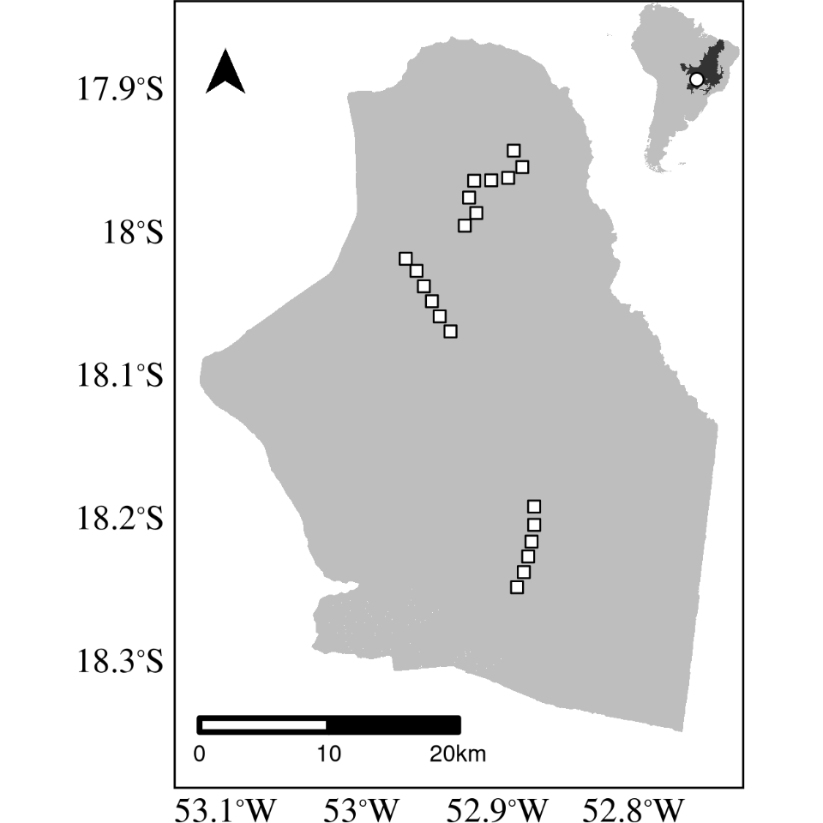

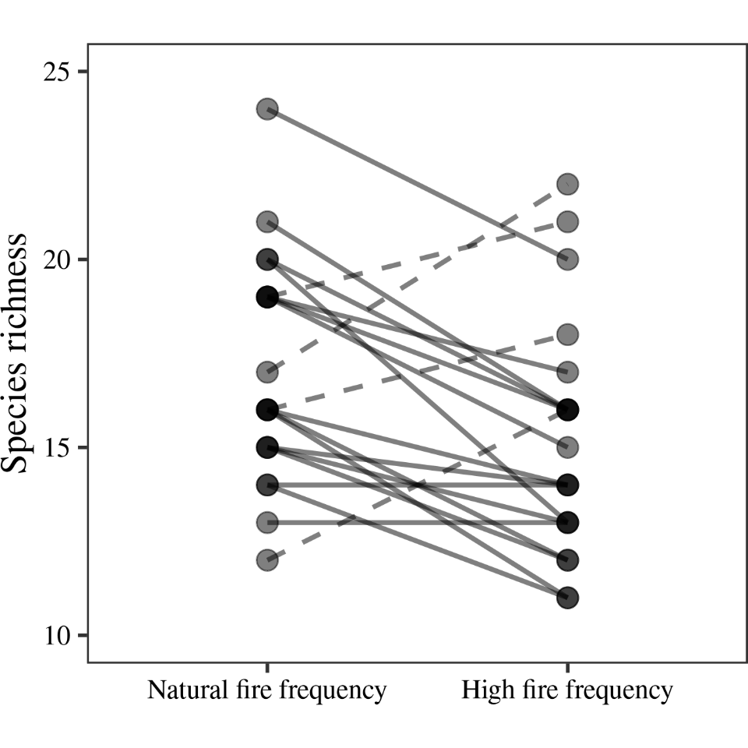

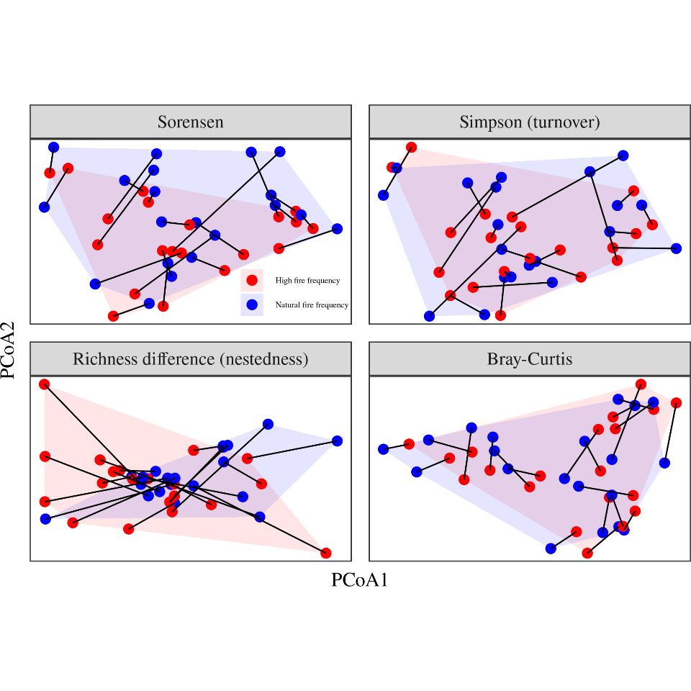

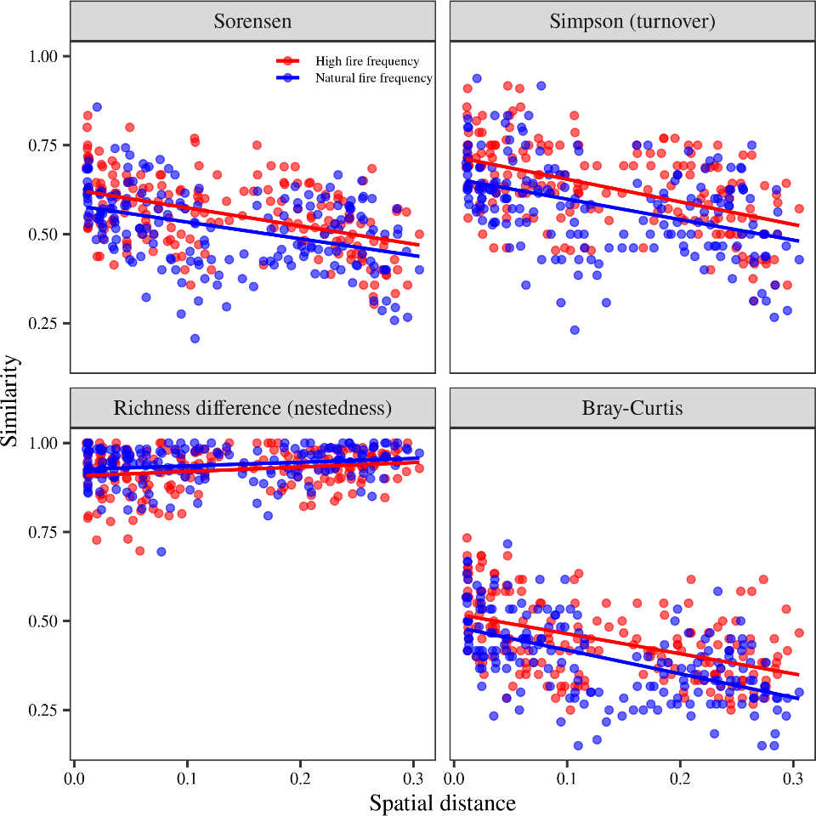

# Appendix

Table A1: Species abundances in the high and natural fire frequency regimes.

| Species | High fire frequency (firebreaks) | Natural fire frequency |
| --- | --- | --- |
| *Agonandra brasiliensis* Miers ex Benth. & Hook.f. | 0 | 2 |
| *Anadenanthera peregrina* var. falcata (Benth.) Altschul | 44 | 38 |
| *Annona crassiflora* Mart. | 35 | 30 |
| *Aspidosperma tomentosum* Mart. & Zucc. | 2 | 16 |
| *Bowdichia virgilioides* Kunth | 0 | 1 |
| *Byrsonima coccolobifolia* Kunth | 7 | 3 |
| *Caryocar brasiliense* Cambess. | 0 | 5 |
| *Casearia sylvestris* Sw. | 6 | 13 |
| *Connarus suberosus* Planch. | 23 | 42 |
| *Cybistax antisyphilitica* (Mart.) Mart. | 1 | 2 |
| *Davilla elliptica* A.St.-Hil. | 1 | 9 |
| *Didymopanax macrocarpus* (Cham. & Schltdl.) Seem. | 1 | 3 |
| *Didymopanax vinosus* (Cham. & Schltdl.) Marchal | 0 | 1 |
| *Dimorphandra mollis* Benth. | 8 | 5 |
| *Diospyros lasiocalyx* (Mart.) B.Walln. | 38 | 59 |
| *Eremanthus glomerulatus* Less. | 32 | 63 |
| *Eriotheca gracilipes* (K.Schum.) A.Robyns | 4 | 10 |
| *Eriotheca pubescens* (Mart. & Zucc.) Schott & Endl. | 13 | 17 |
| *Erythroxylum engleri* O.E.Schulz | 20 | 15 |
| *Erythroxylum suberosum* A.St.-Hil. | 21 | 22 |
| *Erythroxylum tortuosum* Mart. | 2 | 8 |
| *Eugenia aurata* O.Berg | 0 | 3 |
| *Eugenia punicifolia* (Kunth) DC. | 1 | 2 |
| *Guapira noxia* (Netto) Lundell | 8 | 4 |
| *Hancornia speciosa* Gomes | 1 | 1 |
| *Handroanthus ochraceus* (Cham.) Mattos | 22 | 60 |
| *Himatanthus obovatus* (Müll. Arg.) Woodson | 5 | 3 |
| *Hymenaea stigonocarpa* Mart. ex Hayne | 2 | 2 |
| *Kielmeyera coriacea* Mart. & Zucc. | 36 | 37 |
| *Kielmeyera grandiflora* (Wawra) Saddi | 3 | 2 |
| *Lafoensia pacari* A.St.-Hil. | 0 | 2 |
| *Leptolobium dasycarpum* Vogel | 81 | 42 |
| *Machaerium acutifolium* Vogel | 1 | 4 |
| *Miconia albicans* (Sw.) Triana | 0 | 45 |
| *Miconia ferruginata* DC. | 0 | 2 |
| *Miconia ligustroides* (DC.) Naudin | 0 | 2 |
| *Myrcia bella* Cambess. | 9 | 5 |
| *Myrcia camapuanensis* N.Silveira | 6 | 4 |
| *Myrcia guianensis* (Aubl.) DC. | 6 | 1 |
| *Myrcia variabilis* DC. | 2 | 1 |
| *Ouratea hexasperma* (A.St.-Hil.) Baill. | 7 | 10 |
| *Ouratea spectabilis* (Mart.) Engl. | 29 | 31 |
| *Palicourea rigida* Kunth | 61 | 26 |
| *Piptocarpha rotundifolia* (Less.) Baker | 84 | 63 |
| *Plathymenia reticulata* Benth. | 12 | 4 |
| *Plenckia populnea* Reissek | 1 | 1 |
| *Pouteria ramiflora* (Mart.) Radlk. | 153 | 90 |
| *Pouteria torta* (Mart.) Radlk. | 151 | 136 |
| *Psidium laruotteanum* Cambess. | 104 | 118 |
| *Pterodon pubescens* (Benth.) Benth. | 0 | 1 |
| *Qualea parviflora* Mart. | 2 | 2 |
| *Rourea induta* Planch. | 1 | 0 |
| Solanum sp. | 2 | 2 |
| Sp 1 | 0 | 1 |
| Sp 2 | 0 | 1 |
| *Stryphnodendron adstringens* (Mart.) Coville | 141 | 114 |
| *Stryphnodendron rotundifolium* Mart. | 2 | 8 |
| *Tabebuia aurea* (Silva Manso) Benth. & Hook.f. ex S.Moore | 8 | 4 |
| *Vochysia cinnamomea* Pohl | 1 | 2 |