R/C ---🡪 Team--🡪 Share Project

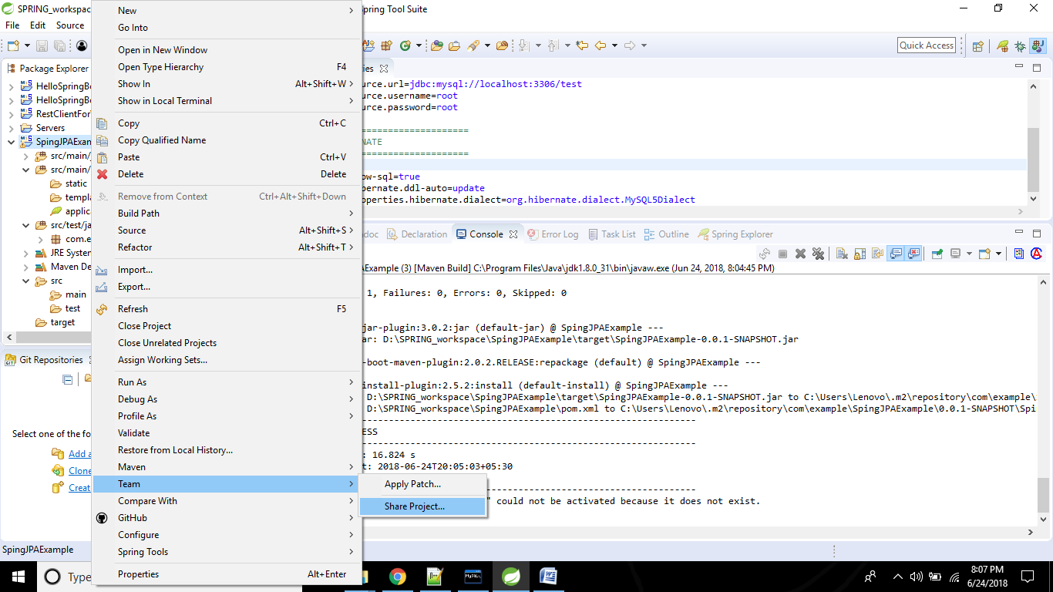

The below window opens and click on create…

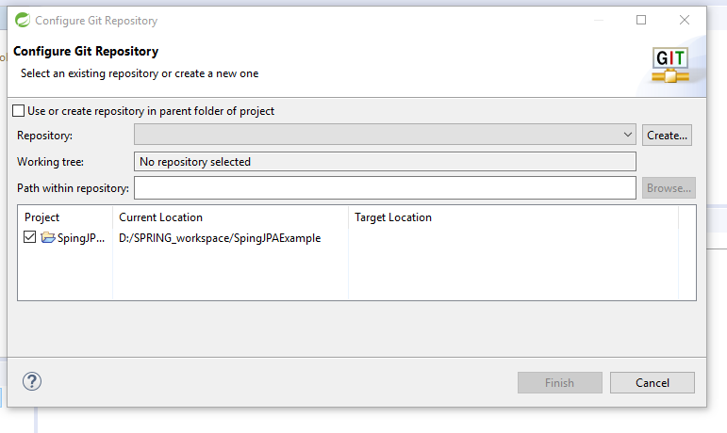

After clicking on “create” the below window appears…

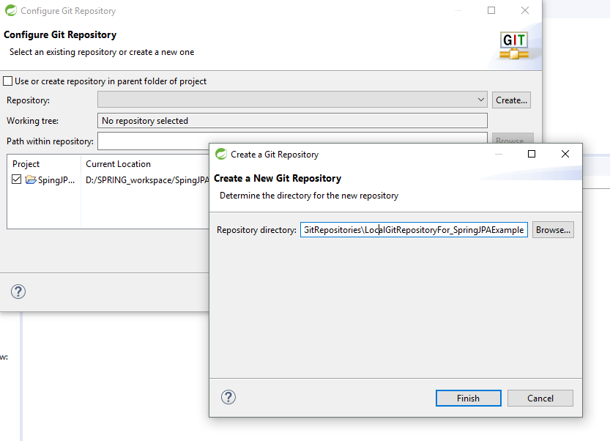

I have planned my Local repositories as this..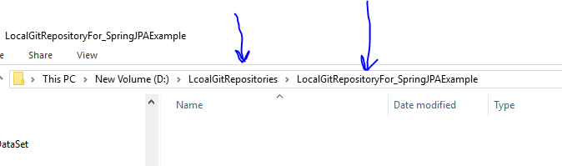

Click on finish

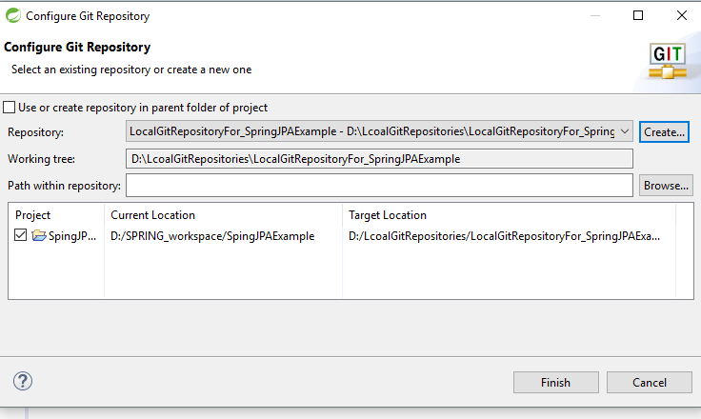

The recent window closes and remaining window appears.Click Finish.

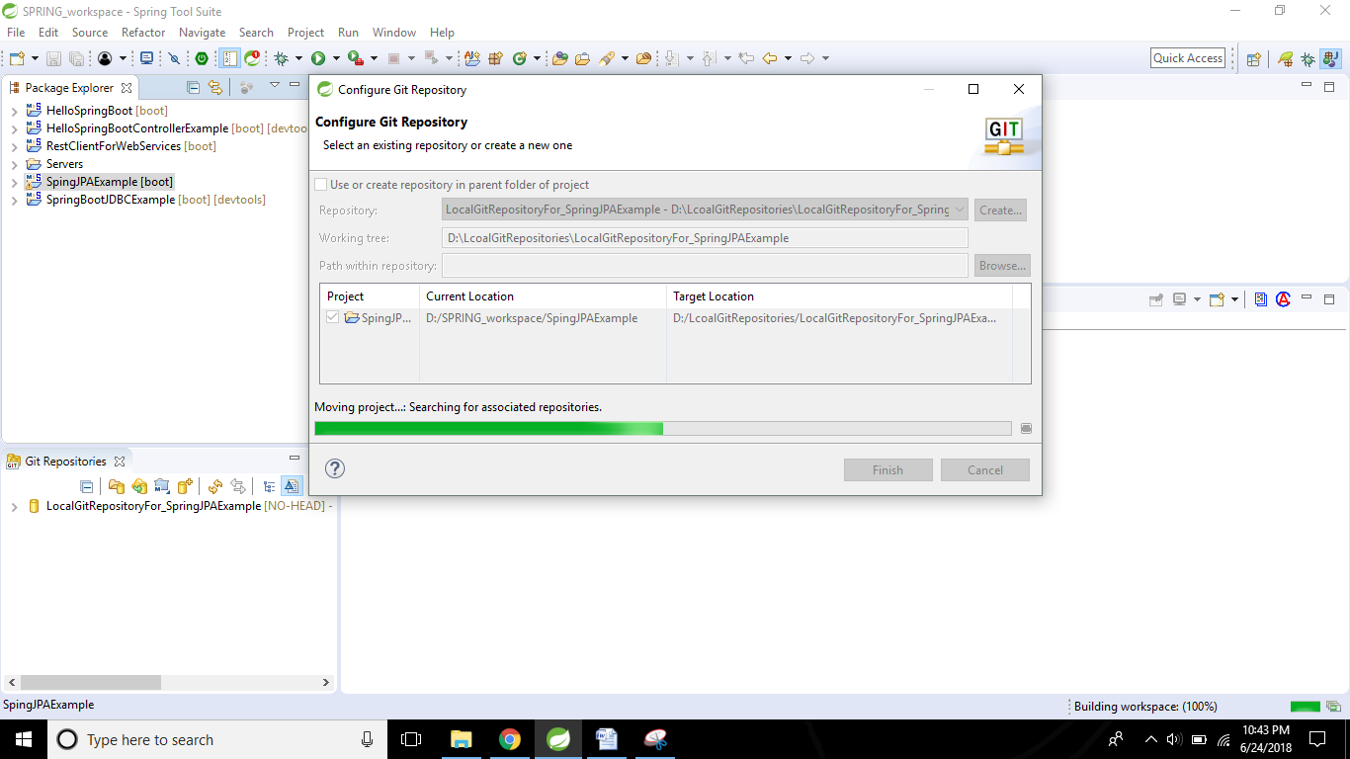

After the above step, we can notice this…

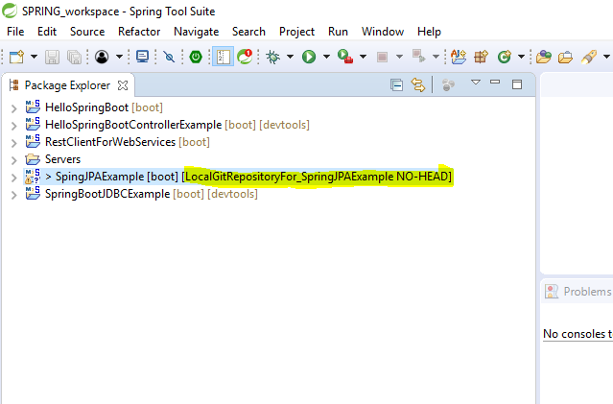

Now, commit your files in the local repository(which we created right now). The navigation way is as below:

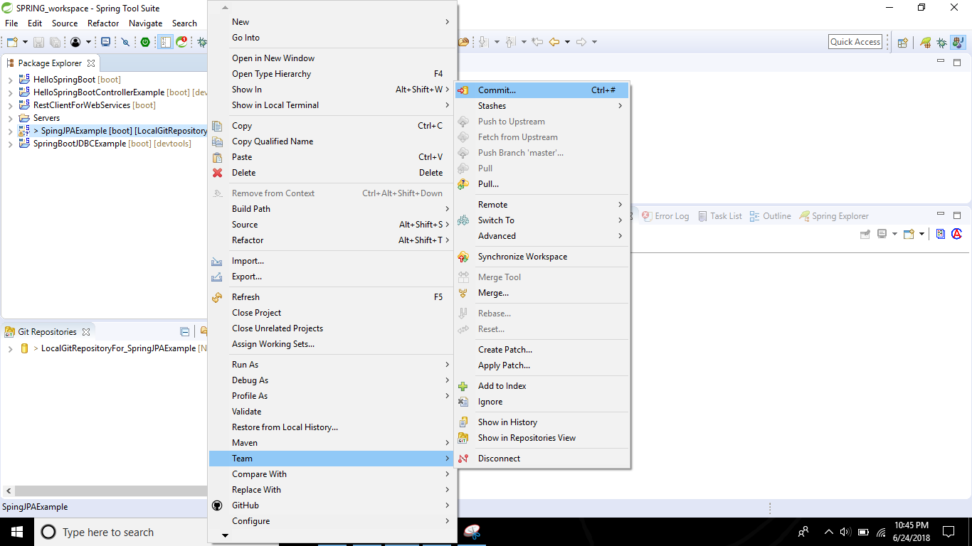

After you click on the Commit button, the below screen appears. Now drag all the files from **UNSTAGED CHNAGES** and drop into **STAGED CHANGES**

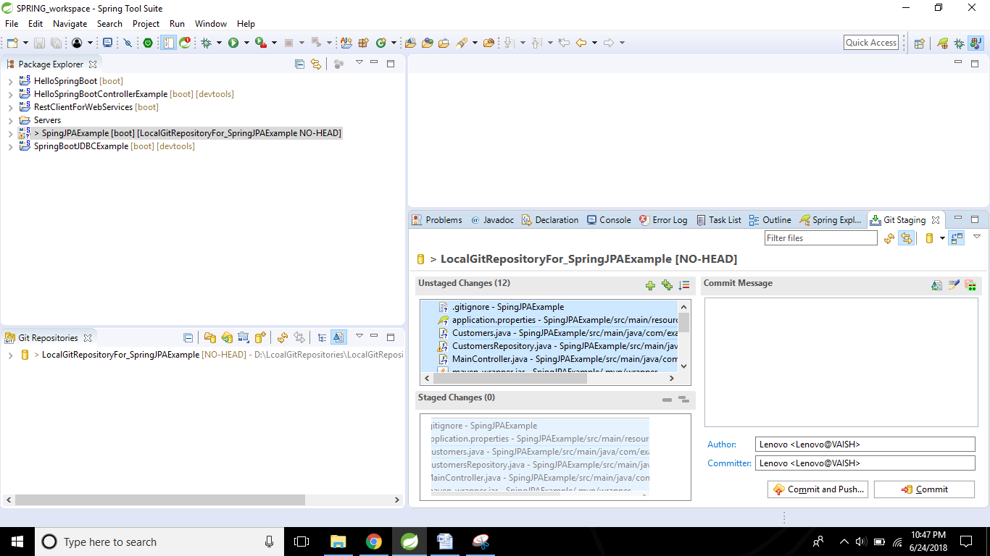

Add some comments in the Commit Message section and click on **COMMIT AND PUSH.**

Now, the below window appears. Now we are planning to push the changes from our local repository to Github.com

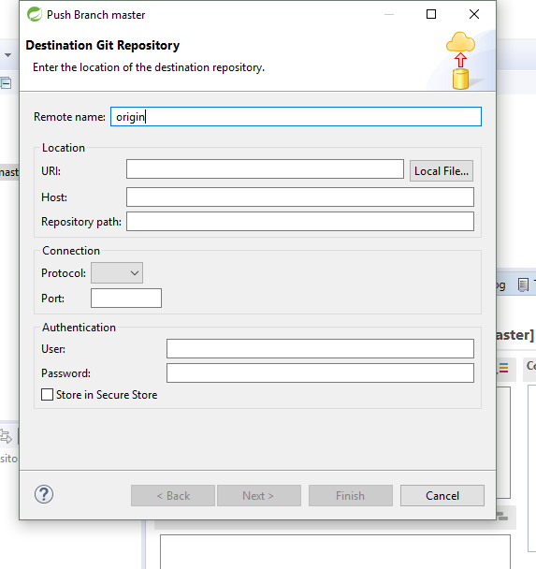

Fill the above window with below values..

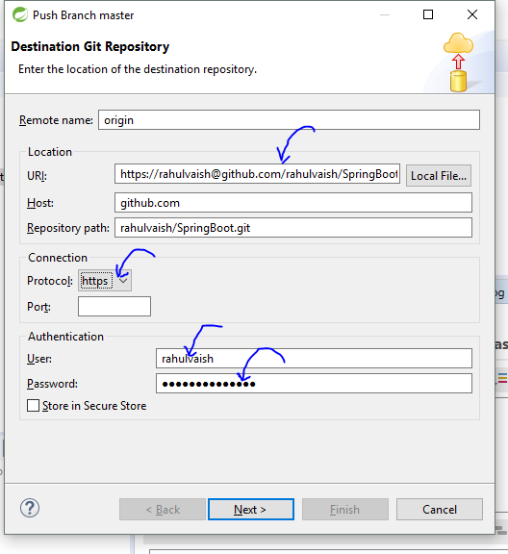

Click on NEXT..

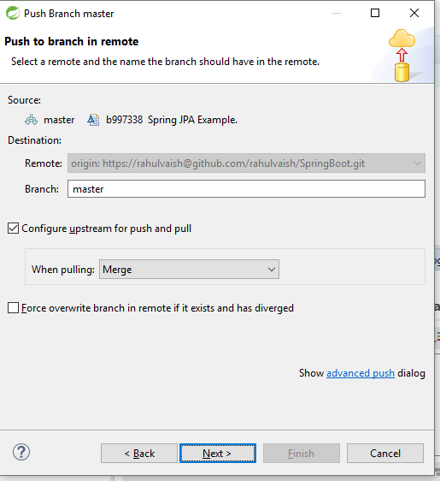

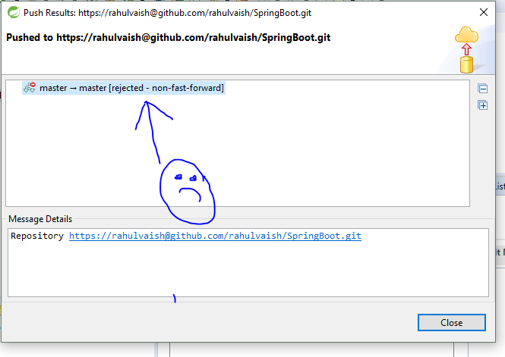

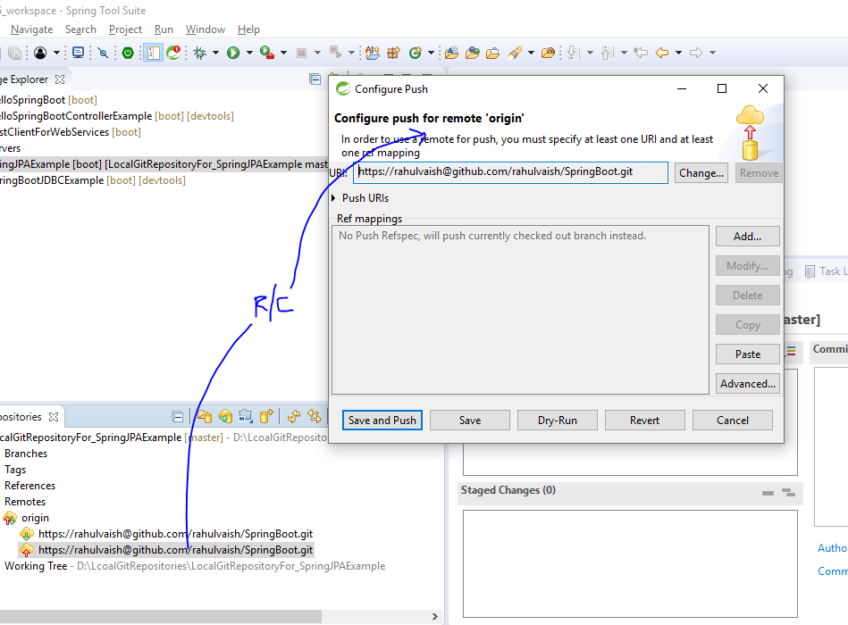

Click on advance….

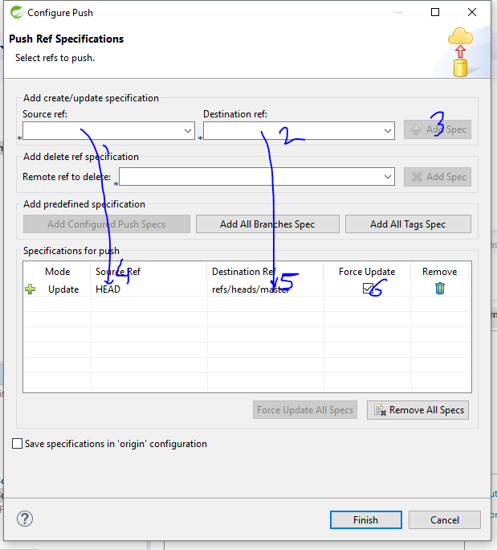

Click on finish..

Clcik on **Save and Push**

