**Jupyter + Docker!**

Docker is an amazing technology. The explanation and concepts of Docker is beyond the scope of this blog. We are here to explore how Docker allows us to run ‘ready to go’ Jupyter notebooks !!

**Step#1:**Login into **hub.docker.com**.

**Step#2:**Search for “Jupyter” over here and you will find a long list of variously published images. Screenshot as below:

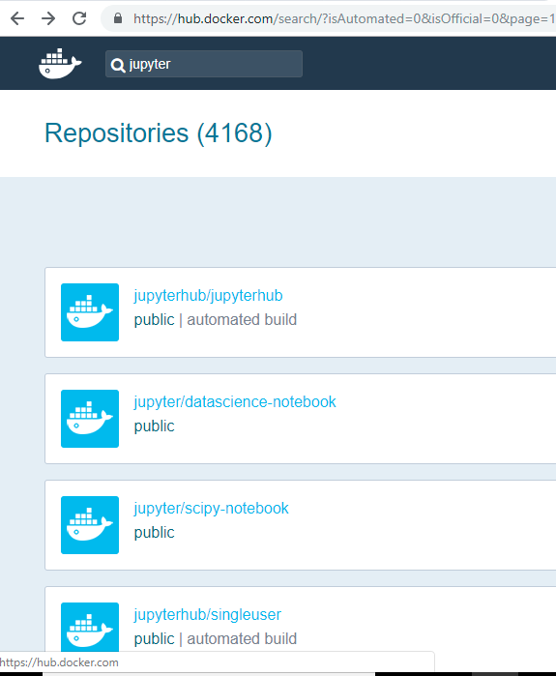

*List of Docker images, published on Docker Hub*

**Step#3: Now,**choose anyone from the above list. Lets select **jupyter/all-spark-notebook**

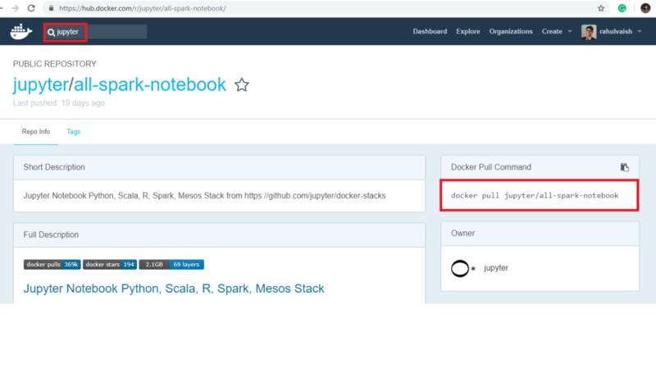

*Selected jupyter/all-spark-notebook image from the Docker Hub.*

**Step#4:**Now initiate Docker Quickstart Terminal, and enter Docker pull command. This command is highlighted in the above screenshot [docker pull jupyter/all-spark-notebook]

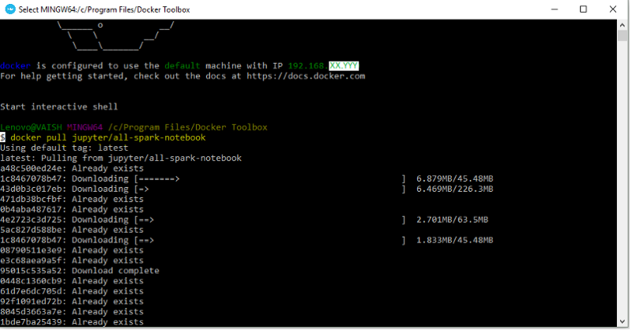

**Step#5:** After downloading, create a folder with two files, as below:

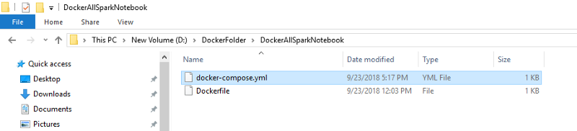

*docker-compose.yml and Dockerfile*

For now, keep Dockerfile as empty whereas docker-compose.yml has the below content:

**Step#6:**On Docker Quickstart Terminal, navigate to your desired folder structure(where the above-created files were kept), and enter the command <**docker-compose up**>

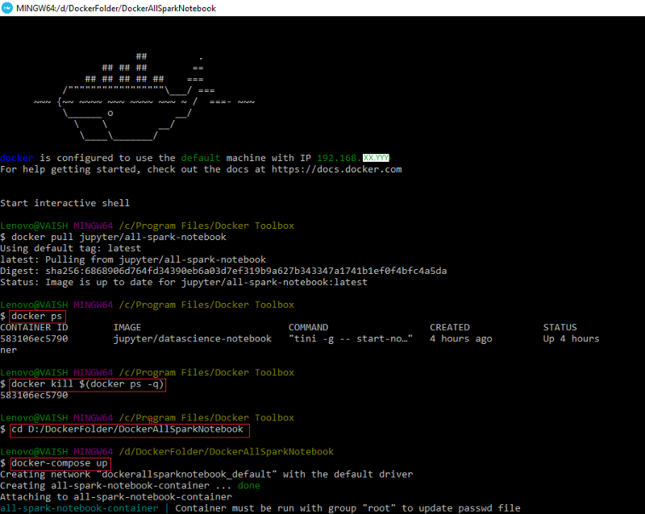

**Step#7:**Now as we know that docker is configured to use the default machine with IP. In our case, it is 192.168.XX.YYY therefore to launch Jupyter Notebook [Docker Image] we will form our URL as:

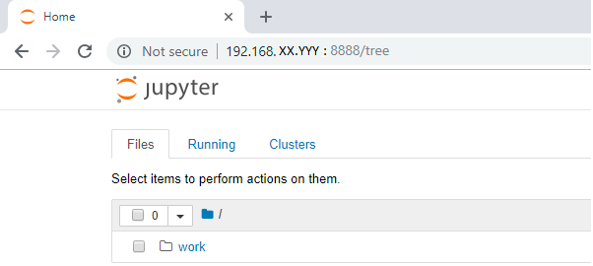

Hope you found this simple basic tutorial helpful. Please share your comments, suggestions and corrections. Thanks :)