In Windows CMD -

pip install flask

pip install flask-restful

Double click on the service, the service gets hosted on the localhost.

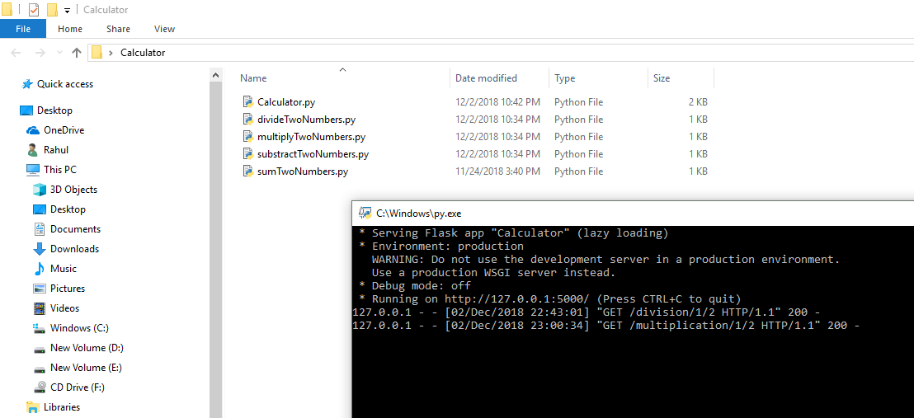

OR

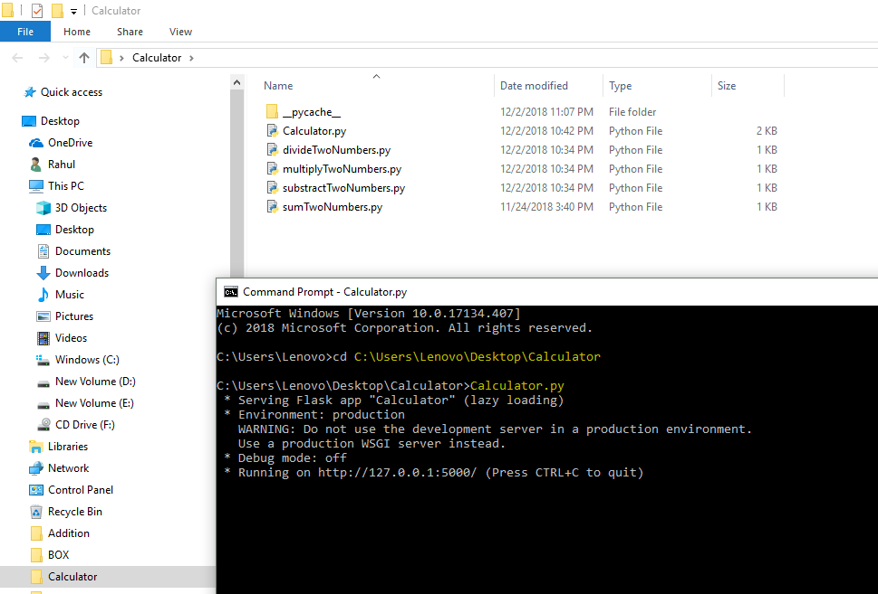

On web browser type -

[1] <http://127.0.0.1:5000/division/1/2>

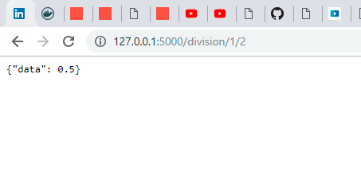

[2] <http://127.0.0.1:5000/multiplication/1/2>

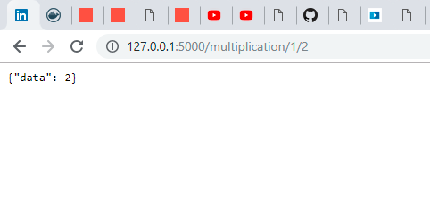

*I* ***have not tried*** *with these library installations on Anaconda!*