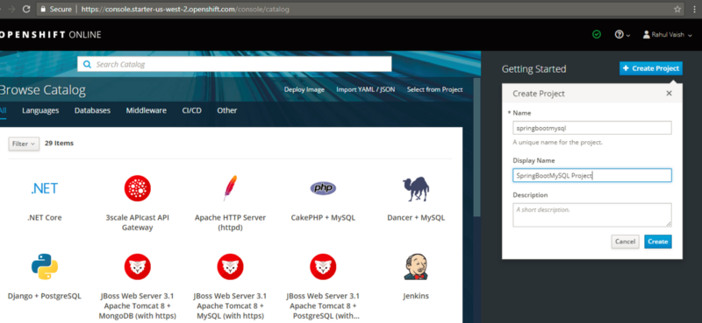

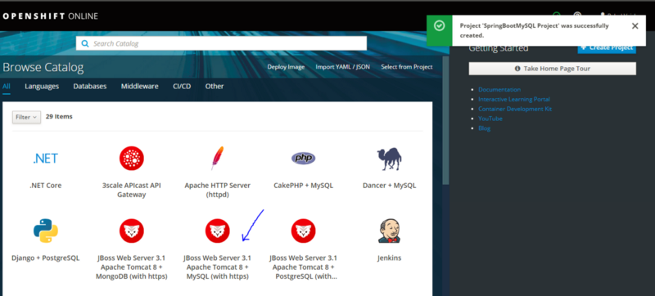

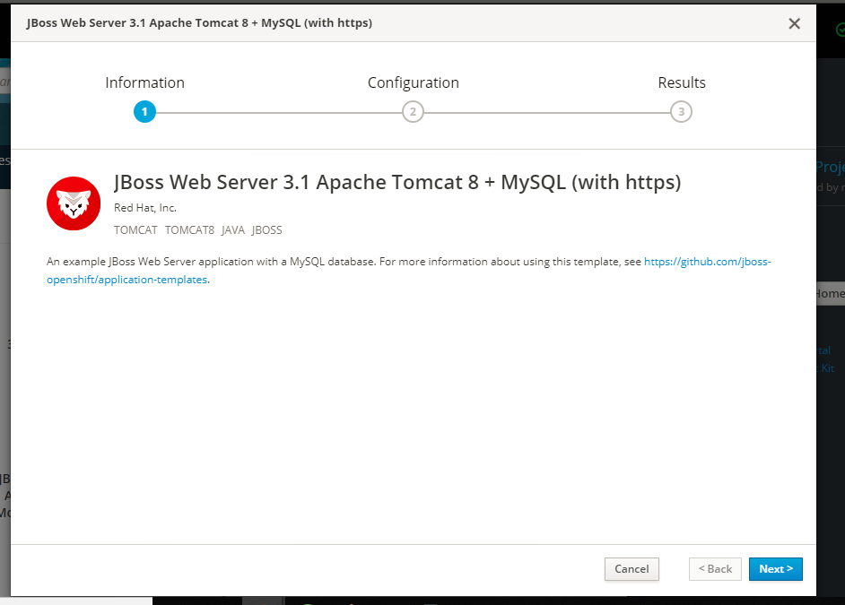

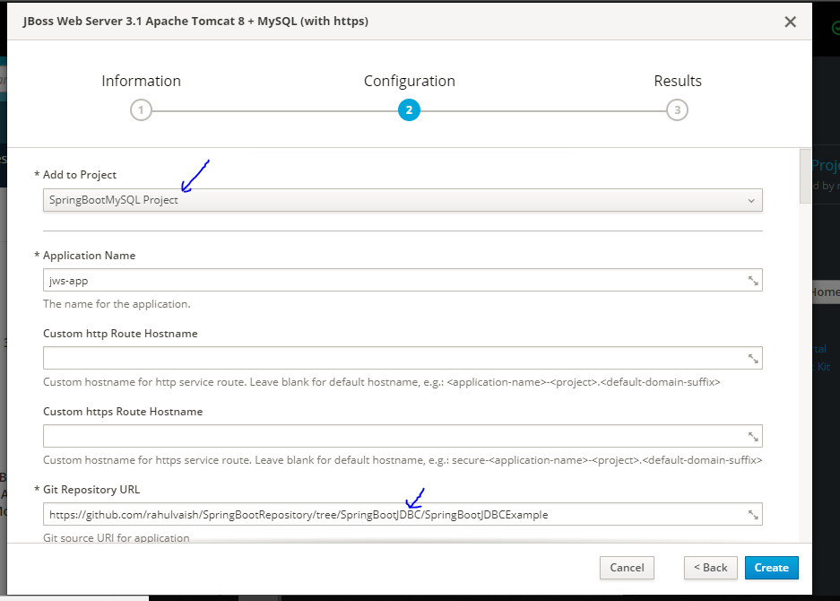

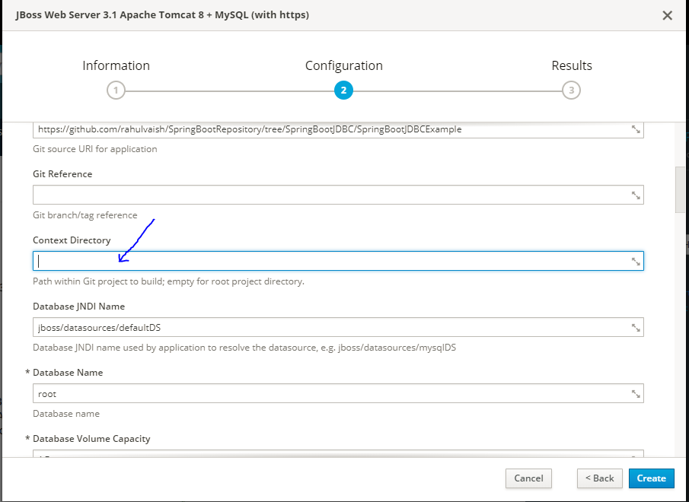

Click on create !

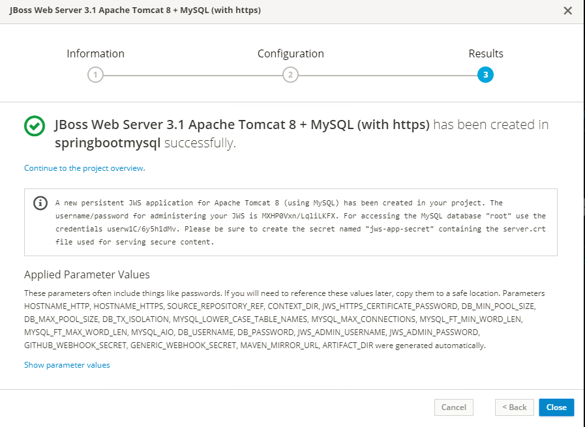

Save the text somewhere and close the window.

A new persistent JWS application for Apache Tomcat 8 (using MySQL) has been created in your project. The username/password for administering your JWS is MXHP0Vxn/LqliLKFX. For accessing the MySQL database "root" use the credentials userw1C/6y5h1dMv. Please be sure to create the secret named "jws-app-secret" containing the server.crt file used for serving secure content.

