* CHANGED THE WORKSPACE NAME – INTRODUCED UNDERSCORE D:\Docker_Workspace
* ADDED JAVA_HOME WITH JDK PATH IN ENVIRONMENTAL VARIABLE.

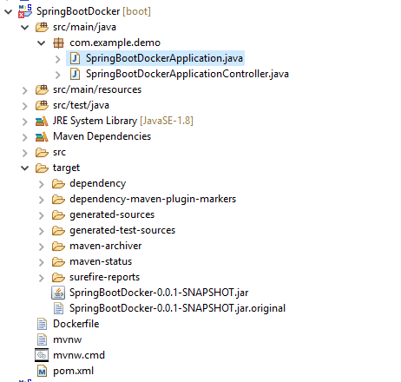

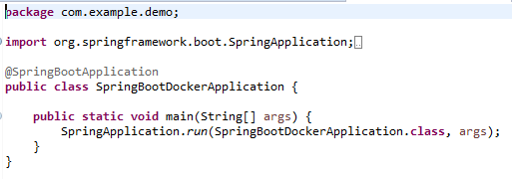

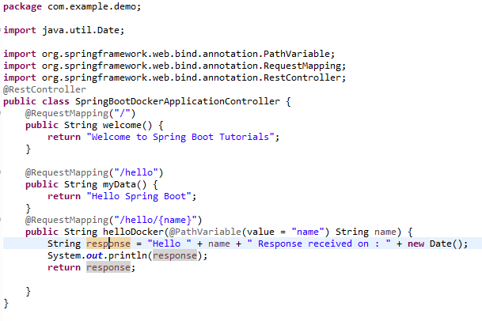

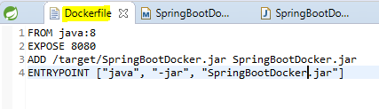



* After that Open Docker Quick start Terminal 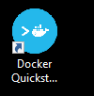 .
* Navigate till the Project.
* Mvn clean
* Mvn install
* Execute the below commands:

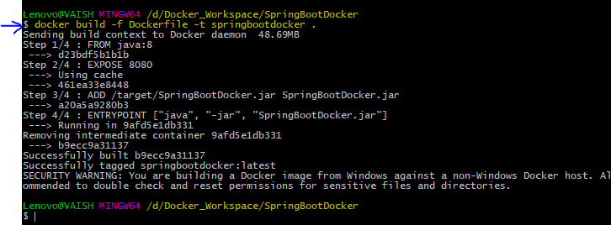

* Run the docker image as:

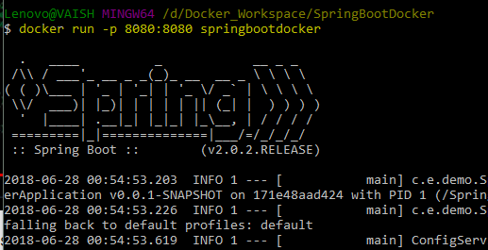

* The application is up and running ☺
* **Ctrl+C** then type **docker-machine ls** to get the IP.

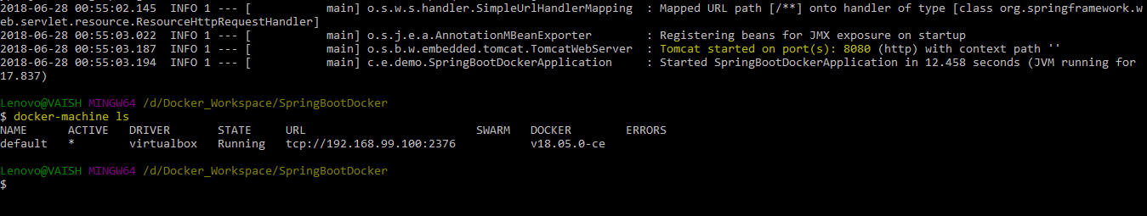

* Now when you have the IP, you can easily call the REST service ☺