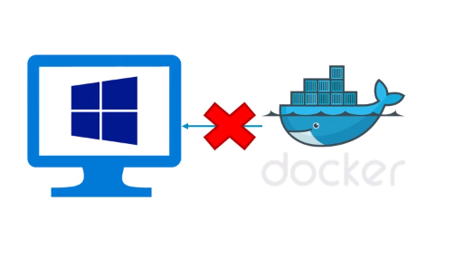

Docker uses features of Linux which windows don’t supports. 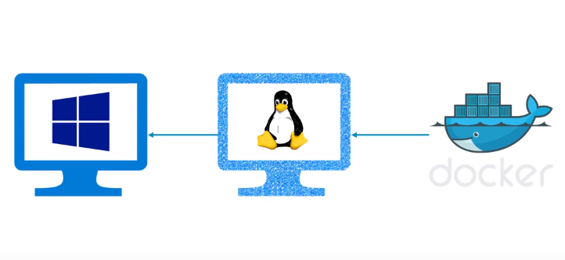

Therefore we need a virtual machine running linux and your docker will run on tat VM, and windows can control it.

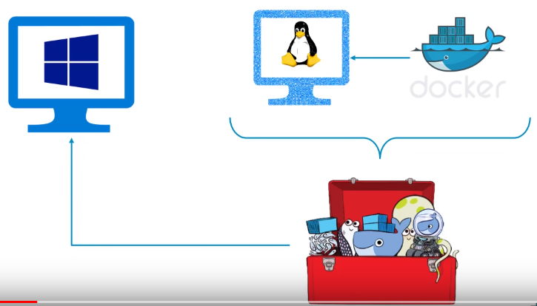

But Docker guys have prepared Docker Toolbox which takes care of this infrastructure.

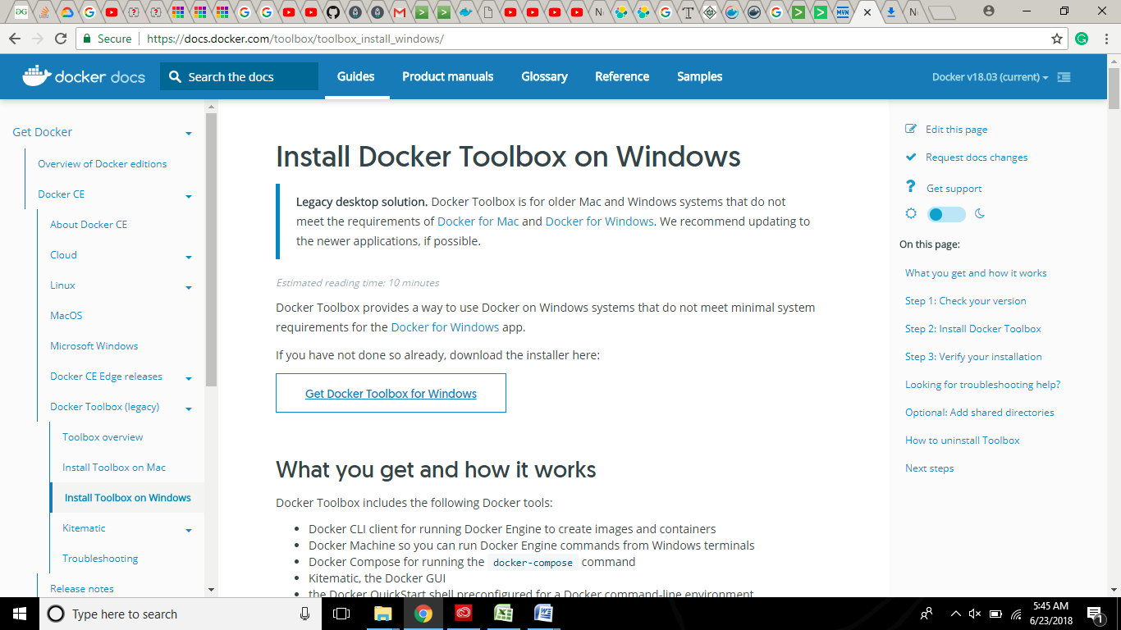

**I think** when we install Docker Toolbox these Environmental Variables get automatically set !

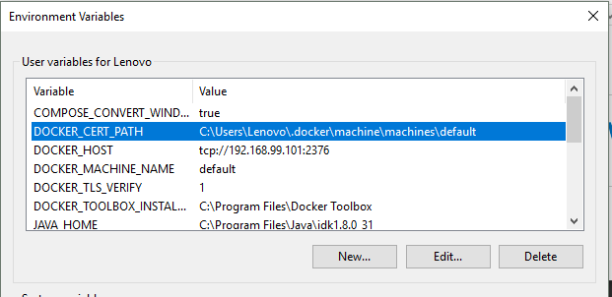

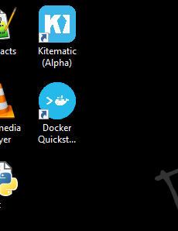

Click on docker Quickstart

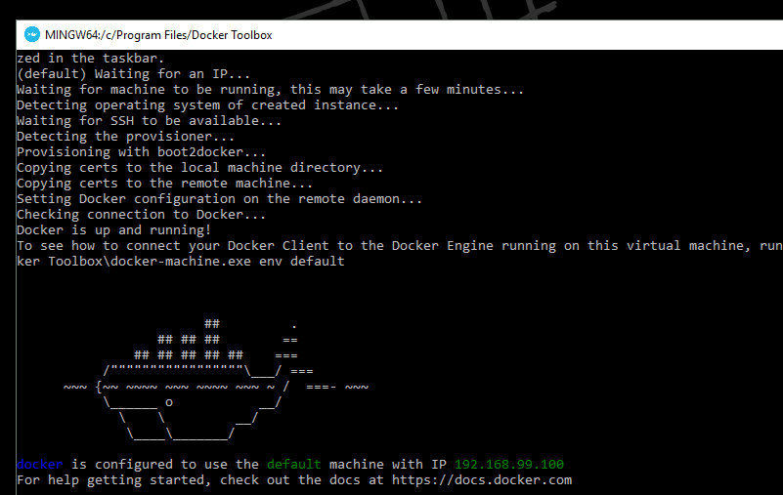

JAVA-------DOCKER

Create a folder and keep two files into it – Hellodocker.java + Dockerfile

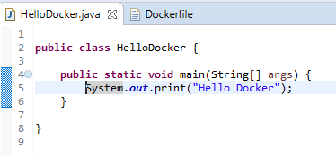

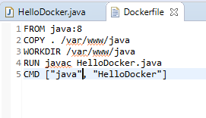

Navigate till there [**In Docker Quickstart Terminal**]…

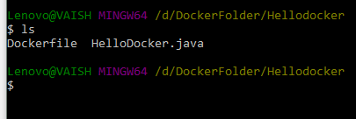

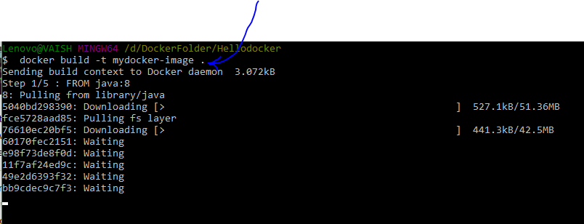

Running Docker Image

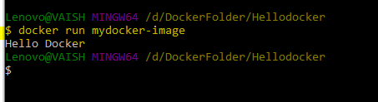

Now exploring web side:

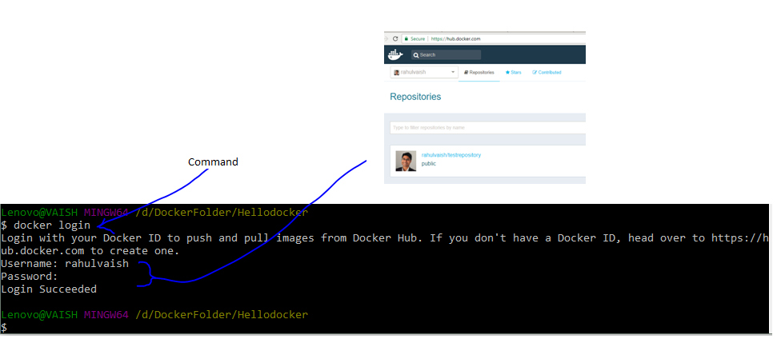

Before we push the image created, we need to first tag the same..

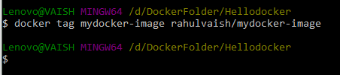

After tagging lets push..

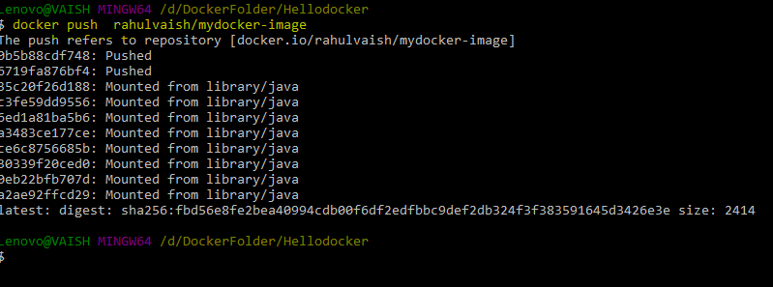

Now, if we check the HUB !!!

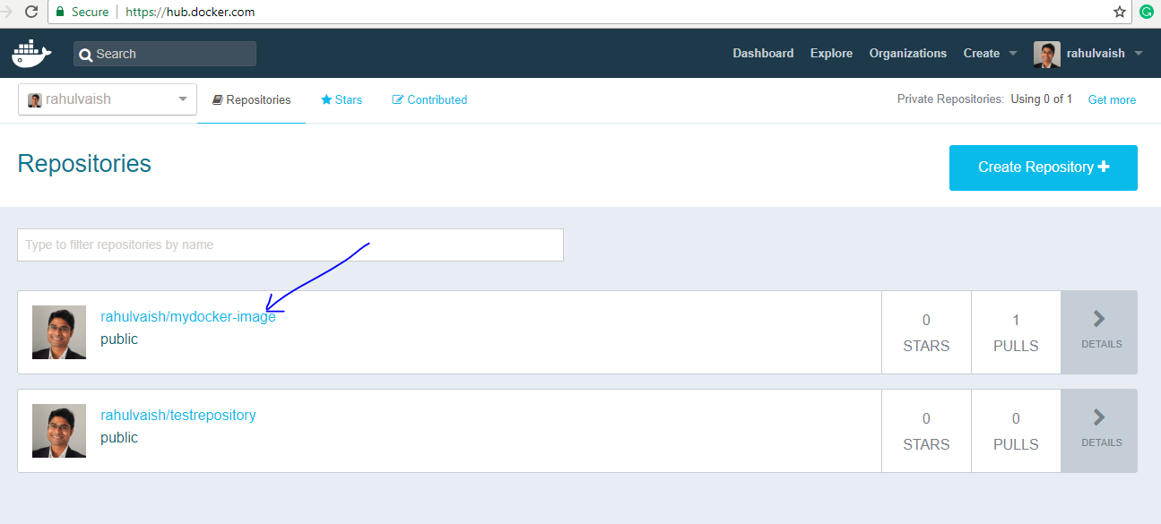

Next time, if you want to use HelloDocker, its easy:

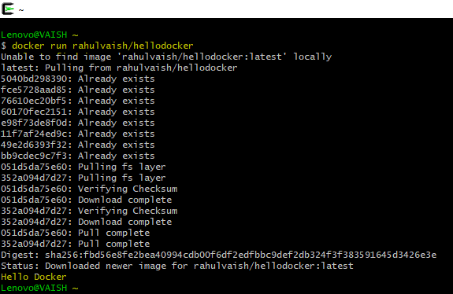

**Additional Miscellaneous Information:**

After this, we can see in the toolbox docker guys have provided us with an image - an .iso file called boot2docker. We can use this iso image in our VMWare ☺

P.S. To know how to import .iso into VMWare - <https://github.com/rahulvaish/ReferenceDocuments/blob/master/MISCELLANEOUS/StepsWithVMWare.docx>

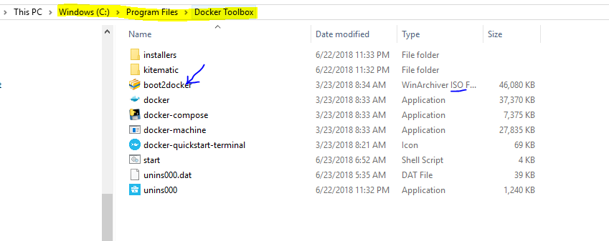

But,

