**REMOTE REPOSITORY**

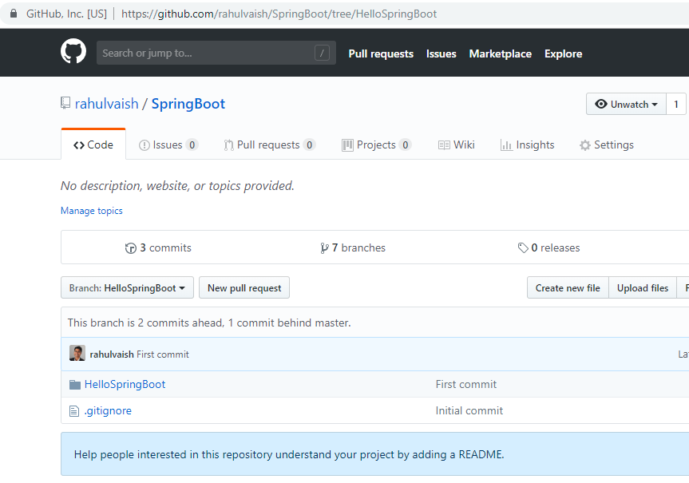

ON MACHINE – **GitClone is the folder [WORKING DIRECTORY]** where we will clone the remote repository. EclipseWorkspace is the folder for eclipse’s workspace purpose.

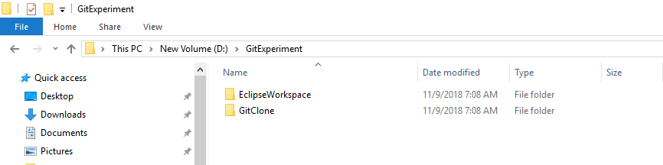

Now you are cloning the remote repository into your machine.

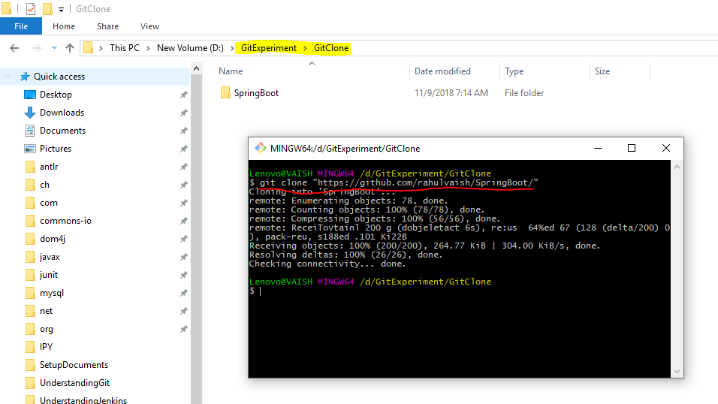

Going inside the clone, you will find **LOCAL REPOSITORY (.git)**

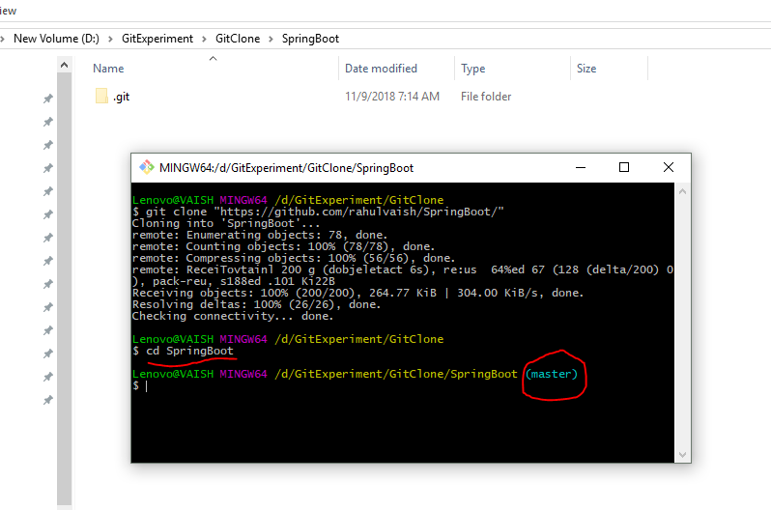

**Going inside .git, we will find the stage/index.**

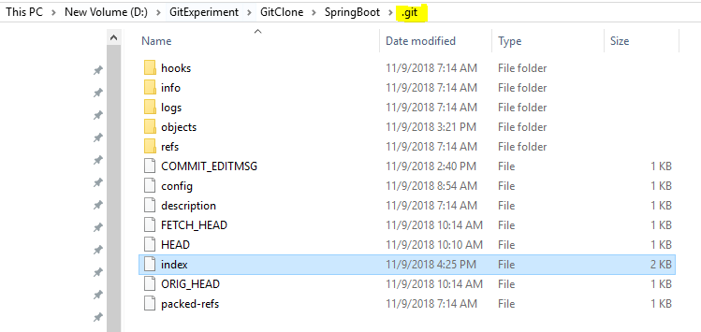

Revising again:

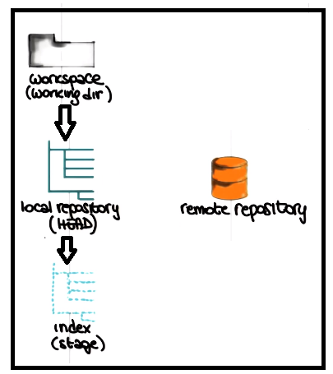

**i.e,**

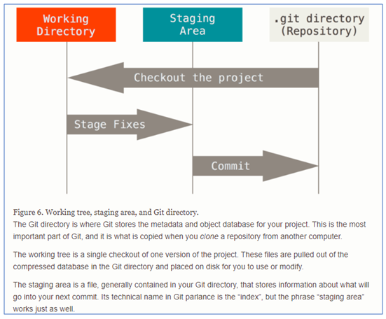

Before we start understanding the flow-

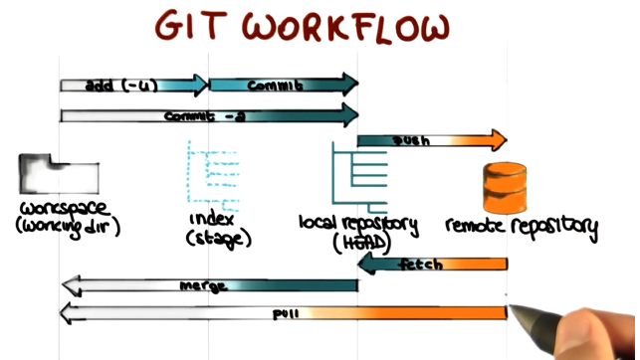

Now if we see the Remote Repository (Github.com), we can see multiple branches, to switch into a particular branch, we need to follow the below step:

**Step#1- List all branches**

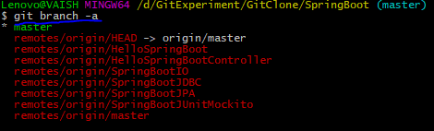

**Step#2: From this menu of branches, choose one to switch:**

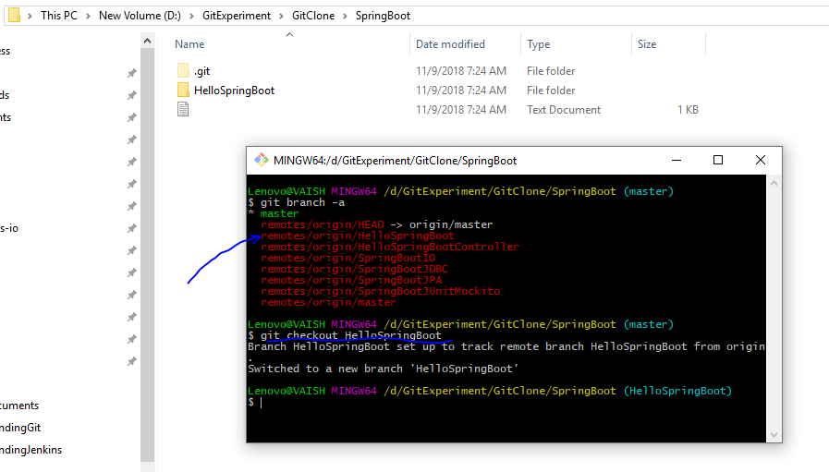

**GIT PULL (FETCH + MERGE)**

**We are in HelloSpringBoot branch and we are pulling stuffs from master branch of Remote Repository.**

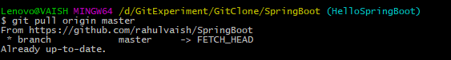

**We are in HelloSpringBoot branch and we are pulling stuffs from SpringBootIO branch of Remote Repository.**

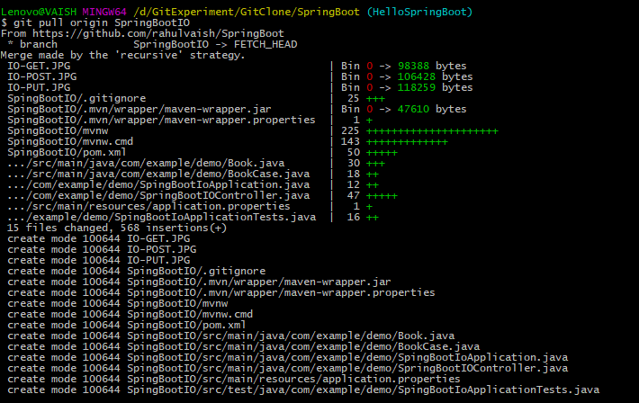

**The result is the combination of HelloSpringBoot + SpringBootIO**

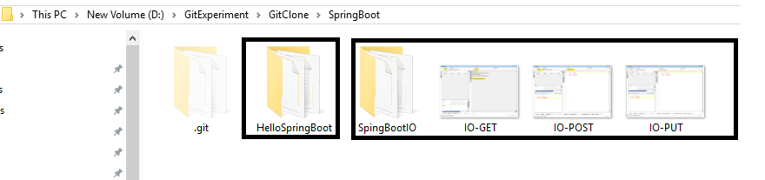

**I did that by mistake, want to keep only HelloSpringBoot.**

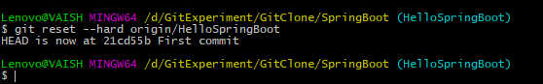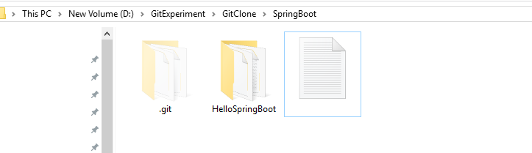

**Now using the other folder of GitExperiment – EclipseWorkspace for Eclipse workspace purpose.**

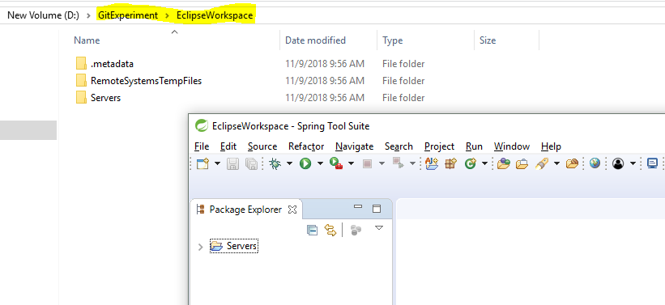

**Importing HelloSpringBoot project in eclipse…**

**Added 2 files:**

HelloMars

HelloMoon

**Changed 1 file:**

HelloWorld

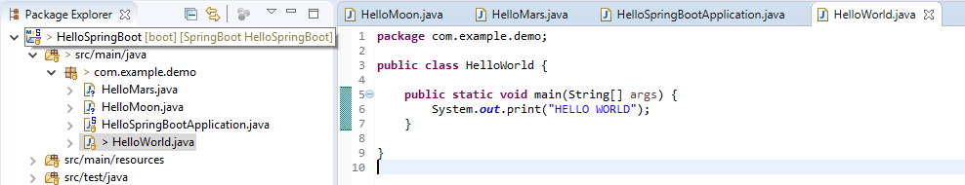

**We can check the same from the command below:**

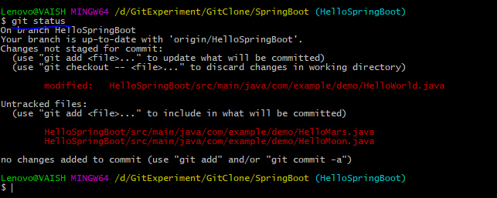

**Now suppose we want to commit only 1 file (**HelloWorld.java**) and don’t want to touch any other files, in that case –**

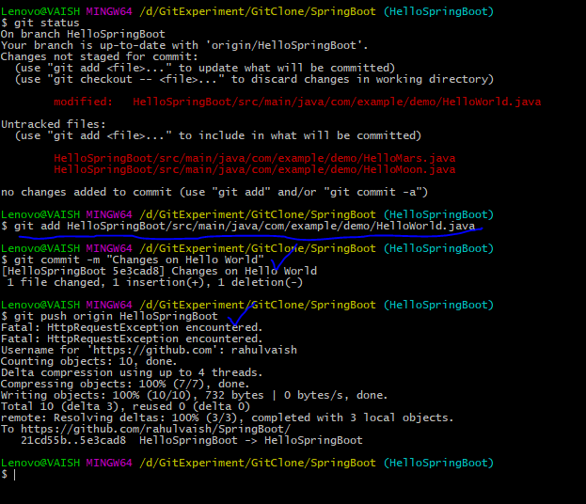

**Now suppose we want to commit both 2 files (**HelloMars.java and HelloMoon.java**) you can execute git add . the command in that case. Now you realized that you did not wanted to add/commit HelloMoon.java, in that case:**

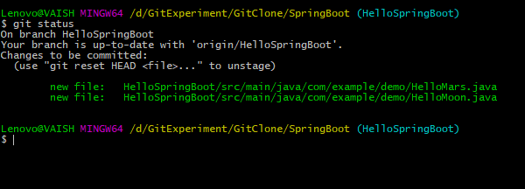

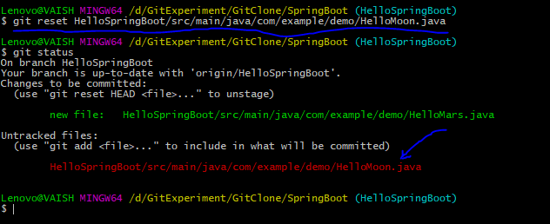

**In case you are pulling from remote repository and your Pull fails, as there are local changes which are stopping you. Git report either to commit the changes or stash them, in that case-**

