**REMOTE REPOSITORY**

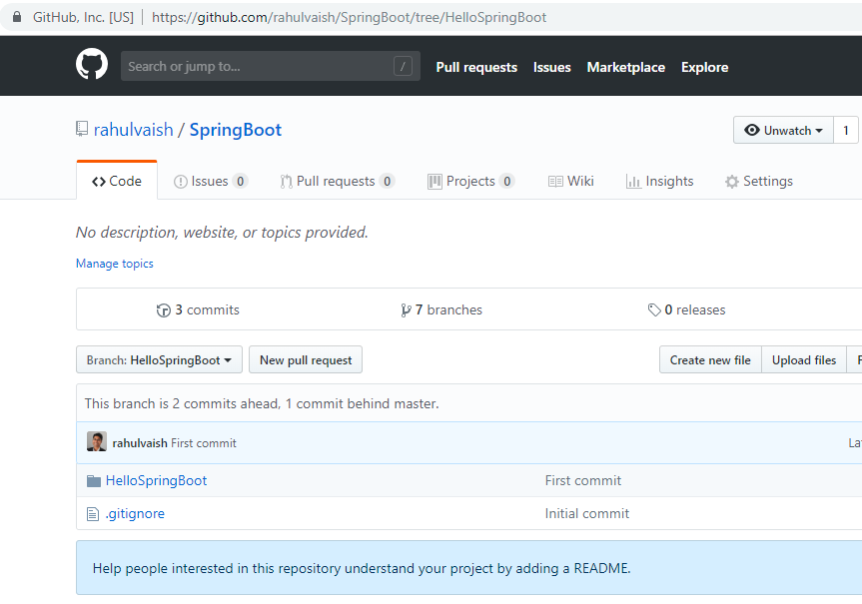

**ON MACHINE – GitClone for cloning the repository purpose. EclipseWorkspace for workspace purpose.**

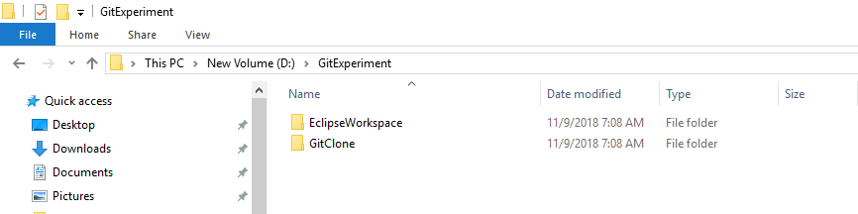

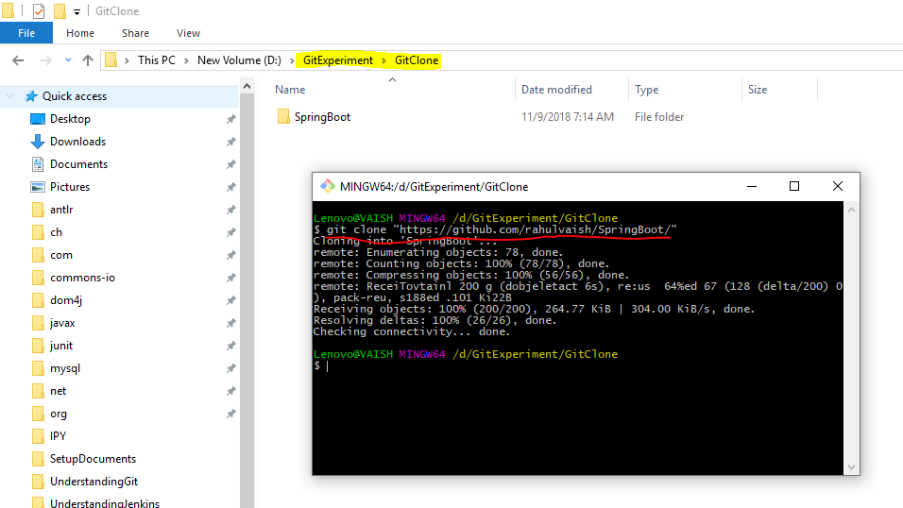

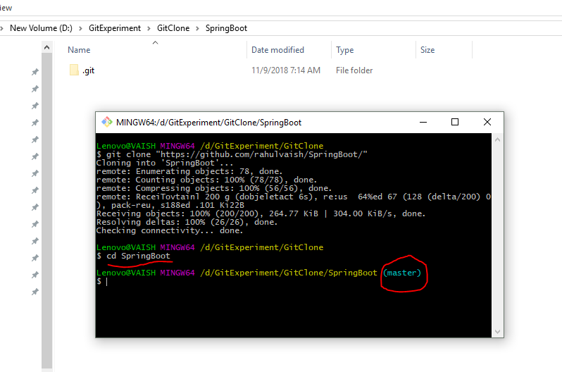

Now within this repository, exist multiple branches, to switch into a particular branch, we need to follow the below step:

**Step#1- List all branches**

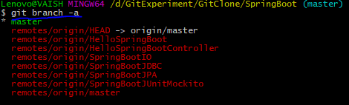

**Step#2: From this menu of branches, choose one to switch:**

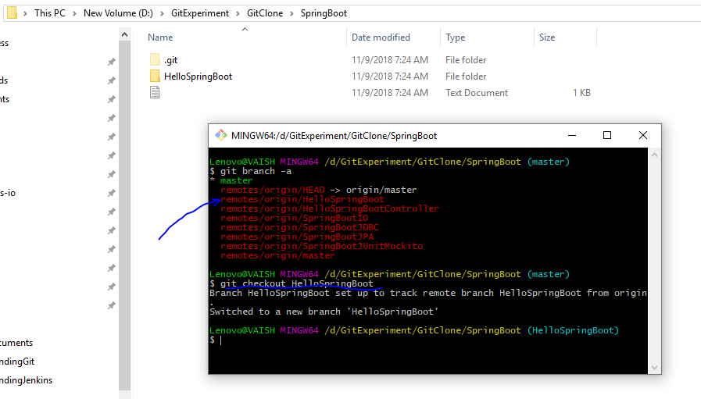

**GIT PULL**

**We are in HelloSpringBoot branch and we are pulling stuffs from master branch of Remote Repository.**

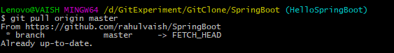

**We are in HelloSpringBoot branch and we are pulling stuffs from SpringBootIO branch of Remote Repository.**

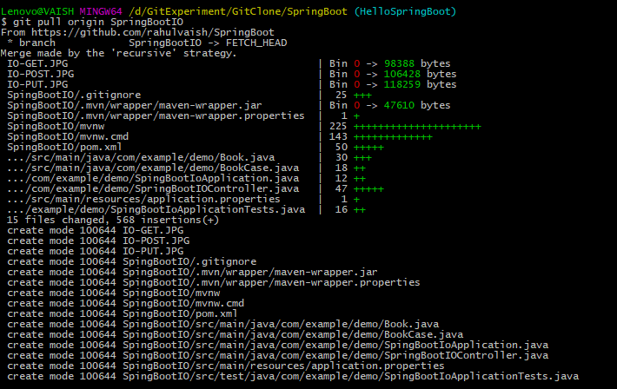

**The result is the combination of HelloSpringBoot + SpringBootIO**

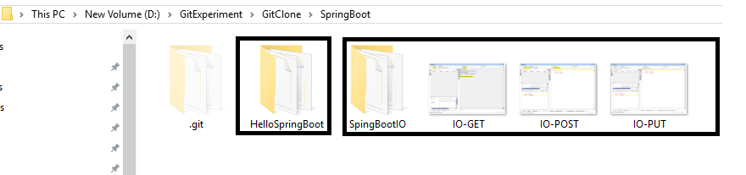

**I did that by mistake, want to keep only HelloSpringBoot.**

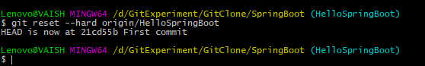

**Now using the other folder of GitExperiment – EclipseWorkspace for Eclipse workspace purpose.**

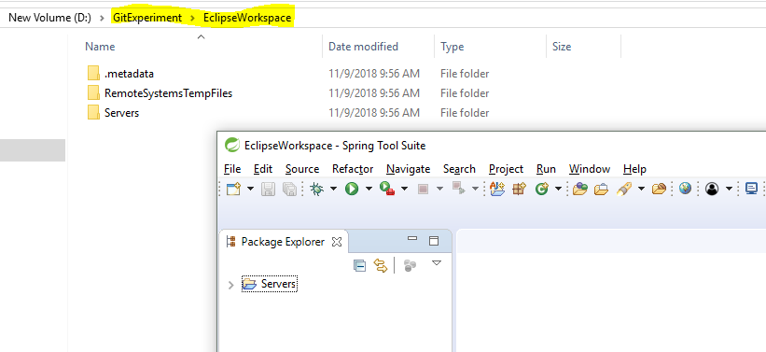

**Importing HelloSpringBoot project in eclipse…**

Added 2 files:

HelloMars

HelloMoon

Changed 1 file:

HelloWorld

