cmp al, 53h ; 'S'

cmp al, 43h ; 'C'

cmp al, 54h ; 'T'

cmp al, 46h ; 'F'

cmp al, 7Bh ; '{'

cmp al, 73h ; 's'

cmp al, 74h ; 't'

cmp al, 72h ; 'r'

cmp al, 6Ch ; 'l'

cmp al, 33h ; '3'

cmp al, 6Eh ; 'n'

cmp al, 5Fh ; '_'

cmp al, 6Ah ; 'j'

cmp al, 75h ; 'u'

cmp al, 6Dh ; 'm'

cmp al, 70h ; 'p'

cmp al, 5Fh ; '_'

cmp al, 63h ; 'c'

cmp al, 61h ; 'a'

cmp al, 6Ch ; 'l'

cmp al, 6Ch ; 'l'

cmp al, 5Fh ; '_'

cmp al, 68h ; 'h'

cmp al, 33h ; '3'

cmp al, 33h ; '3'

cmp al, 7Dh ; '}'

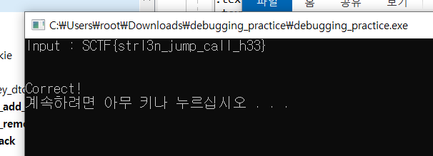

Flag: SCTF{strl3n_jump_call_h33}