Part 2.

You are assigned to provide a detailed answer to a client who is going to use Kendo UI for jQuery for a first time. He wants to visualize the same data from Part 1 in his application. Investigate the client’s needs and write a response with a proposed solution for the case by using Kendo UI for jQuery.

Hello,

I am evaluating your Kendo UI for jQuery product and I need your help.

We are building an application which visualizes a big amount of data from a JSON and enables:

1. filtering the data;

2. grouping the data;

3. the data is displayed on pages; 15 data items per page;

How can we implement this with Kendo UI for jQuery?

This should be really easy to achieve, and your documentation is clearly lacking! I’m sure others are encountering this scenario as well and you should really fix it. Our purchase decision depends on me achieving the above.

Regards,

Olivia

Hi Olivia,

I am happy to assist you using Kendo UI for jQuery.

We have a lot of examples in our web site in url: <https://demos.telerik.com/kendo-ui/>

You could check especially grid representation, it is in url: <https://demos.telerik.com/kendo-ui/grid/index>

We have very usefully examples.

1. For filtering data you need just to add parameter

**filterable**: **true**,

See here:

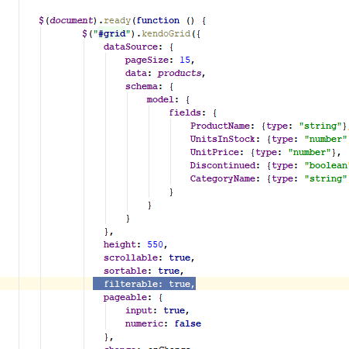

Grid will looks like:

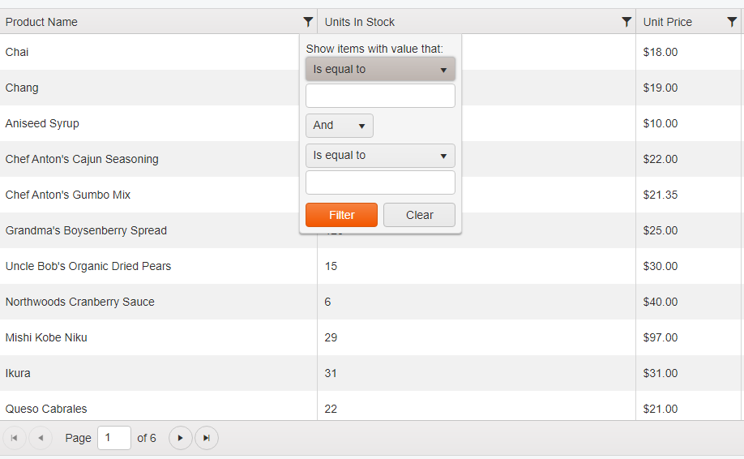

You need to click on icon 

And you will see small window where you could put you constrains for filtering.

2. For grouping data you need to add parameter

**sortable**: **true**

See here:

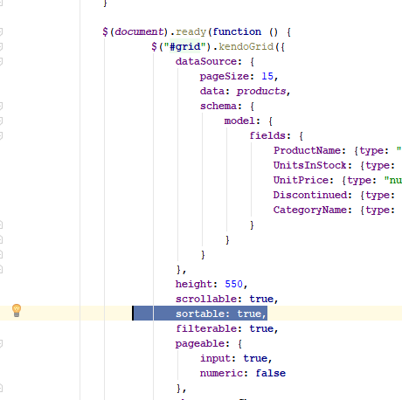

By sorting of column you could group the rows.

You need just to click on the column for which you need to do sorting

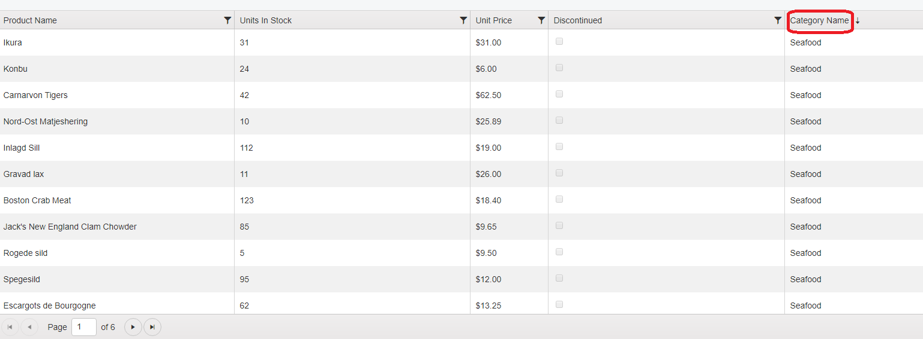

And you will see up or down arrow, up arrow is for ascending order where down arrow is for descending order.

I also checked the JSON data and I saw that it has sub list Category. I will propose to have category as column in the grid and in this way you will easily group products by category.

3. To display 15 items per page you need to add parameter

**pageSize**: 15,

See here:

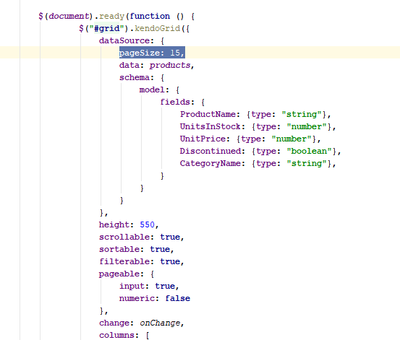

If you need more or less items per page you just need to change the number.

Grid will looks like:

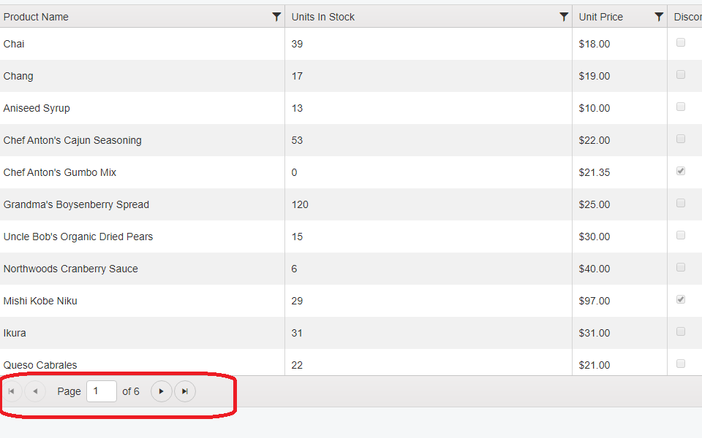

You could see pagination buttons in the bottom of the grid.

You could check my solution in url:

If you have some questions or something is not clear don’t hesitate to ask.

Best Regards,

Krasimir