First need to create some books by hyperlink - Create book

And to create some csutomers by hyperlink - Create Customer

Hyperlink Books shows all books in database.

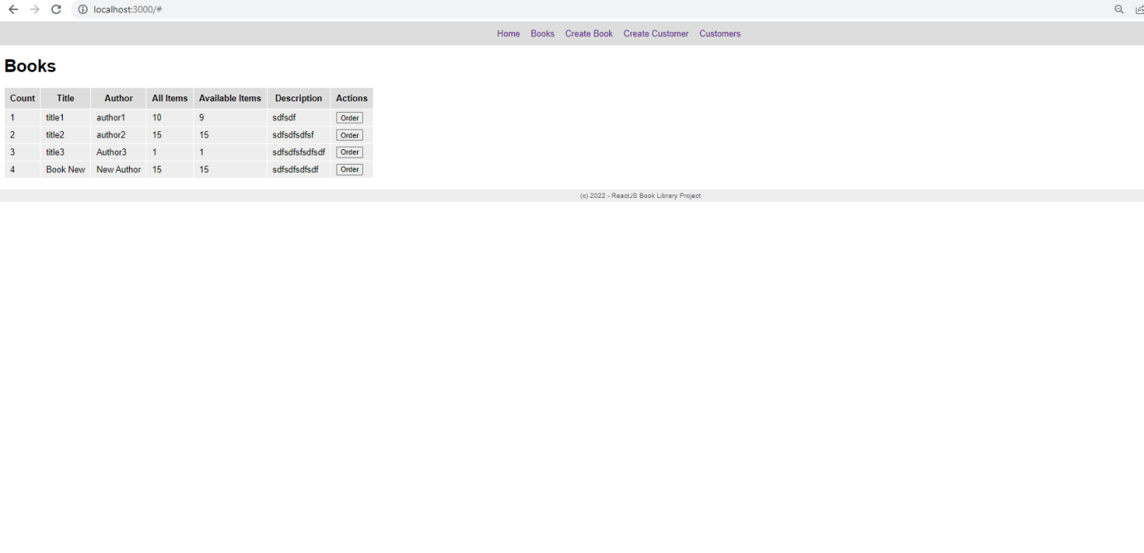

To take the book need to click on Order

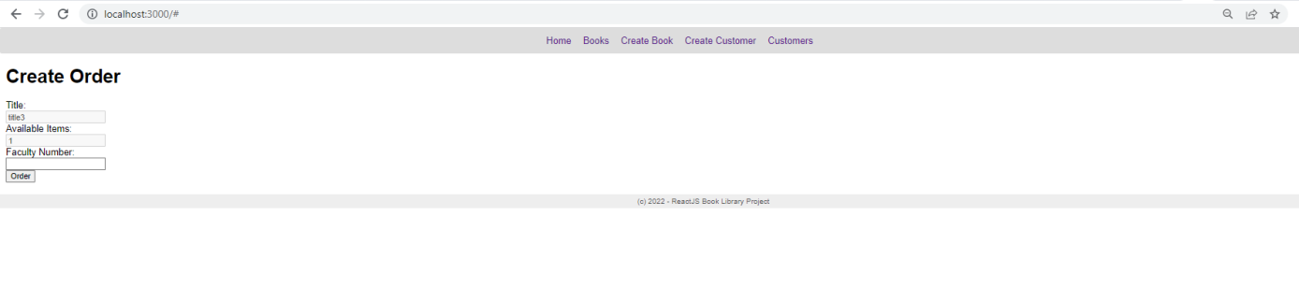

Need to input Faculty Number of the customer and click on Order button.

From Customers shows list with customers.

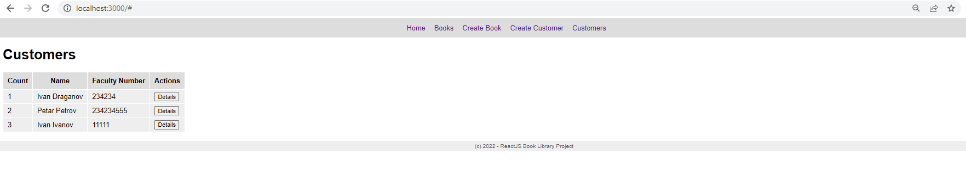

When you click on Details are showing details for the customer.

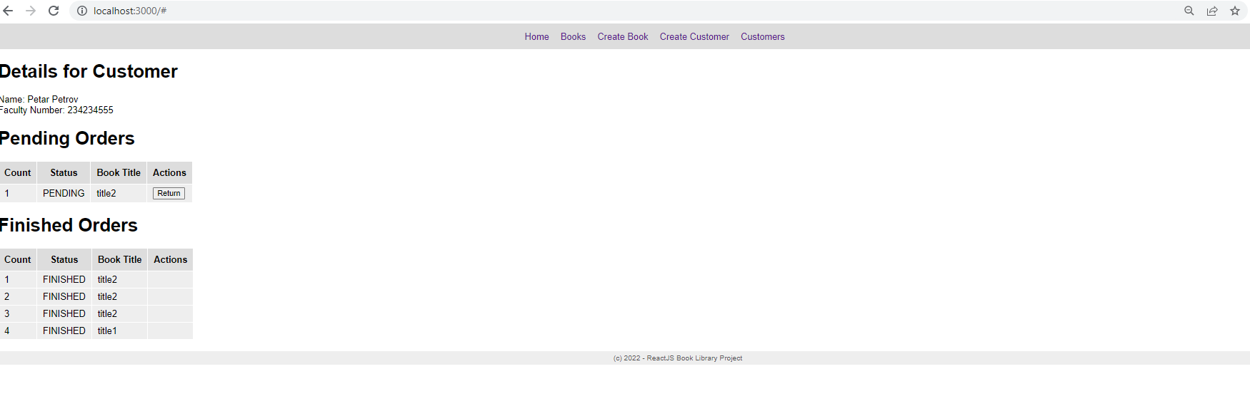

If button Return is clicked then book is returned.