**VIRAT KOHLI DISMISSAL ANALYSIS**

Virat is one of the top 3 batsmen of the IPL and has won some of the orange caps and helped RCB to participate in 3 finals. Now we are going to analyze how Virat gets dismissed (i.e.) in which type bowling he is more prone to dismiss.

I have separated Virat’s deliveries from Deliveries dataset and spotted how he was dismissed by grouping the dataset based on ‘dismissal kind’!

dismissal_kind

bowled 30

caught 95

caught and bowled 2

lbw 7

run out 15

stumped 3

Here we can observe that, Virat dismissed most of his IPL by caught(62.5% of his dismissals) and bowled(16.2%). Since many batsmen will get caught majority number of times, I studied further.

I have separated Virat Kohli’s wicket takers’ names, found out how many times they dismissed the present Indian cricket captain, and took out top ten:

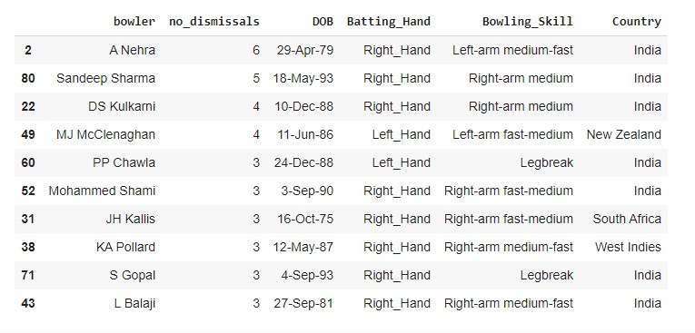

From the figure, we can easily predict that Virat is more likely a wicket for Pace bowling (80%) and spin (20%) of times.

While considering all wicket takers of VK and applying the statistics on type of bowlers who got wicket of V Kohli, I got this:

Bowling_Skill

Right-arm fast-medium 16

Right-arm medium 15

Right-arm medium-fast 11

Right-arm offbreak 9

Left-arm fast-medium 9

Slow left-arm orthodox 8

Right-arm fast 6

Legbreak 6

Left-arm medium-fast 3

Legbreak googly 2

Left-arm medium 2

Slow left-arm chinaman 1

In Pace Category, he is likely a wicket for:

Fast-Medium = 25/57 (44%)

Medium = 17/57 (29%)

Medium-Fast = 14/57 (25%)

In Spin Category, he is likely a wicket for:

Off-Break = 9/26 (35%)

Leg-Break = 6/26 (23%)