**1 Use of product**

Use this product for computers operated by a Windows ® OS operating system. This software can be operated on following systems:

* Windows® 10
  1. **Technical data**

This software requires

* 100MB diskspace
* 2GB RAM
* RS232 serial port
* 1024x768 minimum resolution for the display

**2 Installation**

The provided ZIP file decompresses into your computer. You will see “NVM” folder.

**3 Connect Valve to PC**

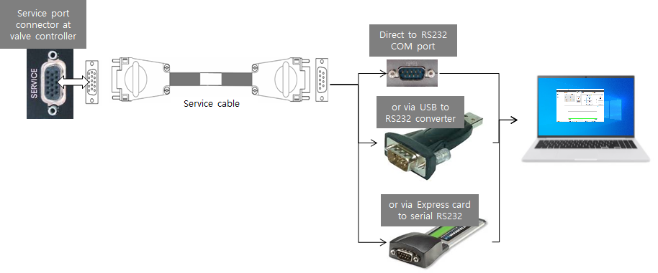

**4 Start up**

Check whether the PC is connected via the service port  to your valve. Make sure, that the valve is supplied by 24VDC.

You need not do any adjustments for the RS232 port in advance. Setup of the RS232-port for the PC is done automatically by NVM Software.

1. Start the program on NVM folder > NVM.exe

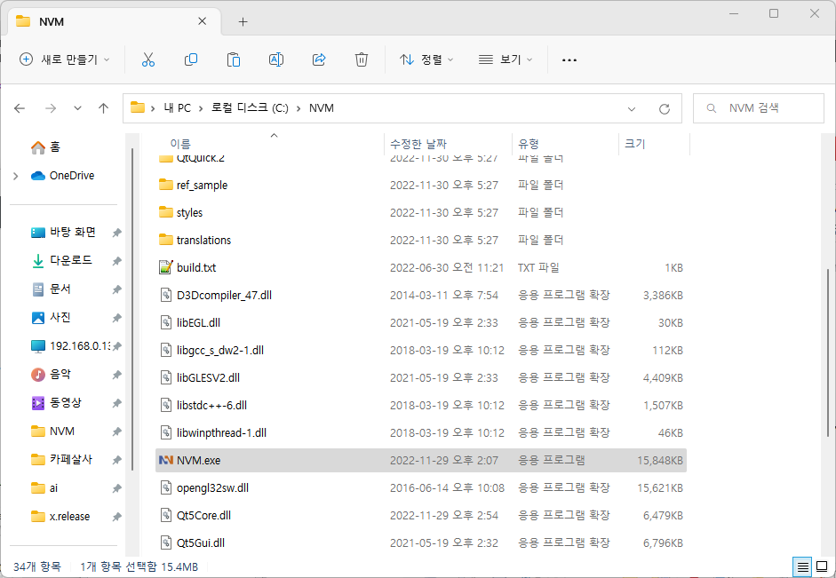

1. After startup is finished, the ‘NVM’ displays it Startup-screen. (example see below)

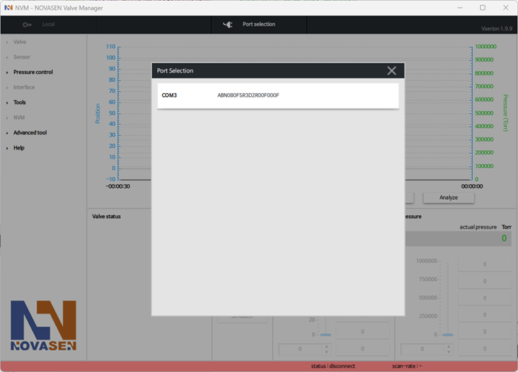

**5 Connect NVM to valve**

Select the port of the valve you want to connect from the port list shown in the pop-up. (double click)

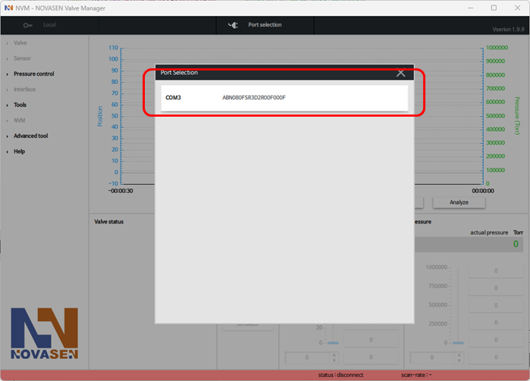

**6 General screen**

**6.1 main screen configuration**

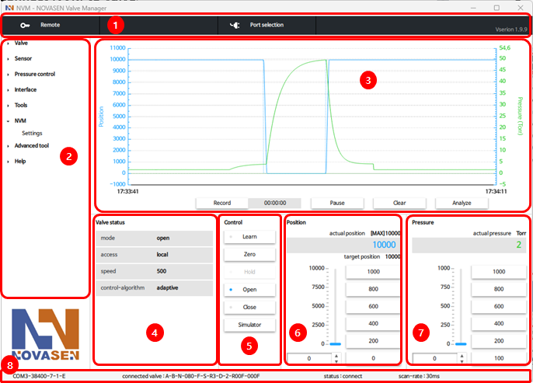

|  |  |  |
| --- | --- | --- |
| **Area** | **Description** | **Function** |
| 1 | Top bar | REMOTE / LOCAL      Port Selection      Version - Release |
| 2 | Navigation | Explorer menus, adjustment and control |
| 3 | Chart | Display target position/pressure and current position/pressure |
| 4 | Valve status | Display the valve status |
| 5 | Control | Control( open/close/hold/learn/zero/simulation) |
| 6 | Position | Monitor, adjust target position |
| 7 | Pressure | Monitor, adjust target pressure |
| 8 | Status bar | Display com port, connected valve, connection status, scan-rate |

**6.2 Chart recorder**

This function is used for record of position and pressure in time.

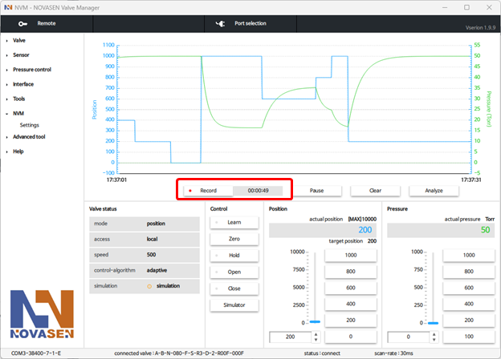

**6.3 Status bar**

Connected (NVM is connected to valve, communication is OK and operation possible)



Disconnected (NVM is not connected to valve, no communication and no operation possible)



**6.4 Use LOCAL MODE**

Using the ‘NVM’ is only possible, when the valve is the 'Local Mode'.

* Click button [Local]

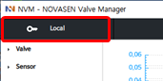

Now the valve can be operated easily via 'NVM'.

First steps should be [Open], [Close] etc.

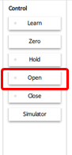

**Note:** If Local operation is finished, please switch back to 'Remote mode'

* Click button [Remote]

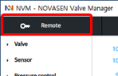

**6.5 Learn**

**6.5.1 Execute learn**

* Click button [Learn]

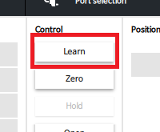

Enter the maximum pressure at which to Learn, and Click Learn

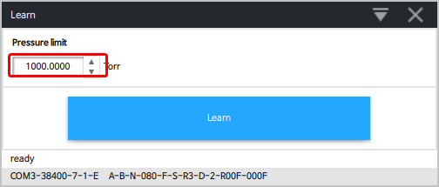

**Note:** Set the MFC or Flow to same as the actual process conditions.

**6.5.2 Learn status**

While learn is running, the actual learn status is indicated in an additional window

* Click [Terminate Learn] button to cancel learn.
* Click [X] to close the learn-status window.

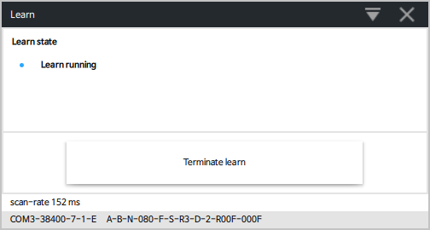

The following error conditions may appear during the learn procedure:

|  |  |
| --- | --- |
| **Error condition** | **Function** |
| Failed by user | Control command was sent during learn procedure was running (e.g. OPEN, CLOSE, POSITION / PRESSURE command or Clicked “Terminate learn” button) |
| Failed by unit | Internal fault interrupting the learn procedure |

**6.6 Zero**

Sensor Zero is a convenience function to calibrate the sensor at base pressure (no adjustment at sensor necessary). When Zero is performed the actual pressure value in set to zero. In case of 2 sensors both are calibrate (zero) at the same time.

Condition for successful ZERO:

* Base pressure is reached (min. 10000 times below SFS)
* Enable Zero
* Valve is open
* No gas flow in system
* Sensor is on operating temperature
* Sensor stable, no shifting

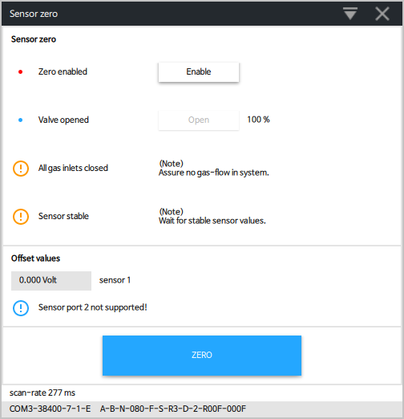

**6.7 Fatal error**

This window comes up if the valve ran into in an error condition. The basic error information is shown in the upper part of the window.

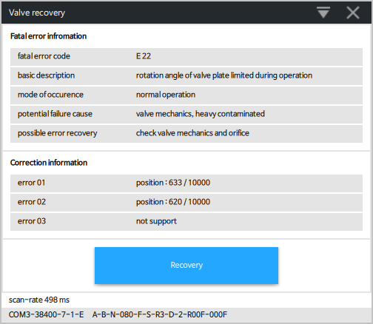

**6.8 Setpoint Position and Pressure**

These functions are used to set the position or pressure set-points.

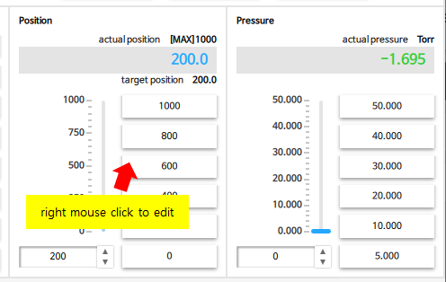

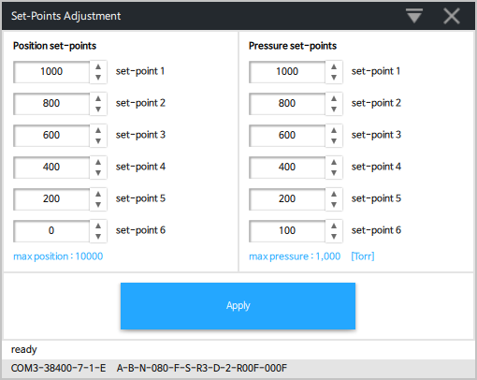

**7 Valve menu**

**7.1 Identification**

This window shows the configuration of the connected valve.

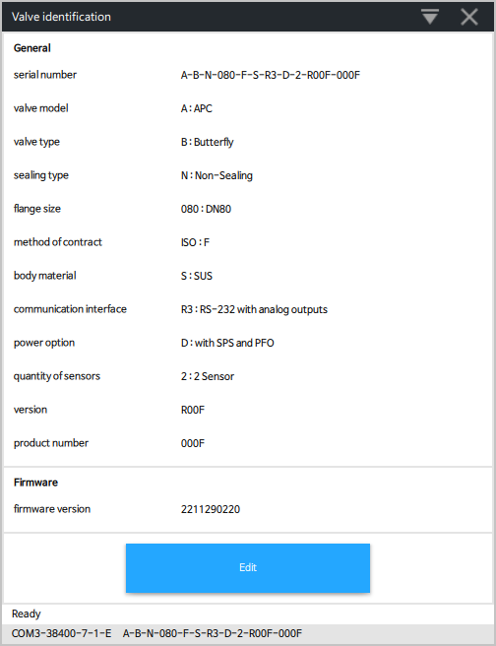

Notice : Edit properties may only be carried out by the NOVASEN service staff.

**7.2 Setup**

Basic configurations of valve must be adapted according to application needs. It is possible to change the settings.

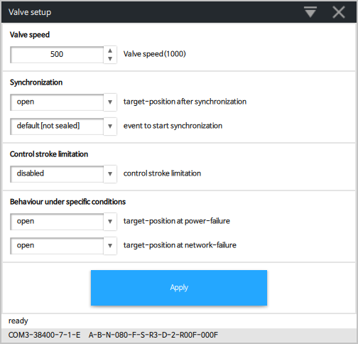

**7.3 Cycle counter**

This window shows the control cycles and the isolation cycles of connected valve. Reset of 'control cycles' and 'isolation cycles' are possible.

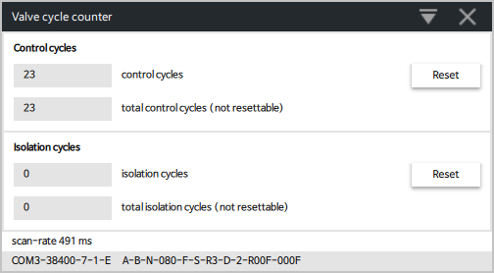

**7.3 Parameters**

Notice : Update valve parameters may only be carried out by the NOVASEN service staff.

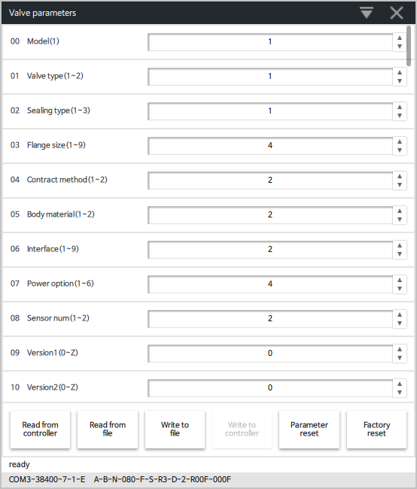

**7.4 Power Fail Status**

PFO = Power Failure Options

This window shows the status of PFO. This function is only available if PFO is installed. It is possible to disable PFO temporary. Click [Disable PFO]

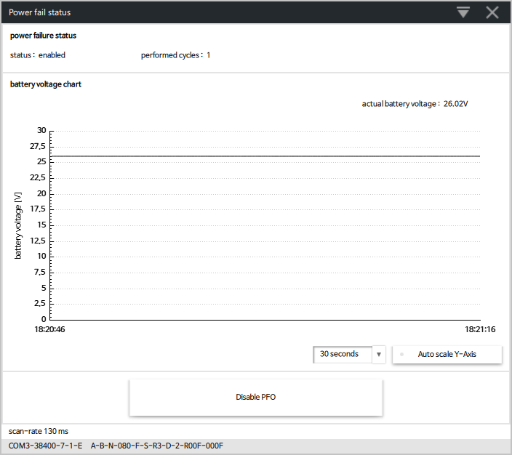

* PFO is always enabled after power up!
* For “Safety”, disable PFO always before maintenance!

**7.5 Recovery**

With this function it is possible to [Reset] Fatal Error and 'Service Request'.

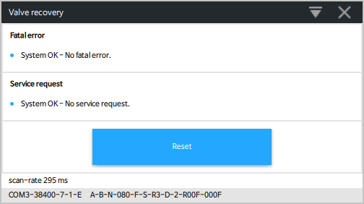

**If Fatal Error appear:**   
The valve is heavily contaminated or gate seal is heavily sticking and valve cleaning is necessary.  
Condition of fatal error = loss of more than 5 motor steps within 1 second.

 1.Do the Maintenance procedure

2.Reset the 'Fatal Error'

**If Service request appear:**  
The contamination of valve is getting higher and valve cleaning is necessary in near future. Condition of service request = loss of more than 5 motor steps within 1 minute.

 1. Do the Maintenance procedure

2. Reset the 'Service Request'

**8 Sensor menu**

**8.1 Setup(for old version )**

A sensor (vacuum gauge) is used for pressure control only. Depending on the hardware-specification **NOVASEN** valve controllers can support 1 or 2 sensors. In general sensors with a linear output-voltage range of 0 to10V are supported. A maximum sensor ratio of 100 is supported (2 sensor version).   
Use the Sensor-Setup window to enter the sensor specifications of the connected sensor(s). For other sensor types please contact **NOVASEN**.

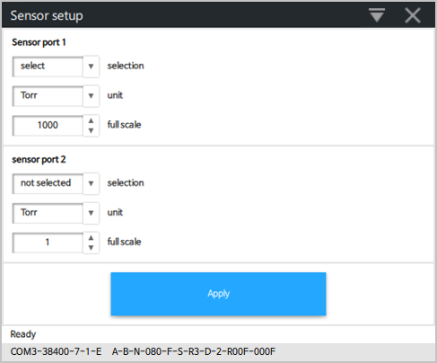

**Settings**

|  |  |
| --- | --- |
| **Item** | **Function** |
| selection | 'Selected' enable pressure control using the sensor connected to the appropriate sensor port 1 or 2.  'Not selected' to exclude this sensor from pressure control. The actual sensor value is still measured by the valve controller but is not used for pressure control. |
| unit | Select the pressure unit of the connected sensor according to the sensor specifications. |
| Full scale | Enter the full-range value of the connected sensor according to the sensor specifications. Data of sensor full scale (SFS) |

**8.2 Setup(for new version )**

A sensor (vacuum gauge) is used for pressure control only. Depending on the hardware-specification **NOVASEN** valve controllers can support 1 or 2 sensors. In general sensors with a linear output-voltage range of 0 to10V are supported. A maximum sensor ratio of 100 is supported (2 sensor version).   
Use the Sensor-Setup window to enter the sensor specifications of the connected sensor(s). For other sensor types please contact **NOVASEN**.

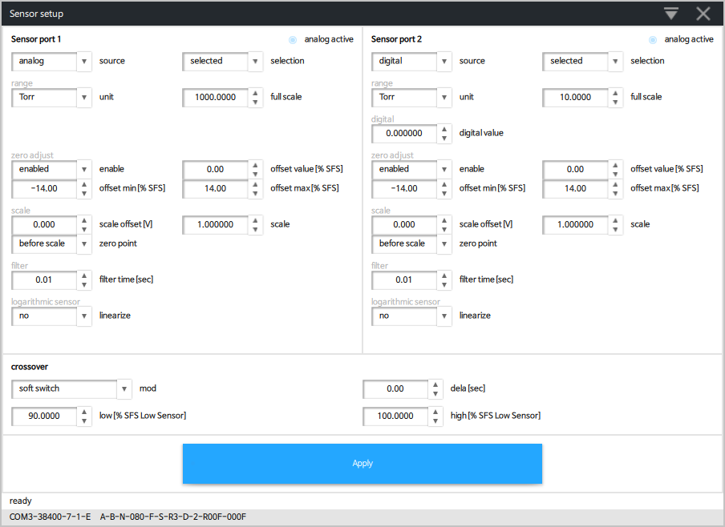

|  |  |
| --- | --- |
| **Item** | **Function** |
| source | none -> if no analog or digital reading happens  analog -> sensor is connected to the valve, read the analog voltage of the sensor  digital -> sensor is not connected to the valve, valve receive the valve from the field bus( EtherCAT, Profibus or CCLink ) |
| selection | “selected” enable pressure control using the sensor connected to the appropriate sensor port 1 or 2.  “not selected” to exclude the sensor from pressure control.  The actual sensor valve is still measured by the valve controller but is not used for pressure control. |
| unit | Select the pressure unit of the connected sensor according to the sensor specifications. |
| full-range | Enter the full-range value of the connected sensor according to the sensor specifications. Data of sensor full scale (SFS) |
| digital value | Actual value of the digital input. (Or it is possible to set the value for test purpose) |
| zero adjust | The feature is used to set the actual pressure value of a vacuum system to zero.  Select enable or disable to activate or deactivate the feature.  Please refer to <<6.6 Zero>> for further details. |
| offset value | Shows resulting value after a zero adjust or can be used to set the value. |
| offset limit min | Depending on the voltage range of the sensor the offset limit can be adjusted.  e.g. range of Sensor -0.2..10.5V --> offset limit min = -0.2, offset limit max = 0.5V |
| offset limit max |
| scale offset | Linear sensors with other voltage range as 0..10V has to be scaled:  Sensor 0..5V --> scale factor = 2, scale offset = 0;  Sensor 1..9V --> scale factor = 1.25, scale offset = 1.0 V  Sensor -10..10V --> scale factor = 0.5, scale offset = -10.0 -10V  Zero adjust must take place at the calculation point where the value should be 0, therefore zeroing must happens before or after scaling.In above example for sensor 1..9V it is after scale, for all others it is before scale. |
| scale factor |
| zero point |
| filter time | Reduces noise of the sensor signal  Note: For pressure control it is not good to have delayed sensor signal, so be carefully with filtering of the sensor signal. |
| linearize log signal | If a logarithmic sensor is used, then there are 2 possibilities:  1. Pressure control with the logarithmic signal    - no linearization on the valve (Linearization 'off' in 'Sensor - Setup')    - linearization in the NVM (Linearization 'on' in NVM - Settings')  - use of PI pressure control algorithm (adaptive algorithm cannot be used because it needs a linear signal)    - advantage: whole range of sensor can be used    2. Pressure control with a linearized signal    - linearization on the valve (Linearization 'on' in 'Sensor - Setup')    - no linearization in the NVM (Linearization 'off' in NVM - Settings')    - can use adaptive or PI pressure control algorithm    - disadvantage: only about 4 decades of the sensor range can be used for pressure control    voltage per decade: normally can be found in the manual of the sensor.  voltage at full scale: highest voltage point of the logarithmic sensor for pressure control |
| voltage per decade |
| voltage at full scale |
| crossover mode | * When two sensor are used for pressure control the crossover handles the two pressure signals to building one system pressure(Actual pressure)     crossover delay : wait time after crossover trigger happens ( only for ‘Hard Switch’) |
| crossover low |
| crossover high |
| crossover delay |

**8.3 Sensor analysis**

The Sensor analysis screen shows the actual data of connected sensor(s).

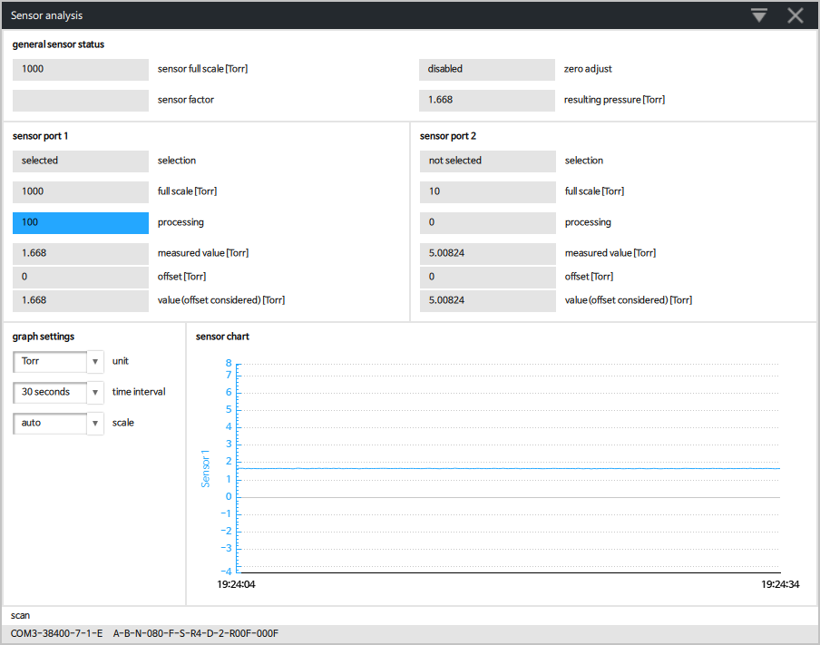

**9 Pressure control menu**

**9.1 setup**

Select the Pressure Control - Setup configuration according to requirement of application. Refer for details to chapter: «4.7 Tuning of pressure control (adaptive) » in the valve manual for function and adjustment procedure.

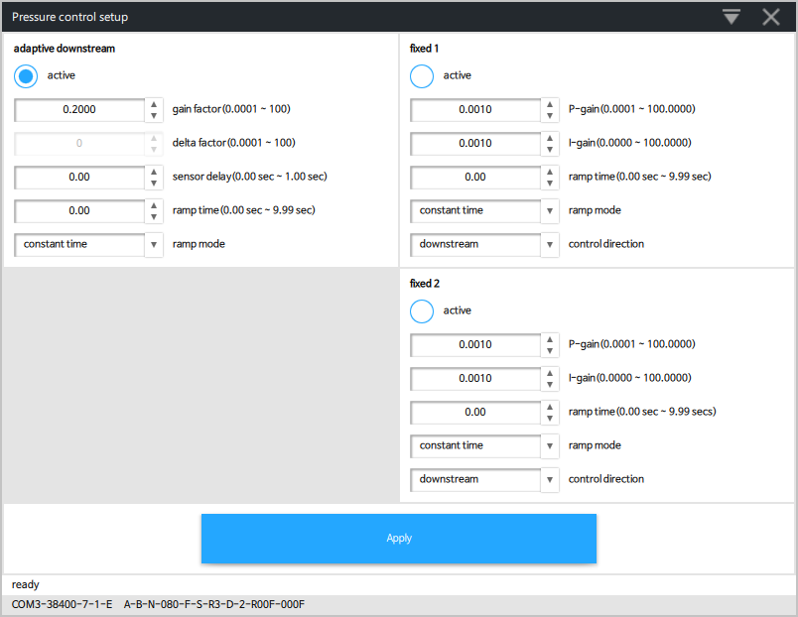

**9.2 Learn parameters**

With this function it is possible to «Load», «Write», «Read» or «Save» the 'Learn Parameters'.

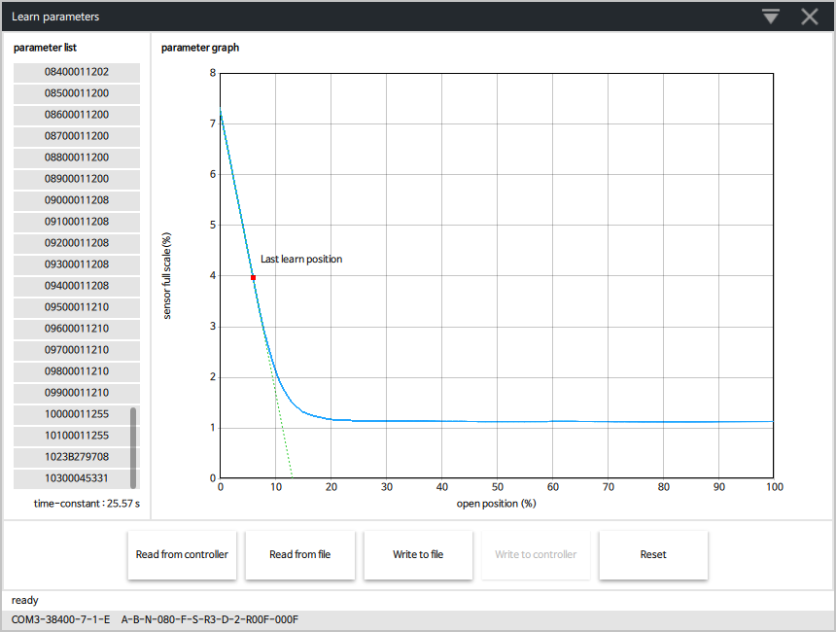

**10 Interface( Logic )**

**10.1 setup**

For setting the Logic interface configuration, select each parameter according to your host computer.

Refer to chapter: «Digital inputs» and «Digital outputs» in the valve manual for details.

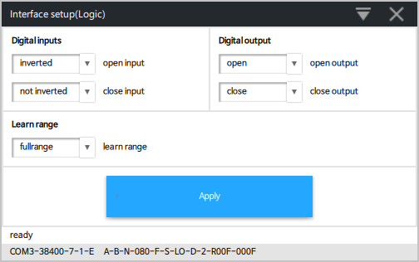

**10.2 status**

This window shows the Status (digital input / digital output / analog input)  of connected valve with Logic interface.

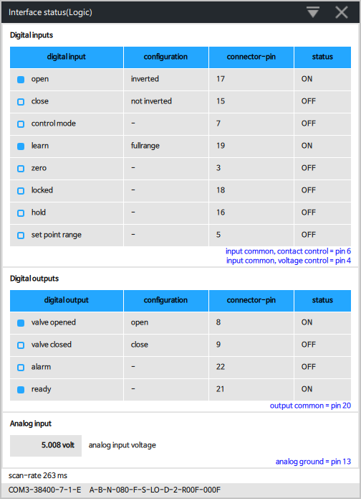

**11 Interface( EtherCAT )**

**11.1 setup**

For setting the EtherCAT interface configuration, select each parameter according to your host computer.

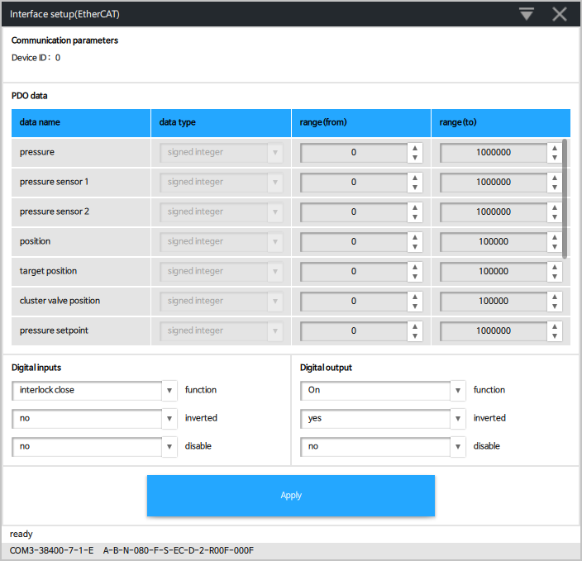

**11.2 status**

This window shows the Status (digital in/out) of connected valve with EtherCAT interface.

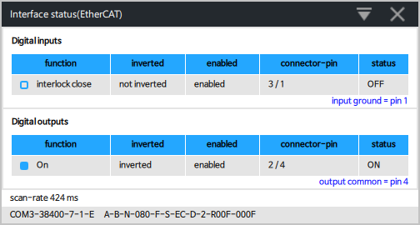

**12 Interface ( RS232 )**

**12.1 setup**

For setting the RS232 interface configuration, select each parameter according to your host computer.

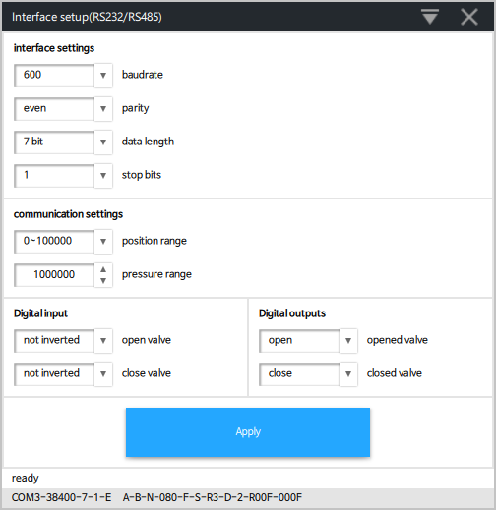

**12.2 status**

This window shows the Status (digital in/out) of connected valve with RS232 interface.

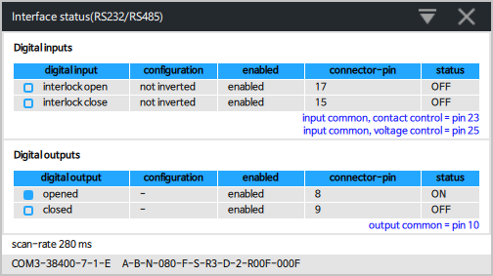

**13 Interface ( RS485 )**

**13.1 setup**

For setting the RS485 interface configuration, select each parameter according to your host computer.

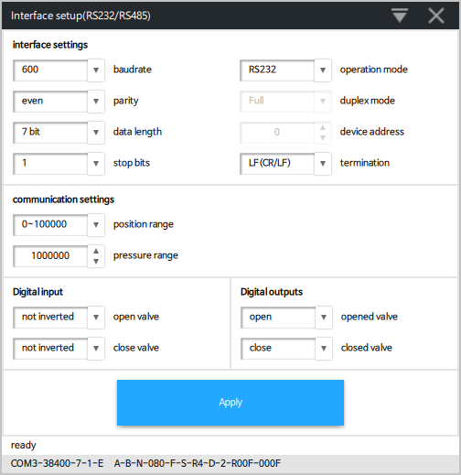

**13.2 status**

This window shows the of connected valve with RS485 interface.

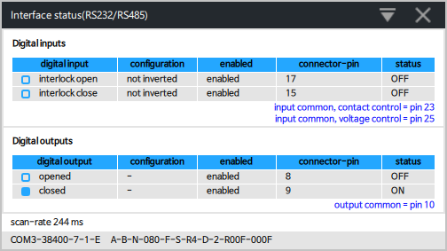

**14 Interface ( DeviceNet)**

**14.1 setup**

For setting the DeviceNet interface configuration, select each parameter according to your host computer.

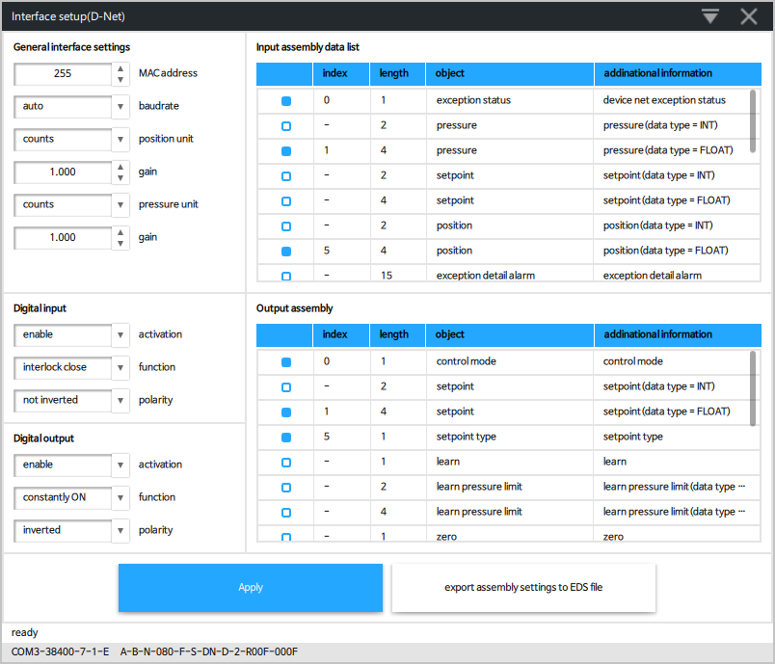

**14.2 status**

This window shows the of connected valve with DeviceNet interface.

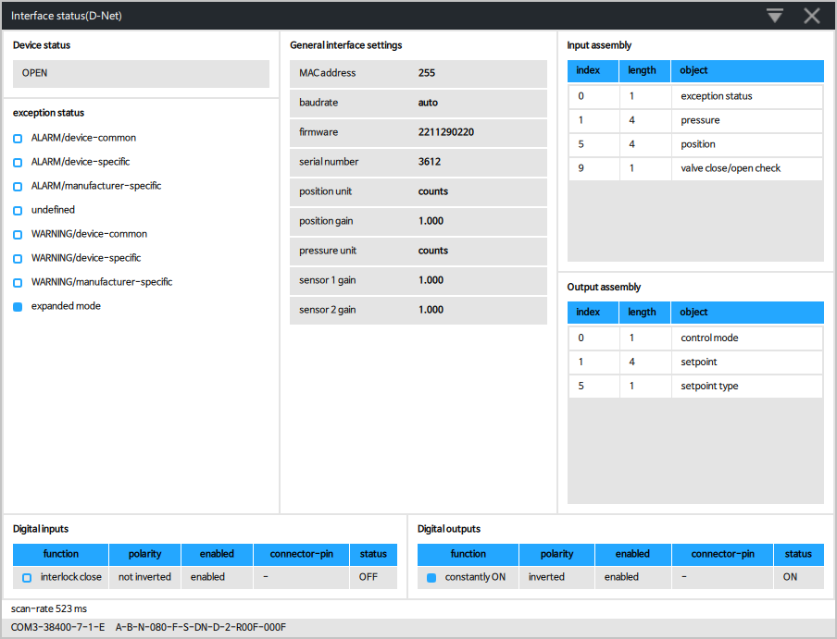

**15 Tool**

**15.1 Graph analyze**

A chart that was recorded by the graph in the main screen can be displayed.

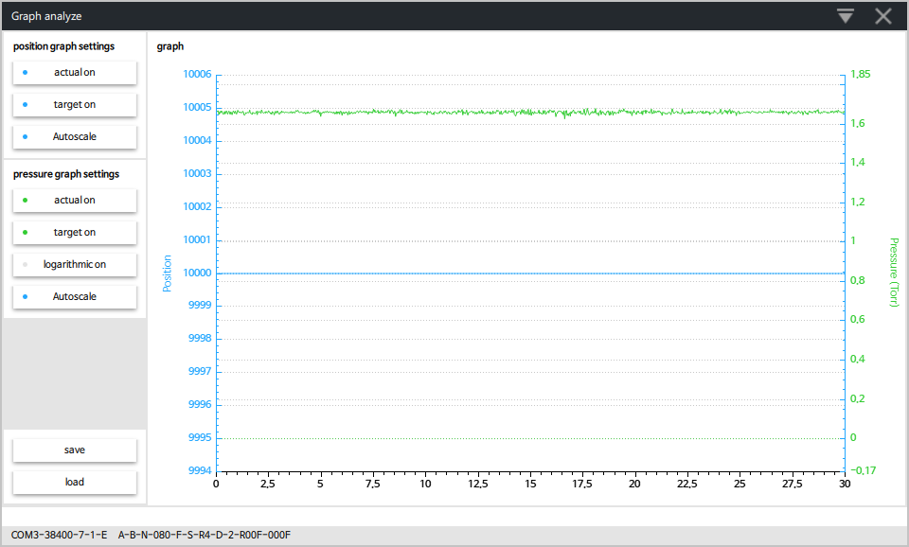

**15.2 Sequencer**

Creating a command sequence.

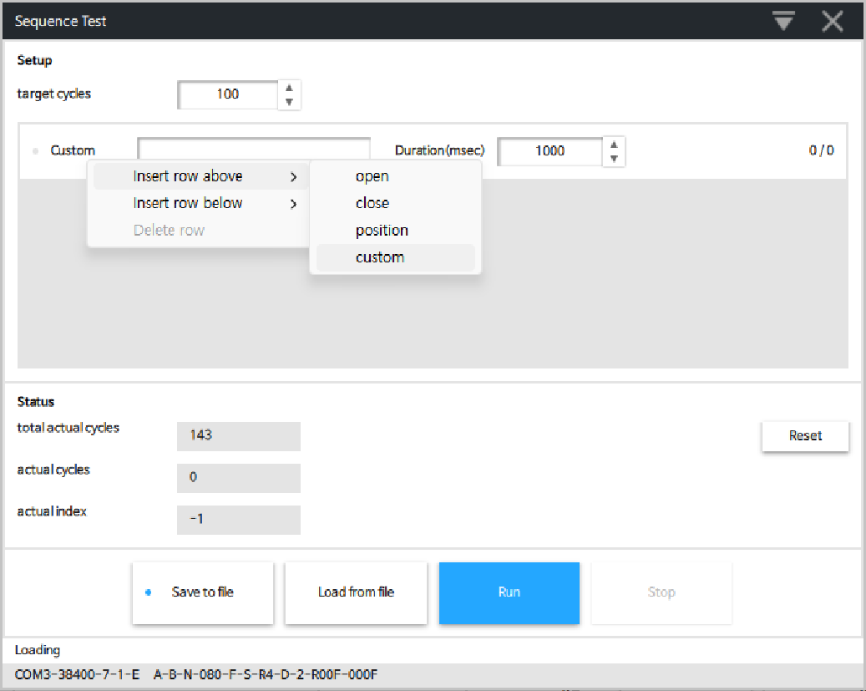

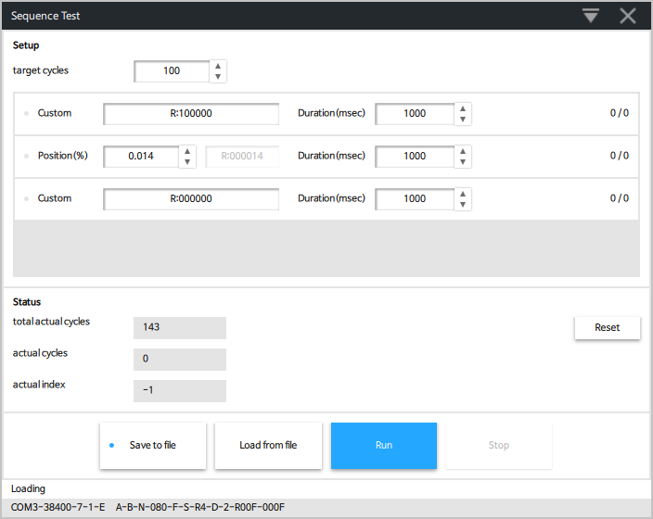

* Choose command or type command
* Input target cycles
* Click [Run] to start the sequence. Click [Stop] to stop the sequence

**15.3 Firmware update**

'Firmware update' is used for update firmware to valve controller.

1. Change access mode to ‘LOCAL’

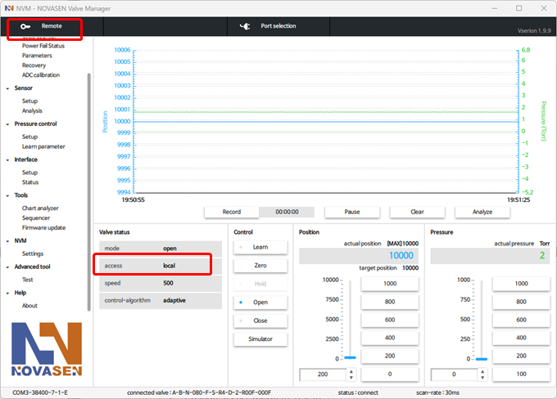

1. Click [Tools->Firmware update]

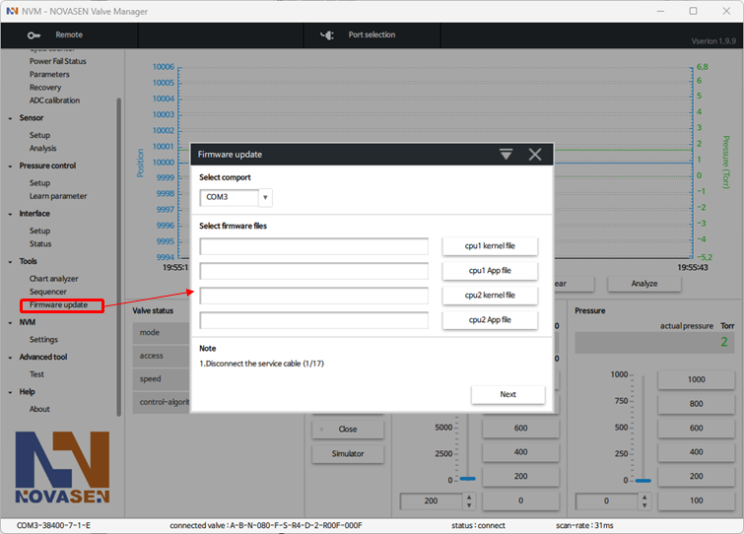

1. Disconnect the service cable. Click “Next”

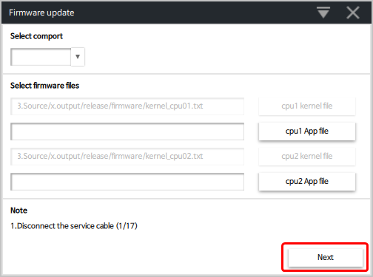

1. Connect the download adapter to the service port. Click “Next”

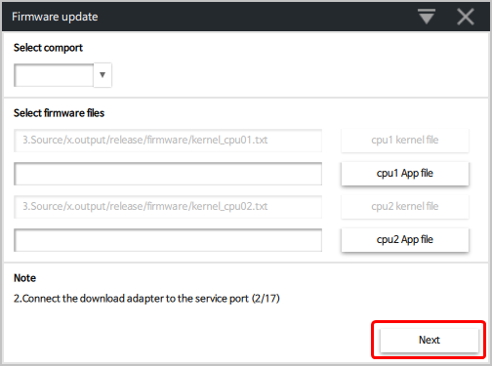

1. Connect the service cable to the download adapter. Click “Next”

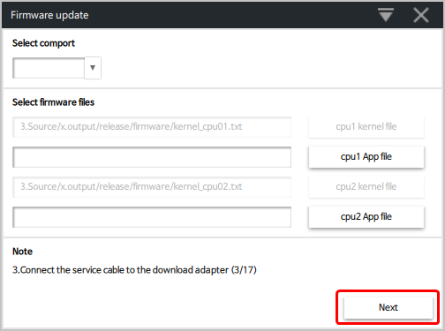

1. If the valve is powered on, power cycle it. If not, turn it on. Click “Next”

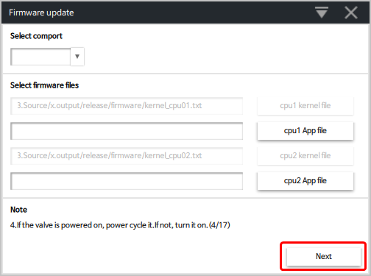

1. Select connected PC port

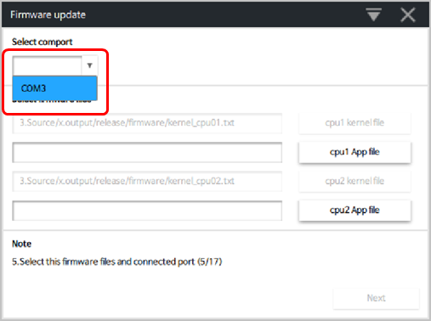

1. Select files for firmware update

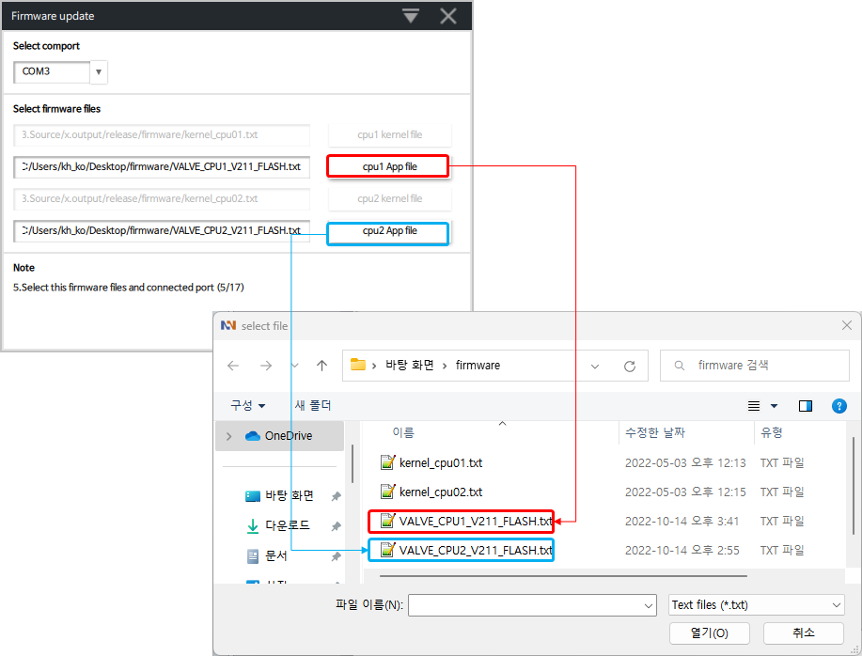

1. Click [Update] to firmeware update

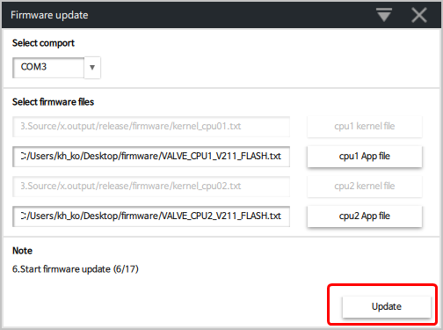

1. Disconnect the download adapter and service cable after the firmware update is finished.

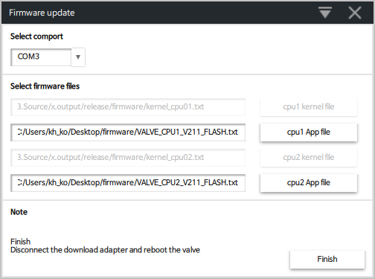

1. Reboot the valve.

**16 NVM**

**16.1 Settings**

The NVM Settings are used for adjustment of 'chart' (display) position, pressure and time axis.

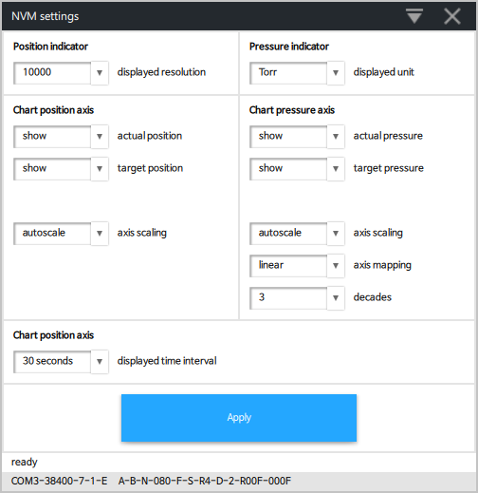

**17 Help**

**17.1 About**

