FORD MOTOR COMPANY
OPERATIONS STRATEGY & BUSINESS UNIT DIFFERENTIATION

Strategic Analysis of Three-Business-Unit Operating Model
2018-2024 Transformation Era

Kevin Hopper
DSCI-5330: Strategy and Operations Management
University of North Texas
November 6, 2025

MEMORANDUM
TO: DSCI-5330 Course Instructors and Classmates
FROM: Kevin Hopper
DATE: November 6, 2025
RE: Ford's Operations Strategy: Three-Business-Unit Differentiation Analysis

EXECUTIVE SUMMARY
Ford Motor Company's transformation from traditional automaker to three-business-unit operating model represents deliberate strategic differentiation requiring distinct operations strategies. Ford Blue (ICE vehicles) pursues cost leadership with 2,279K units and 12.8% EBIT margin. Ford Model e (Electric Vehicles) emphasizes market penetration with 3,861K units but significant losses (-131.8% EBIT margin). Ford Pro (Commercial vehicles) combines cost efficiency with premium software services, delivering 1,503K units and 13.5% EBIT margin.
This transformation reflects Porter's emphasis on clear positioning and trade-offs: each business unit makes distinct strategic choices about which customers to serve, what value propositions to offer, and what operations capabilities to develop. Using Iansiti and Serels' resource-based view of operations strategy, this memorandum examines how Ford's physical resources (manufacturing facilities), human resources (workforce expertise), intellectual property and software capabilities, ecosystem resources (partnerships and networks), and financial resources align across the three business units. Analysis reveals that Ford's resource base—particularly manufacturing scale, dealer networks, and emerging software capabilities—enables competitive advantage in Blue and Pro segments, but Model e's resource requirements for EV competitiveness create strategic misalignment as market demand falls short of projections.

SECTION II: FORD'S AMBIDEXTROUS TRANSFORMATION CHALLENGE
Ford's three-business-unit model emerged from recognition that pursuing unified strategy across ICE trucks and emerging EV technologies creates conflict. Traditional manufacturing culture emphasizes cost control, process efficiency, and long-term planning. EV/software culture emphasizes innovation, rapid iteration, and competitive technology talent acquisition. Legacy manufacturing and emerging technology cannot coexist easily in single organization—resource competition, organizational culture tension, and conflicting time horizons create dysfunction.
Ford's response: separate operating entities enabling strategic clarity. Each business unit manages distinct product lines, manufacturing footprint, profit responsibility, and operational approach. This resolves ambidextrous transformation dilemma but creates new challenges: capital allocation across business units with different return profiles, workforce transition as ICE skills become obsolete and EV/software skills become critical, and portfolio management as Blue declines and Model e/Pro grow.
Market realities confront strategic intent. EV adoption slower than projected, competitive intensity higher, cost structure disadvantage vs. Tesla and Chinese competitors, and labor cost inflation from UAW agreements all pressure the operating model. Success requires disciplined execution on multiple fronts: achieving Blue cost leadership while managing overcapacity, achieving Model e cost reduction to profitability, and scaling Ford Pro software differentiation.

SECTION III: FORD'S RESOURCE-BASED OPERATIONS STRATEGY
Understanding Ford's competitive positioning and operations strategy effectiveness requires analysis of how the company's five resource categories—physical resources, human resources, intellectual property and software, ecosystem resources, and financial resources—are organized, integrated, and developed to support each business unit's strategic positioning. The following resource-based operations strategy matrix examines Ford's resource base, integration across the organization, and development strategy, revealing both competitive advantages and strategic vulnerabilities.

EXHIBIT 1: Ford Motor Company Resource-Based Operations Strategy Matrix
Resource Strategy Dimension | Physical Resources | Human Resources | IP, Software, & Methods | Ecosystem Resources | Financial Resources
Resource Base  (Type, Capacity, Utilization) | 41 manufacturing plants globally; 375+ facilities; 5.5-6M units designed capacity; BlueOval SK battery plants (TN, KY) | 180,000 employees; experienced ICE manufacturing workforce; growing EV/software engineering talent; UAW union labor | Ford+ digital platform; OTA updates; telematics & fleet management software (Ford Pro); data analytics systems | 4,000+ North American dealers; global Tier 1/2/3 supplier network; SK On partnership (BlueOval SK); strategic component suppliers | $185B revenue (2024); access to capital markets; profitable Blue/Pro cash generation; significant transformation investment
Resource Integration  (Organization, Planning, Decision Making) | Three business units with dedicated facilities (Blue ICE, Model e EV, Pro commercial); geographic hub-and-spoke distribution; specialized plant operations | Separate business unit leadership; functional centralization (IT, HR, Finance); UAW labor agreements constraining flexibility; workforce divided between ICE/EV/software expertise | Ford+ platform serves all three units; Pro emphasizes telematics/software revenue streams; autonomous vehicle research emerging; separate development teams by unit | Blue leverages dealer network for cost leadership; Model e navigating EV-specific supply chain (batteries, minerals); Pro integrating software into commercial solutions; supply chain finance program strengthens supplier relationships | Capital allocation across three units with different return profiles; Blue protects legacy profitability; Model e requires EV transition investment; Pro funds software expansion; disciplined ROIC management
Resource Development & Acquisition  (Innovation, Development, M&A) | New EV-dedicated facilities (Mustang Mach-E, F-150 Lightning, MEVC); BlueOval SK expansion (TN plant 2024-25, KY plant 2025-26); some facility consolidation planned | External recruitment from competitors (Tesla, Apple, Google) for EV/software talent; training programs for ICE-to-EV workforce transition; wage inflation from UAW agreements | Organic development of Ford+ ecosystem; partnerships with AWS for cloud services; autonomous vehicle R&D ongoing; machine learning for manufacturing optimization | Multi-year offtake agreements for lithium/cobalt/nickel; strategic equity investments in mining/processing; long-term supplier partnerships; dealer network relatively stable | Profits from Blue/Pro funding Model e transition; external capital for BlueOval SK; billions invested in EV/software transformation; financial flexibility supporting strategic investment

Resource-Based Strategic Analysis
Ford's resource-based analysis reveals both competitive strengths and strategic vulnerabilities. Physical resources—manufacturing scale, global footprint, and specialized facilities—enable competitive advantage in traditional markets (Blue's cost leadership) and create foundation for commercial differentiation (Pro's specialized production). However, excess manufacturing capacity from ICE-to-EV transition creates fixed-cost burden undermining profitability.
Human resources present greatest transformation challenge. Legacy ICE manufacturing expertise loses relevance as EV adoption accelerates. External talent recruitment for EV/software competes with technology sector employers offering higher compensation. UAW labor agreements increase costs, constraining flexibility. Workforce transition success determines Model e and Pro growth capability.
Intellectual property and software capabilities represent emerging competitive advantage. Ford+ platform, OTA update capability, and telematics integration enable differentiation in Pro segment and create foundation for future mobility solutions. However, software development talent remains scarce relative to technology competitors.
Ecosystem resources—dealer networks and supplier partnerships—represent durable competitive advantages in traditional markets. Blue's leverage of 4,000+ dealer relationships enables efficient distribution. However, dealer model adds costs that EV direct-sales competitors avoid, potentially undermining Model e competitiveness. Supply chain finance programs strengthen supplier relationships, but management complexity increases with EV-specific supply chains (batteries, minerals).
Financial resources enable transformation investment but create capital allocation tension. Blue must maintain profitability while Model e requires EV transition investment. Pro offers growth opportunity. Finite capital requires disciplined allocation and forces difficult choices about Model e investment pace and Blue capacity rationalization.

SECTION IV: OPERATIONS DECISIONS SUPPORTING BUSINESS UNIT STRATEGIES

Ford Blue: Cost Leadership Through Manufacturing Excellence
Ford Blue pursues cost leadership positioning in traditional ICE truck market, targeting price-sensitive customers seeking familiar technology and established dealer support. Blue's resource-based competitive advantage derives from decades of F-150 manufacturing expertise, brand equity, dealer network strength, and established supply chains. Resource integration emphasizes efficiency: dedicated ICE plants enable factory-level optimization, high-volume production reduces unit costs, and established platforms avoid redesign costs. Infrastructure decisions support cost focus: experienced manufacturing workforce, established supplier relationships, and proven supply chain. Blue achieves 12.8% EBIT margin demonstrating profitable cost leadership execution.
However, Blue faces structural overcapacity challenge. Legacy ICE plants designed for 4.5-5 million units; actual production 2.3 million units. Excess capacity creates fixed-cost absorption problem—factory overhead, management staff, equipment depreciation continue regardless of production volume. This structural challenge constrains Blue's resource development and ability to invest in adjacent capabilities. Blue must choose: right-size capacity (plant closures) or accept margin erosion from capacity absorption.

Ford Model e: Market Penetration Through Technology Integration
Ford Model e pursues market penetration in electric vehicle segment, accepting near-term value destruction (-131.8% EBIT margin) to establish competitive position in emerging market. Model e competes against Tesla's technology leadership, Chinese manufacturers' cost advantage, and traditional competitors' EV programs. Model e's resource advantage is limited: Ford's manufacturing scale helps but EV competitors achieve lower costs; Ford's brand equity in trucks matters less in EV market; dealer model adds cost that EV competitors avoid.
Model e's critical resource decision: vertical integration into battery manufacturing through BlueOval SK ($11+ billion investment). Battery resources determine EV profitability—30-40% of vehicle cost. Direct manufacturing enables cost control, supply security, and technology innovation. Conversely, battery integration locks Ford into commodity cost exposure (lithium, cobalt, nickel volatility) and capacity timing risk. If EV demand materializes, battery plants become insufficient. If demand slows, expensive battery capacity becomes stranded asset.
Model e faces severe resource constraints. Capacity utilization below breakeven volumes. Wholesale prices compressed by Tesla competition and Chinese manufacturers. Customer price sensitivity to EV premiums remains high. Government incentives (IRA credits) insufficient to drive adoption. Human resource challenge: Model e requires workforce transformation from ICE to EV expertise, competing with Tesla and technology companies for talent. Resource development through external talent recruitment increases costs and creates organizational culture tension.
Model e's resource-strategy misalignment is emerging: structural decisions (battery vertical integration, new EV plants, EV platforms) are correct for EV competitiveness but operate under capacity underutilization pressure. Market demand has not met resource development projections.

Ford Pro: Premium Services Through Hardware-Software Integration
Ford Pro combines commercial vehicle specialization with integrated software services (telematics, fleet management, subscription revenue), creating premium value proposition for professional and fleet customers. Pro's resource base: specialized commercial vehicle platforms (Super Duty, Transit), dedicated manufacturing facilities, and integrated telematics and software capabilities. Pro's human resources include software engineering teams developing Ford Pro applications and customer support specializing in fleet operator workflows. Supply chain focuses on commercial reliability and software integration. Pro delivers 1,503K units with 13.5% EBIT margin—strongest profitability in Ford's portfolio.
Pro's resource integration emphasizes software-hardware integration. Structural decisions (commercial specialization, dedicated facilities) and infrastructure decisions (software teams, customer support) directly enable competitive differentiation. Hardware alone would be commodity; software integration creates defensible advantage and premium pricing. Ecosystem resources—professional customer relationships, fleet operator partnerships, integration with customer business systems—create stickiness.
Pro demonstrates strongest resource-strategy alignment in Ford's portfolio. Market positioning (premium services for professionals) matches resource capabilities (integrated hardware-software). Profitability (13.5% EBIT margin) reflects successful resource leverage and value capture. Growth opportunity significant as software-as-a-service revenue expands—potential for margin improvement through subscription services. Resource development continues strengthening software capabilities while maintaining commercial vehicle excellence.

SECTION V: STRATEGIC FIT AND IMPLEMENTATION EFFECTIVENESS
Strategic-operations alignment reveals varying degrees of resource-strategy fit. Ford Blue demonstrates strong alignment between cost leadership strategy and resource integration: efficient manufacturing, dealer network leverage, supply chain management, and workforce discipline create competitive advantage. Blue's resource development strategy—gradual platform improvements, supplier relationship deepening—appropriately supports cost positioning.
Ford Model e exhibits emerging resource-strategy misalignment. Market penetration strategy assumes rapid EV adoption and margin expansion with volume—projections now contradicted by market reality showing slower adoption, higher competitive intensity, and cost structure disadvantage. Model e's resource development strategy (battery vertical integration, new facilities, external talent recruitment) is correct for EV competitiveness but faces execution challenges. If Model e cannot achieve cost reduction and profitability by 2026, Ford must reconsider resource commitment to this business unit.
Ford Pro demonstrates strongest resource-strategy fit. Premium services positioning combines cost-efficient vehicles with integrated software, creating defensible competitive advantage. Resource decisions (commercial specialization, software engineering, customer focus) directly enable competitive differentiation. Pro represents operational excellence within Ford's portfolio and resource leveraging.
Implementation effectiveness requires coordination across all five resource dimensions. Leadership communication of Ford+ vision provides clarity, but execution challenges persist: legacy manufacturing culture constrains technology adoption, UAW labor agreements limit flexibility, capital allocation tensions create resource conflict between business units, and external talent competition pressures software capability development. Performance measurement through business unit EBIT enables accountability but creates short-term optimization bias potentially conflicting with long-term transformation needs.

EXHIBIT 2: Business Unit Performance and Strategic Positioning
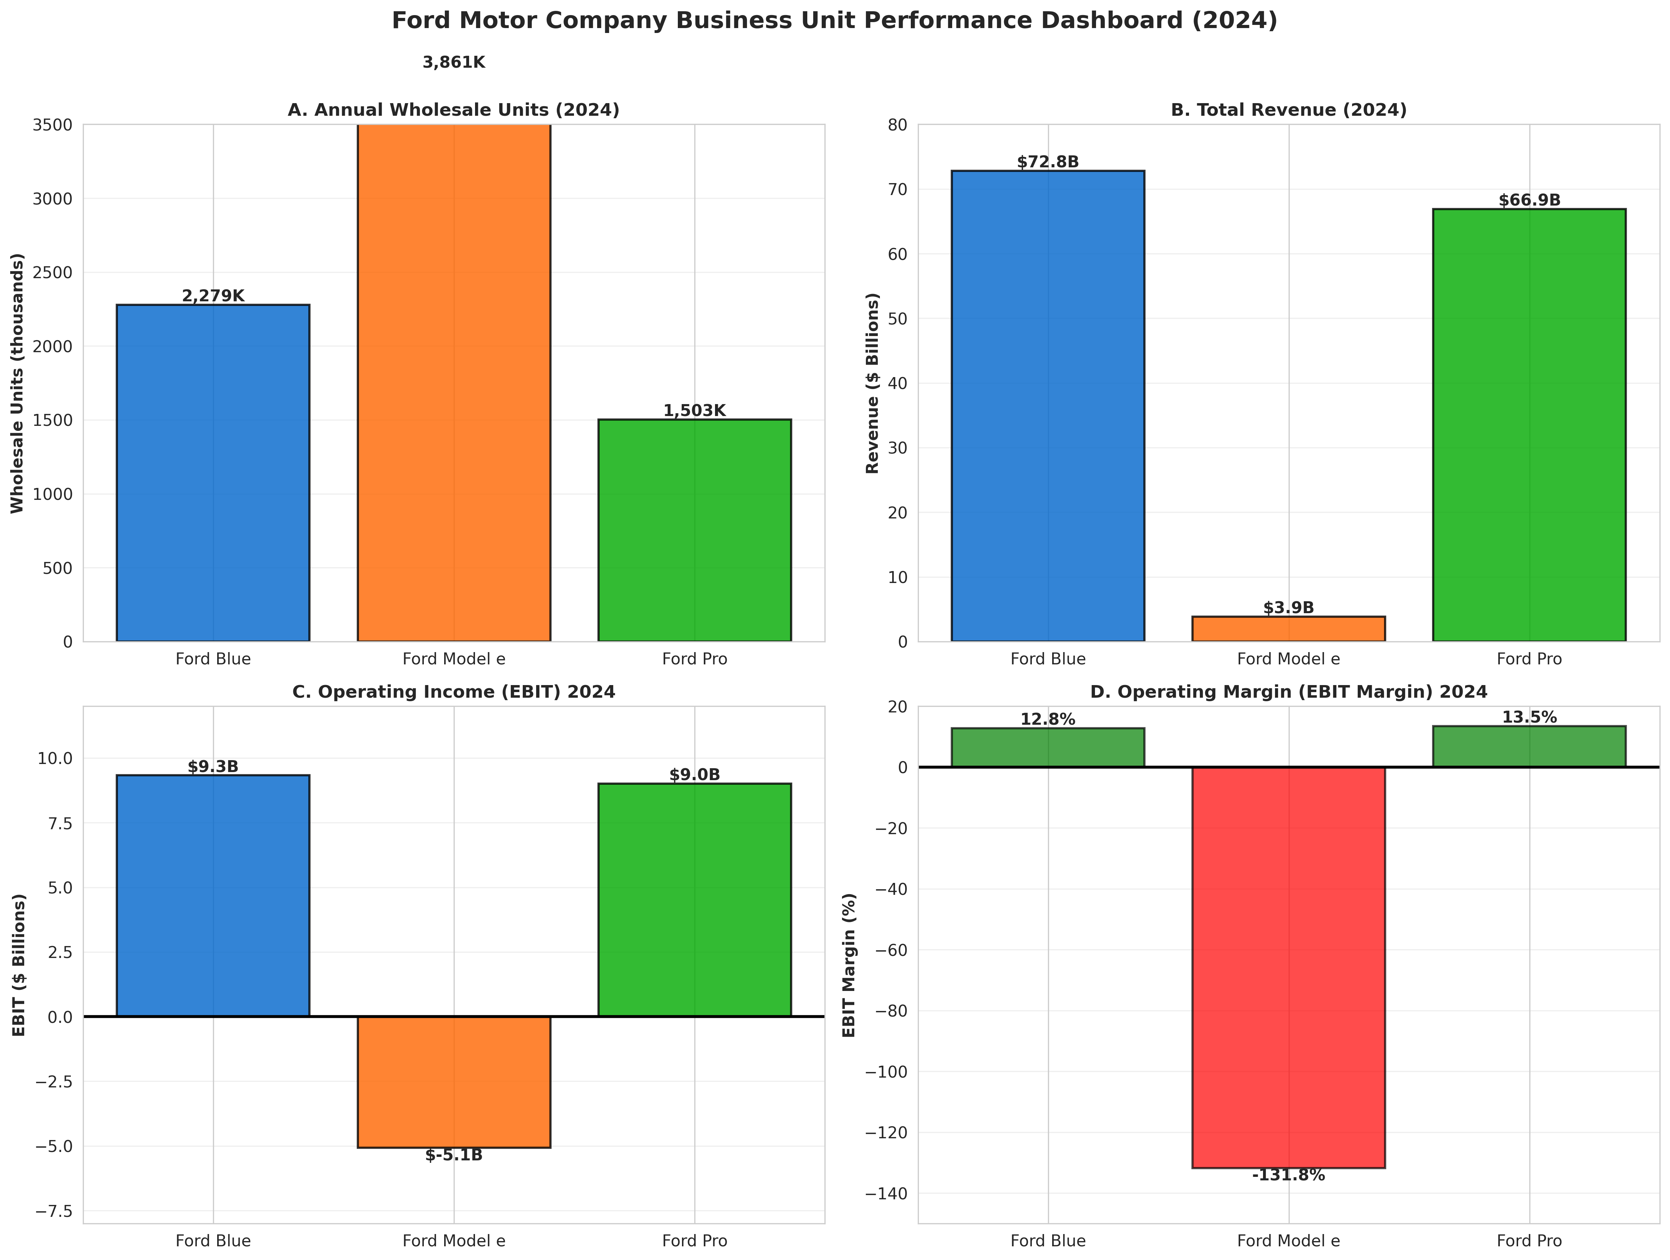

CONCLUSION
Ford Motor Company's three-business-unit operating model reflects strategic clarity about differentiation and positioning—a necessary organizational response to ambidextrous transformation challenge of managing legacy ICE profitability while investing in EV and software future. Through the lens of resource-based operations strategy, analysis reveals Ford possesses valuable resources—manufacturing scale, dealer networks, brand equity, emerging software capabilities—but these resources align better with Blue and Pro strategies than Model e positioning.
Strategic intent is clear. Operations and resource strategy choices (Blue efficiency, Model e technology integration, Pro software differentiation) are conceptually sound. However, implementation effectiveness is uneven. Blue operates successfully but faces structural overcapacity requiring difficult capacity rationalization decisions. Model e faces mounting resource utilization pressure as market demand falls short of projections—cost reduction and profitability achievement by 2026 becomes critical test of strategic assumptions and resource allocation discipline. Pro represents operational excellence and strongest competitive positioning.
The fundamental challenge Ford faces is reconciling strategic ambition (becoming EV leader while protecting Blue, building Pro) with resource constraints (excess capacity, labor cost inflation, talent competition). Success requires disciplined resource development and allocation across multiple fronts: Blue capacity rationalization and cost optimization, Model e cost reduction to achieve profitability, and Ford Pro scaling of software-service capabilities. The 2025-2026 period will be defining for Ford's transformation effectiveness and resource strategy success.

WORKS CITED
Iansiti, Marco, and Alain Serels. "Operations Strategy." Harvard Business School Core Reading 8000, Revised June 1, 2024.
Nieto-Rodriguez, Antonio. Strategy Implementation Roadmap. LinkedIn Learning, 2024.
Porter, Michael E. "What Is Strategy?" Harvard Business Review, vol. 74, no. 6, 1996, pp. 61-78.
Skinner, C. Wickham. "The Focused Factory." Harvard Business Review, vol. 52, no. 3, 1974, pp. 113-121.
Wernerfelt, Birger. "The Resource-Based View of the Firm." Strategic Management Journal, vol. 5, no. 2, 1982, pp. 171-180.
Ford Motor Company. 2024 Form 10-K Annual Report for Year Ended December 31, 2024. Filed February 6, 2025.
Ford Motor Company. 2023 Form 10-K Annual Report for Year Ended December 31, 2023. Filed February 7, 2024.
Ford Investor Relations. Financial Reports and SEC Filings. https://shareholder.ford.com/financials/default.aspx

