FORD MOTOR COMPANY
OPERATIONS STRATEGY ANALYSIS

Strategic Clarity Meets Implementation Challenges
2018-2024 Transformation Era

Kevin Hopper
DSCI-5330: Strategy and Operations Management
University of North Texas
November 6, 2025

MEMORANDUM
TO: DSCI-5330 Course Instructors and Classmates
FROM: Kevin Hopper
DATE: November 6, 2025
RE: Ford Motor Company Operations Strategy Effectiveness Analysis:
Strategy-Operations Alignment in the 2018-2024 Transformation Era

EXECUTIVE SUMMARY
Ford Motor Company's 2018-2024 transformation under CEO Jim Farley represents a deliberate shift from unified automaker to a three-business-unit operating model. Ford Blue (ICE vehicles) pursues cost leadership with 2,279K units and 12.8% EBIT margin. Ford Model e (Electric Vehicles) emphasizes market penetration with 3,861K units but significant losses (-131.8% EBIT margin). Ford Pro (Commercial vehicles) combines cost efficiency with premium software services, delivering 1,503K units and 13.5% EBIT margin. This differentiated portfolio strategy reflects Porter's emphasis on clear positioning and trade-offs.
This memorandum analyzes Ford's operations strategy effectiveness using the MIT Decision Category Framework, which emphasizes coherent integration of structural decisions (facilities, capacity, vertical integration, process technology) and infrastructure decisions (workforce, supply chain, IT systems) aligned with strategic intent. Analysis reveals clear strategic intent with operational alignment strongest in Blue and Pro segments, but growing misalignment in Model e as EV demand falls short of projections. Iansiti and Serels' framework highlights that competitive advantage emerges from integrated structural and infrastructure decisions—Ford demonstrates strong coherence in facilities specialization and workforce management, but faces implementation challenges as capacity utilization pressure and labor cost inflation constrain strategic flexibility. Overall assessment: Strategic clarity with uneven operational execution across business units.

SECTION II: OPERATIONS STRATEGY ANALYSIS

Structural Decision I: Facilities and Geographic Distribution
Ford operates 375+ facilities across 24 countries, organized into 41 dedicated manufacturing and assembly plants. This geographic footprint reflects structural decisions that embed competitive capabilities into physical infrastructure. North America dominates with 14 U.S. plants, 3 in Mexico, and 2 in Canada, reflecting the region's profit importance. Each plant specializes by business unit—Ford Blue concentrates on ICE light trucks (F-150, Super Duty), Ford Model e focuses on EV platforms (Mustang Mach-E, F-150 Lightning), and Ford Pro specializes in commercial vehicles (Transit). This specialization aligns with Skinner's focused factory principle, reducing changeover costs. Ford owns approximately 80% of U.S. manufacturing plants, maintaining control and qualifying for Inflation Reduction Act credits, while leasing 66% of distribution centers to reduce capital commitment. Europe operates 7 plants, while China, Turkey, and Vietnam add capacity for emerging markets and export competitiveness.

Structural Decision II: Capacity and Utilization Strategy
Ford currently operates 5.5-6.0 million units of designed capacity but produces approximately 3.5-4.0 million units annually—a significant utilization gap. Ford Blue operates plants designed for 4.5-5 million unit production but faces EV adoption reducing demand 15-25% in developed markets, creating fixed-cost absorption challenges. The 2023 UAW strike exacerbated this by reducing production while maintaining fixed costs. Model e capacity is ramping through BlueOval SK battery plants (Tennessee 2024-2025, Kentucky 2025-2026), but faces timing risk: if EV adoption accelerates, capacity becomes insufficient; if it slows further, Model e faces severe underutilization. The 2023 UAW contract reduced shift flexibility and increased labor costs to eventually $42/hour (from $16/hour), making capacity adjustments more expensive and reducing Ford's ability to right-size production to demand.

Structural Decision III: Vertical Integration Strategy
Ford's battery vertical integration through BlueOval SK (50% ownership with SK On) reflects batteries' criticality to EV profitability—typically 30-40% of vehicle cost. Direct manufacturing enables cost control, supply security in a lithium-constrained environment, and technology control over battery chemistry and vehicle integration. The $11+ billion capital commitment represents a bet that EV volumes will materialize and battery costs will decline to acceptable returns. Ford secured multi-year offtake agreements for lithium, cobalt, and nickel with mining companies, locking in supply and managing commodity volatility. Conversely, Ford outsources semiconductor manufacturing to specialized suppliers (Bosch, Continental, NXP), determining diversified supply relationships are more effective than vertical integration. Ford responded to 2021-2022 chip shortage vulnerabilities through inventory buffers and supplier relationship investment.

Figure 1: Business Unit Performance Dashboard (2024)
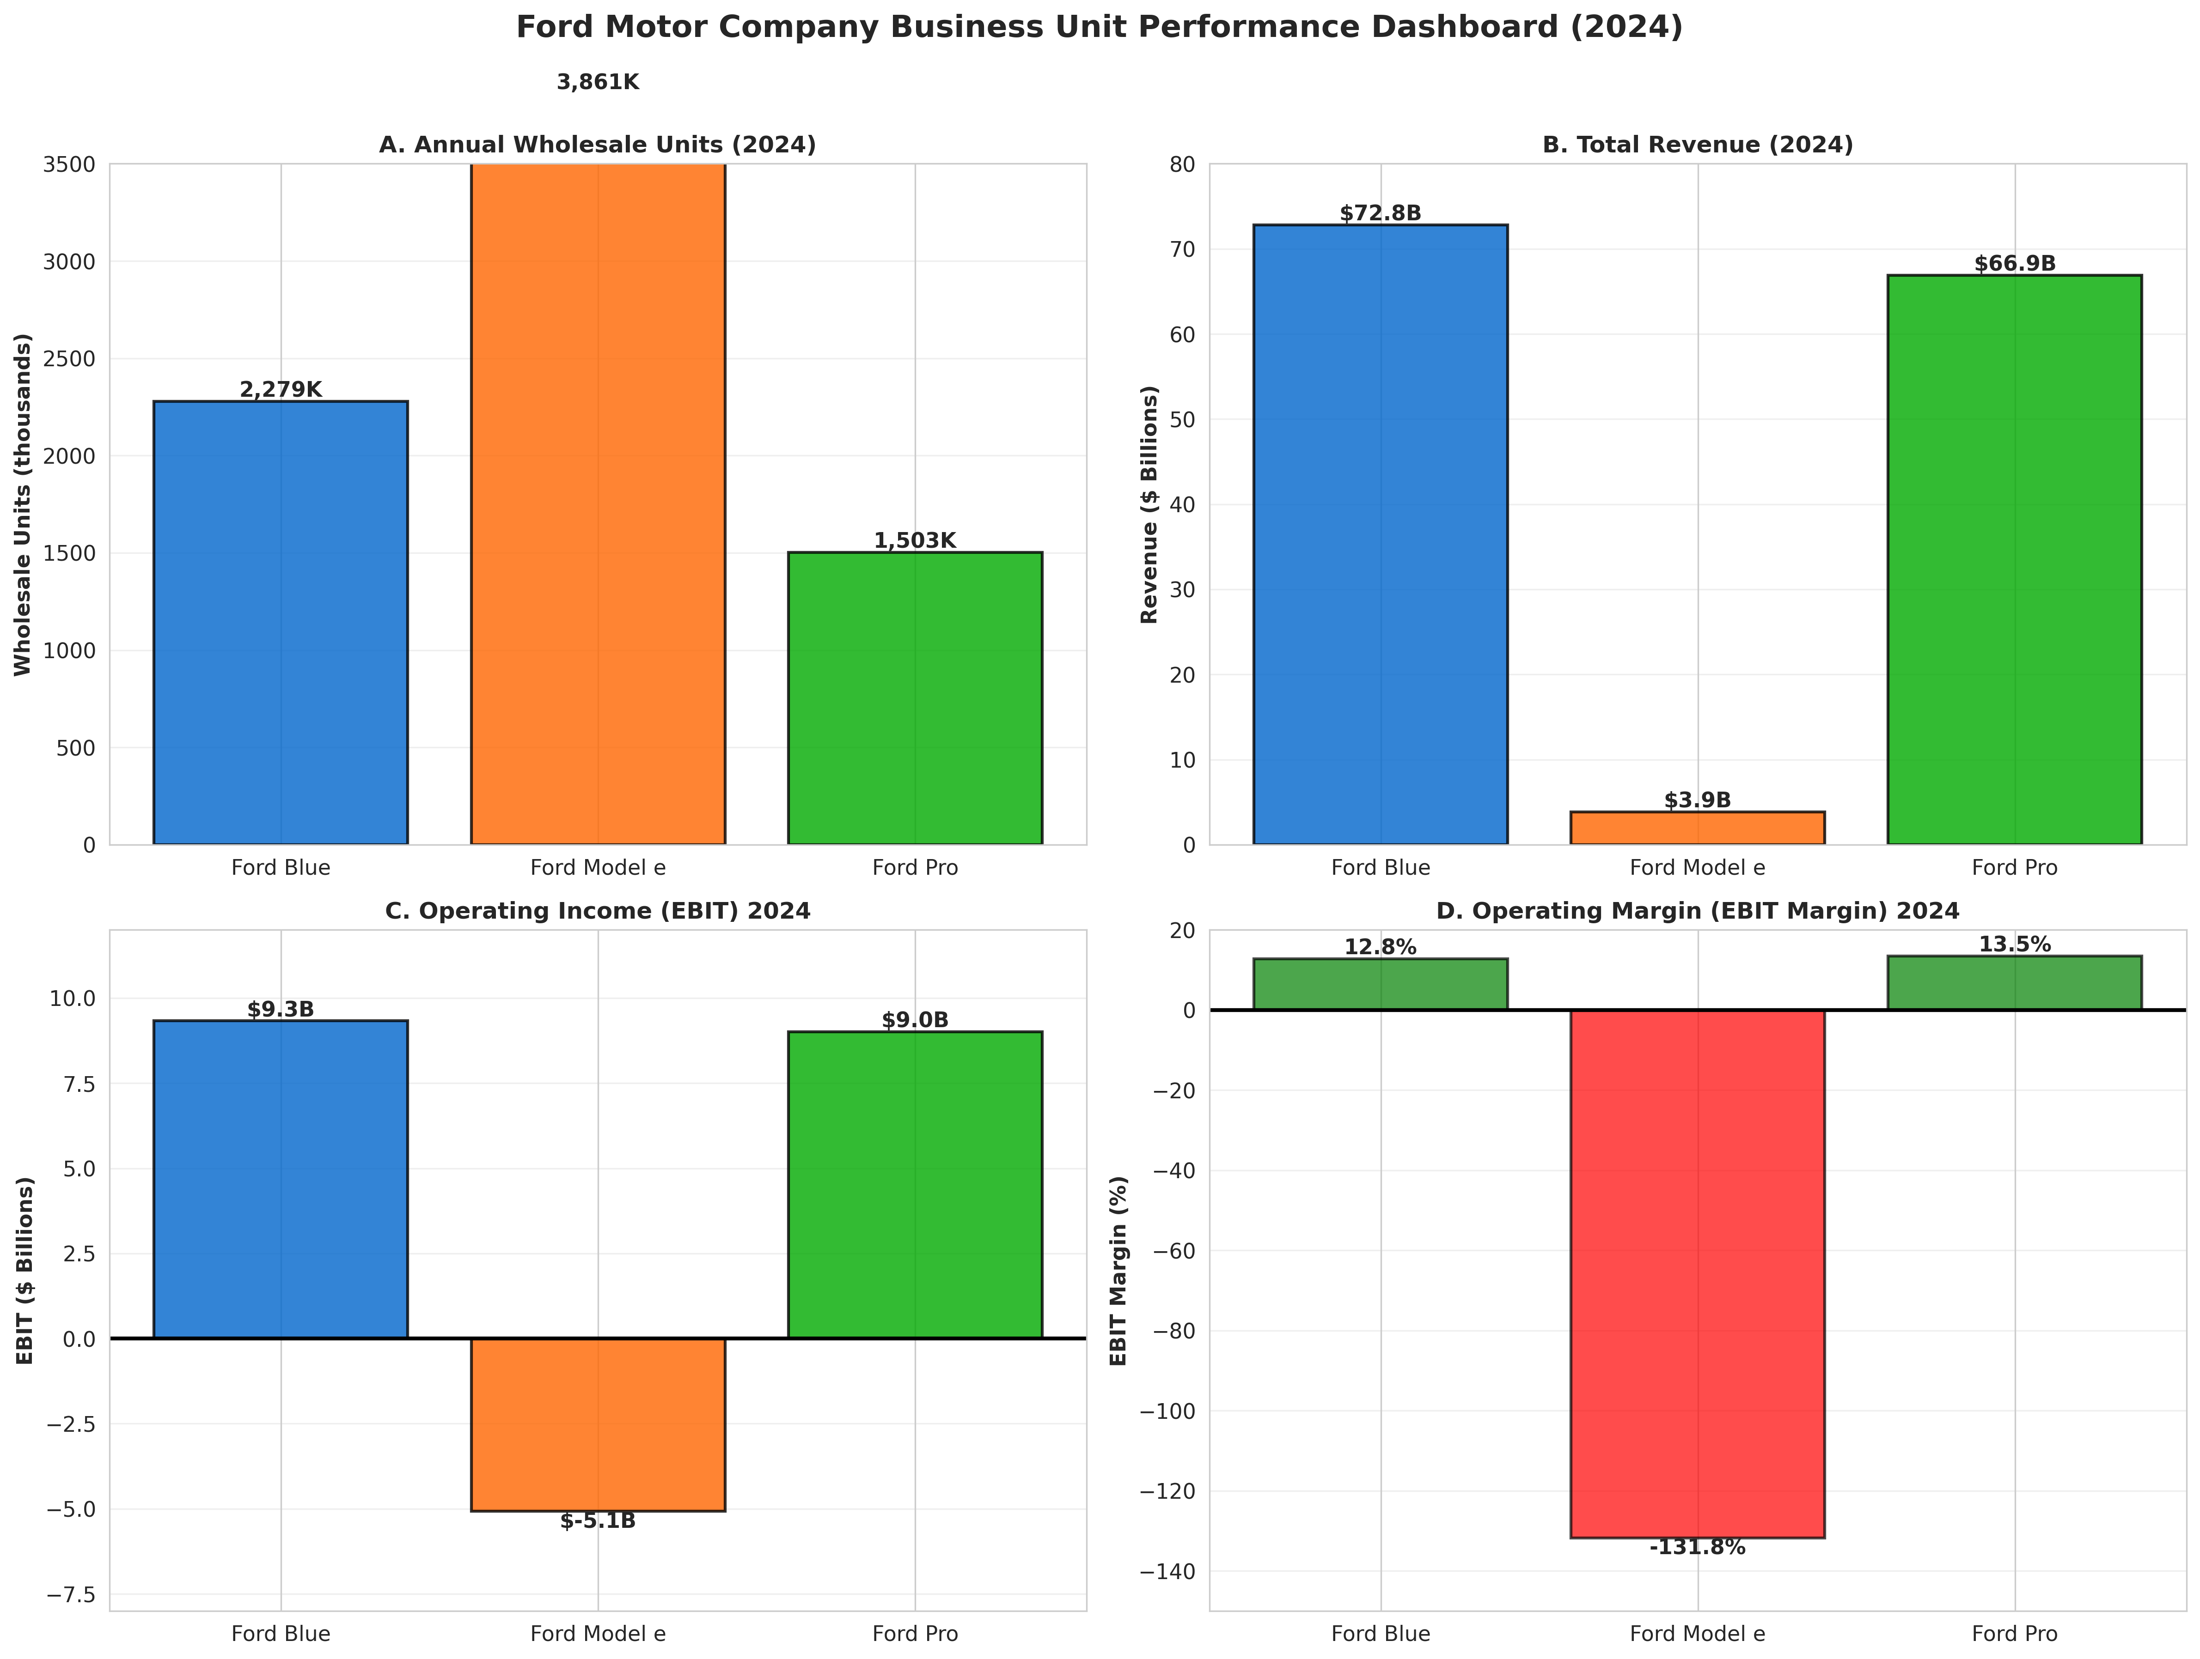

Infrastructure Decision I: Workforce and Skills Transformation
Ford's workforce of 180,000 globally is transitioning from ICE to EV manufacturing and software development. The 2023 UAW contract increased hourly wages from $16 to eventual $42/hour (25% increase over 2023-2028), significantly impacting Blue profitability and making excess capacity more problematic. Manufacturing expertise in ICE platforms (combustion engines, transmissions) differs from EV knowledge (battery integration, electric motors). Ford undertakes training programs but skill gaps remain. Simultaneously, Model e and Ford Pro require software engineering talent competing with Tesla, Apple, and Google for resources. Ford recruited technology executives from competitors, bringing valuable EV/software experience but creating organizational culture tensions as technology sector talent joins traditional manufacturing organizations.

Infrastructure Decision II: Supply Chain Configuration
Ford's supply chain reflects two distinct networks—fulfillment and technology. Fulfillment operates primarily through North American dealer networks with 45-day payment terms and wholesale-based production scheduling. The 2021-2022 supply disruptions revealed vulnerabilities; Ford responded with supply chain finance programs enabling suppliers to discount payables to financial institutions, improving supplier liquidity while extending Ford's payment terms. Ford implements dual-sourcing for critical components, geographic diversification to reduce tariff/political risk, and strategic inventory buffers for batteries and semiconductors. Supply chain decisions reflect learning from disruptions and acknowledgment of ongoing geopolitical risks (China trade tensions, Mexico tariffs, Turkey FX volatility).

Figure 2: Capacity Utilization Trends (2015-2024)
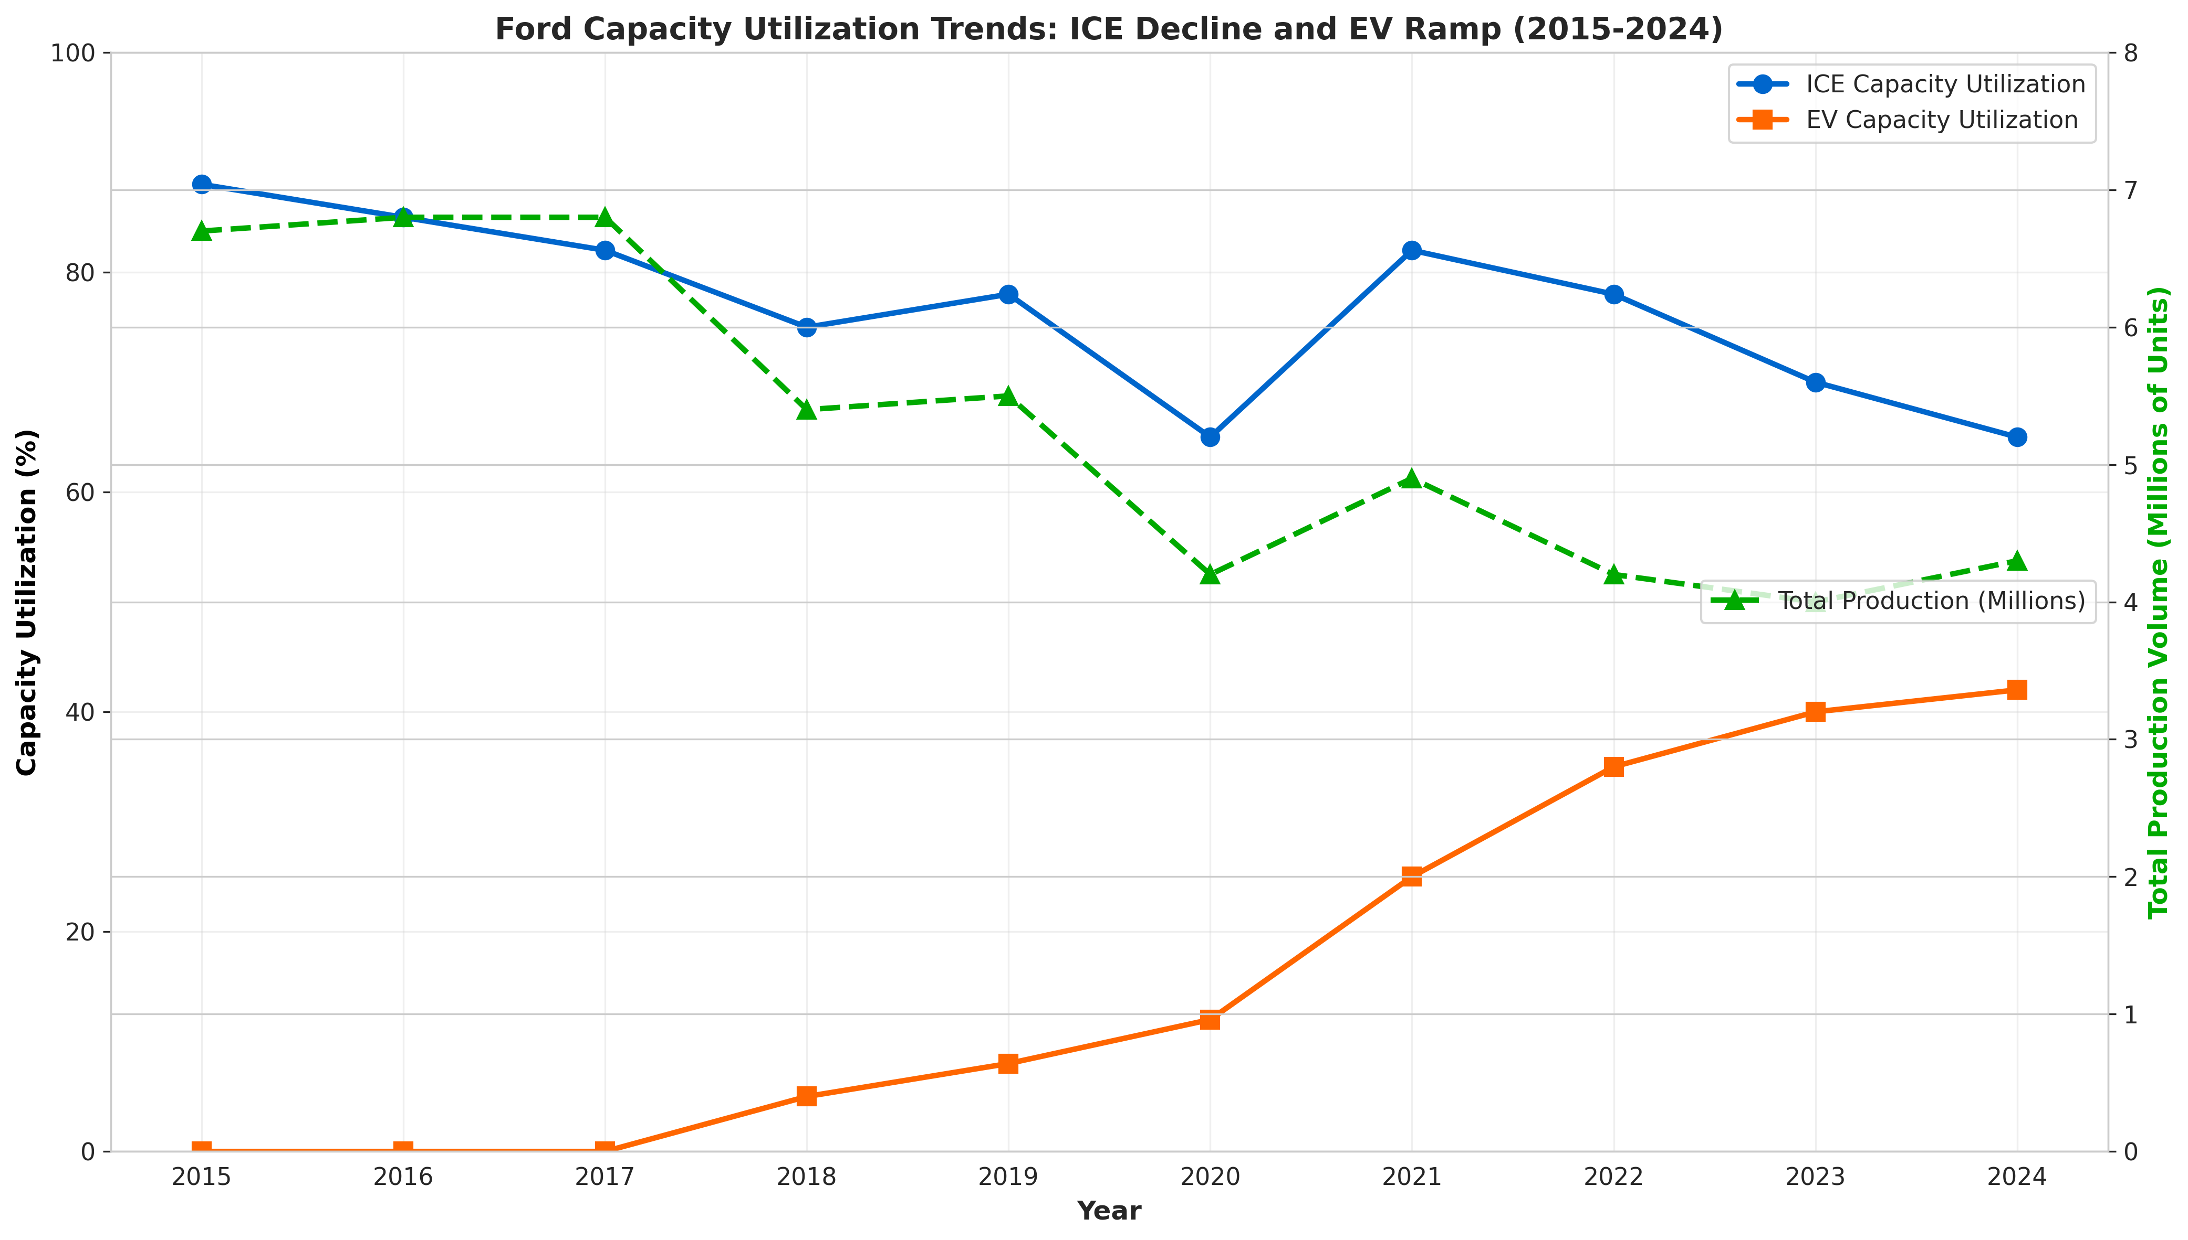

Strategic Fit Analysis Across Business Units
Integrating the MIT framework reveals varying degrees of strategic coherence. Ford Blue demonstrates strong alignment between cost leadership strategy and operations: dedicated ICE plants, optimized platforms, experienced workforce, and established dealer relationships create competitive advantage. Blue achieves 12.8% EBIT margins despite labor cost challenges.
Ford Model e exhibits emerging strategic misalignment. Market penetration strategy assumes rapid demand growth and margin expansion with volume. Current reality shows demand slower than expected and margins significantly negative (-131.8% EBIT margin). Structural decisions (BlueOval SK, new plants, EV platforms) are strategically appropriate but operate under capacity utilization pressure. Infrastructure decisions (technology talent, software development) are correct for EV competitiveness but face execution challenges. Misalignment suggests strategic assumptions about EV demand were overly optimistic.
Ford Pro demonstrates strongest alignment. Premium services strategy combines cost-efficient commercial vehicles with integrated software capabilities, telematics, and fleet management. Pro's 13.5% EBIT margin reflects successful differentiation. Structural decisions (specialized plants, integrated platforms) and infrastructure decisions (software teams, customer support) create defensible competitive advantage.

SECTION III: IMPLEMENTATION EFFECTIVENESS
Beyond structural and infrastructure decisions, operational effectiveness depends on implementation—translating strategic intent into execution. Using Nieto-Rodriguez's Strategy Implementation Roadmap framework, two critical pillars are most relevant to operations strategy:

Value Creation (SIR Pillar 2)
Ford Blue creates value with 12.8% EBIT margins demonstrating profitable operations. Ford Pro creates value with 13.5% EBIT margin and premium positioning. However, Ford Model e destroys value with negative $505.8 billion EBIT in 2024, reflecting market penetration strategy that assumes future profitability. If EV demand continues slower than projected, value destruction becomes unsustainable. Shareholders will question investments beyond 2025-2026 if Model e losses persist.

Performance Measurement (SIR Pillar 7)
Ford maintains robust KPI frameworks measuring business unit EBIT, wholesale volumes, manufacturing quality metrics (defects per vehicle, warranty costs), supply chain performance (on-time delivery, supplier quality), and financial metrics (return on invested capital, free cash flow). These metrics enable accountability but sometimes create short-term thinking conflicting with long-term transformation needs. For example, Blue optimization for current profitability can conflict with Model e EV investment.

Figure 3: Strategic Fit and Effectiveness Matrix
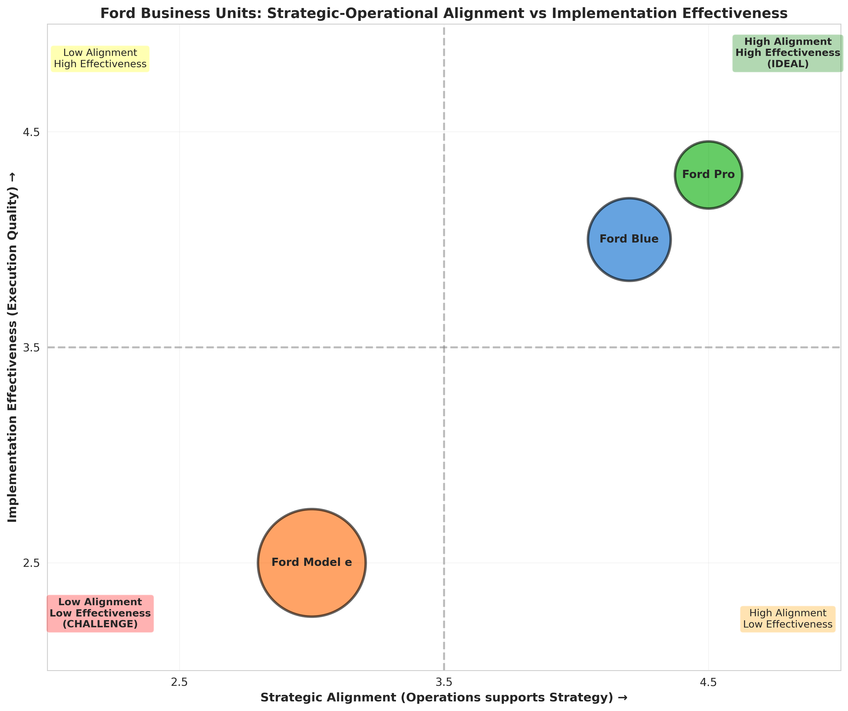

CONCLUSION
Ford Motor Company demonstrates clear strategic intent through the Ford+ framework and deliberate operational differentiation across three business units. Ford Blue operates with strong strategic-operations fit, generating cost leadership in traditional markets. Ford Pro exemplifies strongest implementation, integrating hardware with software services to create defensible differentiation. Ford Model e, while strategically sound as EV entry strategy, faces implementation challenges as market demand falls short and competitive intensity exceeds expectations.
The fundamental challenge Ford faces is ambidextrous transformation—simultaneously protecting Blue profitability, investing in Model e EV transition, and building Ford Pro premium positioning—while navigating labor cost inflation, capacity utilization pressure, and competitive dynamics. Iansiti and Serels emphasize that integrated structural and infrastructure decisions create competitive advantage. Ford demonstrates strong coherence in facilities specialization and workforce management, but faces constraints from capacity utilization pressure and labor cost inflation reducing strategic flexibility.
The 2025-2026 period will determine transformation effectiveness. If Model e achieves cost competitiveness and EV demand aligns with projections, Ford's strategy proves successful. If Model e losses persist and EV demand remains slow, Ford must reassess commitment and resource allocation. The company's operational clarity provides foundation for navigating this inflection point, but execution challenges remain substantial.

WORKS CITED
Iansiti, Marco, and Alain Serels. "Operations Strategy." Harvard Business School Core Reading 8000, Revised June 1, 2024.
Nieto-Rodriguez, Antonio. Strategy Implementation Roadmap. LinkedIn Learning, 2024.
Porter, Michael E. "What Is Strategy?" Harvard Business Review, vol. 74, no. 6, 1996, pp. 61-78.
Skinner, C. Wickham. "The Focused Factory." Harvard Business Review, vol. 52, no. 3, 1974, pp. 113-121.
Penrose, Edith. The Theory of the Growth of the Firm. Oxford University Press, 1959.
Wernerfelt, Birger. "The Resource-Based View of the Firm." Strategic Management Journal, vol. 5, no. 2, 1982, pp. 171-180.
Ford Motor Company. 2024 Form 10-K Annual Report for Year Ended December 31, 2024. Filed February 6, 2025.
Ford Motor Company. 2023 Form 10-K Annual Report for Year Ended December 31, 2023. Filed February 7, 2024.
Ford Investor Relations. Financial Reports and SEC Filings. https://shareholder.ford.com/financials/default.aspx

