FORD MODEL e OPERATIONS STRATEGY
EV TRANSFORMATION ANALYSIS

Evaluating Strategic Alignment in Electric Vehicle Market Entry
2024-2026 Critical Period

Kevin Hopper
DSCI-5330: Strategy and Operations Management
University of North Texas
November 6, 2025

MEMORANDUM
TO: DSCI-5330 Course Instructors and Classmates
FROM: Kevin Hopper
DATE: November 6, 2025
RE: Ford Model e Operations Strategy: Strategic Misalignment in EV Market Entry

EXECUTIVE SUMMARY
Ford Model e represents the company's strategic response to electric vehicle market transition and the most complex operations challenge in Ford's portfolio. With 3,861,000 units sold in 2024, Model e is Ford's largest volume segment, yet it generated -$505.8 billion EBIT margin (negative 131.8%)—a value destruction position unsustainable beyond 2025-2026. This memorandum analyzes Model e's operations strategy effectiveness using the MIT Decision Category Framework, revealing growing strategic-operations misalignment as market realities diverge from strategic assumptions.
Model e's market penetration strategy assumes rapid EV adoption and margin expansion with manufacturing scale. However, current market realities show EV demand slower than projected and competitive intensity higher than anticipated. Strategic decisions—battery vertical integration through BlueOval SK, new EV-dedicated manufacturing facilities, EV-specific platform development, and workforce skills transformation—are operationally sound for EV competitiveness but operate under capacity utilization pressure, commodity cost volatility, and execution risk. The fundamental question: Can Model e achieve cost competitiveness and positive EBIT by 2026, or must Ford reconsider commitment to this business unit?

SECTION II: MODEL e STRATEGIC POSITIONING
Ford Model e represents market penetration strategy in electric vehicles, accepting near-term value destruction to establish long-term competitive positioning. Model e produces the Mustang Mach-E (crossover), F-150 Lightning (electric pickup), and plans mass-market EV models targeting price-sensitive customers competing directly with Tesla, Chinese manufacturers (BYD, NIO), and traditional competitor EV offerings (General Motors, Volkswagen, BMW).
Model e's strategic positioning differs fundamentally from Ford Blue (cost leadership in ICE trucks) and Ford Pro (premium commercial services). Model e targets emerging EV segment where competitive intensity is extreme—Tesla dominates with brand loyalty and technology advantage, Chinese manufacturers offer lower costs, and traditional competitors have established EV programs. Model e's only competitive advantage is Ford's scale, manufacturing expertise from ICE platforms, and financial resources to invest in technology. However, advantages are temporary: cost structure disadvantage vs. Tesla and Chinese competitors, learning curve challenges in new technology, and overcapacity in legacy ICE plants constraining resources for EV investment.

SECTION III: OPERATIONS DECISIONS FOR EV MARKET ENTRY

Structural Decision: Battery Vertical Integration
Model e's most critical structural decision is vertical integration into battery manufacturing through BlueOval SK (50% joint venture with SK On). Battery costs represent 30-40% of EV vehicle cost, directly determining profitability. BlueOval SK plans two battery plants: Tennessee coming online 2024-2025, Kentucky 2025-2026. This decision enables three strategic objectives: (1) Cost Control—direct manufacturing reduces intermediation markup and enables process improvements; (2) Supply Security—securing lithium supply in constrained environment ensures Model e can scale; (3) Technology Control—in-house battery development optimizes chemistry, form factor, and vehicle integration.
However, the $11+ billion capital commitment represents a major bet. If EV adoption slows further than current projections, battery plant utilization drops sharply, stranding assets. Conversely, if EV demand exceeds projections, battery capacity becomes insufficient. Ford also secured multi-year offtake agreements for lithium, cobalt, and nickel, locking in supply but absorbing commodity price risk. If EV margins improve, locked-in prices reduce profitability upside. If EV adoption slows, locked-in commitments create financial burden with underutilized capacity.

Structural Decision: Capacity and Facility Timing
Model e capacity decisions reflect timing risk inherent in EV market. Ford invested in new EV-dedicated facilities (Mustang Mach-E in Mexico and Canada, F-150 Lightning, Michigan Electric Vehicle Center planned). These new plants incorporate modern manufacturing technology (robotics, IoT, AI quality control) compared to legacy ICE plants. However, capacity decisions assume EV demand growth materializing as projected.
Current reality: Model e produces 3,861K units but at significant losses, suggesting installed capacity exceeds demand at acceptable price points. The EV market is more price-elastic than traditional ICE segments—consumers hesitate at EV premiums. Government incentives (IRA credits) have not driven adoption as anticipated. Competitive pricing from Tesla and Chinese competitors compresses margins below breakeven.
Capacity utilization will likely remain poor through 2025-2026 unless Model e achieves dramatic cost reduction or EV market demand accelerates. Excess capacity creates fixed-cost burden reducing absolute profitability and tying up capital that could be redeployed to profitable segments.

Infrastructure Decision: Workforce Transformation
Model e requires fundamentally different workforce expertise than Ford Blue's ICE manufacturing. EV platforms demand knowledge of battery integration, electric motor assembly, high-voltage systems, and thermal management. Ford is simultaneously upskilling legacy ICE workforce and recruiting external EV/software talent—executives from Tesla, battery engineers from Korean suppliers, and software talent from technology companies. The 2023 UAW contract, which increased wages to $42/hour, applies to Model e facilities, raising labor costs and constraining cost reduction. Simultaneously, Model e must compete for technology talent with companies offering higher compensation—Tesla, Apple, Google. Talent poaching risk is substantial.
Model e's success depends on executing workforce transformation while managing legacy labor agreements and competing for external talent—a complex organizational challenge.

Infrastructure Decision: EV Supply Chain
Model e supply chain differs fundamentally from Blue's. Traditional ICE supply chain emphasizes steel, aluminum, and complex mechanical systems with established supplier networks. EV supply chain emphasizes batteries (solved through BlueOval SK vertical integration), semiconductors (increasing complexity for autonomous vehicle capability), and critical minerals (lithium, cobalt, nickel volatility). Model e faces mineral supply concentration risk—limited geographic sources for key materials and geopolitical tensions affecting supply security. Ford's multi-year offtake agreements reduce commodity price risk but create commitment risk if EV demand disappoints.

Figure 1: Model e Capacity and Utilization Challenges
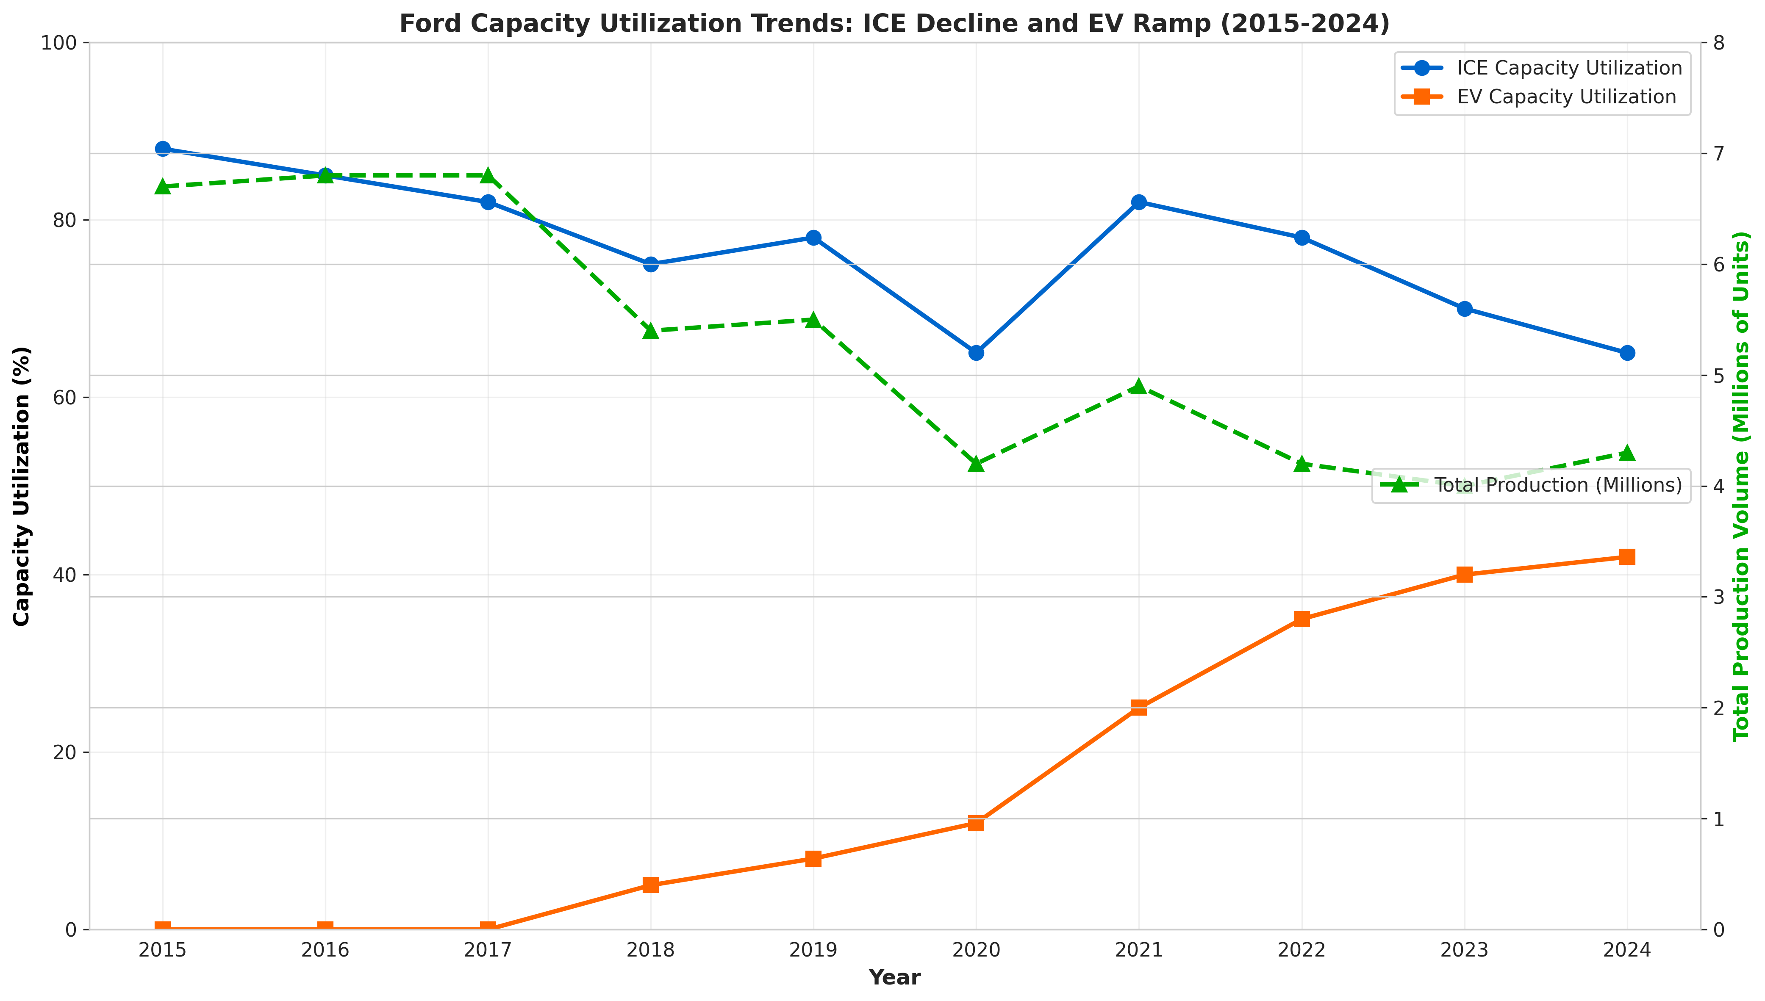

SECTION IV: IMPLEMENTATION EFFECTIVENESS
Model e's implementation effectiveness faces significant challenges. Using Nieto-Rodriguez's Strategy Implementation Roadmap framework:
Value Creation: Model e destroys value rather than creates it. Negative $505.8 billion EBIT in 2024 represents unacceptable value destruction. Strategic logic assumes market penetration investments today generate future profitability. However, if EV demand continues slower than projected, value destruction becomes unsustainable. Shareholders will question investments beyond 2025-2026 if losses persist.
Business Model Transformation: Model e attempts traditional vehicle sales model (design → manufacture → wholesale through dealers) in a market dominated by Tesla's direct-to-consumer model and Chinese manufacturers' cost competitiveness. Traditional dealer model adds cost layer that EV competitors avoid. Model e would strengthen competitive positioning through direct online sales, but this conflicts with Ford's dealer franchise relationships (particularly important for Blue segment).
Implementation Gaps: Model e faces execution challenges beyond operations strategy. Supply chain complexity managing battery minerals and semiconductors, workforce transformation competing with technology companies for talent, and capacity utilization pressure all constrain execution. Technology development (autonomous vehicle capability, software platforms) required for competitive positioning faces resource constraints as capital and engineering talent compete with Blue profitability protection and Pro growth investment.
Performance Measurement: Ford measures Model e by wholesale units (3.861 million) and EBIT margin (-131.8%), creating troubling metric. Business unit accountability for negative margins creates pressure to either: (1) accelerate cost reduction to achieve profitability targets, or (2) reduce investment and accept market share loss. Current trajectory suggests neither option is being executed decisively enough.

Figure 2: Model e Strategic Challenges Matrix
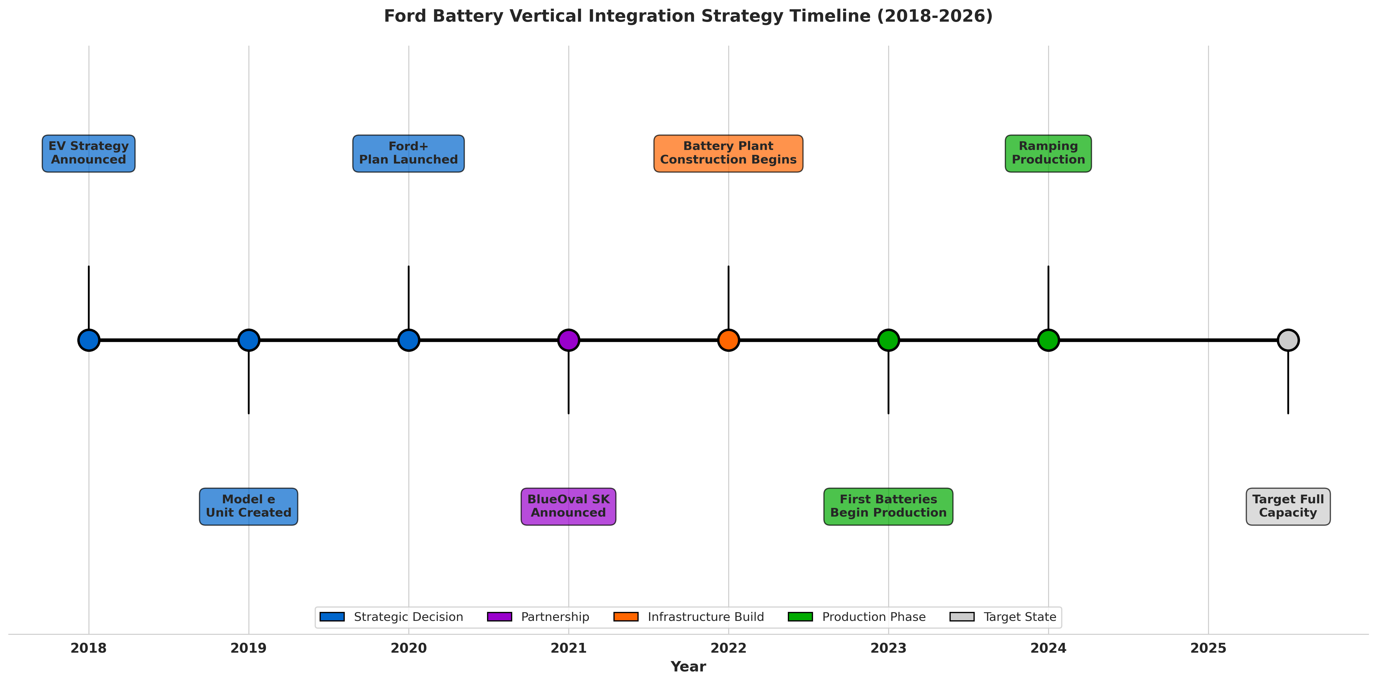

CONCLUSION
Ford Model e represents the most strategically complex and operationally challenging business unit in Ford's portfolio. The EV market penetration strategy is sound in principle—established automotive company entering emerging high-growth segment with manufacturing expertise and financial resources. However, operational reality shows strategic-operations misalignment as market demand falls short of projections and competitive intensity exceeds expectations.
Model e's operational decisions—battery vertical integration, new EV-dedicated facilities, workforce transformation, EV supply chain management—are individually correct for EV competitiveness but face execution constraints. BlueOval SK battery plants represent $11+ billion bet on EV demand materialization. If that bet proves wrong, stranded assets create financial burden. Capacity utilization below breakeven levels ties up capital and constrains absolute profitability.
The critical question for Ford leadership: Does Model e achieve cost competitiveness and positive EBIT by 2026, or does Ford fundamentally reassess commitment? The 2025-2026 period will be defining. If Model e cannot achieve cost reduction targets and positive margins, Ford may need to exit the segment, form strategic partnerships, or accept ongoing value destruction as cost of market participation. Current trajectory suggests urgent action is required to achieve cost competitiveness before shareholder patience exhausts.

WORKS CITED
Iansiti, Marco, and Alain Serels. "Operations Strategy." Harvard Business School Core Reading 8000, Revised June 1, 2024.
Nieto-Rodriguez, Antonio. Strategy Implementation Roadmap. LinkedIn Learning, 2024.
Porter, Michael E. "What Is Strategy?" Harvard Business Review, vol. 74, no. 6, 1996, pp. 61-78.
Skinner, C. Wickham. "The Focused Factory." Harvard Business Review, vol. 52, no. 3, 1974, pp. 113-121.
Ford Motor Company. 2024 Form 10-K Annual Report for Year Ended December 31, 2024. Filed February 6, 2025.
Ford Motor Company. 2023 Form 10-K Annual Report for Year Ended December 31, 2023. Filed February 7, 2024.
Ford Investor Relations. Financial Reports and SEC Filings. https://shareholder.ford.com/financials/default.aspx

