FORD MOTOR COMPANY
OPERATIONS STRATEGY & BUSINESS UNIT DIFFERENTIATION

Strategic Analysis of Three-Business-Unit Operating Model
2018-2024 Transformation Era

Kevin Hopper
DSCI-5330: Strategy and Operations Management
University of North Texas
November 6, 2025

MEMORANDUM
TO: DSCI-5330 Course Instructors and Classmates
FROM: Kevin Hopper
DATE: November 6, 2025
RE: Ford's Operations Strategy: Three-Business-Unit Differentiation Analysis

EXECUTIVE SUMMARY
Ford Motor Company's transformation from traditional automaker to three-business-unit operating model represents deliberate strategic differentiation requiring distinct operations strategies. Ford Blue (ICE vehicles) pursues cost leadership with 2,279K units and 12.8% EBIT margin. Ford Model e (Electric Vehicles) emphasizes market penetration with 3,861K units but significant losses (-131.8% EBIT margin). Ford Pro (Commercial vehicles) combines cost efficiency with premium software services, delivering 1,503K units and 13.5% EBIT margin.
This transformation reflects Porter's emphasis on clear positioning and trade-offs: each business unit makes distinct strategic choices about which customers to serve, what value propositions to offer, and what operations capabilities to develop. The operations strategy for Blue emphasizes high-volume manufacturing efficiency and dealer network optimization. Model e requires battery technology control, new EV-dedicated facilities, and software development capability. Pro focuses on commercial specialization and integrated telematics platforms.
Analysis using the MIT Decision Category Framework—examining how structural decisions (facilities, capacity, vertical integration, process technology) and infrastructure decisions (workforce, supply chain, IT systems) align with strategic intent—reveals varying degrees of effectiveness. Blue demonstrates strong strategic-operations alignment despite capacity challenges. Model e exhibits emerging misalignment as market demand falls short of projections. Pro shows strongest integration of hardware and software into defensible competitive advantage. This memorandum examines how each business unit's operations decisions support or undermine strategic positioning.

SECTION II: FORD'S AMBIDEXTROUS TRANSFORMATION CHALLENGE
Ford's three-business-unit model emerged from recognition that pursuing unified strategy across ICE trucks and emerging EV technologies creates conflict. Traditional manufacturing culture emphasizes cost control, process efficiency, and long-term planning. EV/software culture emphasizes innovation, rapid iteration, and competitive technology talent acquisition. Legacy manufacturing and emerging technology cannot coexist easily in single organization—resource competition, organizational culture tension, and conflicting time horizons create dysfunction.
Ford's response: separate operating entities enabling strategic clarity. Each business unit manages distinct product lines, manufacturing footprint, profit responsibility, and operational approach. This resolves ambidextrous transformation dilemma but creates new challenges: capital allocation across business units with different return profiles, workforce transition as ICE skills become obsolete and EV/software skills become critical, and portfolio management as Blue declines and Model e/Pro grow.
Market realities confront strategic intent. EV adoption slower than projected, competitive intensity higher, cost structure disadvantage vs. Tesla and Chinese competitors, and labor cost inflation from UAW agreements all pressure the operating model. Success requires disciplined execution on multiple fronts: achieving Blue cost leadership while managing overcapacity, achieving Model e cost reduction to profitability, and scaling Ford Pro software differentiation.

SECTION III: OPERATIONS DECISIONS SUPPORTING BUSINESS UNIT STRATEGIES

Ford Blue: Cost Leadership Through Manufacturing Excellence
Ford Blue pursues cost leadership positioning in traditional ICE truck market, targeting price-sensitive customers seeking familiar technology and established dealer support. Blue's competitive advantage derives from decades of F-150 manufacturing expertise, brand equity, dealer network strength, and established supply chains. Operationally, Blue concentrates on high-volume efficient manufacturing—dedicated ICE plants in North America (14 U.S., 3 Mexico, 2 Canada), platform optimization reducing engineering costs, and dealer network that creates customer switching costs.
Cost leadership strategy aligns well with structural decisions: specialized ICE manufacturing plants enable factory-level optimization, high-volume production reduces unit costs, and established platforms avoid redesign costs. Infrastructure decisions support cost focus: experienced manufacturing workforce (though UAW labor cost inflation challenges margins), established supplier relationships developed over decades, and proven supply chain. Blue achieves 12.8% EBIT margin demonstrating profitable cost leadership execution.
However, Blue faces structural overcapacity challenge. Legacy ICE plants designed for 4.5-5 million unit production; actual production approximately 2.3 million units. EV adoption reduces Blue demand 15-25% in developed markets. Excess capacity creates fixed-cost absorption problem—factory overhead, management staff, equipment depreciation continue regardless of production volume. This structural challenge constrains Blue's ability to invest in adjacent technologies or new markets. Blue must choose: right-size capacity (plant closures) or accept margin erosion from capacity absorption.

Ford Model e: Market Penetration Through Technology Integration
Ford Model e pursues market penetration in electric vehicle segment, accepting near-term value destruction (-131.8% EBIT margin) to establish competitive position in emerging market. Model e competes against Tesla's technology leadership, Chinese manufacturers' cost advantage, and traditional competitors' EV programs. Model e's only structural advantages: Ford's manufacturing scale, brand equity in truck segment (F-150 Lightning), and financial resources for technology investment.
Model e's critical operational decision: vertical integration into battery manufacturing through BlueOval SK ($11+ billion investment). Batteries determine EV profitability—30-40% of vehicle cost. Direct manufacturing enables cost control, supply security, and technology innovation. Conversely, battery vertical integration locks Ford into commodity cost exposure (lithium, cobalt, nickel volatility) and capacity timing risk. If EV demand materializes as projected, battery plants become insufficient. If demand slows, expensive battery capacity becomes stranded asset.
Model e faces severe capacity utilization challenge. New EV-dedicated facilities operate below breakeven volumes. Wholesale prices compressed by Tesla competition and Chinese manufacturers. Customer price sensitivity to EV premiums remains high. Government incentives (IRA credits) insufficient to drive adoption. Infrastructure challenge: Model e requires workforce transformation from ICE to EV expertise, competing with Tesla and technology companies for talent. Supply chain adds complexity managing battery minerals (lithium supply concentration), semiconductors (autonomous vehicle requirements), and EV-specific components.
Model e's operations-strategy misalignment is emerging: structural decisions (battery vertical integration, new EV plants, EV platforms) are correct for EV competitiveness but operate under capacity underutilization pressure. Market demand has not met projections. If Model e cannot achieve cost reduction and positive EBIT by 2026, strategic assumptions prove wrong and Ford must reconsider commitment.

Ford Pro: Premium Services Through Hardware-Software Integration
Ford Pro combines commercial vehicle specialization with integrated software services (telematics, fleet management, subscription revenue), creating premium value proposition for professional and fleet customers. Pro targets business users (contractors, fleet operators, delivery services) willing to pay premium for reduced total cost of ownership through software-enabled capabilities. Pro delivers 1,503K units with 13.5% EBIT margin—strongest profitability in Ford's portfolio.
Pro's operations strategy emphasizes differentiation through software-hardware integration. Structural decisions: specialized commercial vehicle platforms (Super Duty, Transit), dedicated manufacturing facilities optimized for commercial customer needs, and integrated telematics and software platforms. Infrastructure decisions: software engineering teams developing Ford Pro applications, customer support specialization understanding fleet operator workflows, and supply chain focused on commercial reliability. Pro's operations decisions directly enable competitive differentiation—hardware alone would be commodity; software integration creates defensible advantage and premium pricing.
Pro demonstrates strongest strategic-operations alignment in Ford's portfolio. Market positioning (premium services for professionals) matches operations capability (integrated hardware-software). Profitability (13.5% EBIT margin) reflects successful value capture. Growth opportunity significant as software-as-a-service revenue expands—potential for margin improvement through subscription services. Pro represents operational excellence and strategic alignment.

SECTION IV: STRATEGIC FIT AND IMPLEMENTATION EFFECTIVENESS
Strategic-operations alignment varies significantly across Ford's three business units. Ford Blue demonstrates strong fit: cost leadership strategy supported by high-volume efficient manufacturing, experienced workforce, and established supply chains. Blue achieves 12.8% profitability despite labor cost inflation, demonstrating operational effectiveness. However, Blue faces structural overcapacity challenge—12.8% margins mask fixed-cost absorption burden from excess manufacturing capacity. Right-sizing capacity (plant closures) is necessary but difficult decision requiring management courage and capacity market acceptance.
Ford Model e exhibits emerging strategic misalignment. Market penetration strategy assumes rapid EV adoption and margin expansion with volume. Market reality shows adoption slower than projected, competitive intensity higher, and cost structure disadvantage vs. Tesla and Chinese competitors. Structural decisions (battery vertical integration, new EV plants) are strategically sound but operate under capacity underutilization. Infrastructure decisions (workforce transformation, supply chain complexity) face execution challenges. Model e's negative EBIT margin (-131.8%) is unsustainable beyond 2025-2026. If Model e cannot achieve cost reduction and positive profitability by 2026, Ford must reconsider commitment. Strategic assumptions about EV demand may prove wrong.
Ford Pro demonstrates strongest strategic-operations alignment. Premium services positioning combines cost-efficient vehicles with integrated software, creating defensible competitive advantage. Operations decisions (commercial specialization, telematics integration, software engineering) directly enable competitive differentiation. Pro's 13.5% EBIT margin reflects profitable value capture. Pro represents operational excellence within Ford's portfolio.
Implementation effectiveness using Nieto-Rodriguez's framework reveals: (1) Leadership Execution: Clear Ford+ vision communicates strategic intent across organization. (2) Value Creation: Blue and Pro create value; Model e destroys value but is strategic bet. (3) Performance Measurement: Ford maintains robust KPIs enabling accountability. (4) Business Model Transformation: Pro advancing (hardware-software integration); Blue traditional; Model e uncertain. (5) Stakeholder Management: UAW labor agreement, dealer relationships, supplier partnerships all being managed but creating constraints. (6) Employee Engagement: Legacy uncertainty in Blue, growth opportunity in Model e/Pro, talent poaching risk for software roles. (7) Organizational Culture: Tension between legacy manufacturing and technology-driven culture being managed through business unit separation.

Figure 1: Business Unit Performance and Strategic Positioning
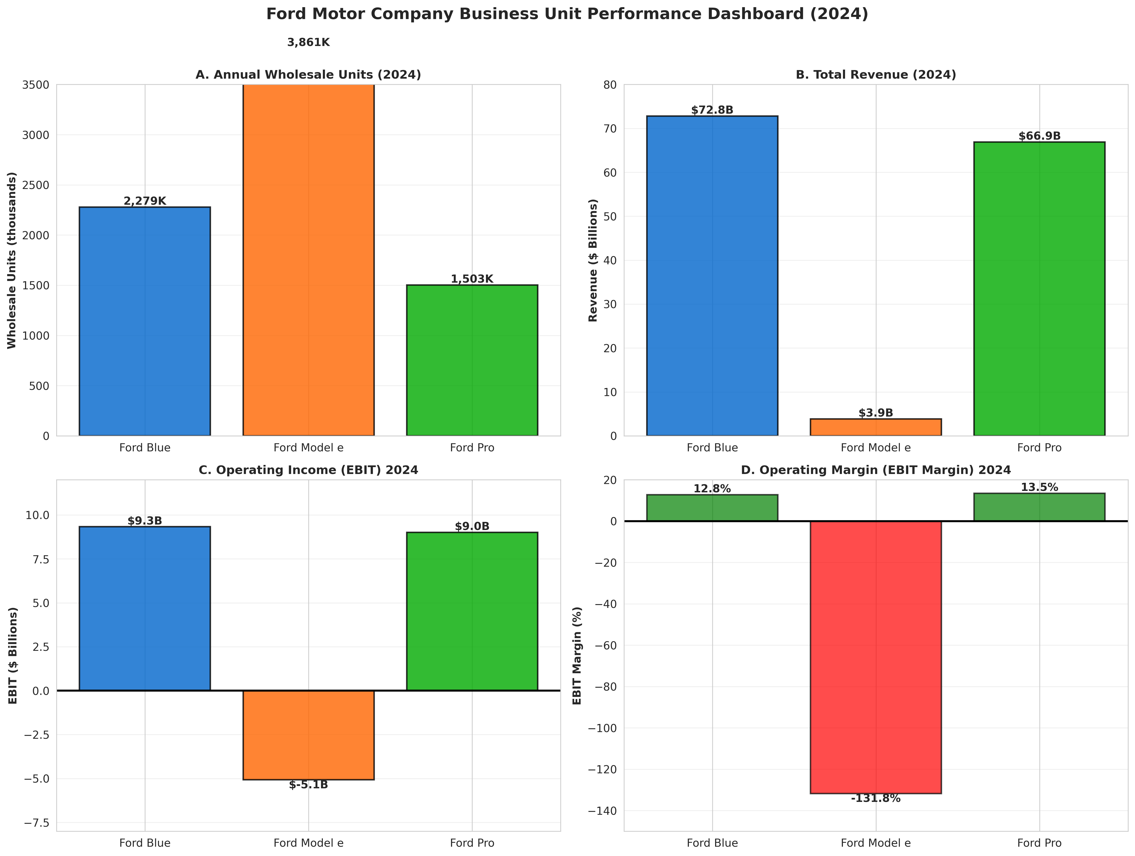

Figure 2: Capacity Utilization and Market Realities
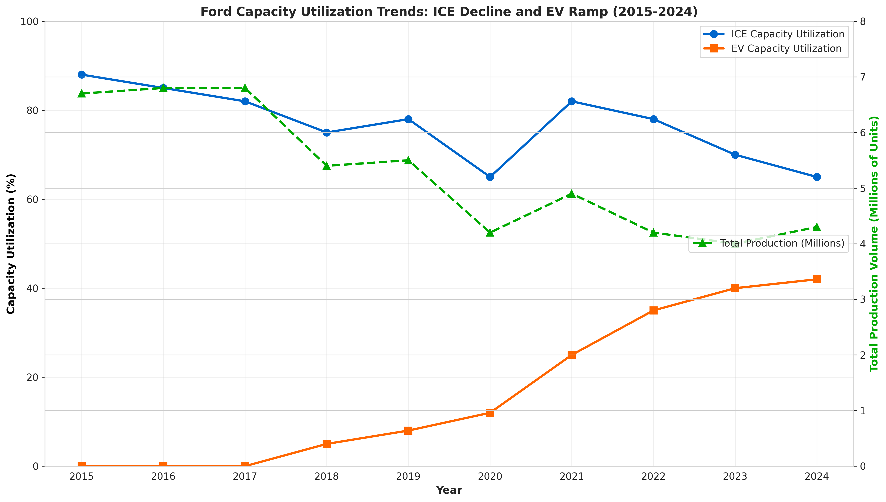

CONCLUSION
Ford's three-business-unit operating model reflects strategic clarity about differentiation and positioning—a necessary organizational response to ambidextrous transformation challenge of managing legacy ICE profitability while investing in EV and software future. Strategic intent is clear. Operations strategy choices (Blue efficiency, Model e technology integration, Pro software differentiation) are conceptually sound.
However, implementation effectiveness is uneven. Blue operates successfully but faces structural overcapacity requiring difficult decisions. Model e faces mounting pressure as market demand falls short of projections—cost reduction and profitability achievement by 2026 becomes critical test of strategic assumptions. Pro represents operational excellence and strongest competitive positioning.
The fundamental challenge Ford faces is reconciling strategic ambition (becoming EV leader while protecting Blue, building Pro) with operational constraints (excess capacity, labor cost inflation, talent competition). Success requires disciplined execution across multiple fronts: Blue capacity rationalization, Model e cost reduction to profitability, and Ford Pro scaling. The 2025-2026 period will be defining for Ford's transformation effectiveness.

WORKS CITED
Iansiti, Marco, and Alain Serels. "Operations Strategy." Harvard Business School Core Reading 8000, Revised June 1, 2024.
Nieto-Rodriguez, Antonio. Strategy Implementation Roadmap. LinkedIn Learning, 2024.
Porter, Michael E. "What Is Strategy?" Harvard Business Review, vol. 74, no. 6, 1996, pp. 61-78.
Skinner, C. Wickham. "The Focused Factory." Harvard Business Review, vol. 52, no. 3, 1974, pp. 113-121.
Wernerfelt, Birger. "The Resource-Based View of the Firm." Strategic Management Journal, vol. 5, no. 2, 1982, pp. 171-180.
Ford Motor Company. 2024 Form 10-K Annual Report for Year Ended December 31, 2024. Filed February 6, 2025.
Ford Motor Company. 2023 Form 10-K Annual Report for Year Ended December 31, 2023. Filed February 7, 2024.
Ford Investor Relations. Financial Reports and SEC Filings. https://shareholder.ford.com/financials/default.aspx

