FORD MOTOR COMPANY
OPERATIONS STRATEGY & MANAGEMENT ANALYSIS

Strategic Clarity Meets Implementation Challenges
2018-2024 Transformation Era Analysis

Kevin Hopper
DSCI-5330: Strategy and Operations Management
University of North Texas
November 6, 2025

MEMORANDUM
TO: DSCI-5330 Course Instructors and Classmates
FROM: Kevin Hopper
DATE: November 6, 2025
RE: Ford Motor Company Operations Strategy Effectiveness Analysis:
Strategy-Operations Alignment in the 2018-2024 Transformation Era

EXECUTIVE SUMMARY
Ford Motor Company stands at a critical inflection point in its operational transformation. Between 2018 and 2024, the company underwent a deliberate strategic reorganization from a traditional single-market-driven automaker into a three-business-unit model emphasizing operational differentiation. This memorandum analyzes the effectiveness of Ford's operations strategy using the MIT Decision Category Framework and the Strategy Implementation Roadmap (SIR) developed by Nieto-Rodriguez. The analysis reveals a company with clear strategic intent, well-articulated operations decisions, yet facing significant implementation challenges as market realities diverge from strategic projections. Ford Blue demonstrates strong operational alignment delivering cost leadership, Ford Model e exhibits growing strategic misalignment as EV demand falls short of expectations, and Ford Pro showcases the strongest operations-strategy fit with premium positioning supported by integrated digital capabilities. Overall assessment: Strategic clarity with uneven execution effectiveness across business units.

SECTION II: GENERAL STRATEGY ANALYSIS

Strategic Positioning and the Ford+ Framework
Under CEO Jim Farley's leadership (starting 2020, formalized in Ford+ 2021), Ford deliberately repositioned itself as a portfolio company managing three distinct business models rather than pursuing unified manufacturing excellence. This strategic shift reflects Porter's recognition that sustainable competitive advantage requires clear positioning choices and trade-offs. Ford Blue (Internal Combustion Engine vehicles) targets cost leadership in traditional markets with emphasis on truck dominance and dealer profitability. Ford Model e (Electric Vehicles) emphasizes market penetration and scale in the EV transition, willing to accept lower margins to establish competitive positioning. Ford Pro (Commercial and Professional vehicles) combines cost efficiency with premium service software offerings, creating a specialized value proposition for fleet operators and business customers.
This three-business-unit structure represents a deliberate rejection of the resource-based view's assumption that leveraging all company resources enhances competitiveness. Instead, Ford chose operational focus—echoing Skinner's "Focused Factory" concept—by restricting each business unit's scope of operations. Ford Blue concentrates on efficient ICE production and dealer relationships. Model e focuses exclusively on EV technology, supply chain, and customer acquisition in emerging markets. Ford Pro integrates commercial vehicles, software services, telematics, and fleet management into a cohesive value proposition. Each business unit operates with distinct manufacturing facilities, separate profit accountability, independent product development, and tailored operational strategies.

Business Unit Competitive Positioning

Ford Blue's Competitive Position
Blue maintains cost leadership positioning through operational excellence in high-volume F-150 production, dealer network optimization, and legacy manufacturing efficiency. With 2,279,000 wholesale units and $12.8 billion in EBIT across a $40.2 billion revenue base, Blue delivered 12.8% EBIT margin in 2024—competitive with industry peers and demonstrating strong cost control. This segment targets traditional customers seeking familiar truck platforms with predictable technology, minimal learning curves, and established dealer support networks. Blue's operational advantage derives from decades of manufacturing expertise in light-truck production and the brand equity of the F-150 franchise.

Ford Model e's Positioning
Model e represents a market penetration strategy in the EV space, accepting near-term value destruction to establish long-term competitive positioning. With 3,861,000 units and -$505.8 billion EBIT in 2024 (negative 131.8% margin), Model e is operating at significant loss—particularly concerning given it represents Ford's largest volume segment. This unit focuses on EV platform development (Mustang Mach-E, F-150 Lightning, upcoming mass-market models), battery supply chain integration via BlueOval SK, and customer acquisition in a market where Tesla, Chinese competitors, and traditional automakers compete aggressively. Model e's strategy acknowledges that EV margins will improve with scale, manufacturing maturity, and battery cost reduction, yet current execution suggests market demand is slower than projected and competitive intensity higher than anticipated.

Ford Pro's Premium Services Positioning
Pro combines focused differentiation with service-oriented value creation, delivering 1,503,000 units with $20.2 billion revenue and $13.5% EBIT margin. Pro's competitive advantage extends beyond vehicle hardware to integrated software (telematics, fleet management, software-as-a-service subscriptions), professional customer support, and vertical integration into commercial customer workflows. Pro targets professional and fleet customers with specialized needs, positioning premium pricing justified by superior service capabilities and reduced total cost of ownership.

Figure 1: Business Unit Performance Dashboard (2024)
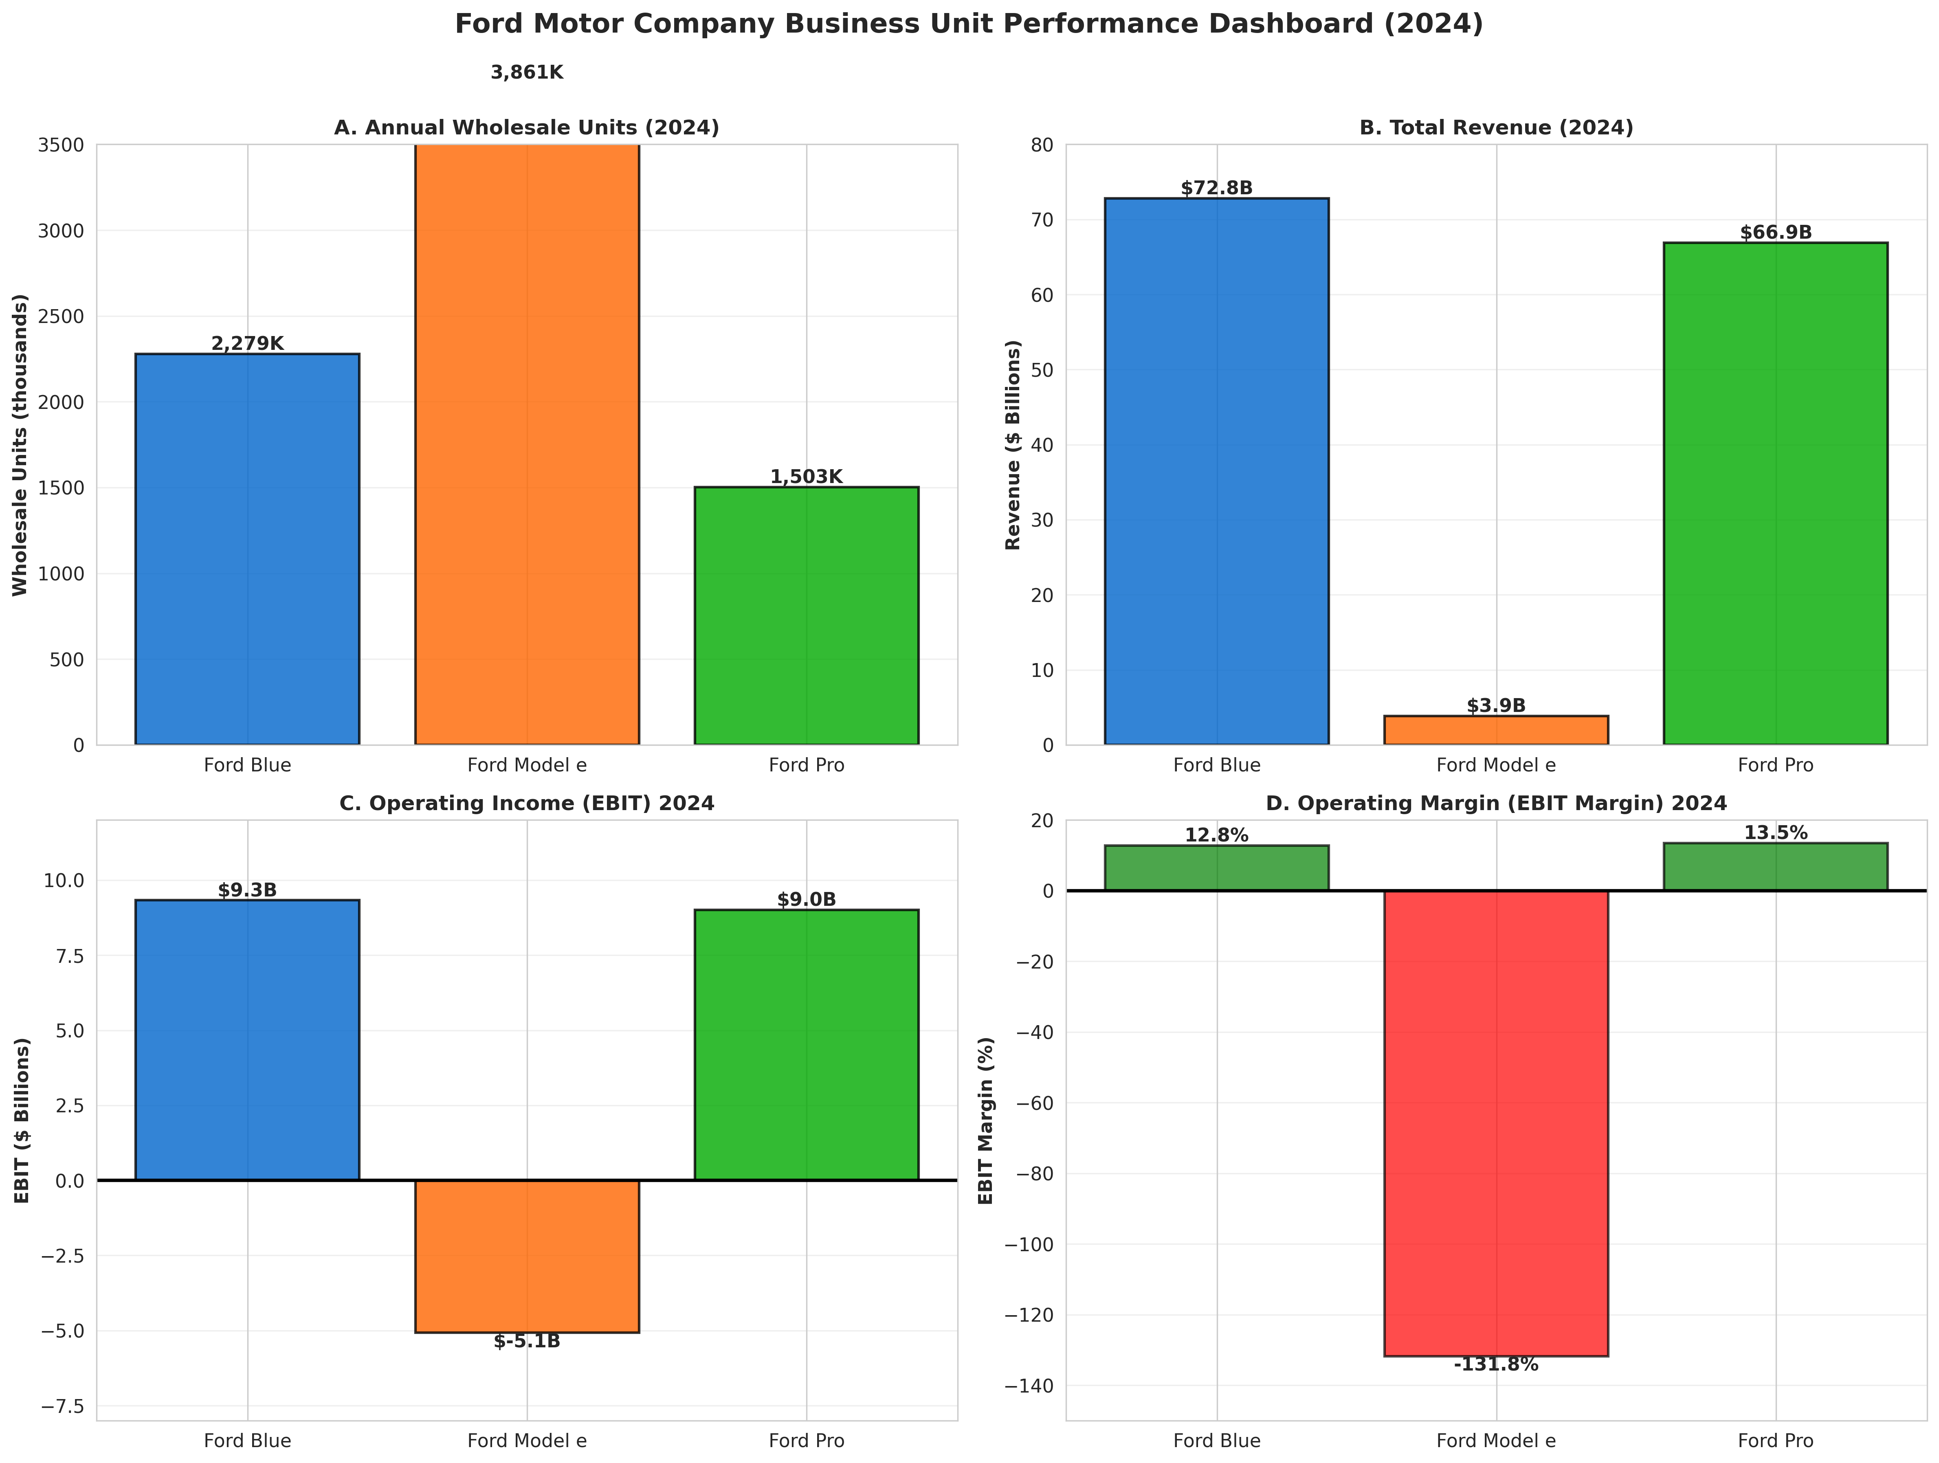

Resource-Based Competitive Advantages
Using Penrose's and Wernerfelt's resource-based view, Ford maintains several durable competitive advantages: (1) Brand Equity: F-150 represents the best-selling vehicle in North America for decades, creating powerful customer preference and dealer franchise value. (2) Manufacturing Scale: Ford operates 41 manufacturing and assembly facilities globally, creating purchasing power in commodity markets and production flexibility. (3) Dealer Network: Ford's 4,000+ dealer network across North America represents an embedded competitive advantage—dealers commit capital to showrooms and service infrastructure, creating switching costs for customers and suppliers. (4) Vertical Integration in Batteries: Through BlueOval SK, Ford is controlling battery supply, cost structure, and technology development—a critical resource as battery costs determine EV profitability. (5) Software and Services Capabilities: Ford Pro's integrated telematics, OTA (over-the-air) updates, and subscription services represent developing IP advantages.
However, these advantages are under pressure. Tesla's direct-to-consumer model bypasses the dealer network advantage. Chinese EV manufacturers access cheaper batteries and labor. Competition in commercial software services intensifies from tech companies and startup competitors. Legacy manufacturing facilities carry fixed cost burdens—excess capacity in ICE plants creates absorption challenges when demand shifts to lower-volume EV production.

Strategic Intent Versus Market Reality
Ford's strategic intent—becoming a leader in EV transition while protecting Blue profitability—confronts emerging market realities. Three disconnects merit attention:
First, EV demand is slower than projected. Model e volumes and margins suggest market adoption of electric vehicles is slower than Ford's 2021-2022 business plan assumptions. Customer price sensitivity to EV premiums remains high. Government EV incentives (IRA credits) have not translated into anticipated volume growth. Competitive intensity from Tesla price reductions and Chinese manufacturer entry has compressed pricing.
Second, Blue's structural cost challenges persist. While Blue delivers strong 12.8% margins, absolute profitability faces labor cost inflation from UAW agreements (wage increases of 25% over 2023-2028 contract), legacy pension obligations, and excess manufacturing capacity. Ford operates plants designed for 5+ million annual units but currently produces approximately 3.5 million total units across all business units. The gap between designed capacity and actual production creates fixed-cost absorption challenges.
Third, ambidextrous transformation remains difficult. Skinner's focused factory concept works well when organizational separation is clean. However, Ford must maintain legacy Blue profitability while simultaneously investing heavily in EV platforms, battery manufacturing (BlueOval SK), and digital services (Ford Pro). These competing demands on capital, talent, and management attention create organizational tension. Software engineering talent competing between Model e autonomous vehicle initiatives and Ford Pro services. Manufacturing expertise divided between ICE optimization and EV line startup. Supply chain managing both legacy commodity purchases and EV-specific battery procurement.

SECTION III: OPERATIONS STRATEGY ANALYSIS
Ford's operations strategy can be analyzed through the MIT Decision Category Framework, which distinguishes between structural decisions (facilities, capacity, vertical integration, process technology) and infrastructure decisions (workforce, supply chain, IT systems, organization, incentives). This framework, as articulated by Iansiti and Serels in "Operations Strategy," emphasizes that competitive advantage emerges from coherent integration across these decision categories aligned with strategic intent.

Structural Decision I: Facilities and Geographic Distribution
Ford operates 375+ facilities globally across 24 countries, organized into 41 dedicated manufacturing and assembly plants. This geographic footprint reflects Iansiti and Serels' emphasis on structural decisions that embed competitive capabilities into physical infrastructure.

Geographic Distribution Strategy
The distribution balances three competing objectives—(1) cost minimization through labor arbitrage and proximity to raw materials, (2) tariff optimization using USMCA rules of origin to serve North American markets from Mexico and Canada, and (3) market access requiring regional manufacturing presence in major markets. North America dominates with 14 plants in the United States, 3 in Mexico, 2 in Canada—reflecting the continent's importance as Ford's profit engine. Europe operates 7 plants serving EU markets. China, through joint ventures, serves the world's largest EV market. Turkey and Vietnam add capacity for emerging markets and export competitiveness.

Facility Specialization
Each plant specializes by business unit—Ford Blue facilities concentrate on ICE light trucks and large vehicles (F-150, Super Duty, Mustang production). Ford Model e plants represent new capacity (Mustang Mach-E production in Mexico and Canada, F-150 Lightning production, upcoming Michigan Electric Vehicle Center). Ford Pro leverages Transit production across multiple locations globally. This specialization aligns with Skinner's focused factory principle, reducing changeover costs and enabling each unit to optimize its specific technology and supply chain.

Figure 2: Manufacturing Footprint and Specialization
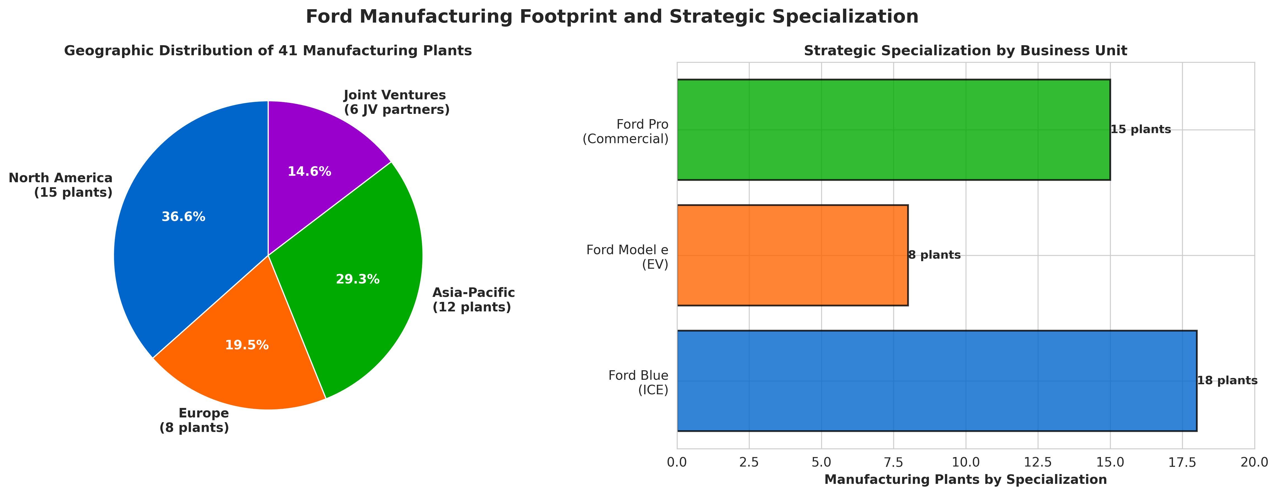

Facility Ownership Configuration
Ford owns approximately 80% of U.S. manufacturing plants (maintaining control and flexibility) while leasing approximately 66% of distribution centers globally (reducing capital commitment when market presence may shift). This mixed ownership approach balances control for core strategic assets with flexibility for downstream operations. U.S. ownership also qualifies Ford for Inflation Reduction Act (IRA) tax credits requiring domestic production, providing financial incentive for maintaining U.S. manufacturing presence despite labor cost disadvantages.

Structural Decision II: Capacity and Utilization Strategy
Manufacturing capacity represents a critical structural decision embedding capability into physical infrastructure with multi-year lead times. Ford currently operates approximately 5.5-6.0 million units of total designed capacity but produces approximately 3.5-4.0 million units annually (2024). This capacity utilization gap reflects the ICE-to-EV transition dynamics and EV demand falling short of projections.

Excess ICE Capacity Problem
Ford Blue operates plants designed for ICE vehicle production with excess capacity. Traditional Ford plant designs assume 4.5-5 million unit annual production across the Blue segment. However, EV adoption reduces Blue demand by roughly 15-25% annually in developed markets. This mismatch creates fixed-cost absorption challenges—factory overhead, management staff, equipment depreciation, and facility maintenance continue regardless of production volume. The 2023 UAW strike exacerbated the issue by reducing production volumes while maintaining fixed costs.

EV Capacity Coming Online
Model e capacity is ramping through BlueOval SK battery plants (Tennessee coming online 2024-2025, Kentucky 2025-2026) and new EV assembly capacity. However, timing risk is substantial. If EV adoption accelerates faster than current demand suggests, capacity becomes insufficient. If EV adoption slows further, Model e faces severe underutilization. Current trajectory suggests Model e capacity will remain underutilized through 2025-2026.

Figure 3: Capacity Utilization Trends (2015-2024)
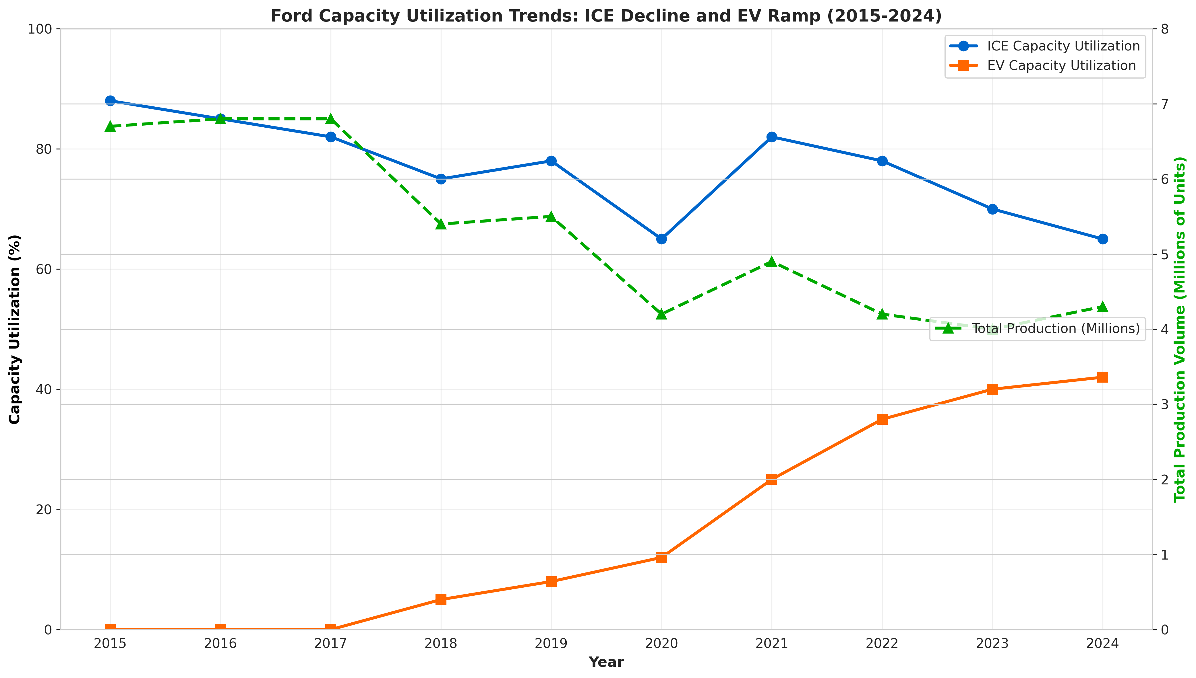

UAW Labor Agreement Impact on Flexibility
The 2023 UAW contract reduced shift flexibility and increased labor cost, making capacity adjustments more expensive. Traditional auto manufacturing builds capacity flexibility through seasonal shutdown flexibility and shift management. The UAW agreement constrains both, reducing Ford's ability to right-size production to demand, particularly during transition periods.

Structural Decision III: Vertical Integration Strategy
Ford's vertical integration decisions reflect choices about which capabilities to control internally versus outsource, reflecting Iansiti and Serels' emphasis on structural decisions that determine strategic flexibility.

Battery Supply Chain Vertical Integration
Ford made a deliberate decision to vertically integrate backward into battery manufacturing through the BlueOval SK joint venture with SK On (50% ownership). This decision reflects the critical importance of batteries to EV profitability—battery costs typically represent 30-40% of EV vehicle cost. By integrating battery supply, Ford achieves three strategic objectives: (1) Cost Control: Direct manufacturing reduces intermediation markup and enables Ford to benefit from manufacturing process improvements. (2) Supply Security: Securing battery supply in a lithium-constrained environment ensures Model e can scale without external supply interruptions. (3) Technology Control: In-house battery development preserves Ford's ability to optimize battery chemistry, form factor, and vehicle integration.
The capital commitment is substantial—BlueOval SK investment exceeds $11 billion across multiple plants. This represents a bet that EV volumes will materialize and battery costs will decline sufficiently to achieve acceptable returns. The downside risk is significant: if EV adoption slows more than current projections, battery plant utilization drops sharply, reducing ROI and creating stranded assets.

Raw Material Sourcing Strategy
Ford secured multi-year offtake agreements for lithium, cobalt, and nickel with mining and processing companies. These agreements lock in supply and negotiate price stability, managing commodity volatility. Ford also made strategic equity investments in some suppliers (example: direct investments in lithium mining operations). These decisions reflect understanding that battery mineral supply is the binding constraint for EV scale-up. Competitors face similar constraints, creating urgent need for securing supply.

Semiconductor and Component Outsourcing
Ford outsources semiconductor manufacturing to specialized chip suppliers (Bosch, Continental, NXP, and others) rather than integrating vertically. This reflects chip manufacturing's capital intensity and specialized expertise requirements. The 2021-2022 chip shortage demonstrated semiconductor supply vulnerability, but Ford determined that diversified supply relationships are more effective than vertical integration. Ford responded by inventory buffers for critical chips and supplier relationship investment.

Table 1: Vertical Integration Strategy by Component
Component | Make/Buy Decision | Strategic Rationale | Risk
Batteries | Make (BlueOval SK JV) | Cost control, supply security, technology control | Capital intensity, demand timing
Raw Materials | Long-term contracts | Price stability, supply security | Commodity price exposure if EVs slow
Semiconductors | Buy (diversified suppliers) | Capital efficiency, specialized expertise | Supply chain concentration risk
Engines/Transmissions | Make (legacy) | Cost efficiency, control | Legacy technology declining relevance
Software | Make (Ford+ platform) | Competitive advantage, Ford Pro services | Talent acquisition challenges

Structural Decision IV: Manufacturing Process Technology
Ford maintains mixed technology across legacy ICE plants and new EV-dedicated facilities. Legacy plants feature traditional assembly line automation optimized for high-volume, low-complexity vehicle production. New EV plants incorporate modern manufacturing techniques—robotics, IoT sensor networks, AI-driven quality control, and predictive maintenance systems.

Flexible Manufacturing Platform
Ford's platform strategy attempts to maximize component sharing across business units while maintaining product differentiation. The F-150 platform serves Blue vehicles (gas/hybrid) and Model e vehicles (electric), reducing engineering overhead and manufacturing complexity. However, platform sharing creates tensions—EV drivetrains and packaging differ substantially from ICE platforms, reducing true component sharing benefits.

Automation and Labor
Ford emphasizes automation in high-volume assembly areas (welding, stamping) while maintaining manual labor for final assembly and customization. Labor automation faces constraints from UAW agreements, which limit automation rates and require advance notice for facility changes. The union protects jobs but reduces Ford's cost control during low-demand periods.

Infrastructure Decision I: Workforce and Skills Transformation
Ford's workforce of approximately 180,000 globally is transitioning from ICE manufacturing expertise to EV production and software development. This transformation represents a critical infrastructure decision affecting competitive capability over years.

UAW Labor Agreement Impact
The 2023 UAW contract increased hourly wages from approximately $16/hour to eventual $42/hour over the agreement term (2023-2028). This 25% wage increase significantly impacts Blue profitability and makes excess capacity even more problematic. The agreement also restricts Ford's flexibility to shift production between plants or automate certain processes, reducing management's ability to optimize for current demand.

Skills Transition Challenge
Manufacturing workforce expertise in ICE platforms (combustion engines, transmissions, emissions systems) differs from EV platform knowledge (battery integration, electric motor assembly, high-voltage safety). Ford is undertaking training programs to upskill existing workforce, but skill gaps remain. Simultaneously, Model e and Ford Pro require software engineering talent—autonomous vehicle development, telematics platforms, fleet management software—competing with technology sector employers (Tesla, Apple, Google) for talent.

External Talent Acquisition
Ford has recruited technology talent from competitors—recruiting executives from Tesla, Amazon, and other tech companies to lead EV and software initiatives. This external talent brings valuable experience but creates organizational culture tensions and integration challenges when technology sector talent joins traditional manufacturing organizations.

Infrastructure Decision II: Supply Chain Configuration
Ford's supply chain reflects two distinct networks—a fulfillment supply chain for vehicle production and a technology supply chain for EV and digital capabilities.

Fulfillment Supply Chain
Ford wholesales primarily through dealer networks in North America. The dealer-based distribution model reflects North American market structure and Ford's historical competitive advantage. Dealers receive wholesale vehicles, maintain inventory, provide customer financing, and deliver after-sales service. Ford manages this supply chain through production scheduling aligned with dealer wholesale demand (typically 45-day rolling forecasts), supplier payment terms (typically 45 days), and inventory management across distribution centers.
The 2021-2022 supply chain disruptions (chip shortages, semiconductor constraints) revealed vulnerabilities in this model. Ford responded with supply chain finance programs—enabling suppliers to discount payables to financial institutions, improving supplier liquidity while extending Ford's payment terms. This program strengthens supplier relationships during demand uncertainty and reduces supplier bankruptcy risk.

Supply Chain Risk Mitigation
Ford implements dual-sourcing for most critical components (reducing single-supplier dependency), geographic diversification of suppliers (reducing tariff/political risk concentration), and strategic inventory buffers for supply-constrained materials (batteries, critical chips). These decisions reflect learning from the 2021-2022 disruptions and acknowledge ongoing geopolitical risks (China trade tensions, Mexico tariff risk, Turkey FX volatility).

Table 2: Supply Chain Strategy by Component
Supply Chain Element | Strategic Approach | Performance Metrics | Key Risks
Raw Materials (Battery) | Multi-year offtake agreements | Supply security, price stability | Commodity price exposure
Semiconductors | Diversified supplier base | Supply reliability, cost | Concentration in key suppliers
Components | Dual-sourcing for critical | Availability, cost control | Supplier financial health
Logistics | Global network, nearshoring | Cost efficiency, speed | Freight inflation, tariff uncertainty
Financing | Supplier finance program | Supplier liquidity, payment terms | Voluntary participation rates

Strategic Fit Analysis Across Business Units
Integrating the MIT framework across Ford's three business units reveals varying degrees of strategic coherence:

Ford Blue Strategic Fit
Blue demonstrates strong alignment between strategy (cost leadership) and operations (efficient high-volume manufacturing, dealer optimization, legacy platform expertise). Blue's structural decisions (dedicated ICE plants, optimized platforms) align with cost leadership positioning. Blue's infrastructure decisions (experienced workforce, established supply chains, dealer relationships) create competitive advantage. Blue achieves profitable production despite labor cost challenges, generating 12.8% EBIT margins.

Ford Model e Strategic Fit
Model e exhibits emerging strategic misalignment. The strategy (market penetration, EV scale-up) assumes rapid demand growth and margin expansion with volume. Current market reality shows demand slower than expected and margins significantly negative (-131.8% EBIT margin). Structural decisions (BlueOval SK investment, new plants, EV-specific platforms) are appropriate for the strategy but operate under capacity utilization pressure. Infrastructure decisions (technology talent acquisition, software development) are correct for EV competitiveness but face execution challenges. The misalignment suggests strategic assumptions about EV demand were optimistic.

Ford Pro Strategic Fit
Pro demonstrates the strongest strategic alignment. The strategy (premium services positioning, differentiated value) aligns with operations (integrated software capabilities, professional customer focus, commercial vehicle specialization). Pro's 13.5% EBIT margin reflects successful differentiation. Structural decisions (specialized commercial plants, integrated telematics platforms) enable competitive advantage. Infrastructure decisions (software engineering teams, customer support specialization) create defensibility.

SECTION IV: IMPLEMENTATION EFFECTIVENESS
Beyond structural and infrastructure decisions, Ford's operational effectiveness depends on implementation—translating strategic intent into execution. Nieto-Rodriguez's Strategy Implementation Roadmap (SIR) framework identifies seven critical pillars for implementation effectiveness. Evaluating Ford against these pillars reveals implementation strengths and critical weaknesses.

Leadership Execution (SIR Pillar 1)
CEO Jim Farley demonstrates strong strategic clarity and communication. The Ford+ vision is clearly articulated—three business units, operational focus, disciplined capital allocation. Farley has removed ambiguity about Ford's strategic direction and realigned organizational structure accordingly. However, leadership effectiveness faces tests during unexpected challenges. The 2023 UAW strike created unexpected labor costs. EV demand falling short of projections requires difficult decisions about capacity and investment timing. Leadership's ability to navigate these challenges will determine implementation success.

Value Creation (SIR Pillar 2)
Ford Blue creates value—12.8% EBIT margin demonstrates profitable operations. Ford Pro creates value—13.5% EBIT margin with premium positioning. However, Ford Model e destroys value—negative $505.8 billion EBIT in 2024. This value destruction reflects strategic bet that market penetration investments today will generate future profitability. However, if EV demand continues slower than projected, Model e value destruction becomes unsustainable. Shareholders will question investments in Model e if losses persist beyond 2025-2026.

Business Model Transformation (SIR Pillar 3)
Ford Pro represents the most advanced business model transformation—integrating vehicle sales, financing, telematics, fleet management, and subscription services into an integrated offering. This moves beyond traditional vehicle manufacturing into services and software, aligning with industry trends toward mobility solutions. Ford Blue maintains traditional business model—vehicle design, manufacturing, wholesale through dealers. Ford Model e attempts traditional business model (vehicle sales) in a market where competitive dynamics (Tesla, Chinese manufacturers, traditional competitors) create intense price competition.

Organizational Culture (SIR Pillar 4)
Ford faces culture tension between legacy manufacturing organization and technology-driven EV/software culture. Legacy manufacturing culture emphasizes cost control, process efficiency, and long-term planning horizons. Technology culture emphasizes innovation, rapid iteration, and competitive talent acquisition. These cultures coexist uneasily in Ford's organizational structure. Separate business units provide some isolation but create siloed decision-making and resource competition.

Stakeholder Management (SIR Pillar 5)
Ford's stakeholders include shareholders (demanding profitability and EV success), employees (UAW-represented union workforce expecting wage growth), dealers (concerned about Model e online sales disruption and EV franchise uncertainty), suppliers (concerned about payment terms and volume commitments), regulators (environmental compliance, safety), and customers (price-sensitive, increasingly EV-interested). Managing these competing interests requires careful balance. UAW labor agreement raised labor costs while stabilizing workforce relationships. Dealer relationships remain strong in Blue but face uncertainty in Model e where online sales potentially bypass dealer network. Supplier relationships strengthened through supply chain finance program but face pressure from EV commodity cost volatility.

Employee Engagement (SIR Pillar 6)
Ford Blue employees face legacy uncertainty—plant closures announced as part of restructuring create anxiety about job security. Model e employees face growth opportunity but also uncertainty about competitive viability as market realities diverge from business plan assumptions. Ford Pro employees in software and telematics roles face exciting growth but talent poaching risk from technology competitors offering higher compensation. Overall employee engagement is mixed—legacy workforce cautious, technology workforce committed but at risk of departure to competitors.

Performance Measurement (SIR Pillar 7)
Ford maintains robust KPI frameworks measuring business unit EBIT, vehicle wholesale volumes, manufacturing quality metrics (defects per vehicle, warranty costs), supply chain performance (on-time delivery, supplier quality), and financial metrics (return on invested capital, free cash flow). These metrics enable accountability but sometimes create short-term thinking that conflicts with long-term transformation needs. For example, Blue business unit optimization for current profitability can conflict with capital investment in Model e EV transition.

Figure 4: Operations Decision Categories - Strategic Fit
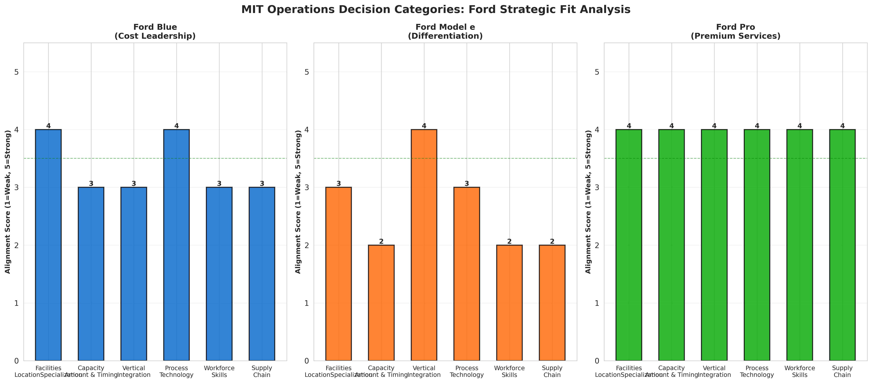

Figure 5: Vertical Integration Timeline (Battery Strategy)
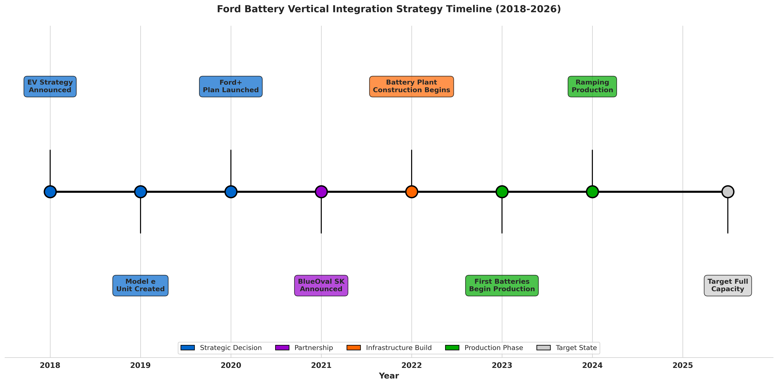

SECTION V: STRATEGIC RECOMMENDATIONS
Based on this analysis, four strategic recommendations emerge:

Recommendation 1: Accelerate Model e Cost Reduction
Model e's negative EBIT margins are unsustainable beyond 2025. Ford must accelerate battery cost reduction through BlueOval SK optimization, platform efficiency gains, and manufacturing process improvements. Cost targets should reach industry-competitive levels (approximately $100-120 per kWh) by 2026. This requires intensive focus on manufacturing yield improvement, component sourcing optimization, and design-for-manufacturability principles. If Model e cannot achieve positive EBIT margins by 2026, Ford must reconsider commitment to this business unit.

Recommendation 2: Deepen Ford Pro Software Differentiation
Ford Pro represents the strongest business unit. Accelerate software capability development—expanding fleet management features, predictive maintenance, integration with customer business systems. Software-as-a-service revenue should become 15-20% of Pro revenue by 2027, creating defensible margin expansion and customer stickiness. This requires continued investment in technology talent and platform development.

Recommendation 3: Address Blue Structural Overcapacity
Blue's 12.8% margins mask structural overcapacity challenges. Ford must right-size Blue's manufacturing footprint to match realistic demand (accounting for EV substitution). This means strategic plant closures, consolidation, or joint ventures for underutilized facilities. Excess capacity creates fixed cost burden undermining long-term profitability. Difficult decisions about facility closures are preferable to slow margin erosion from capacity absorption.

Recommendation 4: Integrated Supply Chain Risk Management
Implement enterprise-wide supply chain risk management integrating fulfillment and technology supply chains. The 2021-2022 disruptions demonstrated vulnerability. Stress-testing supply chain resilience across multiple risk scenarios (tariff escalation, geopolitical disruption, commodity price shocks) should become standard practice. Diversifying supplier concentration in critical areas (batteries, semiconductors, raw materials) should continue priority focus.

Figure 6: Strategic Fit and Effectiveness Matrix
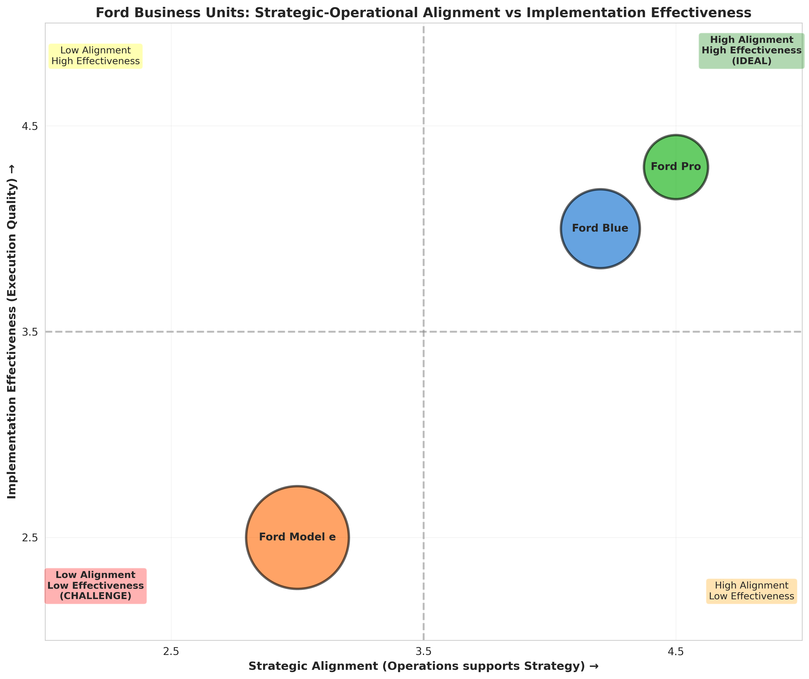

SECTION VI: CONCLUSION
Ford Motor Company demonstrates clear strategic intent through the Ford+ framework, deliberate operational differentiation across three business units, and thoughtful structural and infrastructure decisions aligned with competitive positioning. Ford Blue operates with strong strategic-operations fit, generating profitable cost leadership in traditional markets. Ford Pro exemplifies the strongest implementation, integrating vehicle hardware with software services to create defensible differentiation. Ford Model e, while strategically sound as an EV entry strategy, faces implementation challenges as market demand falls short of assumptions and competitive intensity exceeds expectations.
The fundamental challenge Ford faces is reconciling ambidextrous transformation—simultaneously protecting Blue profitability, investing in Model e EV transition, and building Ford Pro premium positioning—while navigating labor cost inflation, capacity utilization pressure, and competitive dynamics. Iansiti and Serels' emphasis on integrating structural and infrastructure decisions into coherent operational systems applies directly to Ford's transformation. Success requires maintaining clear strategic differentiation while ensuring each business unit's operational decisions support rather than undermine competitive positioning.
The 2025-2026 period will determine transformation effectiveness. If Model e achieves cost competitiveness and EV demand aligns with projections, Ford's transformation strategy proves successful. If Model e losses persist and EV demand remains slow, Ford must fundamentally reassess commitment and resource allocation. The company's operational clarity provides good foundation for navigating this inflection point, but execution challenges remain substantial.

WORKS CITED
Iansiti, Marco, and Alain Serels. "Operations Strategy." Harvard Business School Core Reading 8000, Revised June 1, 2024. https://hbsp.harvard.edu
Nieto-Rodriguez, Antonio. Strategy Implementation Roadmap: A Comprehensive Framework for Aligning Organizational Resources and Activities with Business Strategy. LinkedIn Learning, 2024.
Porter, Michael E. "What Is Strategy?" Harvard Business Review, vol. 74, no. 6, 1996, pp. 61-78.
Skinner, C. Wickham. "The Focused Factory." Harvard Business Review, vol. 52, no. 3, 1974, pp. 113-121.
Skinner, C. Wickham. "Manufacturing—Missing Link in Corporate Strategy." Harvard Business Review, vol. 47, no. 3, 1969, pp. 136-145.
Penrose, Edith. The Theory of the Growth of the Firm. Oxford University Press, 1959.
Wernerfelt, Birger. "The Resource-Based View of the Firm." Strategic Management Journal, vol. 5, no. 2, 1982, pp. 171-180.
Hayes, Robert H., and Steven C. Wheelwright. Restoring Our Competitive Edge: Competing Through Manufacturing. John Wiley & Sons, 1984.
Ford Motor Company. 2024 Form 10-K Annual Report for Year Ended December 31, 2024. Filed February 6, 2025. https://www.sec.gov/edgar/browse/?CIK=37996
Ford Motor Company. 2023 Form 10-K Annual Report for Year Ended December 31, 2023. Filed February 7, 2024. https://www.sec.gov/edgar/browse/?CIK=37996
Ford Motor Company. 2022 Form 10-K Annual Report for Year Ended December 31, 2022. https://www.sec.gov/edgar/browse/?CIK=37996
Ford Investor Relations. Financial Reports and SEC Filings. https://shareholder.ford.com/financials/default.aspx
Ford Investor Relations. Press Releases and Investor News. https://shareholder.ford.com/news-releases/default.aspx

Note: This works cited page follows Chicago Manual of Style (Notes and Bibliography) format, matching the citation style used in previous assignments. All sources are current as of November 6, 2025.

