1. Introduction: 1
2. Lab Goal: 1
3. Methodology and Setup for the Lab: 1
4. Basic Device Settings: 1
4.1. DHCP Configuration: 1
4.2. Verification: 1
5. Figures and Outcomes: 2
Figure 1 2
Figure 2 : 2
Figure 3: 2
Figure 4: 3
Figure 5: 4
Figure 6: 4
Figure 7: 5
Figure 8: 5
Figure 9: 5
Figure 10: 6
Figure 11: 6
Figure 12: 6
6. Findings and Notes: 7
7. In summary: 7

1. Introduction:
This report goes over the hands-on work of setting up a network space and getting DHCP services working. The project aimed at making sure the network talked well and that giving out IP addresses was automatic using DHCP.
2. Lab Goal:
Setting up routers R1 and R2 to dynamically assign IPv4 addresses to devices connected to two distinct subnets was the main goal of the experiment. In order to forward DHCP queries, R1 has to be configured as the DHCP relay agent and R2 as the server for DHCP.

3. Methodology and Setup for the Lab:
Network Topology Setup: The two switches, two PCs (PC-A and PC-B), three routers (R1, R2, and ISP), and two routers made comprised the network topology. According to the topology diagram that was supplied, physical connections were built.

4. Basic Device Settings:
All routers have their basic security configurations, such banners and passwords, set up. The addressing table that was given was used to assign hosts and IPv4 addresses. Clock rates were set up on DCE serial ports in order to synchronize. RIPv2 was put into use on routers R1 and R2 for dynamic routing.

4.1. DHCP Configuration:
On R2, LANs linked to R1 had their DHCP server settings set up. For every LAN, address pools were created, with some IP addresses excluded. For DHCP clients, default gateways, DNS servers, domain names, and lease durations were specified. R1 has setup IP helper addresses to relay DHCP queries to R2.
4.2. Verification:
Ping tests were used to confirm that routers were connected to the network. By using the ipconfig /all command to examine PC IP settings, DHCP operation was verified.

5. Figures and Outcomes:
Figure 1 :
The outcomes of network-wide connection tests are displayed in Figure 1, emphasizing completed troubleshooting and successful pings.
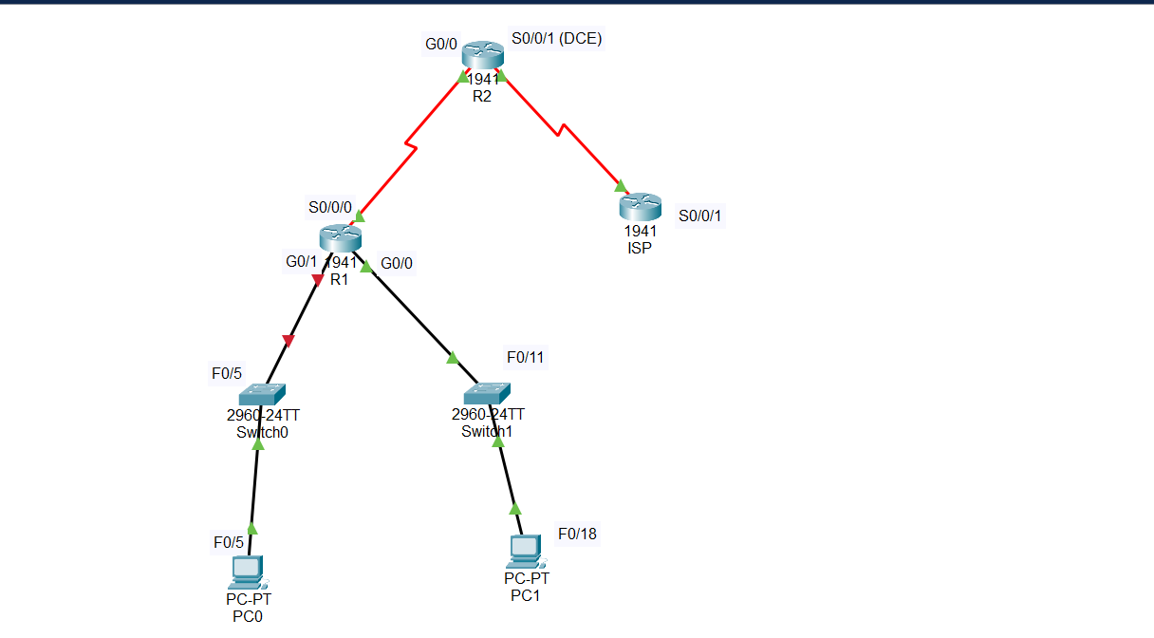
Figure 1: Topology Diagram

Figure 2 :
The configuration of the routers utilized in the lab is displayed in this snapshot, along with the precise instructions and parameters that were used to accomplish the required network functionality.
Figure 2: Router Configurations

Figure 3:
The DHCP configuration of Router R2 is shown in this Figure, which also includes the assignment of default gateways, DNS servers, domain names, and lease durations, as well as the creation of DHCP address pools and the exclusion of IP numbers.
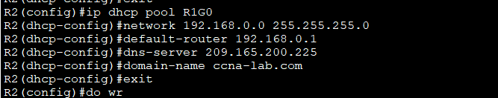
Figure 3: DHCP Configuration on R2

Figure 4:
This Figure below shows how R1 is set up to function as a DHCP relay agent, including how IP helper addresses are assigned to transfer DHCP queries to R2's DHCP server.
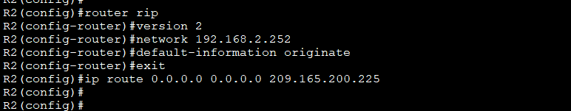
Figure 4: DHCP Relay Agent Configuration on R1

Figure 5:
The IP settings of PCs A and B are seen in this snapshot, illustrating the IP addresses that the DHCP server provided to the computers.
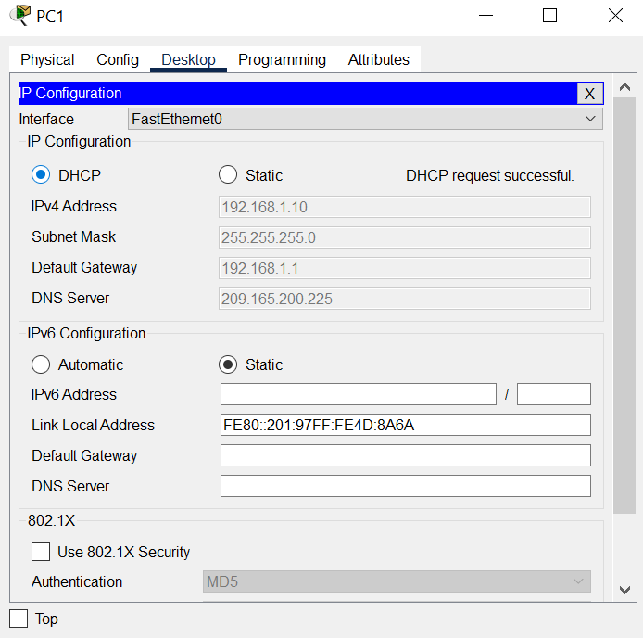

Figure 5: IP Configurations on PCs

Figure 6:
The hostname and IP address setup on Router R1, as configured in the lab, is shown in this Figure.
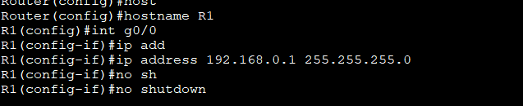
Figure 6: Hostname R1 and IP

Figure 7:
The DHCP configuration commands for Router R1, as listed in Appendix A of the lab instructions, are shown in this screenshot.
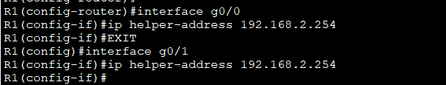
Figure 7: Appendix A DHCP R1

Figure 8:
This Figure shows how to set up a password on a router to allow access to user mode. This improves security by preventing unauthorized users from using privileged commands.
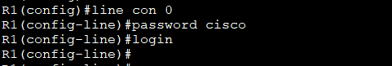
Figure 8: User Mode Security password

Figure 9:
The setup of a router's "enable secret" command, which sets an encrypted enable password for privileged EXEC mode access and improves security, is shown in this Figure.

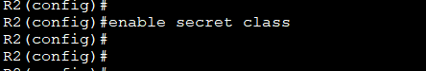
Figure 9: Enable Secret key

Figure 10:
This image shows how to set up a router to use the "service password-encryption" command, which improves security by encrypting any plaintext passwords kept in the device's configuration.

Figure 10: Service Password-Encryption

Figure 11:
In order to ensure that console messages are synced with user input and improve the overall CLI experience, this Figure shows how to configure the "logging synchronous" command on a router.
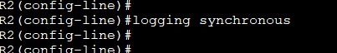
Figure 11: Logging Synchronous

Figure 12:
This Figure displays the commands typed to establish remote access to the device via SSH or Telnet, and it also shows how the vty lines are configured on a router.

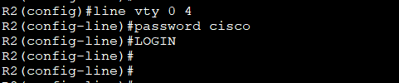
Figure 12: Line vty o Command

6. Findings and Notes:
With success, the network was set up, and DHCP services were running.
PC-A and PC-B were given IP addresses on a dynamic basis, proving how well DHCP works to automate address assignment.
The establishment of network connection amongst routers guaranteed smooth network communication.
7. In summary:
In summary, the lab was successfully finished, accomplishing the goals of network configuration and DHCP service setup. A deeper comprehension of network design and DHCP implementation was attained through this practical experience.

