Assignment 2

Kholoud Alsadi

10/26/2021

## R Markdown

*Data summary of the data trees and the mean of the variable Girth.*

summary(trees)

## Girth Height Volume   
## Min. : 8.30 Min. :63 Min. :10.20   
## 1st Qu.:11.05 1st Qu.:72 1st Qu.:19.40   
## Median :12.90 Median :76 Median :24.20   
## Mean :13.25 Mean :76 Mean :30.17   
## 3rd Qu.:15.25 3rd Qu.:80 3rd Qu.:37.30   
## Max. :20.60 Max. :87 Max. :77.00

mean(trees$Girth)

## [1] 13.24839

## Plots:

**this a histogram that discribe the trees height and their frequancies.**

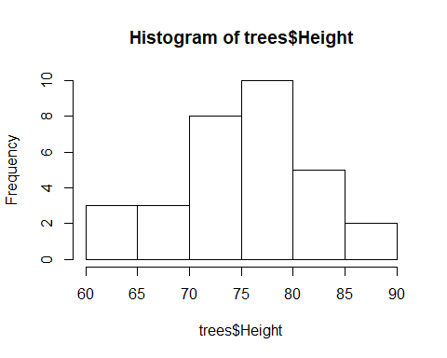

# Omama

The boxplot for the Height variable is symmetric, while those for Girth and Volume are right skewed, and there is one outlier on the Volume boxplot.

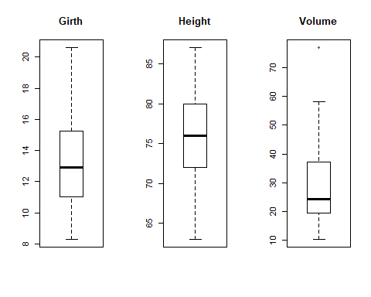

# Updated by Hanan

### Including scatter plots

Scatter plots for all three variables are given below :

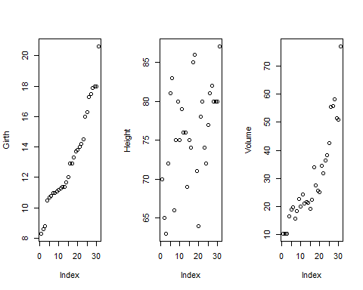

The structure for the data can be found using the ’ str ’ function. There are 31 observations and 3 numerical variables.

## 'data.frame': 31 obs. of 3 variables:  
## $ Girth : num 8.3 8.6 8.8 10.5 10.7 10.8 11 11 11.1 11.2 ...  
## $ Height: num 70 65 63 72 81 83 66 75 80 75 ...  
## $ Volume: num 10.3 10.3 10.2 16.4 18.8 19.7 15.6 18.2 22.6 19.9 ...