DSP Project
Report

Names:

1) Khalil Ismail Khalil (24)
2) Ahmed Mohamed EL-Bawab (9)
3) Abdelrahmen Ahmed Torki (36)

Code:

We created 10 Filters [7 FIR Filters and 3 IIR Filters],
Types of FIR:
1) Constr_band_equiripple
2) Constr_Least_squares
3) Equiripple
4) Generalized_equiripple
5) Least_squares
6) Window_Chebyshev
7) Window_Rectangular
Types of IIR:
1) Butterworth_
2) Chebyshev_type_1
3) Chebyshev_type_2

As well as, we created three main functions [initialize_data(), amplify_signal() and add_filterd_signal()]

In initialize_data(), we convert original signal from time domain to frequency domain then we filter the original signal and create 9 output signals in time domain then convert them to frequency domain.

In amplify_signal(), we multiply the 9 filtered signals in gains that user enters then convert 9 amplified signals from time domain to frequency domain.

In add_filterd_signal(), we add 9 amplified signals to create the composite signal then convert it from time domain to frequency domain.

GUI:

In our GUI, we give user the ability to:

1) import any audio as input.
2) export or save the audio after filteration and amplification.
3) choose the filter type.
4) enter 9 gains for 9 filters.
5) play or stop the audio.
6) choose the sampling ratio.
7) enter filter order.
8) plot (input and composite signals) or (analysis of each filter) or (output signals from filters).

GUI Screenshots:

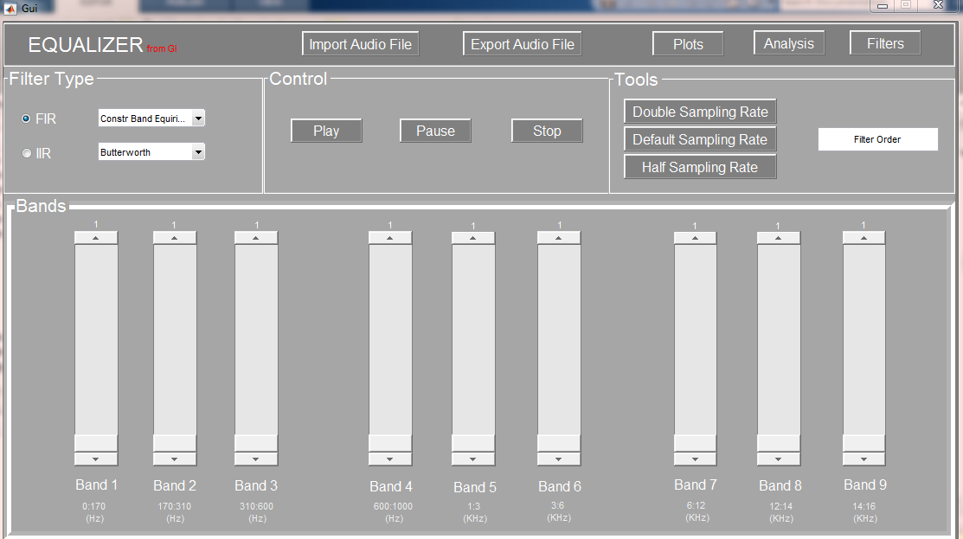
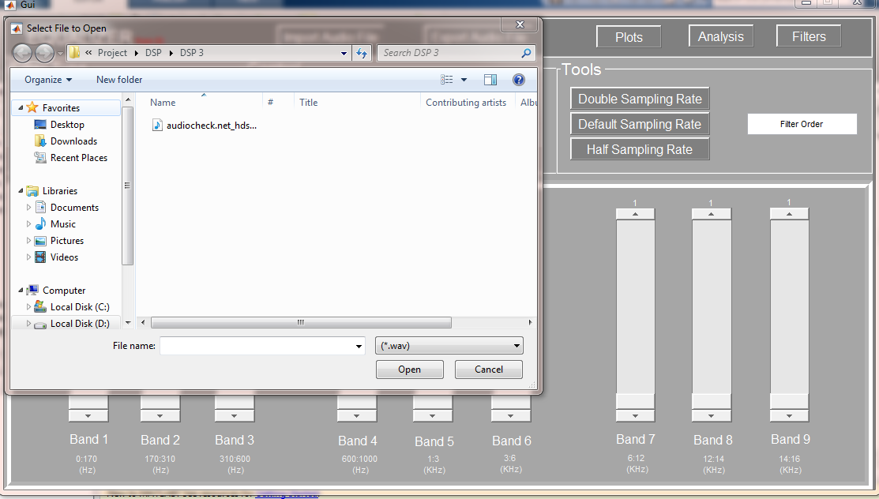

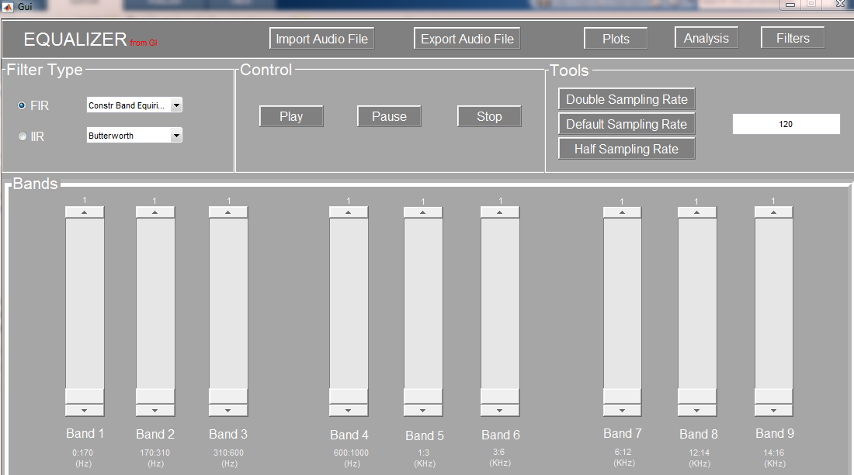

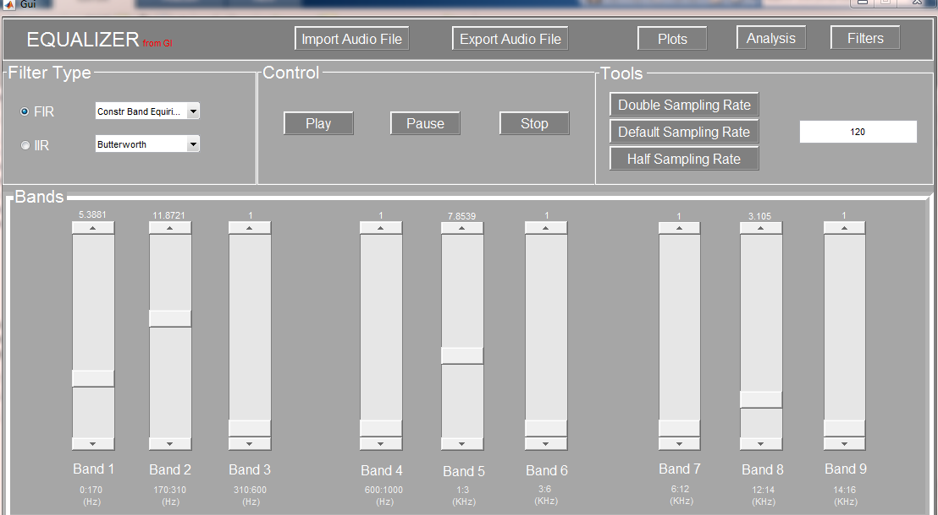

Original and Composite signals:

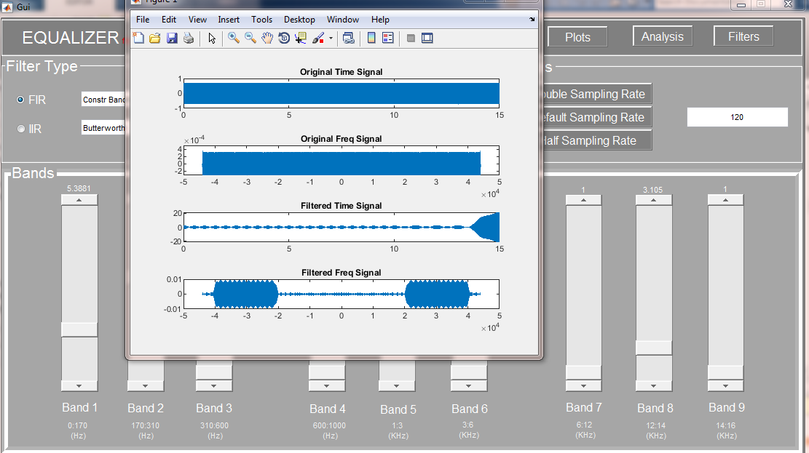

Filters’ Analysis:

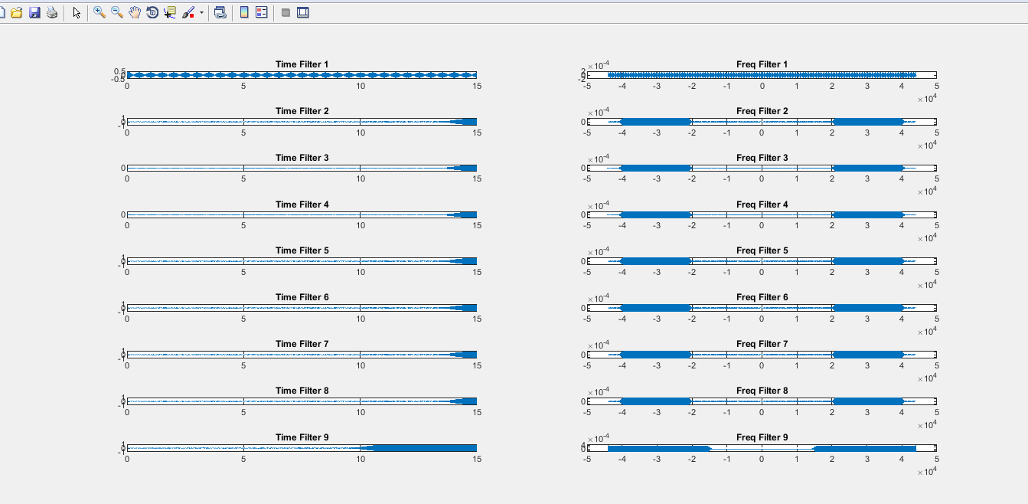

Signal Filteration:

