Database Project
Report

Names:

Khalil Ismail Khalil (24)
Ahmed Mohamed EL-Bawab (09)
Mohamed Abo-Bakr (50)

ER Diagram:

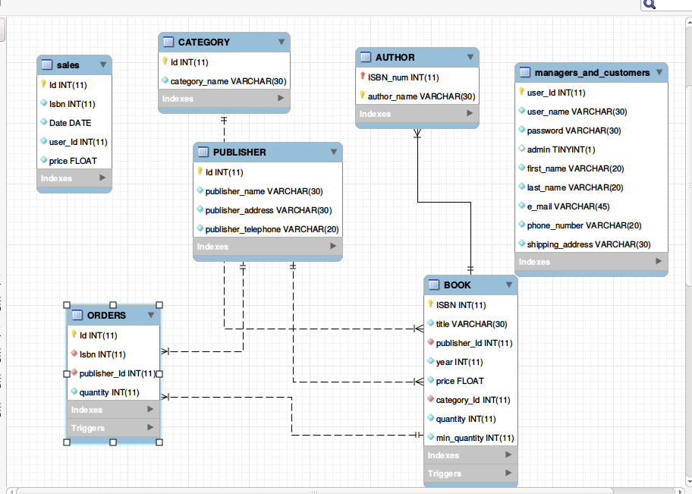

Detailed analysis of all the triggers:

we use in our database three triggers:-

1) TRIGGER `Database_project`.`not_negative` BEFORE UPDATE ON `Database_project`.`BOOK`

- we used this to ensure that user can’t buy books that will make
the quantity of the book in the store negative.

2)TRIGGER `Database_project`.`check_order`
AFTER UPDATE ON `Database_project`.`BOOK`

- we used this to check if the quantity of the book in the store
become less than min quantity then we made a request from the publisher and insert new order in table orders.

3)TRIGGER `Database_project`.`confirm_order`
BEFORE DELETE ON `Database_project`.`ORDERS`

- we used this to increase the quantity of the book when the order from publisher confirmed.

Screenshots:

