Computer Networks
Assignment 01

Name: Khalil Ismail Khalil

ID: 23

1) Client App:

1- Client checks for inputs {host name and port number}, if there is no port number, Client set it to default port number = “80”.

2- Client uses those {host name and port number} to get list of addresses.

3- From this list of addresses, Client tries to get a socket through it Client can connect with host name(Server).

4- Once Client could get connection with Server, It starts to read commands from input file.

5- Then, from array of commands, Client Start to create requests {GET and POST} , if the request is “post”, set data with the request.

6- Then, loop in list of requests and start to send them to the server, after Client send each request, It check responses

7- After sending all requests, Client close socket.

2) Server App:

1- Server checks for input “port number”, if there is no port number, Server set it to default port number = “80”.

2- Server uses “port number” to get list of addresses.

3- From this list of addresses, Server tries to get a socket binding with the port number through this socket, Server can connect with Clients.

4- Then, Server listens for new connection.

5- If there is new connection, Server accept it and creates child process with new socket.
6- On this new socket, Server starts to receive requests from Client.

7- At the end of this connection, server close the new socket.

2) Example:

1- Input File (commands):

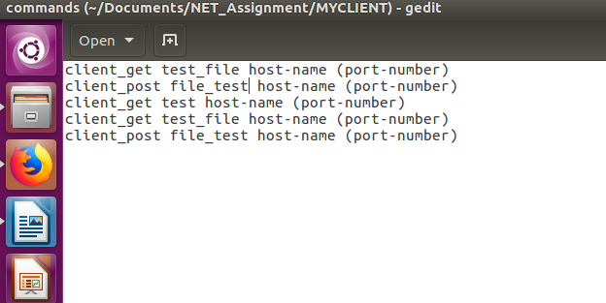

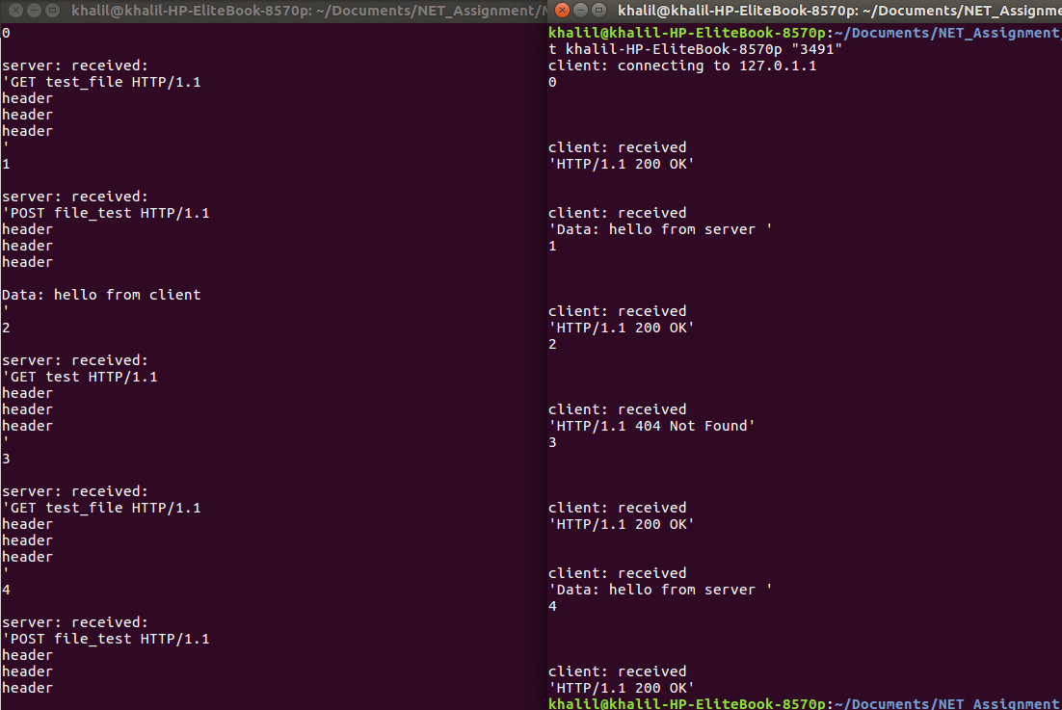
2- Results:

