صورة تحتوي على رمز, الخط, الرسومات, شعار

تم إنشاء الوصف تلقائياً

**College of Engineering and Computing in Al-Qunfudhah Software Documentation and Technical Writing CS3123**

**1st Semester 1446H**

**Jarir Bookstore**

Technical Writing Document

**Authors**:

Raghed Al-Masari 444001447

Kholod Al-Amri 444001301

**Abstract**

The "Jarir Bookstore App" project aims to develop a mobile application that includes creating a shopping experience for Jarir Bookstore users, a leading Saudi company in the field of selling books and educational electronics in the Middle East. The application will provide an easy-to-use interface, allowing customers to browse and purchase their products. It includes main features, digital payment options, and order tracking, offering exclusive deals. The app will also include a community section that allows users to review products and share their experiences. Through modern brand identification and data analytics, the application of sports science to enhance customer interaction and satisfaction, ultimately leading to increased sales and customer loyalty.

**Table of Contents**

Abstract

Introduction

Section 1: Analysis

1. Program`s Purpose
2. Functional Requirements
   1. User Requirements
   2. System Requirements
3. Non-Functional Requirements
   1. Product Requirements
   2. External Requirements
4. Main Tasks
5. Survey Result
6. Existing Programs

Section 2: Design

1. System Architecture
   1. Client-Side (Frontend)
   2. Server-Side (Backend)
   3. Business Logic Layer
   4. The Jarir Bookstore Application Algorithm
   5. Database
   6. Technologies
   7. Languages
   8. Security
   9. Interface
2. Data Model

Conclusion

Reference

Appendices

**Introduction**

One of the top merchants in the Middle East, Jarir Bookstore provides a large selection of books, gadgets, and educational materials. Offering a quick and easy mobile shopping experience has become crucial due to people's growing reliance on technology in their daily lives. The "Application Jarir Bookstore" project seeks to satisfy consumer demands by creating a cutting-edge application that enables users to swiftly and easily browse and buy products.  
  
The app will have an easy-to-use design with tailored recommendations, secure digital payment choices, and advanced search capabilities. Customers will also be able to track their orders and take advantage of special deals thanks to it. Furthermore, the application will feature a community part where users may contribute their product reviews and experiences, fostering greater user interaction and boosting customer confidence in their selections.

The initiative is to increase Jarir Bookstore's standing as the area's top shopping destination by enhancing brand loyalty, increasing sales, and improving customer experience.

Section 1: Analysis

1. **Program`s Purpose**

The bookstore application exists for anyone who wants to buy any electronic devices or special books that doesn’t find in any store or other things related to office and solve problem of Inability to receive from the store directly or lack of a branch in certain areas.

1. **Functional Requirements:**

**Introduction:** This document outlines improving user experience and expediting the purchasing process, the "Jarir Bookstore" application, the functional and non-functional requirements. The application's goal is to give users a simple and entertaining way to access a variety of goods, such as gadgets, books, and educational resources.

* 1. **User Requirements**
     1. **View app Services and products:** User can browse the store sections and its products without creating an account.
     2. **Create account:** User should create an account if they want to place an order.
     3. **Choose Location:** Users should add their location to complete the order.
     4. **Oreder products:** After adding products to the cart, users can choose a payment method when purchasing.
     5. **Exchange devices:** User can exchange devices purchased from Jarir.
     6. **Extend the warranty:** User can extend the warranty on devices purchased from Jarir.
     7. **Request maintenance:** User can request maintenance services.
  2. **System Requirements**
     1. **View app Services and products:** System shall allow the user to browse products and add items to the cart without creating an account.
     2. **Create account:**
        1. System shall allow the user to complete the purchase after creating an account / logging in.
        2. System shall activate a new Jarir card once the account is created.
        3. System shall allow the user to add multiple items to the cart.
     3. **Chose Location**: System shall enable the user to add their location to choose the delivery method (either from the nearest branch or home delivery).
     4. **Oreder products**: System shall allow the user to pay in full or in installments.

1. **Non-Functional Requirements**
   1. **Product Requirements**
      1. **Useability**:
         1. Existed icons for store`s sections.
         2. Each service in the Jarir services section have a description.
      2. **Security**:
         1. Send a verification code to the user`s number.
   2. **External Requirements** 
      1. Accounting Requirements
         1. The system should allow installment payments
         2. A tax summary displayed under the "Complete Purchase" button.
2. **Main Tasks:**
   1. Selling various products (books, smart devices, electronics, office supplies, etc.).
   2. Protecting and providing warranty services for devices.
   3. Exchanging and maintaining devices
3. **Survey Result:**

The objective of this survey is to collect user's feedback and the problems they faced when using app.

Based on survey results the improvement will be in:

* 1. UI understanding: Add short video about Bookstore tools to make it easier for users.
  2. Suspension: Download new versions that had bug fixes make the application smoother.
  3. Books: Add various books and e-books.
  4. Fast searching: There is existing button in top left for scanning products barcodes.
  5. Difficult selecting location: Add feature that takes user location from SPL application.
  6. Adding bank card information: Add feature that takes bank card information by take picture for it.
  7. For more discounts: A feature will be added that give user point for each comment then convert the points into discount.

1. **Existing Programs:**

**Table.1** showstheAdvantages and DisadvantagesofJarir **Bookstore and** Virgin Megastore**.**

**Table.1**

|  |  |  |
| --- | --- | --- |
| Application | Advantages | Disadvantages. |
| Jarir Bookstore | 1. A wide variety of products, especially books and stationery.  2. Ongoing offers and discounts.  3. Good customer service and flexible exchange procedures. | 1. Some prices may be high compared to competitors.  2. The shopping experience may be less interactive. |
| Virgin Megastore | 1. Focus on entertainment and music products.  2. Exclusive offers and premium memberships.  3. An engaging user experience. | 1. Less diversity in other categories like books.  2. Customer service may need improvement at times. |

The offerings of Jarir's app are notable for their wide range of goods and services, as well as for their compelling bargains and continuous sales, efficient customer support, and accommodating return and exchange policies. However, exchanges and customer support might be slower on the Virgin Megastore app, which focuses more on entertainment items and provides memberships and special offers.

Section 2: Design

1. **System** **Architecture**

The Jarir Bookstore application offers a seamless shopping experience with a robust system architecture, including a mobile application and server-side backend. Its data models organize user, product, order, and review information for personalized experiences and efficient inventory management. Technical specifications ensure high performance, security, and usability.

* 1. **Client-Side (Frontend):** Mobile Application: Developed for iOS and Android platforms using frameworks Flutter. User Interface: Designed with a focus on usability, including sections for product browsing, user accounts, and support**.**
  2. **Server-Side (Backend):** 
     1. **Web Server:** Handles requests from the mobile application using frameworks like Node.js or Django.
     2. **API Layer:** RESTful API or GraphQL for communication between the client and server, enabling efficient data exchange.
     3. **Database:** Relational Database Management System (RDBMS) like PostgreSQL or MySQL for structured data storage.
  3. **Business Logic Layer**
     1. Microservices: Individual services for handling different domains, such as:
     2. Product Service: Manages product listings, details, and categories.
     3. Order Service: Handles cart operations, order processing, and payments.
     4. User Service: Manages user profiles, authentication, and authorization.
  4. **Application Algorithm**
     1. **Registration and Login Procedure:**

Enter your email address and password to log in, or register using your details to sign up.

Operations: Check the data that was entered.

Verify the password's accuracy if the user is registered.

Log the user in or create a new account if the info is valid.

Results: Send the user to the account settings or home page.

* + 1. **Perusing Products:**

Product category or search term as inputs. Operations: To obtain a list of items depending on the category or search, query the database. Present the user with the results together with the product data (name, image, and price). Results: A list of the goods that are offered.

* + 1. **Include Item in Cart:**

Product ID and quantity are inputs.

Operations: Verify if the product is in stock.

Place the item in the user's shopping cart if it is available.

Outputs: Updated cart totals and confirmation that the product has been added to the cart.

* + 1. **Inputs for the checkout process:**

delivery address, payment details, and cart information. Operations: Verify the address and payment details. Update the database with a new order. Restock the shelves with the items that have been purchased. Give the user a confirmation of their order.

Outputs: A shipment information page and an order confirmation message.

* + 1. **Requests for After-Sale Services inputs:**

The kind of service (repair, warranty extension, or exchange) that is being sought. Operations: Confirm the request for service. In the database, make a new service request. Provide the user with a confirmation of the requested service. Results: A confirmation of the service request along with an update.

* + 1. **Order ID is an input for order tracking:**

Operations: To find out the order's current status, query the database. Give the user a view of the order's current status. Outputs: Information on the status of the order (processed, shipping, delivered)

* 1. **Database:**
     1. **Well-Ordered Storage of Data:** All the information pertaining to the Jarir Bookstore application is kept in the database. This comprises:
        1. **User Data:** Details including phone numbers, locations, hashed passwords, email addresses, and usernames.
        2. **Product Data:** Information about individual products, such as names, pricing, stock levels, and categories.
        3. **Order Data:** Details about user orders, such as dates, totals, modes of payment, and order statuses.
        4. **Review Data:** Ratings and comments left by users on products.
        5. **Service Requests:** Information about the different kinds and statuses of user service requests.   
           This data is kept in a central database, which is often managed using structured data management systems such as PostgreSQL or MySQL.
     2. **Information Recovery:** SQL queries are used by the Jarir Bookstore application to retrieve data when needed. The database receives queries from users seeking specific information, like order histories or product details, and responds promptly with the needed information.
     3. **Day-to-day Database:** The database oversees daily activities to guarantee seamless functionality:
        1. Data Updates: The database instantly updates itself to make sure all data is up to date whenever new information is input, such as when a new user is registered, or a product is added.
     4. **Authorization and Access:** Access control is used by the application to guarantee that users can only see or alter data relevant to their roles:
        1. **Customers:** Have access to their own account information, product details, and orders.
        2. **Admins:** Have more access to check all user data, manage products, and keep an eye on system performance.
        3. **Service Staff:** Able to handle maintenance or warranty inquiries and retrieve service requests. Specialized tables that hold data on users and their roles are used to manage permissions, allowing administrators to control what each user may access.
     5. **Managing Extensive Data Sets:** The Jarir Bookstore application encounters difficulties as it expands due to rising data volumes:
        1. **Distributed Storage:** Putting storage technologies into practice to guarantee effectiveness and speed.
        2. **Indexing:** Using indexing techniques to enable effective searching and expedite data retrieval from huge tables.
     6. **Restore and Backup:** Considering the significance of the Jarir Bookstore program, a regular backup of the database is performed to guard against data loss:
        1. **Daily Backups:** To guarantee data integrity, the complete database is included.
        2. **Recovery Mechanism:** In the event of a problem, it allows for rapid restoration from backups to reduce operational disturbance.
     7. **Data security and protection:** The Jarir Bookstore app prioritizes user data protection and uses cutting-edge security techniques to do so:
        1. **Encryption:** To prevent unwanted access, sensitive data, including passwords and payment details, is encrypted.
        2. **Firewalls and Security Protocols:** To stop intrusion attempts and illegal database access, sophisticated defensive mechanisms are put in place.

The Jarir Bookstore app's customer database can assist in organizing client data and analyzing their actions as shown in table 2.

**Table 2**

|  |  |  |  |  |  |  |  |
| --- | --- | --- | --- | --- | --- | --- | --- |
| **User-id** | **name** | **email** | **password** | **phone number** | **location** | **account created** | **account type** |
| 1 | John Doe | john@example.com | hashed_password_1 | 1234567890 | Riyadh | 2024-01-01 10:00:00 | Customer |
| 2 | Jane Smith | jane@example.com | hashed_password_2 | 0987654321 | Jeddah | 2024-01-02 11:00:00 | Customer |
| 3 | Admin User | admin@example.com | hashed_password_3 | 1122334455 | Dammam | 2024-01-03 12:00:00 | Admin |

* 1. **Technologies**:
     1. **Content Management Description:** Product listings, promotions, and instructional materials pertaining to books and other products can all be managed with the help of the Jarir Bookstore application's content management system.  
        Functional Analysis: Creating categories, managing inventory, and uploading product information are all simple tasks for administrators. The system makes it possible to efficiently sort, update, and categorize things, guaranteeing that consumers can locate pertinent items with ease.
     2. **Interactive Resources:** To improve user involvement, the program includes interactive features including product evaluations, Q&A sections, and feedback forms.  
        Functional Analysis: By allowing users to communicate with one another, ask questions about items, and exchange experiences, these features help to create a community around the store. For any questions, clients can also get in touch with support directly.
     3. **Online showrooms:** The Jarir Bookstore app has virtual showrooms where customers may investigate merchandise using immersive features like augmented reality and 3D views.  
        Functional Analysis: Before making a purchase, users can explore products in a more interactive way, which helps them better comprehend features, dimensions, and aesthetics.
     4. **Instruments for Payment and Evaluation:** The program includes options for tracking purchase history and preferences in addition to safe payment channels.  
        Functional Analysis: Credit cards, PayPal, installment payments, and other secure payment methods are available for users to complete transactions. By keeping track of customer preferences and purchases, the system may provide tailored promos and recommendations.
     5. **Data Analytics Description:** The program offers strong analytics capabilities for tracking customer activity, inventory control, andsalesperformance.Functional Analysis: The Jarir Bookstore may make better business decisions by using these tools to analyze customer trends, optimize stock levels, and assess the success of marketing efforts.
  2. **Languages:**
     1. **Java:** Popular backend programming language, renowned for its security and scalability. allows for cross-platform interoperability, guaranteeing smooth system functioning.
     2. **JavaScript:** improves the user interface by using tools like React.js for responsive design to enable dynamic interactions and enhance the user experience.
     3. **CSS and HTML:** used to ensure an appealing and user-friendly interface by organizing and decorating the application's frontend.
     4. **SQL:** vital to database management, enabling effective creation, updating, and retrieval of user and product data.
     5. **JSON and XML:** JSON is favored due to its lightweight form and efficiency while exchanging data between system components and external systems.
     6. **PHP:** can be used to integrate external services and run server-side scripts, providing backend processes with flexibility.
     7. **Python:** used in machine learning and data analysis applications to offer individualized suggestions depending on user behavior.
  3. **Security:**
     1. **Encryption:** To safeguard data both during transmission and at rest, advanced encryption technologies are used, such as SSL/TLS.
        1. **Functional Analysis:** Prevents unauthorized access to sensitive user data, making it more difficult for hackers to intercept or alter data.
     2. **Access control and account management:** Users can only access information that is approved since access permissions are specified according to user roles.
        1. **Functional Analysis:** By requiring a password and a verification code sent to the user's device, multi-factor authentication adds an extra degree of protection.
     3. **MFA, or multi-factor authentication:** Requires several types of authentications, which improves user identity verification.
        1. **Functional Analysis:** Even if passwords are compromised, it lowers the possibility of unwanted access.
     4. Prevention of Cyberattacks: The system uses intrusion detection systems and firewalls, among other cutting-edge techniques, to protect against cyberattacks.
        1. Functional Analysis: Keeps an eye out for odd activity and sends out alerts in case there are any security breaches.
  4. **Interface:**

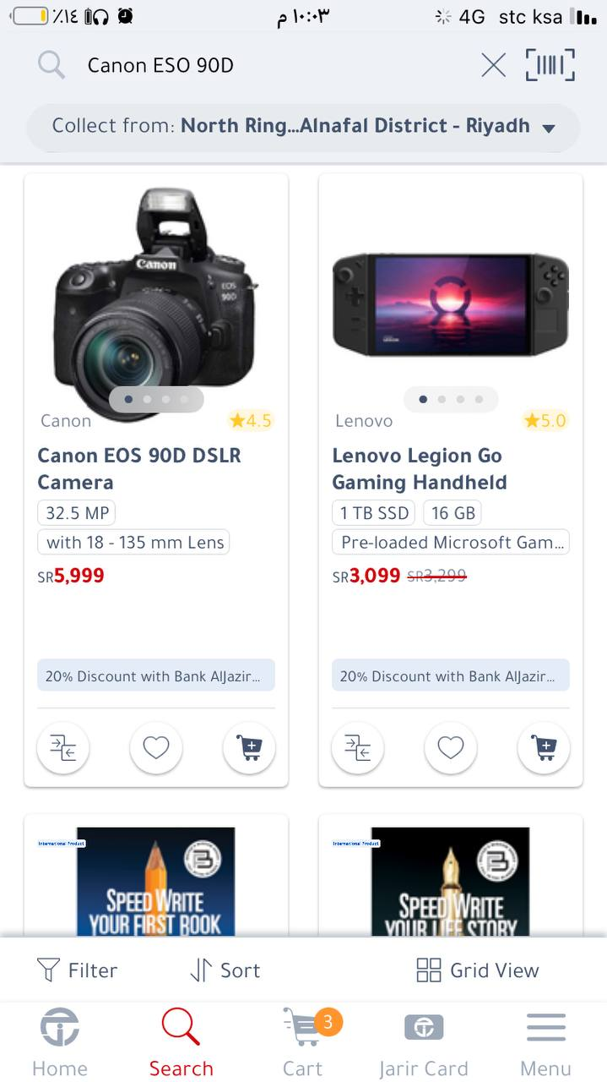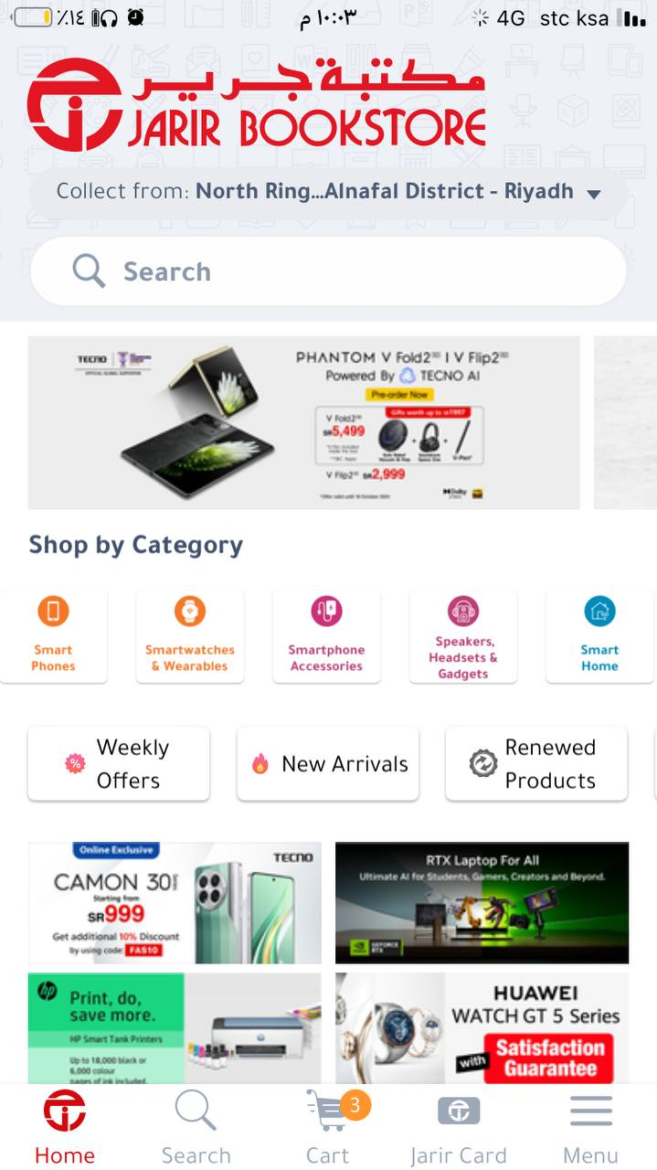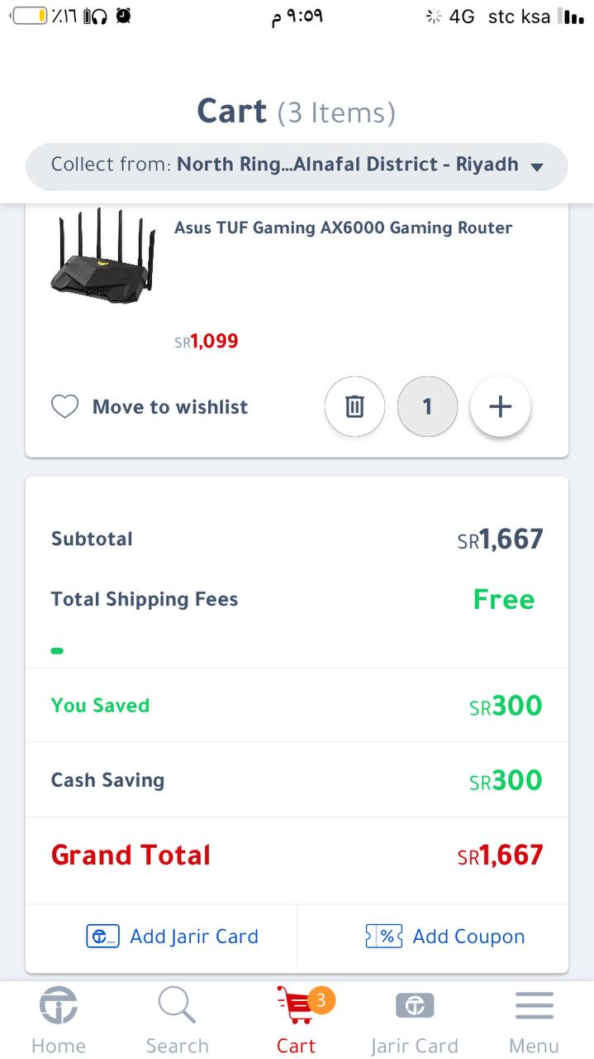

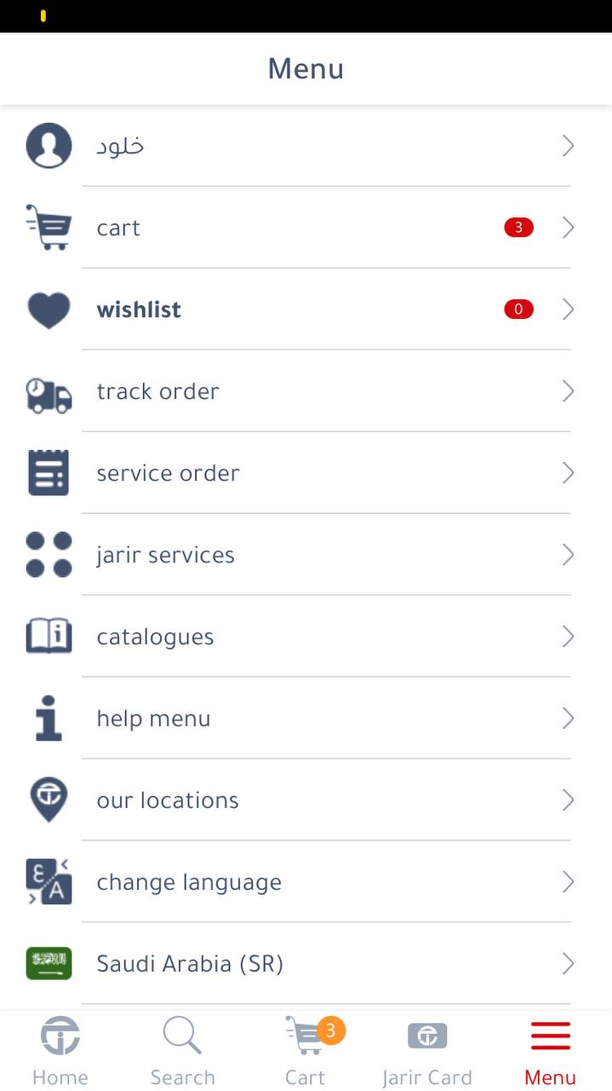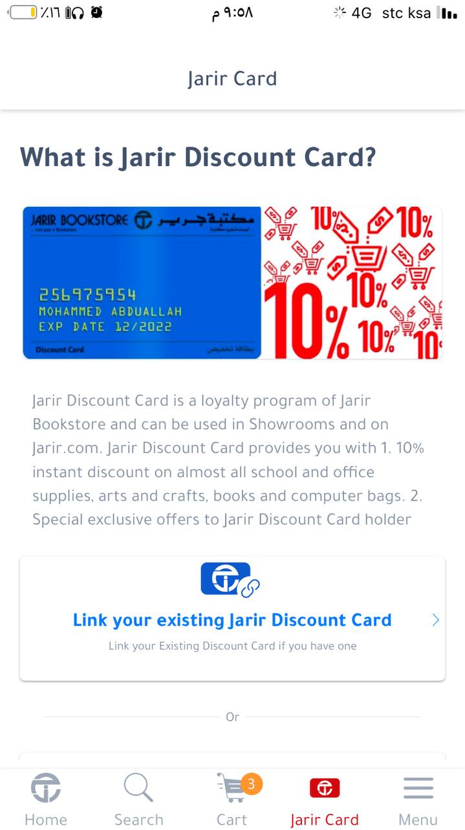

1. **Data Model**

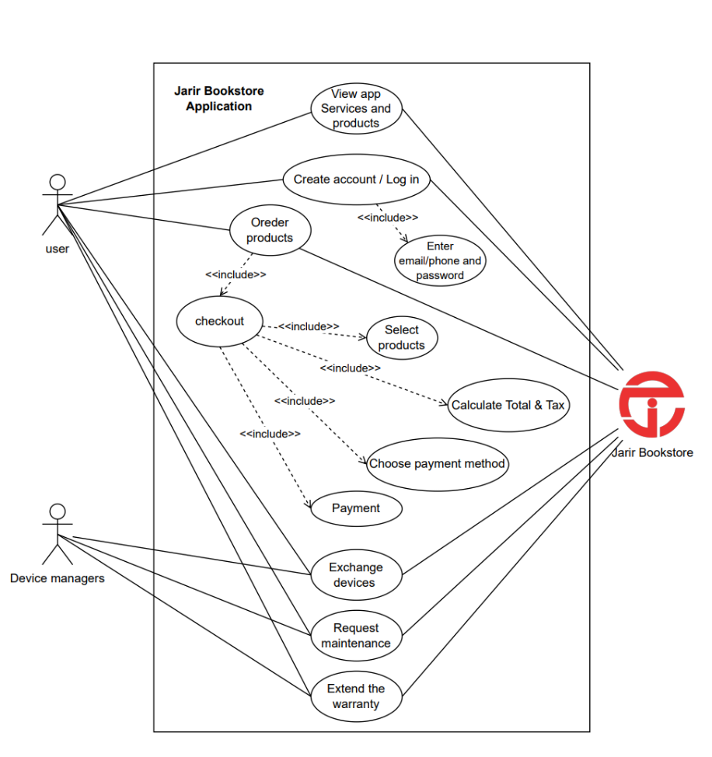

**Use Case Diagram**

|  |  |
| --- | --- |
| Jarir Bookstore Application | System |
| View app Services and products | Use case |
| User | Actors |
| Product details, services descriptions | Data |
| User opens the application and navigates to view products and services | Stimulus |
| Display services and products with details | Response |
| User can also products by scanning barcode | Comments |

|  |  |
| --- | --- |
| Jarir Bookstore Application | System |
| Create account / Log | Use case |
| User | Actors |
| User information (email/phone and password) | Data |
| User enters his information or sings up to create a new account | Stimulus |
| App verifies entered information and logs user in or create a new account | Response |
| Verification code will send to phone number or email to complete creation account process | Comments |

|  |  |
| --- | --- |
| Jarir Bookstore Application | System |
| Order products | Use case |
| User | Actors |
| Product details, user account, and delivery information | Data |
| User selects products, add delivery information and press "checkout" button | Stimulus |
| The app confirms the order and processes it for delivery | Response |
| User should choose one of the payment methods Mada card, Apple pay and Loyalty programs | Comments |

|  |  |
| --- | --- |
| Jarir Bookstore Application | System |
| Exchange devices | Use case |
| User, Device Managers | Actors |
| Device details, user account | Data |
| Device manager initiates a device exchange request | Stimulus |
| The app processes the exchange and updates the device records | Response |
| ------ | Comments |

|  |  |
| --- | --- |
| Jarir Bookstore Application | System |
| Request maintenance | Use case |
| User, Device Managers | Actors |
| Device details, maintenance history | Data |
| User or Device manager submits a maintenance request | Stimulus |
| The app schedules maintenance request | Response |
| ------- | Comments |

|  |  |
| --- | --- |
| Jarir Bookstore Application | System |
| Extend the warranty | Use case |
| User, Device Managers | Actors |
| Device details, warranty period, user account | Data |
| User requests an extension of the warranty period for their device | Stimulus |
| The app processes the request and updates the warranty details | Response |
| ------ | Comments |

**Conclusion**

**Reference**

**Appendices**

[**Survey Link**](https://forms.bsure.sa/runner/gtc9Fqo1DhFHGOXH9GQU)