Kasim - 104016

Design documentation

[Document subtitle]

Contents

Introduction 2

Purpose and scope 2

Class diagram 2

Sequence diagrams 2

Data Dictionary 3

Human Interface Design (screen images and objects 4

Bibliography 5

# Image result for tic tac toe pngIntroduction

The application will be a simple noughts and crosses game where two players will be able to interact. The game is played on a 3x3 grid in which players take turn marking the grid one with noughts and one with crosses. The goal of the game is to be the first player to get 3 in a row, which can be either vertically, horizontally or diagonally. If no player is able to get 3 in a row, then the game is a draw.

# Purpose and scope

Figure 1 Tic Tac Toe gameplay

The main purpose of the application is to entertain the users playing. The purpose of developing the game is to demonstrate object oriented programming techniques and to demonstrate how to design, build and test a program.

The scope of the program:

* Develop in C# using OOP techniques
* Score board to keep track of number of wins by each player
* Be able to play the game with no errors

# Class diagram

The diagrams below will describe the structure and contents of the game showing the relationships between classes.

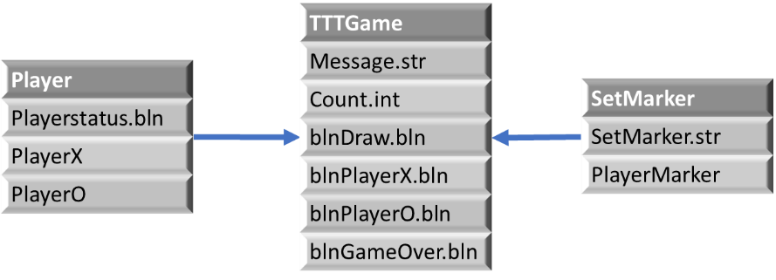

# Sequence diagrams

The sequence diagrams below will illustrate the behaviour of the program

Figure 2 New/Resetting game diagram

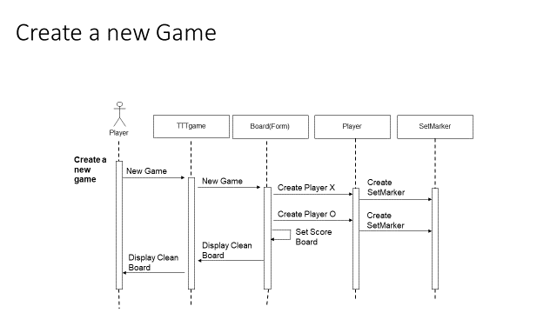

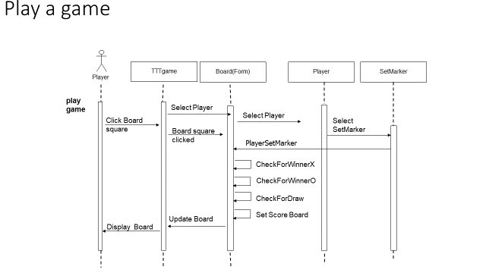

Figure 3 Playing game diagram

Figure 2 shows the sequence for creating a new game and figure 3 for playing a game.

# Data Dictionary

The data dictionary below will list all of the data the program will use including the classes

|  |  |  |
| --- | --- | --- |
| **Data type** | **Variable** | **Use** |
| Boolean | blnDraw | Used to check whether a draw has taken place |
| Boolean | BlnPlayerX | Used to check if player X has won |
| Boolean | BlnPlayerO | Used to check if player O has won |
| Boolean | blnGameOver | Used to allow game to continue or stop if game is over |
| String | Message | Welcome message when opening the application |
| Int | count | Used to check whether a draw has taken place by increasing count by one every time a button is pressed. |
| string | strMarker | Store Authors name in 20 character array |
| Boolean | blnPlayerStatus | Used to show progress off player in number of wins |
| class | TTTgame | Class for main form |
| class | Player | Class for player |
| class | Marker | Class for marker |

# Human Interface Design (screen images and objects

The objects used are labels and the buttons as shown below in the main interface:

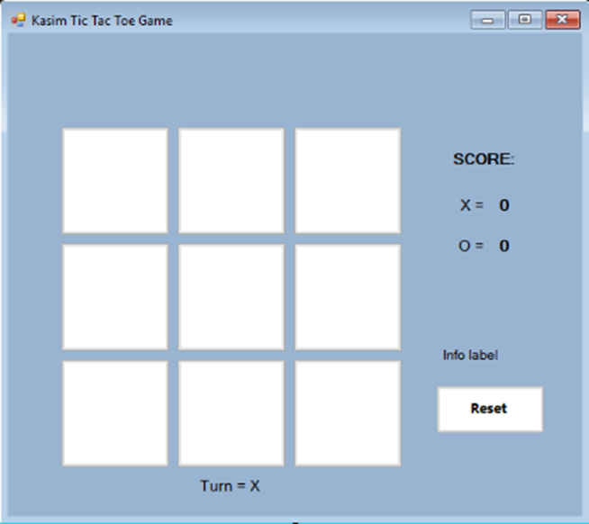

# Bibliography

1. The Spruce Crafts. 2019. Learn Tic-Tac-Toe Game Rules With Variants. [ONLINE] Available at: <https://www.thesprucecrafts.com/tic-tac-toe-game-rules-412170>. [Accessed 21 May 2019].