Test Plan

Task 3 (P5)

Kasim Hussain - 104016

Contents

Test strategy 2

Functional testing (black box testing) 2

White box testing using debugging tools 4

Bibliography 5

# Test strategy

This document will show black box testing in which the application will be tested by a user’s point of view. Additionally, white box testing was used in the application to get a more thorough test to make sure that everything worked such as the variables used having the correct values throughout the program.

## Functional testing (black box testing)

The table shows the entire test plan with screen shots of the application on the right side of what happens on each test.

|  |  |  |
| --- | --- | --- |
| **Test** | **Date** | **Result** |
| Form loads | 02/05/19 | The form loads |
| Welcome message displayed | 02/05/19 | Welcome message is displayed |
| Click on button TopLeft | 02/05/19 | X is displayed on button |
| Click on button TopCentre | 02/05/19 | O is displayed button |
| Click on button TopRight | 02/05/19 | X is displayed on button |
| Click on button CentreLeft | 02/05/19 | O is displayed on button |
| Click on button CentreCentre | 02/05/19 | X is displayed on button |
| Click on button CentreRight | 02/05/19 | O is displayed on button |
| Click on button BottomLeft | 02/05/19 | X is displayed on button |
| Click on button BottomCentre | 02/05/19 | Nothing displayed |
| Click on button BottomRight | 02/05/19 | Nothing displayed |
| Click reset button | 02/05/19 | The grid clears and “Game reset” displayed |

## White box testing using debugging tools

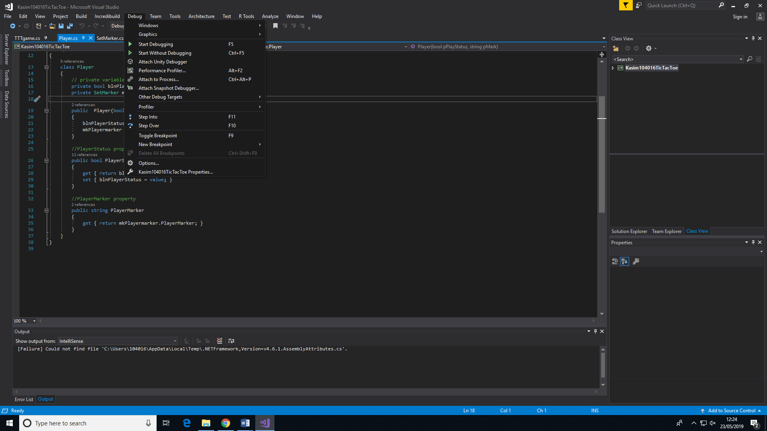Visual studio has debugging tools which were useful in testing the application. For example, the debugging tools such as the breakpoints, step into and step over were used to test functions. This was useful as it eradicated discrepancy and errors in the program. In the images below the debugging tools were used and it helped in the project but also gave knowledge on how the program works.

