[ 16 ] 메일발송(hybrid0506 – 0506hybrid)

1. 우선 gmail 계정을 이용한다. 아래의 사이트에 들어가 [보안 수준이 낮은 앱 허용]을 사용한다

로그인 후 → 보안 → 보안 수준이 낮은 앱의 액세스 사용

<https://myaccount.google.com/lesssecureapps?utm_source=google-account&utm_medium=web>

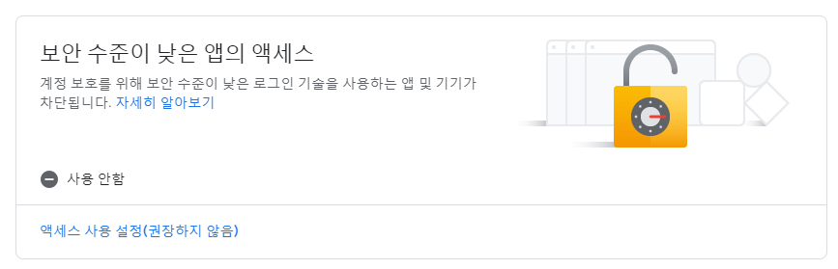

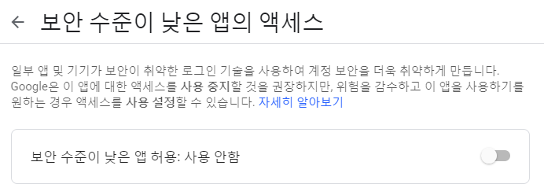

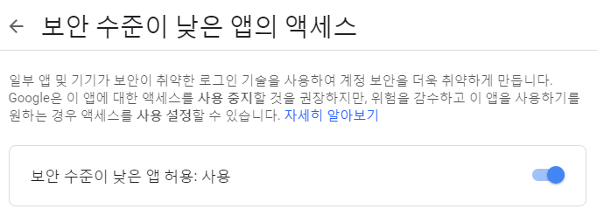

1. 의존추가(pom.xml)

<dependency>

<groupId>javax.mail</groupId>

<artifactId>mail</artifactId>

<version>1.4</version>

</dependency>

1. 빈생성 (servlet-context.xml)

<beans:bean id=*"mailSender"*

class=*"org.springframework.mail.javamail.JavaMailSenderImpl"*>

<beans:property name=*"host"* value=*"smtp.gmail.com"*/>

<beans:property name=*"port"* value=*"587"*/>

<beans:property name=*"username"* value=*"hybrid0506"*/>

<beans:property name=*"password"* value=*"0506hybrid"*/>

<beans:property name=*"javaMailProperties"*>

<beans:props>

<beans:prop key=*"mail.smtp.auth"*>true</beans:prop>

<beans:prop key=*"mail.smtp.starttls.enable"*>true</beans:prop>

<beans:prop key=*"mail.debug"*>true</beans:prop>

</beans:props>

</beans:property>

</beans:bean>

1. 소스 추가(컨트롤러)

**package** com.tj.ch17;

**import** javax.mail.Message;

**import** javax.mail.internet.InternetAddress;

**import** javax.mail.internet.MimeMessage;

**import** org.springframework.beans.factory.annotation.Autowired;

**import** org.springframework.mail.SimpleMailMessage;

**import** org.springframework.mail.javamail.JavaMailSender;

**import** org.springframework.mail.javamail.MimeMessagePreparator;

**import** org.springframework.stereotype.Controller;

**import** org.springframework.ui.Model;

**import** org.springframework.web.bind.annotation.RequestMapping;

**import** org.springframework.web.bind.annotation.RequestMethod;

@Controller

**public** **class** HomeController {

@Autowired

**private** JavaMailSender mailSender;

@RequestMapping(value = "/", method = RequestMethod.***GET***)

**public** String home() {

**return** "join";

}

@RequestMapping(value="textMail", method = RequestMethod.***GET***)

**public** String textMail(String name, String mailaddr, Model model){

System.***out***.println(name+"님("+mailaddr+")께 메일을 발송하는 로직");

SimpleMailMessage message = **new** SimpleMailMessage();

String text = name+"님 방가 회원가입 축하합니다\n어서오세요\n여긴 html태그가 안 먹혀요<h1>거봐!</h1>";

message.setFrom("*hybrid0506*@gmail.com"); // 관리자 gmail 계정

message.setTo(mailaddr); // 받을 메일

message.setSubject(name+"님 회원가입감사합니다(setText)");

message.setText(text);

mailSender.send(message);

model.addAttribute("sendResult", "메일 발송 성공");

**return** "sendResult";

}

@RequestMapping(value="mail", method = RequestMethod.***GET***)

**public** String mail(**final** String name, **final** String mailaddr, Model model){

System.***out***.println(name+"님("+mailaddr+")께 메일을 발송하는 로직");

MimeMessagePreparator message = **new** MimeMessagePreparator() {

String content =

" <h1>"+name+"님의 회원가입을 축하드립니다</h1>"+

" <div>" +

" <div>" +

" 아무개 싸이트에서만 쓰실 수 있는 쿠폰을 드립니다\n\n" +

" <hr color=\"red\"/>" +

" </div>" +

" <did>" +

" <p style=\"color:blue;\" >파란색 글씨부분</p>" +

" <p style=\"color:red;\">빨간색 글씨부분</p>" +

" </did>" +

" </div>" +

" <div>" +

" <img src=\"https://t1.daumcdn.net/daumtop_chanel/op/20170315064553027.png\" />\n" +

" </div>" +

" <div style=\"font-weight: blod; font-size: 1.2em;\">아무개 사이트 일동</div>\n" +

" <div style=\"color:red;\">서울시 종로구 몰라17길 51 어떤빌딩 8층</div>";

@Override

**public** **void** prepare(MimeMessage mimeMessage) **throws** Exception {

mimeMessage.setRecipient(Message.RecipientType.***TO***, **new** InternetAddress(mailaddr));

mimeMessage.setFrom(**new** InternetAddress("*hybrid0506*@gmail.com"));

mimeMessage.setSubject(name+"님 회원가입감사합니다(HTML)");

mimeMessage.setText(content, "utf-8", "html");

}

};

mailSender.send(message);

model.addAttribute("sendResult", "html로 메일 발송 성공");

**return** "sendResult";

}

}

1. 뷰단(join.jsp)

<%@ page language=*"java"* contentType=*"text/html; charset=UTF-8"*

pageEncoding=*"UTF-8"*%>

<!DOCTYPE html>

<html>

<head>

<meta http-equiv=*"Content-Type"* content=*"text/html; charset=UTF-8"*>

</head>

<body>

<h1>메일 작성해서 회원가입버튼 누르면 환영메일 감</h1>

<form action=*"textMail"*>

<p>이름 <input type=*"text"* name=*"name"* required=*"required"*></p>

<p>메일 <input type=*"email"* name=*"mailaddr"* required=*"required"*></p>

<input type=*"submit"* value=*"회원가입(TEXT단순 메일감-HTML 못 씌움)"*>

</form>

<form action=*"mail"*>

<p>이름 <input type=*"text"* name=*"name"* required=*"required"*></p>

<p>메일 <input type=*"email"* name=*"mailaddr"* required=*"required"*></p>

<input type=*"submit"* value=*"회원가입(HTML 형태로 넘어감)"*>

</form>

</body>

</html>

1. sendResult.jsp

<body>

<h2>${sendResult }</h2>

</body>