**[ VIII ] 테블릿 레이아웃 – I**

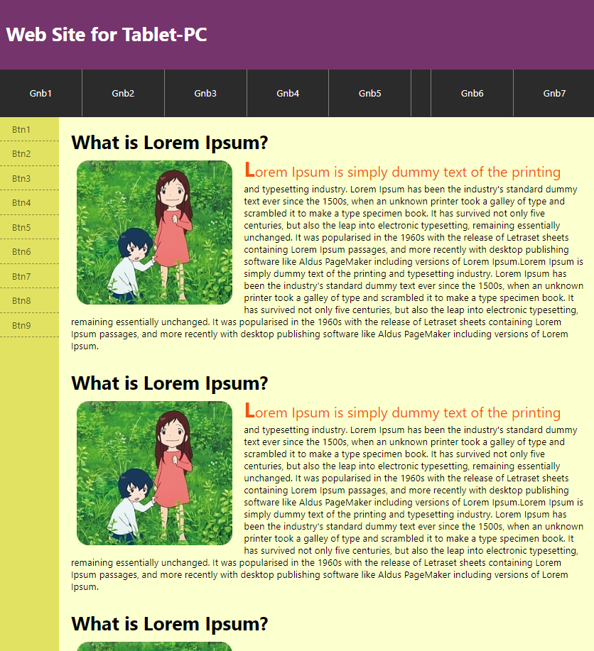

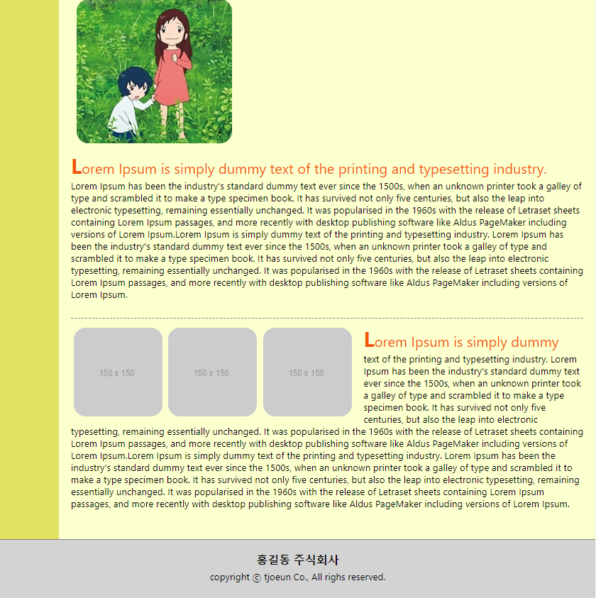

1. #header
   * p
2. #nav_gnb
   * 1. ul & li….
     2. ul & li….
3. #section
   * #nav_lnb

ul과 li

* + #content_wrap <!-- margin-right:-100px;-->

#content

div : h1, img, p

div : h1, img, p

div : h1, img, p

div : ul li3개 – img 3개와 li 기사

1. #footer
   * <p>태그 1개

<!DOCTYPE html>

<html lang="en" xmlns="http://www.w3.org/1999/xhtml">

<head>

<meta charset="utf-8" />

<title></title>

<style>

* {margin:0; padding:0; font-family:'Segoe UI', Tahoma, Geneva, Verdana, sans-serif;}

li{list-style:none;}

a{text-decoration:none;}

body{min-width:1000px;}

#header{height:100px; line-height:100px; padding:10px;

background-color:#75356c; color:white; font-size:2em;

font-weight:bold;

}

#nav_gnb{

background-color:#2b2b2b; height:80px; line-height:80px;

overflow:hidden;

}

#nav_gnb ul:first-child{

float:left;

}

#nav_gnb ul:last-child{

float:right;

}

#nav_gnb ul li{

float:left;

}

#nav_gnb ul li a{display:block; padding:0 50px;

border-right: 1px solid gray;

color:white;

}

#nav_gnb ul:last-child li:first-child{

border-left:1px solid gray;

}

#section {overflow:hidden; background-color:#e1e262;}

#section #nav_lnb{

float:left; width:100px;

}

#section #nav_lnb ul li a{

display:block;

padding:10px 20px;

border-bottom:1px dashed #868b43; color:#585716;

}

/**************#section 의 #content_wrap*/

#section #content_wrap{float:left;

width:100%; margin-right:-100px; background-color:#fcffce;

}

#section #content_wrap #content{

padding:20px 120px 20px 20px;

}

#section #content_wrap #content div{margin-bottom:30px; overflow:hidden;}

#section #content div img{border-radius:20px; margin:10px;}

#section #content div p::first-line{

font-size:1.5em; color:#f25505;

}

#section #content div p:first-letter{

font-size:1.5em; font-weight:bold;

}

#section #content div:nth-child(1) img {float:left; margin-right:20px;}

#section #content div:nth-child(2) img {float:left; margin-right:20px;}

#section #content div:nth-child(4){overflow:hidden;

border-top:1px dashed gray;

padding:10px 0 0 0;

}

#section #content div:nth-child(4) ul li img{margin:5px; float:left;}

#section #content div:nth-child(4) ul li:nth-child(3) img{

margin-right:20px;

}

footer {

height: 100px;

background-color: lightgray;

border-top: 1px solid gray;

text-align: center;

}

footer p:first-child{font-size:1.2em; font-weight:bold; margin:20px 0 5px;}

</style>

</head>

<body>

<div id="header">

<p>Web Site for Tablet-PC</p>

</div>

<div id="nav_gnb">

<ul>

<li><a href="#">Gnb1</a></li>

<li><a href="#">Gnb2</a></li>

<li><a href="#">Gnb3</a></li>

<li><a href="#">Gnb4</a></li>

<li><a href="#">Gnb5</a></li>

</ul>

<ul>

<li><a href="#">Gnb6</a></li>

<li><a href="#">Gnb7</a></li>

</ul>

</div>

<div id="section">

<div id="nav_lnb">

<ul>

<li><a href="#">Btn1</a></li>

<li><a href="#">Btn2</a></li>

<li><a href="#">Btn3</a></li>

<li><a href="#">Btn4</a></li>

<li><a href="#">Btn5</a></li>

<li><a href="#">Btn6</a></li>

<li><a href="#">Btn7</a></li>

<li><a href="#">Btn8</a></li>

<li><a href="#">Btn9</a></li>

</ul>

</div>

<div id="content_wrap">

<div id="content">

<div>

<h1>What is Lorem Ipsum?</h1>

<img src="0121_imgTab/img.jpg" />

<p>Lorem Ipsum is simply dummy text of the printing and typesetting industry. Lorem Ipsum has been the industry's standard dummy text ever since the 1500s, when an unknown printer took a galley of type and scrambled it to make a type specimen book. It has survived not only five centuries, but also the leap into electronic typesetting, remaining essentially unchanged. It was popularised in the 1960s with the release of Letraset sheets containing Lorem Ipsum passages, and more recently with desktop publishing software like Aldus PageMaker including versions of Lorem Ipsum.Lorem Ipsum is simply dummy text of the printing and typesetting industry. Lorem Ipsum has been the industry's standard dummy text ever since the 1500s, when an unknown printer took a galley of type and scrambled it to make a type specimen book. It has survived not only five centuries, but also the leap into electronic typesetting, remaining essentially unchanged. It was popularised in the 1960s with the release of Letraset sheets containing Lorem Ipsum passages, and more recently with desktop publishing software like Aldus PageMaker including versions of Lorem Ipsum.</p>

</div>

<div>

<h1>What is Lorem Ipsum?</h1>

<img src="0121_imgTab/img.jpg" />

<p>Lorem Ipsum is simply dummy text of the printing and typesetting industry. Lorem Ipsum has been the industry's standard dummy text ever since the 1500s, when an unknown printer took a galley of type and scrambled it to make a type specimen book. It has survived not only five centuries, but also the leap into electronic typesetting, remaining essentially unchanged. It was popularised in the 1960s with the release of Letraset sheets containing Lorem Ipsum passages, and more recently with desktop publishing software like Aldus PageMaker including versions of Lorem Ipsum.Lorem Ipsum is simply dummy text of the printing and typesetting industry. Lorem Ipsum has been the industry's standard dummy text ever since the 1500s, when an unknown printer took a galley of type and scrambled it to make a type specimen book. It has survived not only five centuries, but also the leap into electronic typesetting, remaining essentially unchanged. It was popularised in the 1960s with the release of Letraset sheets containing Lorem Ipsum passages, and more recently with desktop publishing software like Aldus PageMaker including versions of Lorem Ipsum.</p>

</div>

<div>

<h1>What is Lorem Ipsum?</h1>

<img src="0121_imgTab/img.jpg" />

<p>Lorem Ipsum is simply dummy text of the printing and typesetting industry. Lorem Ipsum has been the industry's standard dummy text ever since the 1500s, when an unknown printer took a galley of type and scrambled it to make a type specimen book. It has survived not only five centuries, but also the leap into electronic typesetting, remaining essentially unchanged. It was popularised in the 1960s with the release of Letraset sheets containing Lorem Ipsum passages, and more recently with desktop publishing software like Aldus PageMaker including versions of Lorem Ipsum.Lorem Ipsum is simply dummy text of the printing and typesetting industry. Lorem Ipsum has been the industry's standard dummy text ever since the 1500s, when an unknown printer took a galley of type and scrambled it to make a type specimen book. It has survived not only five centuries, but also the leap into electronic typesetting, remaining essentially unchanged. It was popularised in the 1960s with the release of Letraset sheets containing Lorem Ipsum passages, and more recently with desktop publishing software like Aldus PageMaker including versions of Lorem Ipsum.</p>

</div>

<div>

<ul>

<li><a href="#"><img src="http://placehold.it/150x150" /></a></li>

<li><a href="#"><img src="http://placehold.it/150x150" /></a></li>

<li><a href="#"><img src="http://placehold.it/150x150" /></a></li>

<li><p>Lorem Ipsum is simply dummy text of the printing and typesetting industry. Lorem Ipsum has been the industry's standard dummy text ever since the 1500s, when an unknown printer took a galley of type and scrambled it to make a type specimen book. It has survived not only five centuries, but also the leap into electronic typesetting, remaining essentially unchanged. It was popularised in the 1960s with the release of Letraset sheets containing Lorem Ipsum passages, and more recently with desktop publishing software like Aldus PageMaker including versions of Lorem Ipsum.Lorem Ipsum is simply dummy text of the printing and typesetting industry. Lorem Ipsum has been the industry's standard dummy text ever since the 1500s, when an unknown printer took a galley of type and scrambled it to make a type specimen book. It has survived not only five centuries, but also the leap into electronic typesetting, remaining essentially unchanged. It was popularised in the 1960s with the release of Letraset sheets containing Lorem Ipsum passages, and more recently with desktop publishing software like Aldus PageMaker including versions of Lorem Ipsum.</p></li>

</ul>

</div>

</div>

</div>

</div>

<footer>

<p>홍길동 주식회사</p>

<p>copyright ⓒ tjoeun Co., All righs reserved.</p>

</footer>

</body>

</html>**[ VIII ] 테블릿 레이아웃 - II**

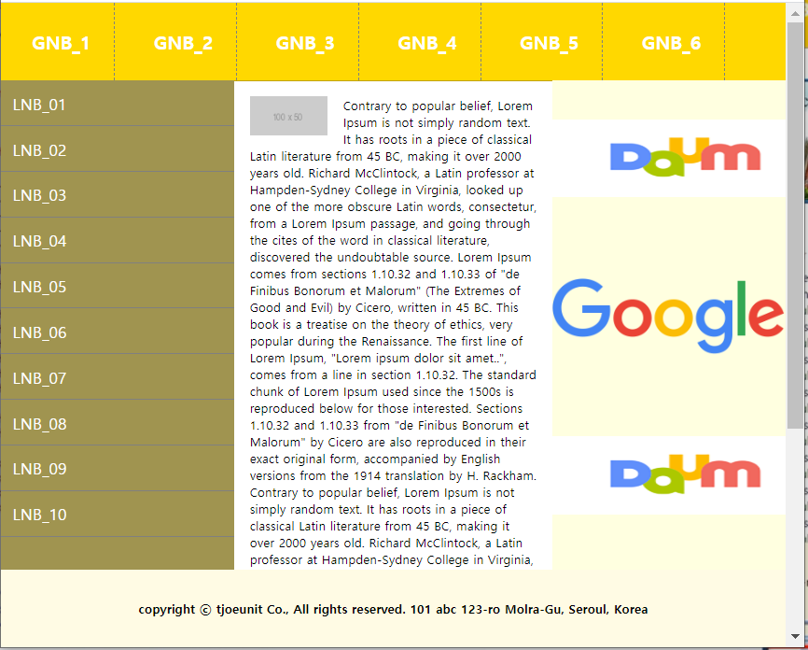

<!DOCTYPE html>

<html lang="en" xmlns="http://www.w3.org/1999/xhtml">

<head>

<meta charset="utf-8" />

<title></title>

<style>

*{margin:0; padding:0;}

html{height:100%;}

body{height:100%;}

li{list-style:none;}

a{text-decoration:none;}

/* * * * * * * * * #top_bar * * * * * * * * * * * */

#top_bar{position:fixed; top:0; left:0;right:0;

height:100px; line-height: 100px;

background-color:#ffd800; border-bottom:1px solid #c0a300;

}

#top_bar ul{overflow:hidden;}

#top_bar ul li{float:left;}

#top_bar ul li a {

display:block; padding:0 30px; margin:0 10px;

border-right: 1px dashed gray;

color:white; font-size:1.5em; font-weight:bold;

}

/* * * * * * * * * #top_bar * * * * * * * * * * * */

#bottom_bar{

position:fixed; bottom:0; left:0; right:0;

height:100px; line-height:100px;

background-color:#fffbe4;

font-weight:bold;

text-align:center;

}

#left_bar{

position:fixed;

top:100px; bottom:100px; left:0;

width:300px; background-color:#a09450;

}

#left_bar ul li a{

display:block;

padding:15px;

color:white;

font-size:1.3em;

border-bottom:1px solid gray;

}

#right_bar{

position:fixed; bottom:100px; top:100px; right:0;

width:300px; background-color:lightyellow;

}

#right_bar ul li{padding:50px 0;}

#right_bar img{

width:300px; height:100px;

}

#wrap {margin:100px 300px 100px 300px; padding:20px;}

#wrap img{float:left; margin-right:20px;}

</style>

</head>

<body>

<div id="top_bar">

<ul>

<li><a href="#">GNB_1</a></li>

<li><a href="#">GNB_2</a></li>

<li><a href="#">GNB_3</a></li>

<li><a href="#">GNB_4</a></li>

<li><a href="#">GNB_5</a></li>

<li><a href="#">GNB_6</a></li>

</ul>

</div>

<div id="left_bar">

<ul>

<li><a href="#">LNB_01</a></li>

<li><a href="#">LNB_02</a></li>

<li><a href="#">LNB_03</a></li>

<li><a href="#">LNB_04</a></li>

<li><a href="#">LNB_05</a></li>

<li><a href="#">LNB_06</a></li>

<li><a href="#">LNB_07</a></li>

<li><a href="#">LNB_08</a></li>

<li><a href="#">LNB_09</a></li>

<li><a href="#">LNB_10</a></li>

</ul>

</div>

<div id="right_bar">

<ul>

<li><a href="http://www.daum.net" target="_blank"><img src="https://t1.daumcdn.net/daumtop_chanel/op/20170315064553027.png" alt="다음" /></a></li>

<li><a href="http://www.google.com" target="_self"><img src="https://www.google.com/images/branding/googlelogo/2x/googlelogo_color_272x92dp.png" alt="구글" /></a></li>

<li><a href="http://www.daum.net" target="_blank"><img src="https://t1.daumcdn.net/daumtop_chanel/op/20170315064553027.png" alt="다음" /></a></li>

<li><a href="http://www.google.com" target="_self"><img src="https://www.google.com/images/branding/googlelogo/2x/googlelogo_color_272x92dp.png" alt="구글" style="width:400px; height:100p "/></a></li>

</ul>

</div>

<div id="bottom_bar">

<p>copyright ⓒ tjoeunit Co., All rights reserved. 101 abc 123-ro Molra-Gu, Seroul, Korea</p>

</div>

<div id="wrap">

<img src="http://placehold.it/100x50" />

<p>

Contrary to popular belief, Lorem Ipsum is not simply random text. It has roots in a piece of classical Latin literature from 45 BC, making it over 2000 years old. Richard McClintock, a Latin professor at Hampden-Sydney College in Virginia, looked up one of the more obscure Latin words, consectetur, from a Lorem Ipsum passage, and going through the cites of the word in classical literature, discovered the undoubtable source. Lorem Ipsum comes from sections 1.10.32 and 1.10.33 of "de Finibus Bonorum et Malorum" (The Extremes of Good and Evil) by Cicero, written in 45 BC. This book is a treatise on the theory of ethics, very popular during the Renaissance. The first line of Lorem Ipsum, "Lorem ipsum dolor sit amet..", comes from a line in section 1.10.32.

The standard chunk of Lorem Ipsum used since the 1500s is reproduced below for those interested. Sections 1.10.32 and 1.10.33 from "de Finibus Bonorum et Malorum" by Cicero are also reproduced in their exact original form, accompanied by English versions from the 1914 translation by H. Rackham.

Contrary to popular belief, Lorem Ipsum is not simply random text. It has roots in a piece of classical Latin literature from 45 BC, making it over 2000 years old. Richard McClintock, a Latin professor at Hampden-Sydney College in Virginia, looked up one of the more obscure Latin words, consectetur, from a Lorem Ipsum passage, and going through the cites of the word in classical literature, discovered the undoubtable source. Lorem Ipsum comes from sections 1.10.32 and 1.10.33 of "de Finibus Bonorum et Malorum" (The Extremes of Good and Evil) by Cicero, written in 45 BC. This book is a treatise on the theory of ethics, very popular during the Renaissance. The first line of Lorem Ipsum, "Lorem ipsum dolor sit amet..", comes from a line in section 1.10.32.

The standard chunk of Lorem Ipsum used since the 1500s is reproduced below for those interested. Sections 1.10.32 and 1.10.33 from "de Finibus Bonorum et Malorum" by Cicero are also reproduced in their exact original form, accompanied by English versions from the 1914 translation by H. Rackham.

</p>

</div>

</body>

</html>